Based on an equivalent model and synthetic storm: of 250 m average depth

Modified:

* Location of the new development. Added in new land cover characteristics
* Changed roughness values of proposed development area.

Table of results with a 250 mm rain event

|  |  |  |  |  |
| --- | --- | --- | --- | --- |
| **Scenario** | **Peak flow** | **Peak timing** | **Vol of flow** | **% Increase in Flow Vol over Base case** |
| Present Day LU | 3,856.5 | 840 mins | 32,624,637 |  |
| Low-intensity Developed | 3,839.4 | 840 mins | 32,672,969 | 0.148% |
| High intensity Developed | 3,754.1 | 840 mins | 32,767,408 | 0.438% |

Table of results with a 500 mm rain event

|  |  |  |  |  |
| --- | --- | --- | --- | --- |
| **Scenario** | **Peak flow** | **Peak timing** | **Vol of flow** | **% Increase in Flow Vol over Base case** |
| Present Day LU | 11,670 | 780 mins | 95,939,134 |  |
| Low-intensity Developed | 11,644 | 780 mins | 96,357,085 | 0.436% |
| High intensity Developed | 11,479 | 780 mins | 95,967,928 | 0.030% |

**Hydrograph of current day land use**

Hydrograph of present day non-developed landscape mostly fallow grassland = (Mannings N of 0.34)

250 mm event

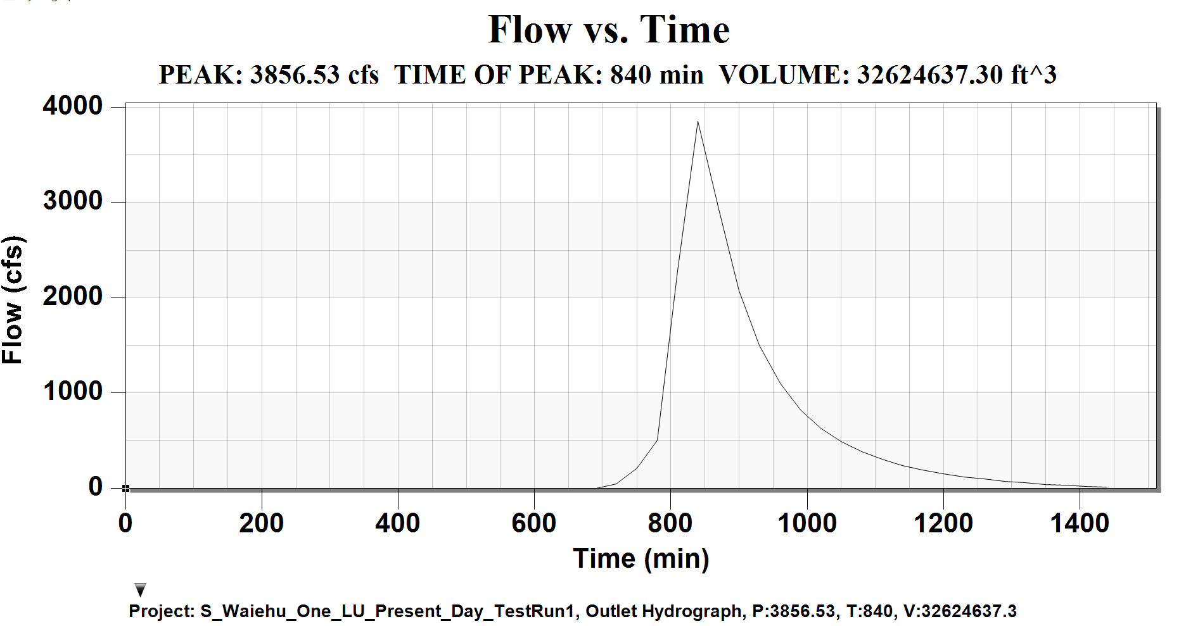

Hydrograph of developed area with **Low_impact development** (Mannings N of 0.18)

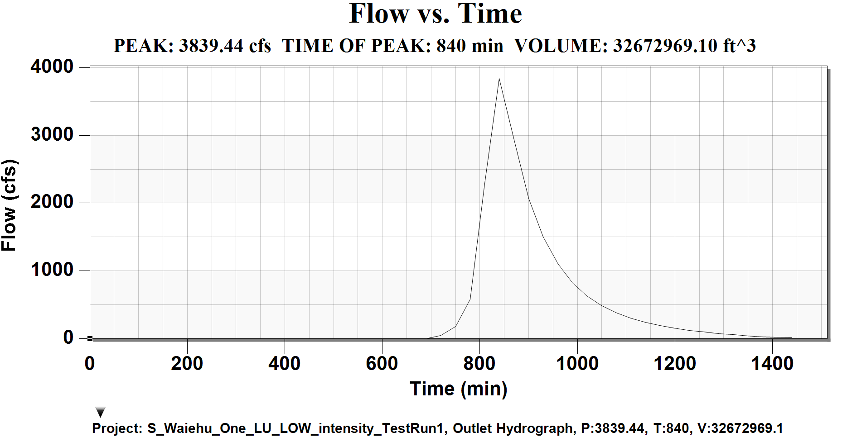

Hydrograph of developed area with **High-Impact development** (Mannings N of 0.04)

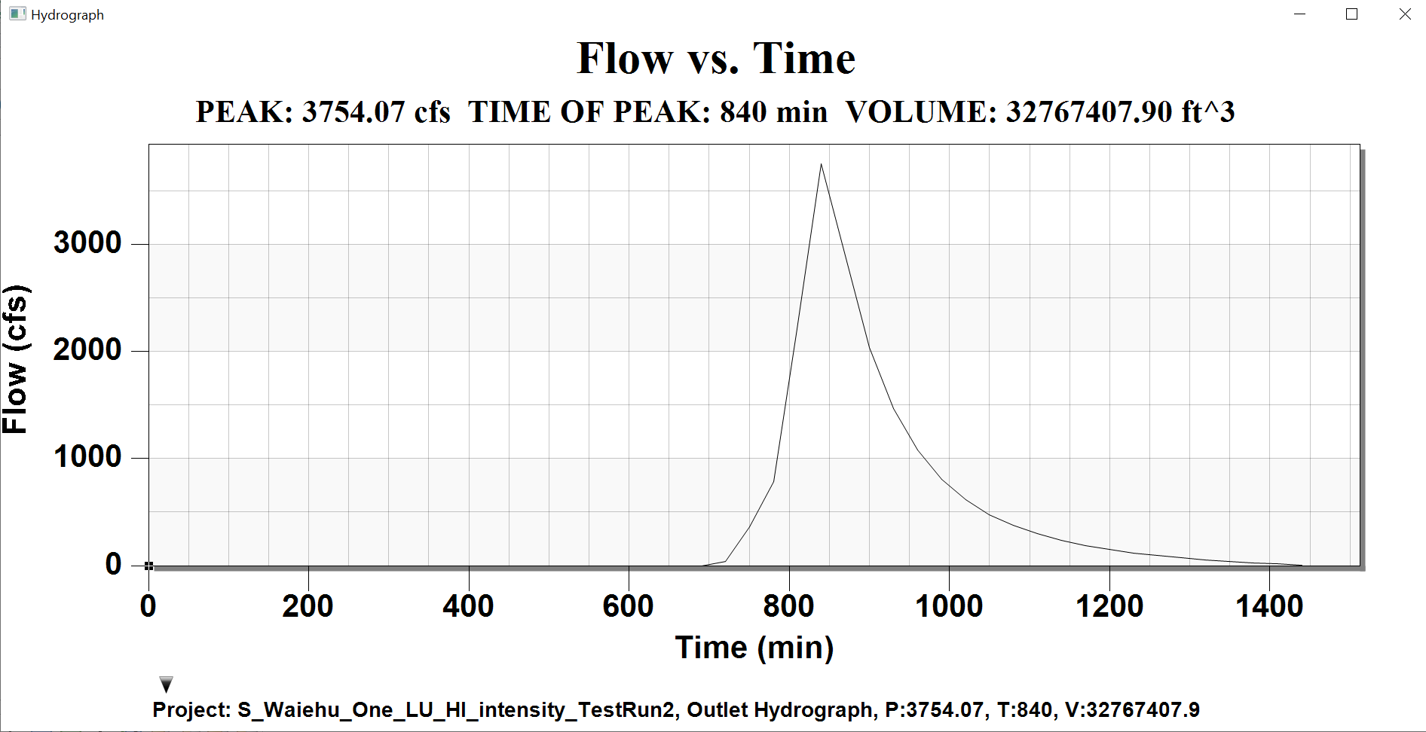

Flood extent, still need to define channel geometries or much smaller cells

