**Crisis In Governance at the College of Staten Island**

John Verzani

Chair, College Council

This summer I had the opportunity to attend the *2021 AAUP Shared Governance Conference*. This was in support of a few AAUP sponsored reports:

* A report on [Covid-19 and Academic Governance](https://www.aaup.org/report/covid-19-and-academic-governance)
* A report on its [Shared Governance Survey](https://www.aaup.org/news/new-survey-data-provides-snapshot-shared-governance-then-and-now#.YQgMAxNKjlw), the first such national survey since 2001.

The first “details an investigation of the crisis in academic governance that has occurred in the wake of the COVID-19 pandemic, with a focus on eight institutions.” We will highlight **numerous** similarities between the current **assault** on shared governance at the College of Staten Island in the context of national trends.

The second provides national ranges for twenty-nine areas of institutional decision-making. We will subjectively rank the college’s governance structure as it is *and* how it would be, given the President’s proposed governance plan of March 3, 2021.

## The national picture

The AAUP report on COVID-19 and Academic Governance speaks for itself:

This report is about those responses to the crisis that, in disregard of the norms of academic governance, were effected largely by administrative fiat, with little or no consultation with the faculty even where austerity and emergency measures had dramatic effects on the curriculum, an area traditionally considered the faculty’s primary responsibility.

In this respect, as in so many others, COVID-19 served as an accelerant, turning the gradual erosion of shared governance on some campuses into a landslide.

The AAUP report “[COVID-19 and Academic Governance](https://www.aaup.org/special-report-covid-19-and-academic-governance)” details investigations into eight institutions, but has lessons for all institutions of higher education:

It charts two parallel developments that have transferred decision-making authority to administrations and instituted a corporate model of university governance: one, the expansion of areas of university administration, from the financial office to the office of the general counsel to the offices of risk management, in which the faculty has no involvement; and two, the casualization of the faculty workforce entailed in the decades-long transition from a majority tenured to a majority nontenured faculty. Some institutional leaders seem to have taken the COVID-19 crisis as an opportunity to turbocharge the corporate model, allowing them to close programs and lay off faculty members as expeditiously as if colleges and universities were businesses whose CEOs suddenly decided to stop making widgets or shut down the steelworks.

As noted in the report: the investigation was prompted largely by opportunistic exploitations of catastrophic events, a phenomenon generally known as “disaster capitalism.”

In this respect, as in so many others, COVID-19 served as an accelerant, turning the gradual erosion of shared governance on some campuses into a landslide.

It is noted that “The COVID-19 pandemic has presented the most serious challenges to academic governance in in the last fifty years.” To illustrate, the *crisis*, the following examples are [provided](https://www.aaup.org/special-report-covid-19-and-academic-governance#Crisis-in-academic-governance):

* Discontinuance of academic programs (College of St. Rose, University of Vermont)
* Termination of faculty positions (Ithaca College, Marquette, Pennsylvania System, University of Colorado)
* Unilaterally moving forward with a new governance structure for the institution citing the need to be “innovative and flexible.” (Saint Leo University)
* Avoidance of faculty input in adminstrative searches (SUNY)

The following reflection from the report describes the conditions at CSI at the cusp of the pandemic:

Perhaps the most obvious shared element among these examples and the eight cases discussed in this report is the pandemic’s exacerbation of years of preexisting financial difficulties caused primarily by stagnant or declining enrollments at small private institutions coupled with, at public institutions, ever-lower levels of state funding.

The report notes that “As soon as news of this investigating committee and its charge was released, faculty members from a wide range of institutions contacted the AAUP’s staff with accounts of similar developments on their campuses.” The College of Staten Island has **experienced all of the above** to some degree:

* Though no programs have been canceled, the college has argued that some programs in Education should no longer be supported; the Nursing program is teetering on the edge of losing its accreditation.
* Though faculty positions have not been out right terminated, the college has lost 35 faculty positions between F19 and S21 (354 to 319, or 10%) in a period of time when only 34 full time positions in total were lost. (CUNY’s 3rd quarter financial report). The college has failed to keep up with separations and retirements. While there have been no attempts to institute “Force Majeure–Type Provisions” or declare “Financial Exigency” either by CSI or CUNY, the loss of faculty expertise through these stringent austerity measures undertaken while ample federal funding has been made available hurts no less.
* In describing his proposed governance plan, the president notes “It is intended to be flexible and dynamic.” The initiation of this proposal and the president’s often stated position of not needing campus approval to move forward on a **wholesale replacement** of the governance plan makes this effort nothing short of *unilateral*.
* The president has moved forward with several *interim* appointments for positions this summer (two cabinet level appointments in advancement and government affairs, and Associate Provost, and appointments in communications and athletic directorship) Not only do these interim appointments bypass the regular consultation with the College Council Executive Committee on the search committee composition, they should be seen as a means to bypass competitive national searches.

A common rationalization for such actions is the fact that the college has a “structural deficit.” This message has been utilized for *several* years now. The AAUP in response to such excuse making states:

The president is “largely responsible for the maintenance of existing institutional resources and the creation of new resources.” It appears that boards and administrations at institutions that endured years of financial trouble before the onset of the pandemic may simply have failed to fulfil these obligations. Corrective action taken during those years, if taken at all, was obviously ineffective—and then the pandemic struck.

In addition to these issues, the AAUP has noted that the process employed nationally – and at the College of Staten Island – is problematic.

The AAUP notes that many institutions have undertaken unilateral suspension of faculty handbooks. At the College of Staten Island, the draft faculty handbook was *rewritten* in March 2021 to include an *unapproved* proposed governance plan. While this action was later reconsidered, the initial consideration of such is sufficiently alarming.

The AAUP also expresses concern as to how faculty are co-opted into participating with these efforts to undermine college governance. At CSI this summer, a group of chairpersons were queried to help smooth out the many warts of the proposed plan, bypassing the established governance structure. Further, this group was given specific boundaries as to what would be allowed to be modified from the original proposed plan.

Faculty members at the investigated institutions faced the dilemma of either participating in ad hoc governance processes they knew to be flawed in the hope of shaping their outcomes or refusing on principle to participate at all, thereby allowing administrators and board members to move forward without them. As the faculty members who work most closely with the administration and, where applicable, the governing board, faculty senate leaders appeared to feel this tension particularly acutely.

For any such efforts the AAUP writes

When faculty members opt to participate in a makeshift governance process as part of such a group, they should do so under the same conditions that govern their participation in the standing governance structure: they should be elected by the faculty rather than appointed by the administration, and they should be free to discuss the body’s work with their colleagues and report regularly to them, as called for in the Statement on Government and derivative AAUP policy documents such as Confidentiality and Faculty Representation in Academic Governance.

## The shared governance survey

The shared governance survey gives a snapshot of governance plans throughout Higher Education institutions in the US. Despite a characterization that “the proposed plan submitted for your review focuses on common practices among governance plans in CUNY and across the nation,” we can **clearly** see this is **patently false**. The scorecard at the end shows that under the proposed plan **nearly every** benchmark category shifts to “administrative primacy” or “administrative dominance” Nearly every change results in the college being near the absolute bottom of the range of institutions.

In the survey there were 5 characterizations: Administrative Dominance, Administrative Primacy, Joint Authority, Faculty Primacy, Faculty Dominance. In the following, is a fair-minded attempt to fill out the survey were it given to CSI under the current governance plan and the proposed on.

### Academic

Program-level curricular decisions, including the approval of individual courses and major/minor requirements.

In the current governance plan, the curriculum committees consider such. These committees are chaired by faculty and comprised primarily by faculty. Their decisions are subject to Faculty Senate Approval.

The proposed plan removes the approval process, and places administrative chairs on the new committees..

🡺This would move the college from the [63.2, 100] range (faculty dominance) to the [24, 63.2] range (faculty primacy).

🡺 We use the initial March 3, 2021 plan as it being closest to the president’s initial intent

Establishment of new academic programs.

In the current governance plan, the IPC would receive a presentation on any such proposals which would then be reported to the College Council. The IPC agenda is set by the administration, but has equal representation of faculty and administrators.

In the proposed plan the IPC is abolished, no such sub-committee would assume this role.

🡺 This would move the college from the middle [27.5, 69.1] range (joint authority) to the bottom, [0, 4] range (administrative dominance)

Institutional curricular decisions (general education/distribution requirements, minimum/maximum number of requirements in major, etc.).

In the current governance plan, the General Education Committee and Undergraduate Curriculum committees would would consider such details. These are currently faculty chaired, with a primarily faculty compositions. These bodies are subject to Faculty Senate approval. This body is traditionally chaired by faculty and the composition is primarily faculty.

In the proposed plan, the departments are obliged to create a committee with the department chair as chair; each division and school then must have a committee chaired by the dean; then the College Senate is tasked with review (not approval). The president’s approval is noted as necessary.

🡺 This would move the college from top [81.3, 100] range (faculty dominance) to near the bottom [2.7, 14.4] range (administrative primacy)

Grade assignments to individual students.

This would remain unchanged, the college is in the top [6.7,100] range (faculty dominance)

Undergraduate admissions requirements.

The current admissions committee is comprised of 9 faculty and 4 administration members, ex officio. Decisions are forwarded to the Faculty Senate for approval.

The proposed replacement committee would have 5 faculty, 5 administration members, and all appeals would be presented to the provost

🡺 This would move the college from top [88.6, 97.2] range(faculty primacy) to near the bottom [0,30.7] range (administrative dominance)

Teaching assignments of individual faculty members.

The current plan has this duty of the department chair: “be responsible for assigning courses to and arranging programs of instructional staff members of the Department”

The proposed plan removes these duties, leaving this vague, though the listed duties are from the Manual of General Policy, so would presumably remain intact.

🡺 Current practice is in the top [67.6, 100] range (faculty dominance) future practice could lower this

Institutional policies concerning intellectual property.

This would not change under the proposed plan, and is not covered in the current plan

Institutional policies concerning mode of course delivery, including online learning.

This is not part of either plan.

The administration did not respond to a report approved by the faculty senate. It would be fair to say currently this is currently “administrative primacy”, or the [9.2, 33.2] range.

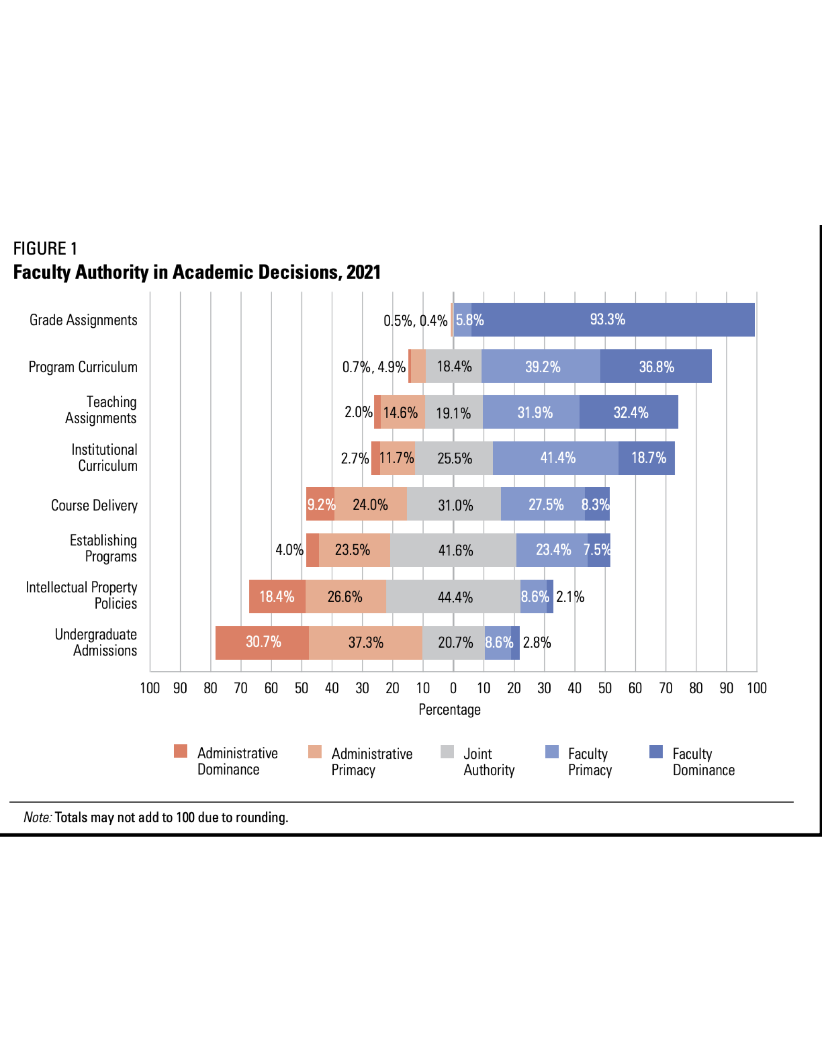

Faculty Authority in Academic Decisions, 2021

### Personnel

Searches for tenure-track faculty members.

The department chair is currently “responsible for the recruitment of faculty subject to the approval of the Department Appointments Committee;”

These duties are dropped from the proposed plan, though the listed duties are from the Manual of General Policy, so would presumably remain intact.

Recent shifts in practice of the role of the dean, would contribute to moving this from faculty primacy to joint authority.

🡺 This has moved from the [16, 38.4] range (faculty primacy) to the [38.4, 83] range (joint authority)

Evaluation of tenure-track faculty members for reappointment prior to the tenure decision.

The current structure has the departmental appointments committee making recommendations to the College-wide P&B. This body currently allows only faculty vote. It makes recommendation to the college president, who presumably canvases the administration before decisions.

The proposed structure has 7 administrators, 2 students, and 5 faculty members serve college-wide; a department tenure and promotion committee (not a representative appointments committee); a non-specific division/school academic review committee

🡺 This moves from the [60.5, 93.3] range (faculty primacy) to the [0, 5.4] range (administrative dominance)

Setting standards for promotions of tenured and tenure-track faculty members.

The current Personnel and Budget committee can create additional subcommittees and procedures: “The Personnel and Budget Committee may create additional procedures or subcommittees to aid in its deliberations, consonant with bylaws and policies of the Board of Trustees.”

The new plan does not mention this

🡺 This would move from the [47.5, 85] range (faculty primacy)

Individual promotion decisions for tenured and tenure-track faculty members.

Currently, the recommendation to the president for promotion consists solely of faculty votes

The proposed plan has a College Personnel and Budget Committee with a super majority of administrative or students votes.

🡺 This would move from the [57.6, 93,] range (faculty primacy) to the [4.1, 25.8] range (administrative primacy)

Setting standards for awarding of tenure.

Individual tenure decisions.

Currently, the recommendation to the president for promotion consists solely of faculty votes

The proposed plan has a College Personnel and Budget Committee with a super majority of administrative or students votes.

🡺 This would move from the [60.5, 93.3] range (faculty primacy) to the [5.4, 26] range (administrative primacy)

Searches for part-time faculty members (such as adjunct faculty).

This is a duty of the chair subject to approval of the appointments committee and the administration.

This is not addressed in the proposed plan, presumably the chair would have this as a duty subject to approval of the administration (there is not appointments committee).

🡺 This would *likely* remain as faculty primacy, [38.5, 69.5] range

Evaluation of part-time faculty members (such as adjunct faculty) for reappointment.

This is contractual and currently subject to review by the department appointments committee and the college P&B

The new plan does not have department review specified

🡺 This would likely remain as faculty primacy, [40.3, 71.5]

Searches for full-time non-tenure-track faculty members (such as lecturers and clinical, research, or teaching faculty).

The college historically has such hires suggested by the department appointment’s committee, approved by the administration, and reviewed by the P&B.

There is no appointments committee, so this would be subject to the department chair, the college wide P&B, and the administration

🡺 This would move from the [42.9, 85.6] range (faculty primacy) to the [4.7, 20.3] range (administrative primacy)

Evaluation of full-time non-tenure-track faculty members (such as lecturers and clinical, research, or teaching faculty) for reappointment.

This is also contractual. The current plan has review by the appointments committee and the P&B.

The proposed plan would have review by a chair (presumably) and the P&B.

🡺 This would move from the [50.2, 84.9] range (faculty primacy) to the [9.2, 29.6] range (administrative primacy)

Setting standards for promotions of full-time non-tenure-track faculty members (such as lecturers and clinical, research, or teaching faculty).

The current plan has review by the appointments committee and the P&B.

The proposed plan would have review by a chair (presumably) and the P&B.

🡺 This would move from the [55, 87.5] range (faculty primacy) to the [7.2, 20.5] range (administrative primacy)

Individual promotion decisions for full-time non-tenure-track faculty members (such as lecturers and clinical, research, or teaching faculty).

The current plan has approval by a department promotion committee and the P&B

The proposed plan would have review by a chair (presumably) and the P&B.

🡺 This would move from the [67.5, 91] range (faculty primacy) to the [7.6, 36.6] range (administrative primacy)

Faculty salary policies.

This is contractual.

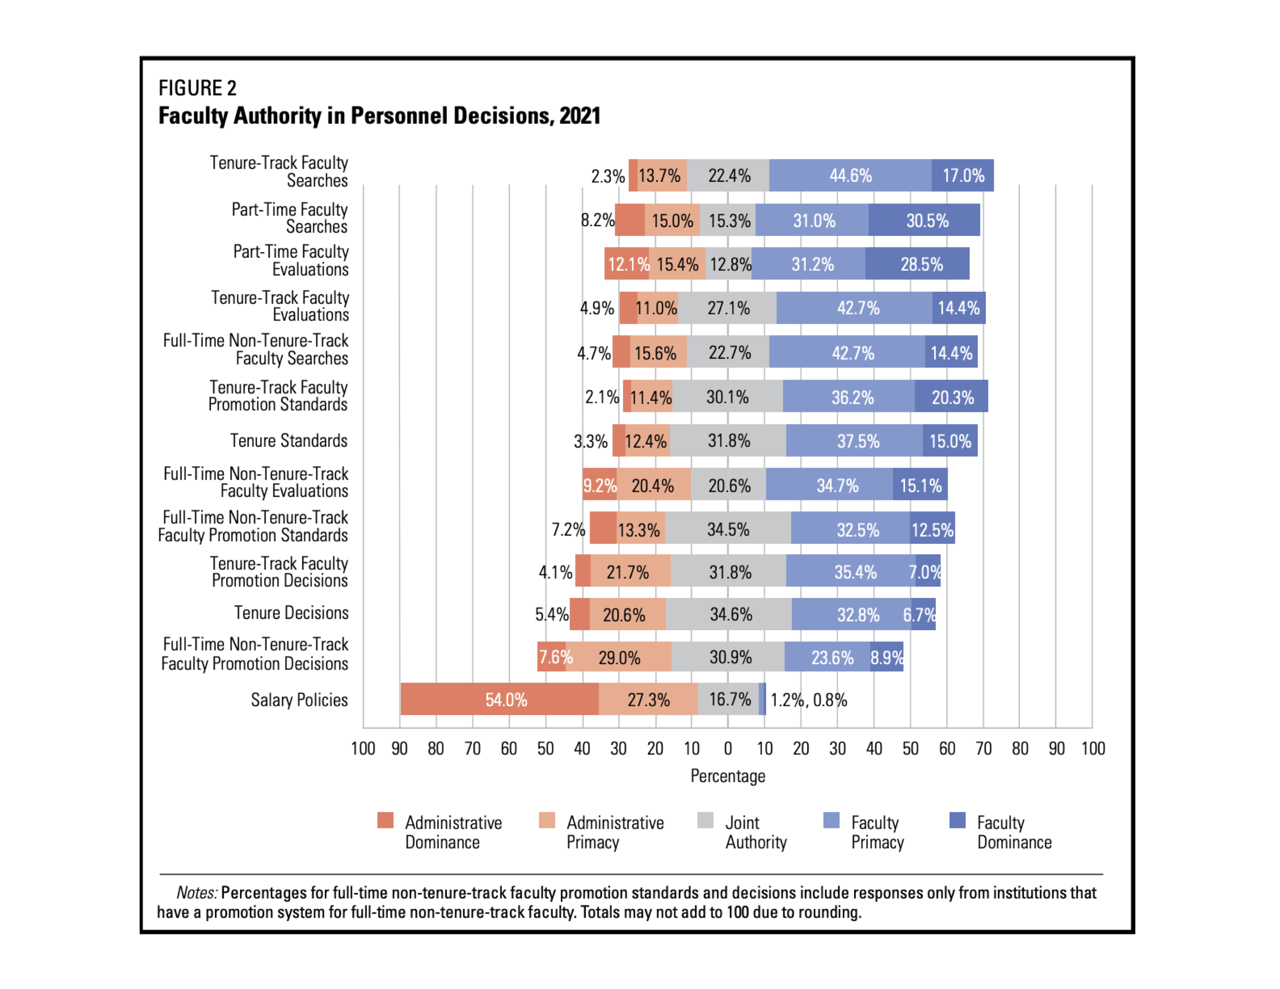

Faculty Authority in Personnel Decisions, 2021

### Administrative

Allocation of faculty positions to departments or programs.

The Lines and Budget Subcommittee has an equal number of faculty and administrators discussing the allocation of faculty lines.

The proposed plan has no faculty involvement.

🡺 This would move the college from the [86.4, 96.5] range (joint authority) to the bottom [0, 45.2] range (administrative dominance)

Decisions about facilities and buildings (such as demolitions, new construction, renovations, etc.).

The current governance plan includes two facilities committee, one primarily comprised of faculty and focusing on academic issues, the other a wider more college-oriented body.

The proposed plan reduces the faculty voice, has direct appointments by the administration, has an administrative chair,

🡺 This would move the college from the [71.8, 98.8] range (administrative primacy) to the bottom [0, 71.8] range (administrative dominance)

Selection of vice president for academic affairs, provost, or equivalent.

The current plan assigns duties to the College Council Executive Committee to consult on searches for ECP positions.

The proposed plan has no role for faculty input

🡺 This would move the college from the [32.7, 82.3] range (administrative primacy) to the bottom [0, 32.7] range (administrative dominance)

Selection of academic deans, division directors, or equivalent.

The current plan assigns duties to the College Council Executive Committee to consult on searches for ECP positions.

The proposed plan has no role for faculty input

🡺 This would move the college from the [30.5, 80.9] range (administrative primacy) to the bottom [0, 30.5] range (administrative dominance)

Selection of department chairs or heads.

Would not change.

CSI is in the [86.7, 100] range (faculty dominance)

Policies regarding teaching loads.

This is contractual and would not change.

Institutional budgetary planning.

The College Council Budget Committee would be abolished.

The College Personnel and budget committee, with 8 administrators, 2 students, and 5 faculty (possibly appointed) would make recommendations on the annual budget request.

🡺 This would move the college from the [63.3, 96.3] range (administrative primacy) to the bottom [0, 63.3] range (administrative dominance)

Institutional strategic planning.

The IPC would be abolished.

There is no replacement committee; only the CSI College Senate has a policy function of “Planning for the continued development of the college.”

🡺 This would move the college from the [79.1,96.7] range (joint authority) to the bottom [0, 22.3] range (administrative dominance)

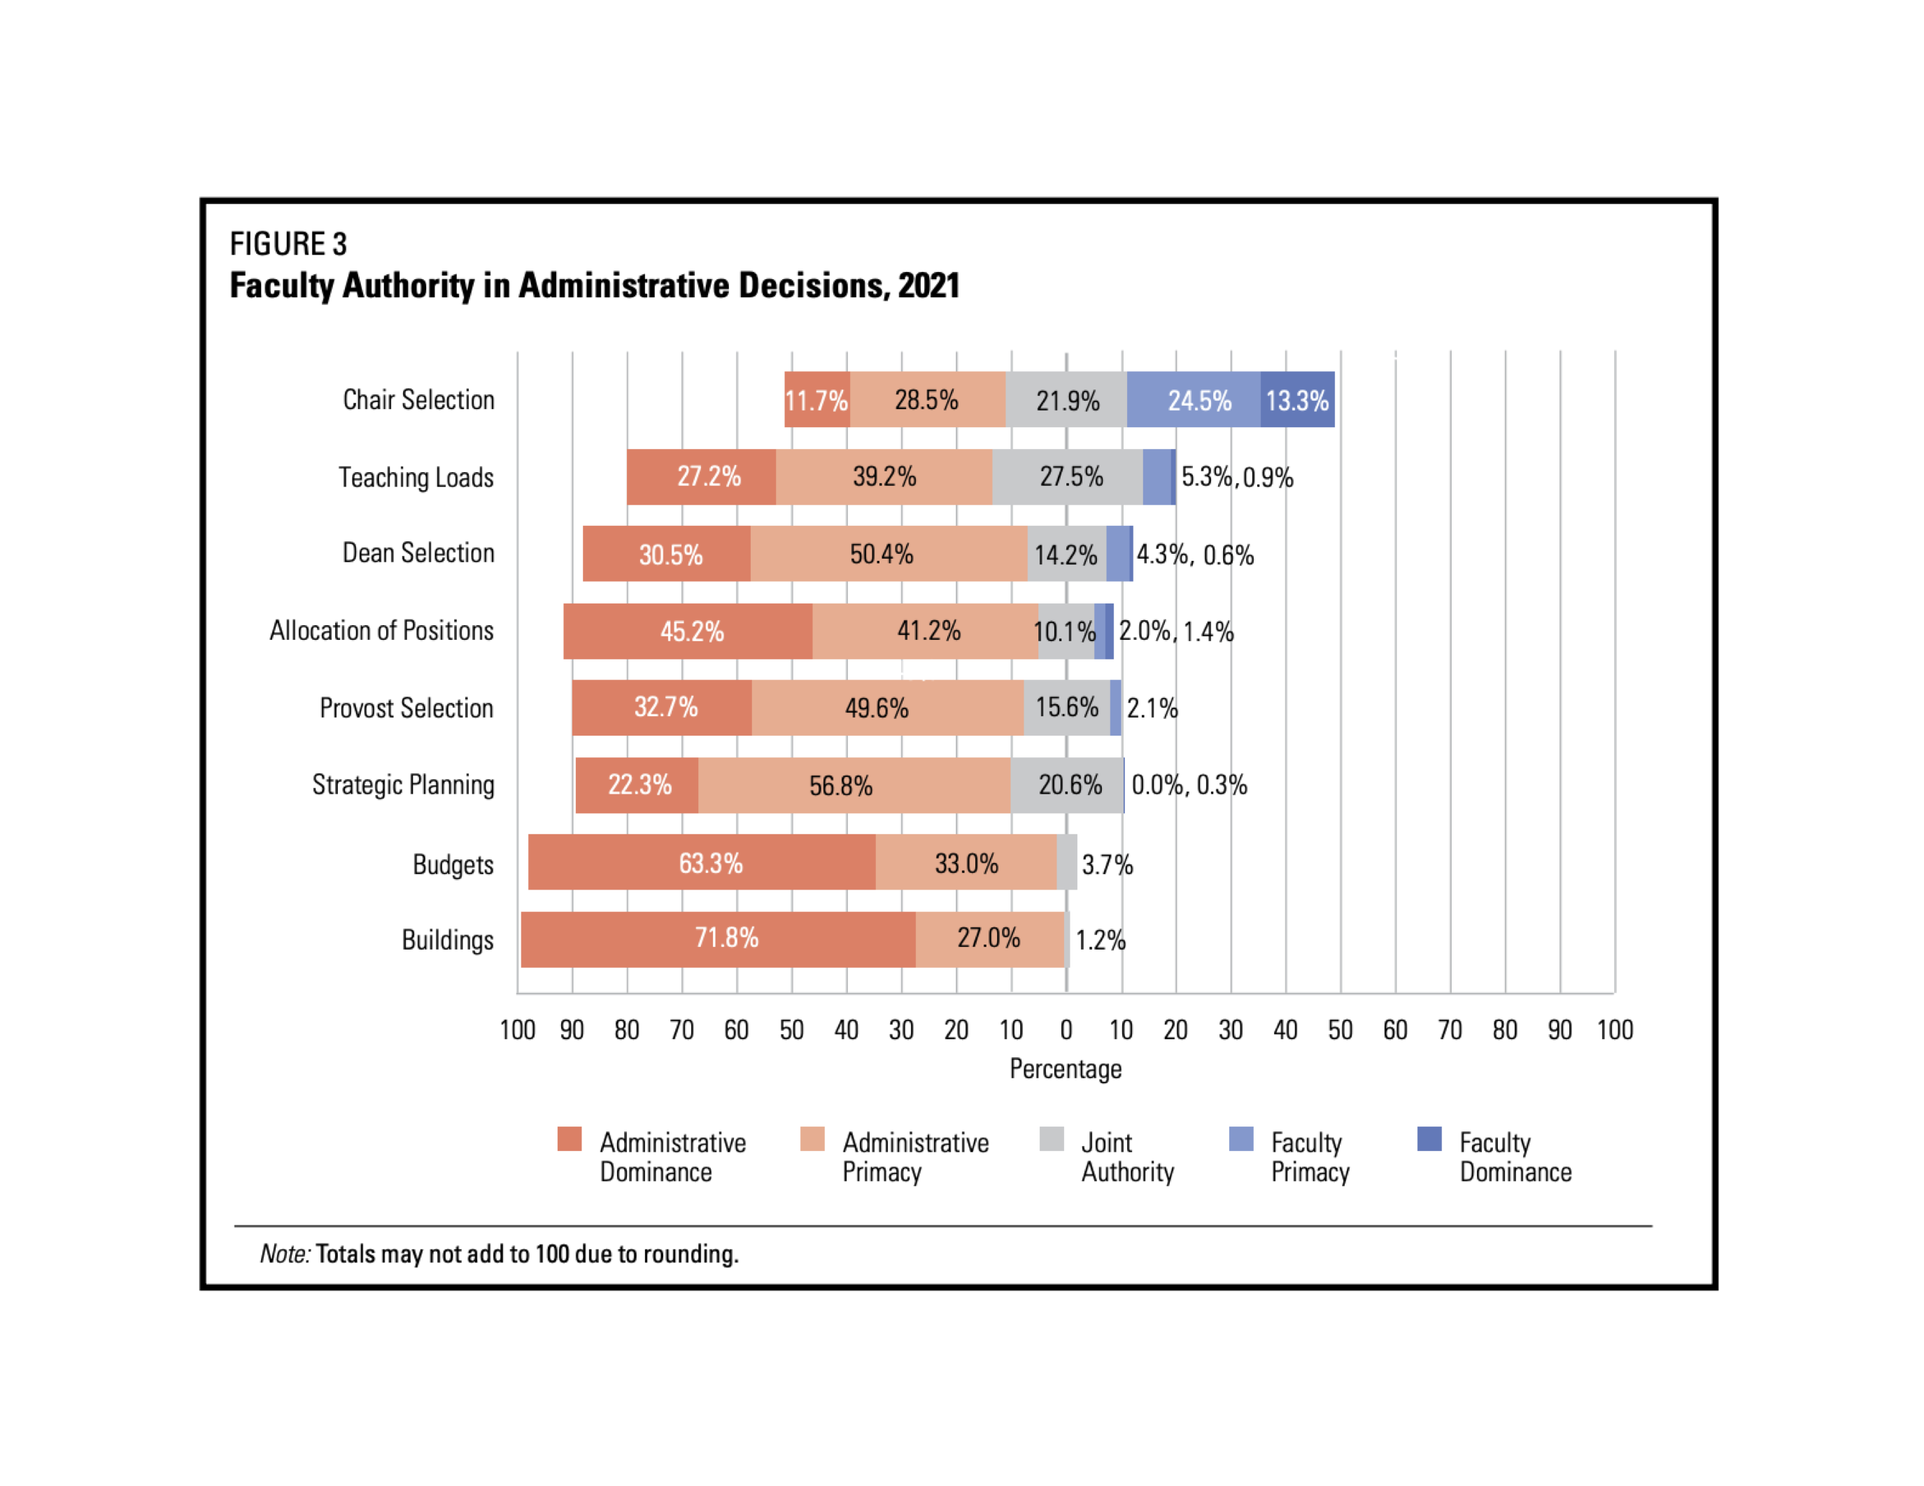

Faculty Authority in Administrative Decisions, 2021

The report contains variations in the above numbers based on type of institution (by Carnegie classification, CSI is “Master’s”) and whether the institution has collective bargaining, like CUNY. The former shows between group variation, though relatively small. The latter similarly so. The chart for the latter follows:

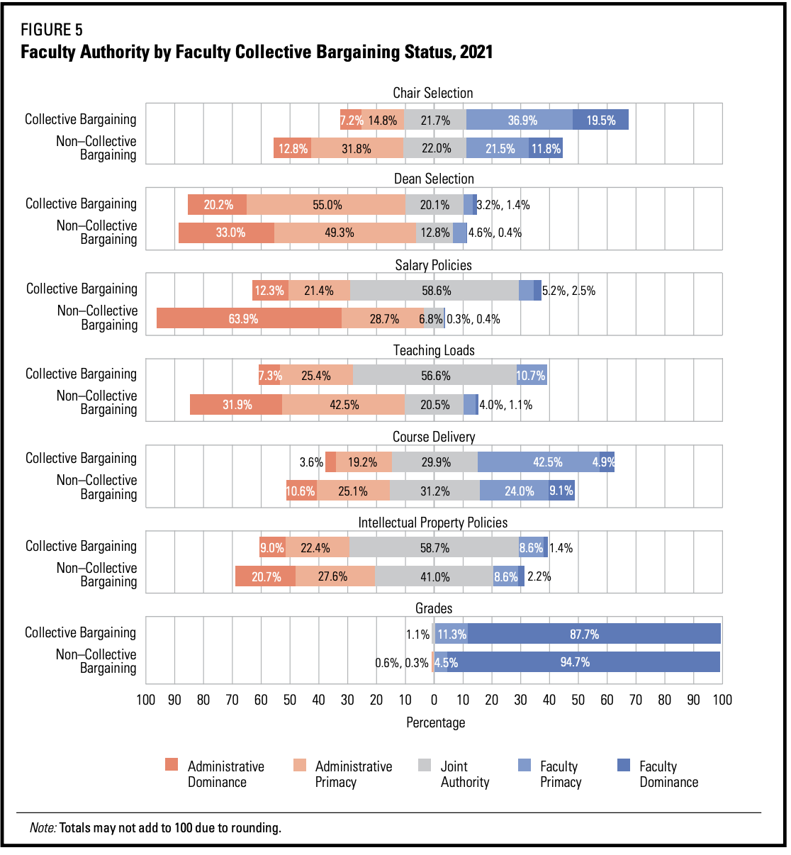

Faculty Authority by Faculty Collective Bargaining Status, 2021

### 

### Scorecard

|  |  |
| --- | --- |
| Grade Assignments | No change; FD |
| Program Curriculum | FP ⇊ AD |
| Teaching Assignments | No change?; FD |
| Institutional Curriculum | FD ⇊ AP |
| Course Delivery | No change; AP |
| Establishing Programs | JA ⇊ AD |
| Intellectual Property | No change |
| UG Admissions | FP ⇊ AD |
|  |  |
| Tenure Track (TT) Searches | FP ⇊ JA |
| TT Evaluations | JA ⇊ AD |
| TT Promotion Standards | FP to ? |
| TT Promotion Decisions | FP ⇊ AP |
| Tenure Decisions | FP ⇊ AP |
| PT Searches | FP to ?? |
| PT Evaluations | FP to ?? |
| Full-Time, Non-Tenure Track (FTNTT) Searches | FP ⇊ AP |
| FTNTT Evaluations | FP ⇊ AP |
| FTNTT Promotion Standards | FP ⇊ AP |
| FTNTT Promotion Decisions | FP ⇊ AP |
| Salary Policies | Contractual |
|  |  |
| Chair Selection | Contractual, FD |
| Teaching Loads | Contractual, JD |
| Dean Selection | AP ⇊ AD |
| Allocation of Positions | JA ⇊ AD |
| Provost Selection | AP ⇊ AD |
| Strategic Planning | JA ⇊ AD |
| Budgets | AP ⇊ AD |
| Buildings | AP ⇊ AD |