Laboratory Assignment 1

1 Installation and Setup

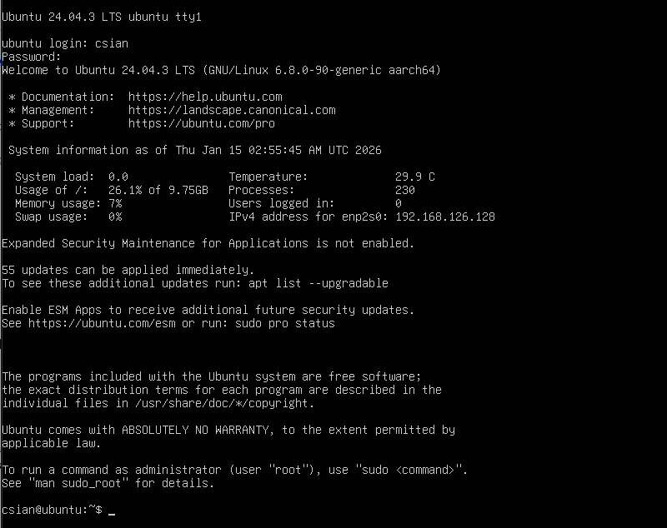

ubuntu-24.04.3-live-server-arm64.iso install on VMware Fusion (Apple M4 pro)

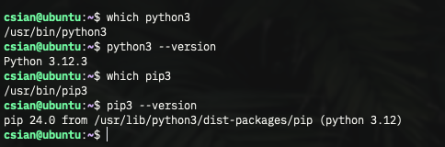

installed Python3 and pip3

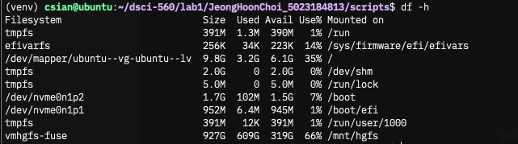

created and used a Python virtual environment using venv, and mounted a folder on the host PC using vm-tools.

2 Get Familiar with Linux and Python

2.1 Playing around with Linux Terminal

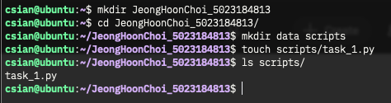

creating directories and files using built-in Linux commands

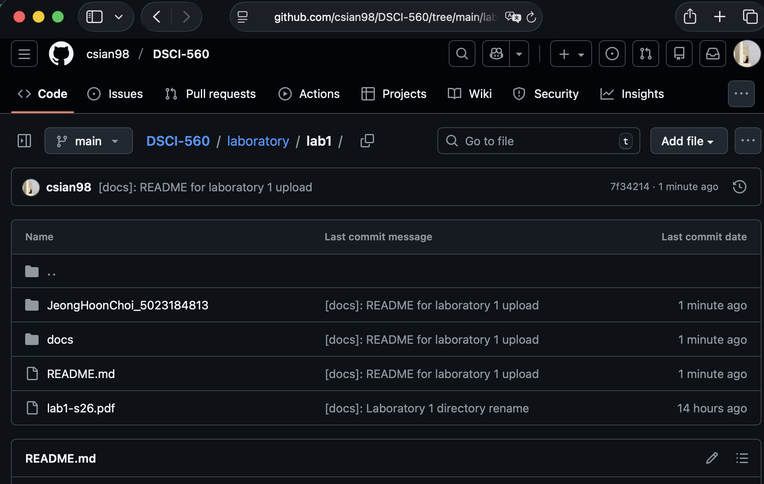

uploaded codes on the GitHub user account csian98
https://github.com/csian98/DSCI-560/tree/main/laboratory/lab1
2.2 A basic Python Script

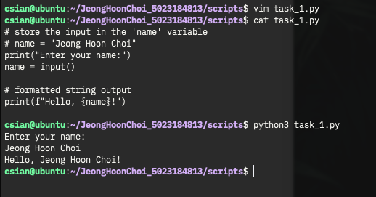

Python standard input (stdin) and standard output(stdout)

2.3 Python Web-scraping Task

I tried to read the file statically using the `requests` library, but the JavaScript file containing the market data was loaded as is. Dynamic web scraping was performed using a browser engine.

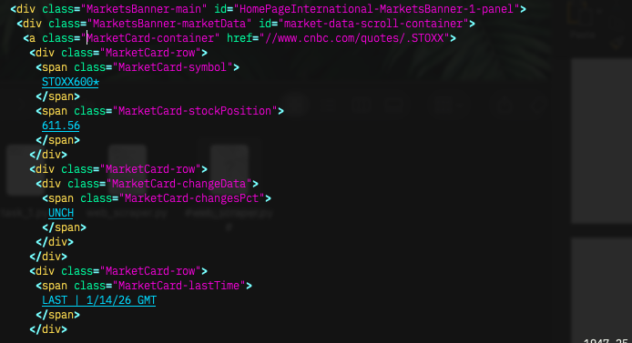
All MarketCard-row data is contained within the div.MarketBanner-main element.

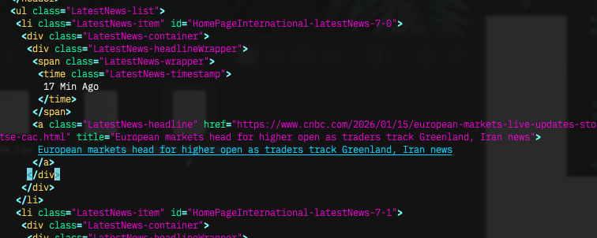

All LastestNews-item data is contained within the ul.LatestNews-list element.

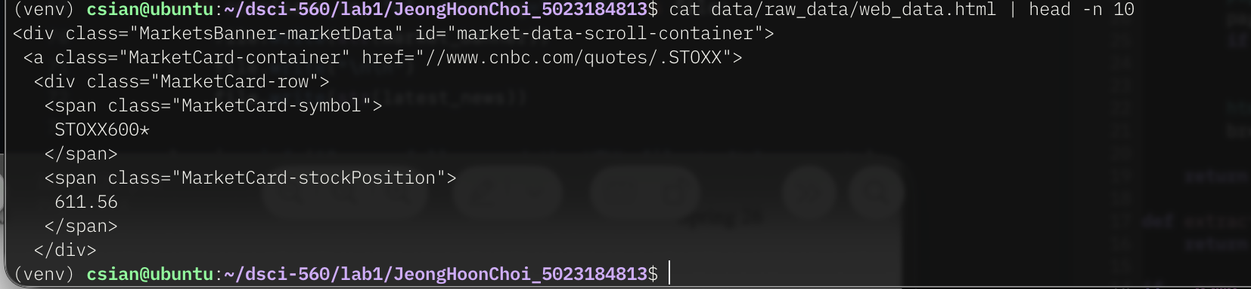

Parsing web_data.html, printing the first 10 lines

2.4 Data Filtering Task

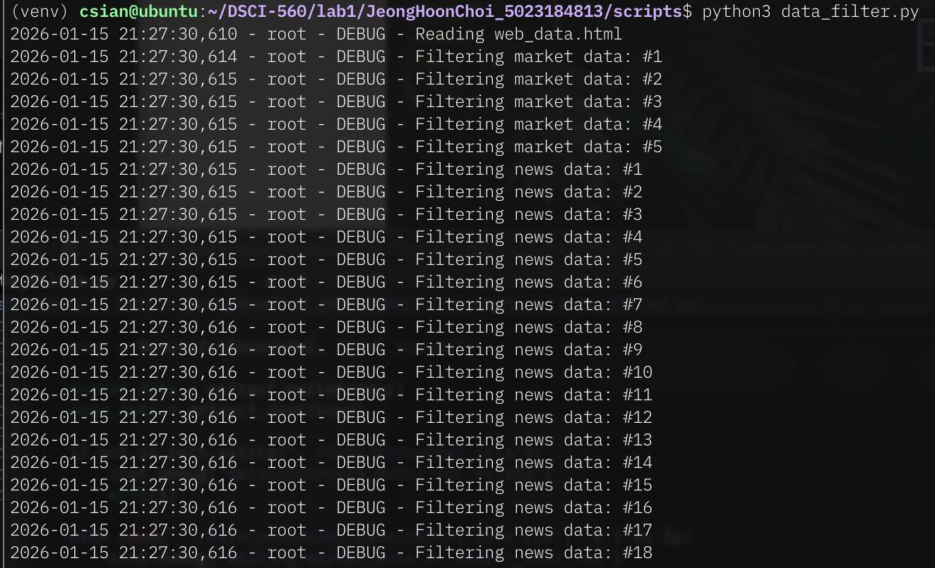

execute data_filter.py, including logging

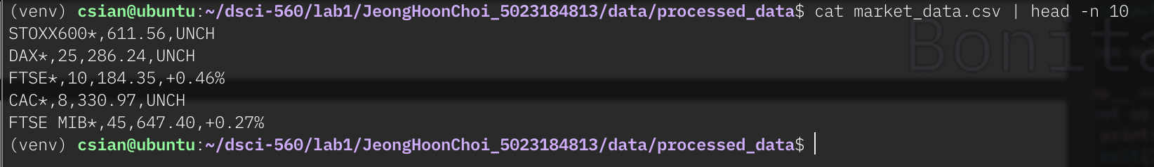

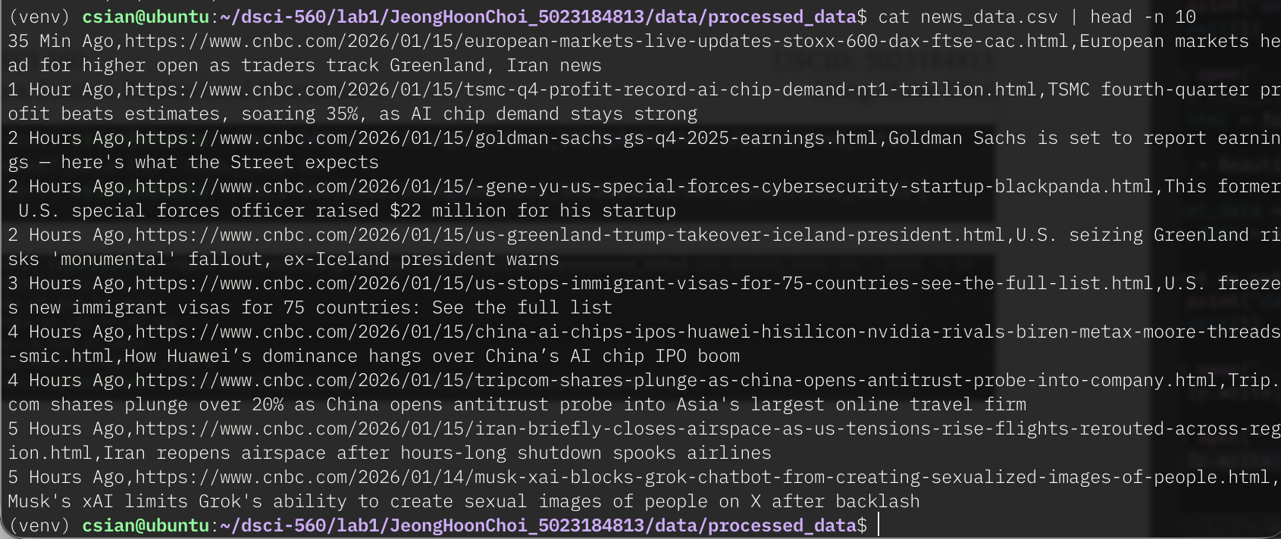

The data for marketCard_stockPosition, LatestNews-title iteself contains commas. Substitution and string processing are required for the CSV format.

