Laboratory Assignment 2

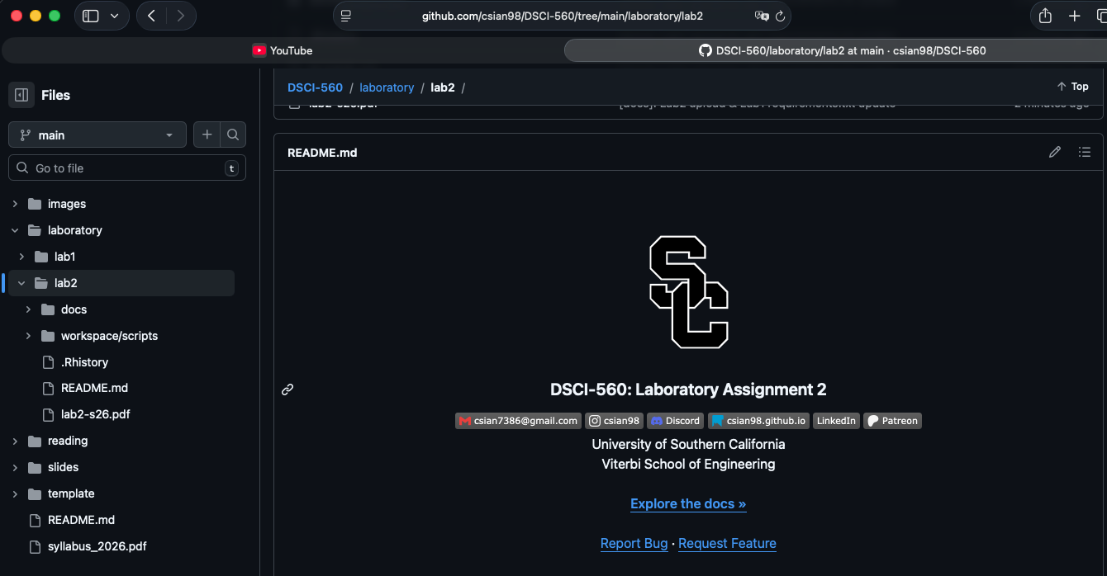
https://github.com/csian98/DSCI-560/tree/main/laboratory/lab2

1. Team Formation
Jeong Hoon Choi (USCID: 5023184813)
Viraj Bansal (USCID: 7366023502)
Chih-Yun Pai (USCID: 6777867067)

2. Real-World Applications and Domain-Specific Data

Companies like CrowdStrike, which provide EDR services for platforms including Windows, must perform appropriate analysis (using ML and DL models, etc.) based on data collected from each user. When anomalous data is detected, they must send alerts to the relevant users and companies, including a confidence score based on the data and the instances that triggered the anomaly.

3. Examples of Tools for Data Collection

4. Data Collection

