Laboratory Assignment 2

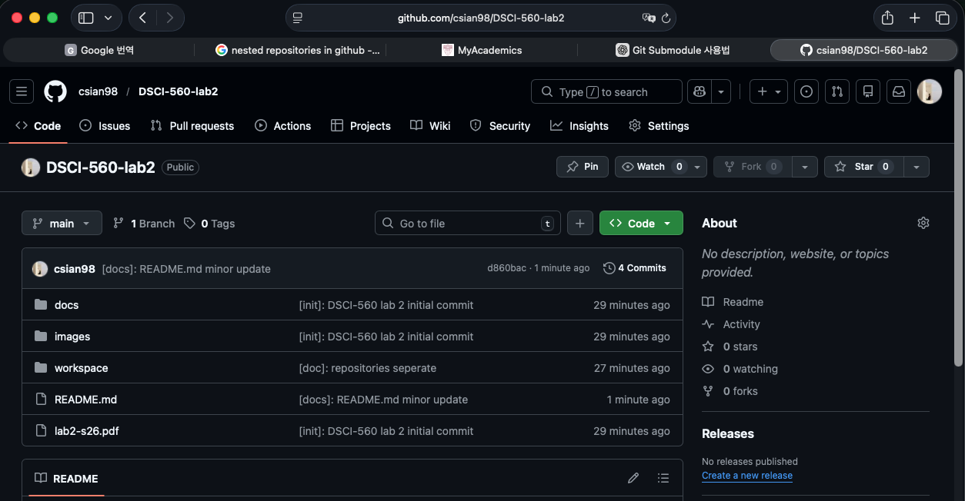
https://github.com/csian98/DSCI-560-lab2

1 Team Formation
Jeong Hoon Choi (USCID: 5023184813)
Viraj Bansal (USCID: 7366023502)
Chih-Yun Pai (USCID: 6777867067)

2 Real-World Applications and Domain-Specific Data

[Domain 1] System Log Normalization and Alert System (Jeong Hoon Choi)
[Domain Description] This system parses log(text) data stored in various formats using traditional parsing methods, Encoder-Decoder models, or LLM models.
It then performs anomaly detection (i.g. Autoencoder, Isolation Forests) and, based on the results, uses an LLM to generate an alert containing relevant information such as IP, user, error details, justification for the detection, and a risk score, which is then deliver to the appropriate user.

[Dataset] LogHub
loghub: https://github.com/logpai/loghub
Loghub provides logs for various services, along with labels that have been appropriately parsed using a Log Parser (drain).

[Reason]
Many commercial software solutions are available that collect and respond to various logs from systems such as SIEM, IDS/IPS, and EDR. Because these systems use different log formats depends on the services, normalization of these logs is crucial. These logs can then be processed using LLMs or encoder-decoder models, and an appropriate response/alert (message/chat) system can be applied based on the processed data.
[Domain 2] Recipe (Chih-Yun Pai)
[Domain Description] A recipe-based food assistant that supports group chat communication by helping users decide what meals they can prepare based on available ingredients. Through messages, the AI agent can suggest suitable recipes, identify missing ingredients, and later assist with planning grocery purchases (if we are able to do that).

[Dataset]
https://www.kaggle.com/datasets/paultimothymooney/recipenlg/data

[Reason]
It's a use case where users can seek quick, practical assistance through messaging. A scenario I come up with is when we text "I want to have a quick dinner cuz I'm working heavily for the final project", based on previous message and the recipe database, AI agent may suggest a easy-to-prepare meal like spaghetti.

[Domain 3] LLM Stock Bot (Viraj Bansal)
[Domain Description] A message bot that can retrieve stock prices and some sort of news/forum posting about the stock and then allow users to discuss and talk about different stocks they are interested of investing. users can use messages and chatbot to propose and debate on different stocks while using the llm bot to fact check, learn, run analysis, buy/sell stocks, and generate reminders about their stocks' positions (individually or as groups).

[Dataset]
yahoo finance (https://pypi.org/project/yfinance/) and stock news api (https://stocknewsapi.com/)

[Reason]
This can allow users to discuss, debate, and trade stocks with access to all real time data and news feed at there finger tips. they can also watch and praise/make of fun of each others portfolios position as they go up/down.

3 Examples of Tools for Data Collection

Log Parser:
logparser: https://github.com/logpai/logparser

Data Retrieve:
requests: https://pypi.org/project/requests/
beautifulsoup4: https://pypi.org/project/beautifulsoup4/
playwright: https://pypi.org/project/playwright/
pandas: https://pypi.org/project/pandas/
pytesseract: https://pypi.org/project/pytesseract/
pillow: https://pypi.org/project/pillow/
pdfplumber: https://pypi.org/project/pdfplumber/
python-docx: https://pypi.org/project/python-docx/
yfinance: https://pypi.org/project/yfinance/

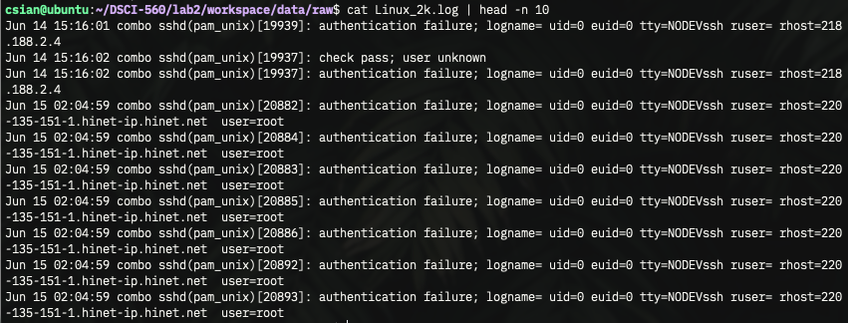
As an example of the data to be used in the project, I downloaded and used Linux syslog data from Loghub.

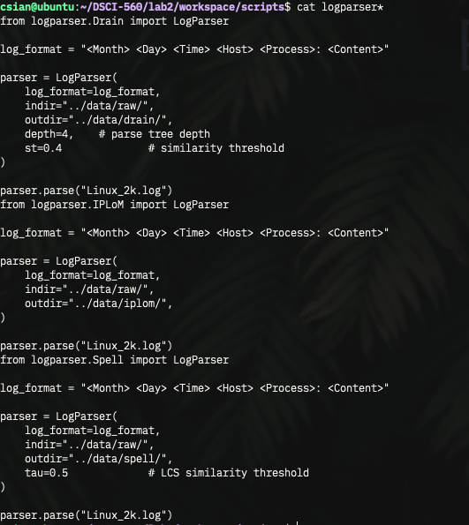

Using logparser3, I parsed the logs using the Drain, IPLoM, and Spell methods, and I was able to easily parse the syslog, which maintains a relatively consistent format.

4 Data Collection

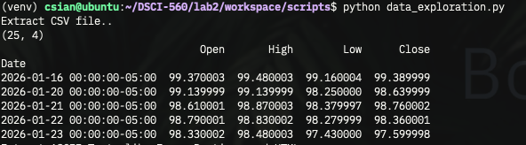

Using the yfinance Python library provided by Yahoo Finance, I collected the dollar index (DX-Y.NYB) data for the past 30 days and saved and loaded it as a CSV file.

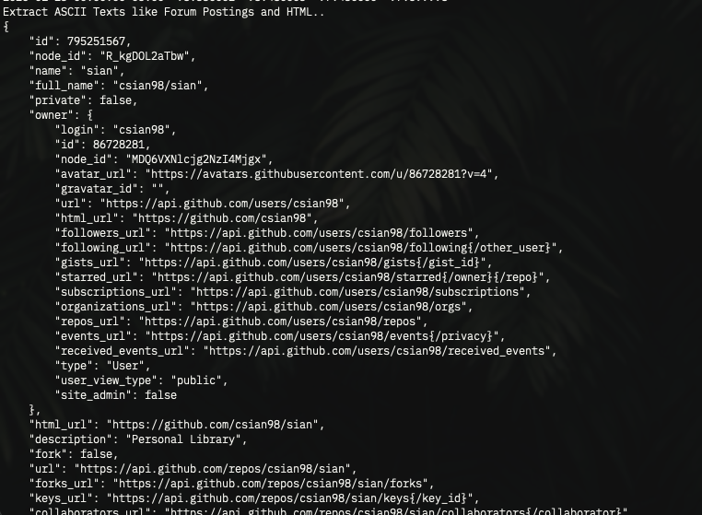

Additionally, I used the API provided by GitHub to scrape data about users and repositories, converted it to JSON format, and saved it.

Finally, I extracted text from three images, a Microsoft Word document, and a PDF file. I used the same resume for all three.
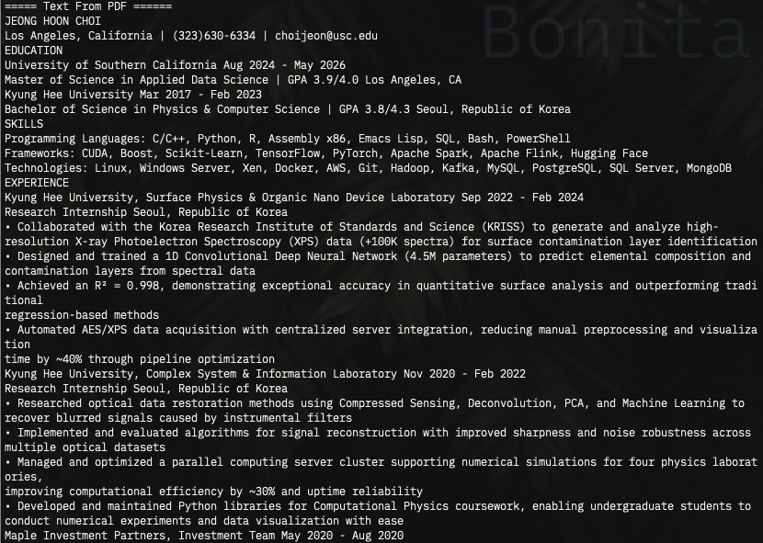

I used pdfplumber to extract text from the PDF file.

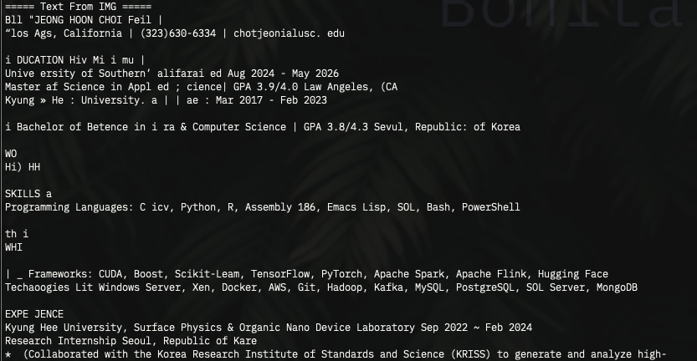

Tesseract was used to extract text from relatively low-resolution image files of resumes taken with a mobile phone.

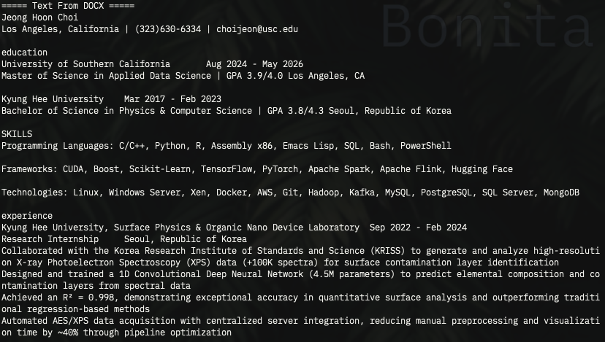

Finally, I used python-docx to extract text directly from a Microsoft Word file with the *.docx extension.

Jeong Hoon Choi (USCID: 5023184813)

