Laboratory Assignment 4

Group 15: Jeong Hoon Choi, Viraj Bansalm, Chih-Yun Pai

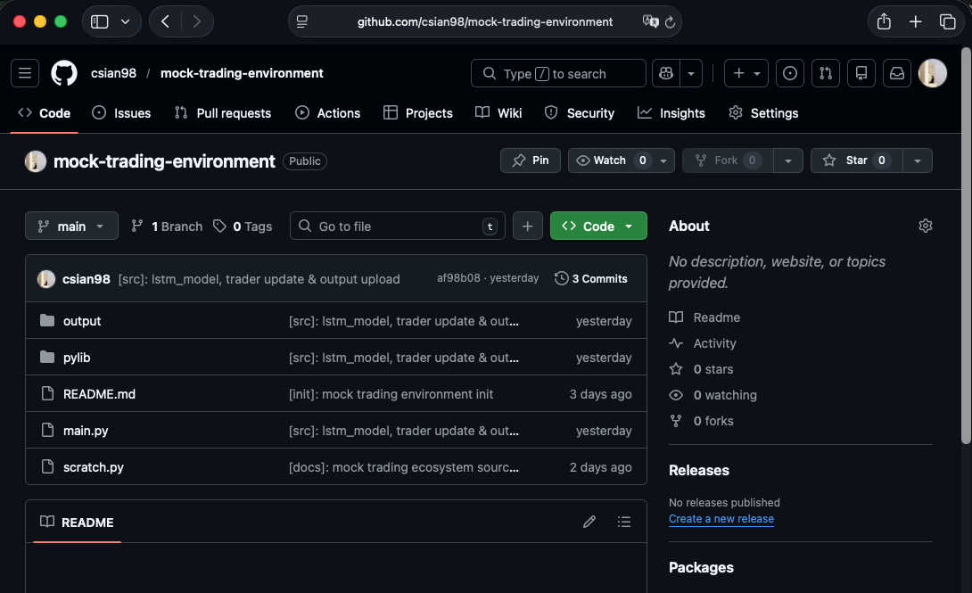
https://github.com/csian98/mock-trading-environment

We have developed a mock trading environment using the LSTM and Bollinger_RSI methods.
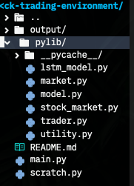
All Python code is stored inside the pylib/ directory, and training and prediction are performed using main.py

model.py and market.py each provide implementation decalarations.

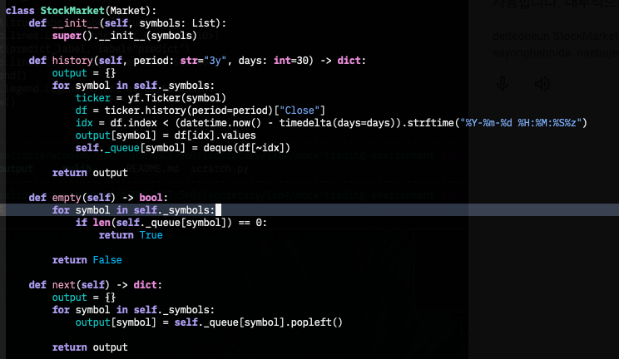

The data is provided using a StockMarket class instance. Internally, it uses yfinance to provide data for the specified stock, and provides data for training and daily price predictions through the history and next methods.

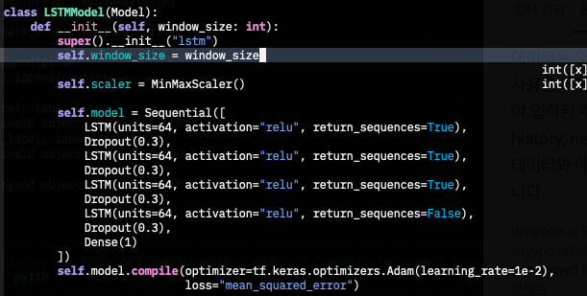

LSTM used a model with a simple structure consisting of four layers.

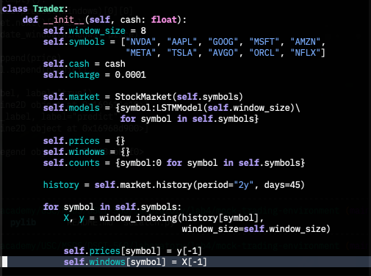

All transactions utilize the Trader class.
We used two years of price data for a total of 10 stocks, excluding the last 45 days, for training, and then used the remaining 45 days as simulated trading data.
While no separate fee was charged when buying stocks, a commission of 0.01% of the sale amount was charged when selling stocks.

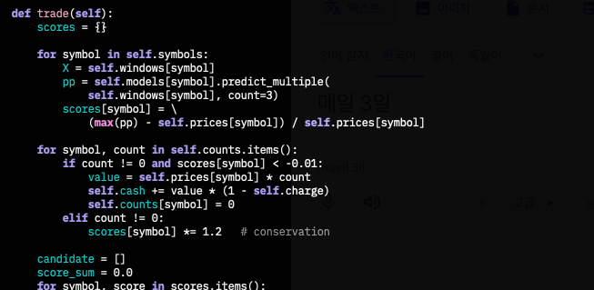

We created a strategy based on 3-day price predictions for all symbols every day. If the predicted decline exceeded 1%, sold all holdings. We then weighted the remaining stocks I held and, for stocks with a predicted increase exceeding 3%, diversified our purchases based on the score ratios.

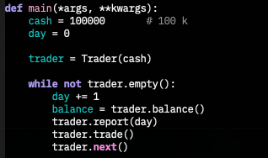

The scenario starts with $100,000 each time. Then, it calculates and outputs the total assets held each day.

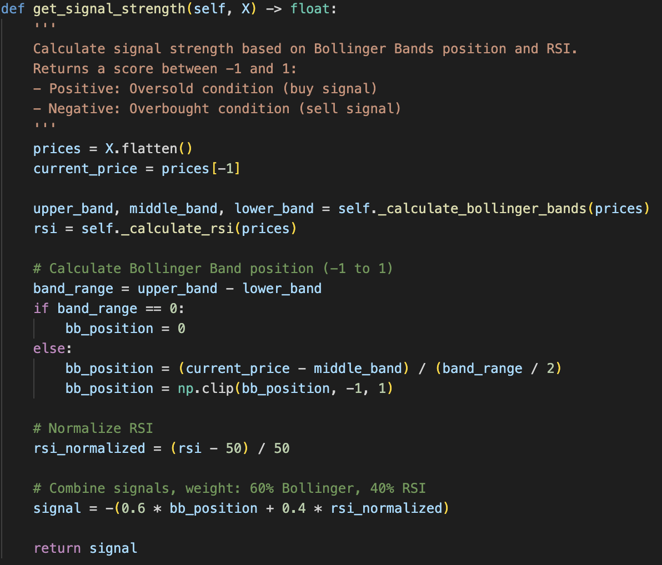
For the Bollinger_RSI model, we use the same data to mock the stock market, the core concept of this model is to buy stocks when they are oversold and sell them when they are overbought on the contrary. For instance, the model combines two technical indicators: Bollinger Bands (measuring how far the current price deviates from its <20>-day moving average) and RSI (measuring momentum over 14 days). The signal composts of the two indicators is then weighted and used to decide whether to sell, trim or buy.

For the detailed trading strategy, we can split it into three stages. First, it calculates signal strength for all stocks and immediately exits any positions with signals below <-0.3> (strongly overbought), converting them entirely to cash. Second, it identifies buy candidates—stocks with signals above <0.7> (strongly oversold)—and if none exist, the function returns without trading. Third, it performs portfolio rebalancing by calculating each candidate's target allocation proportional to its signal strength (using <95%> of total portfolio value), then compares the target to current holdings. If underweight by more than one share's worth, it buys more shares; if overweight, it trims the position.
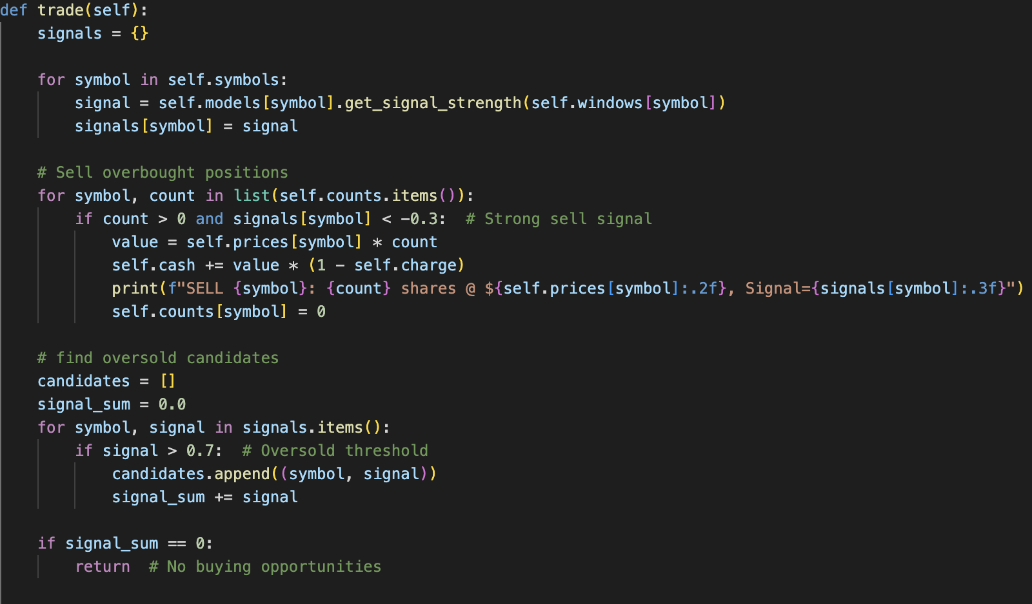
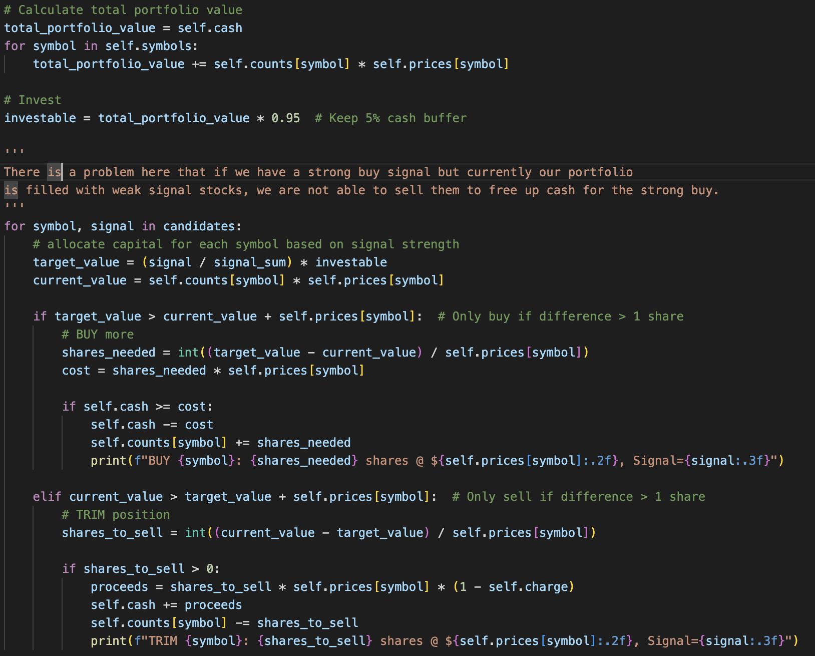
However, as noted in the code comment, this approach has a critical flaw—if strong buy signals appear but the portfolio holds stocks with weak signals (between <-0.3> and <0.7>), those positions cannot be liquidated to free up cash, potentially blocking the strategy from capitalizing on the strongest opportunities.

