Laboratory Assignment 1

1 Installation and Setup

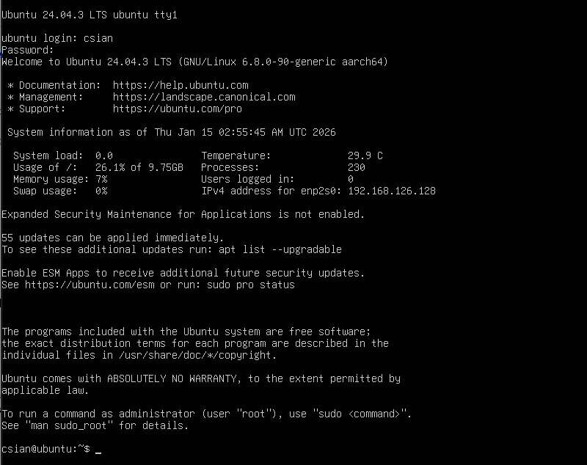
- ubuntu-24.04.3-live-server-arm64.iso install on VMware Fusion

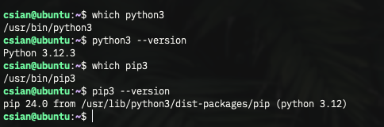

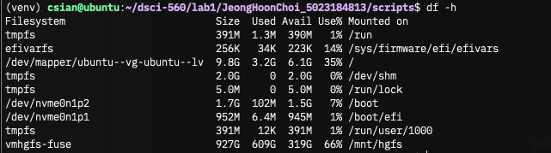

2 Get Familiar with Linux and Python

2.1 Playing around with Linux Terminal
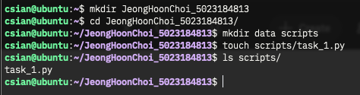

2.2 A basic Python Script
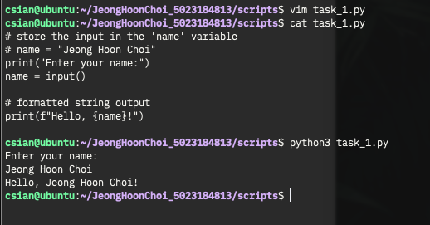

2.3 Python Web-scraping Task

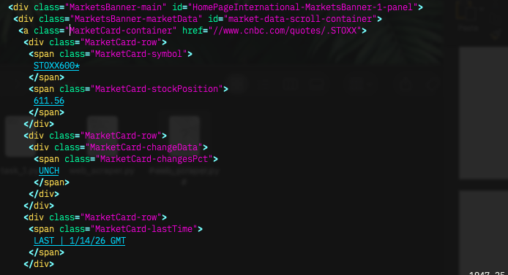

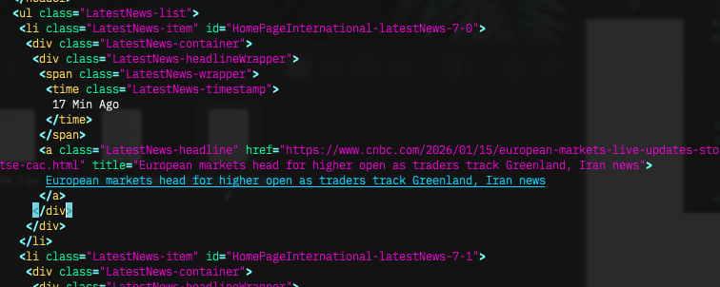

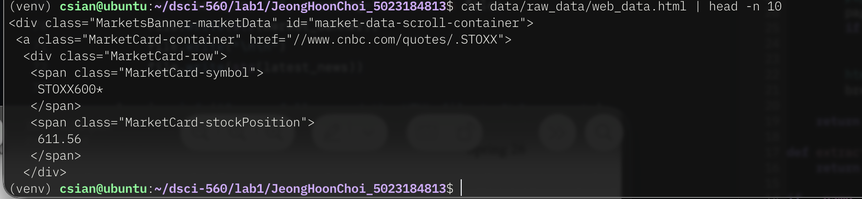

2.4 Data Filtering Task

