Description For Using T28DISPLAY program – Version 1.0

- The “Display Hail” option

It is designed to display the hail data for the STEPS 2000 project. After choosing this option the following window will open:

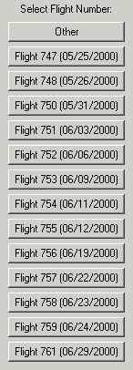
Choose a flight number and a summary of the SEA records is shown: 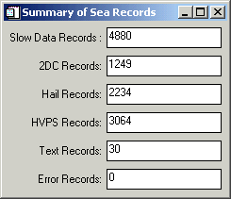

The user is asked if buffer times to be ploted. 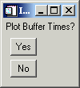 If the answer is yes, then this plot is displayed:

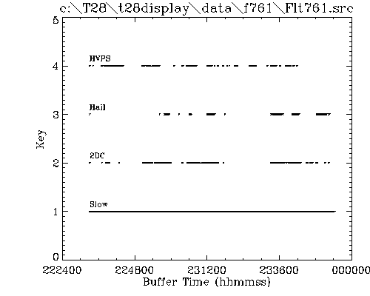

The next window allows the user to select time/buffer interval to process:

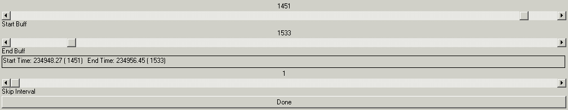

followed by 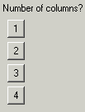 Choose for example 3 columns and a display like this will follow:

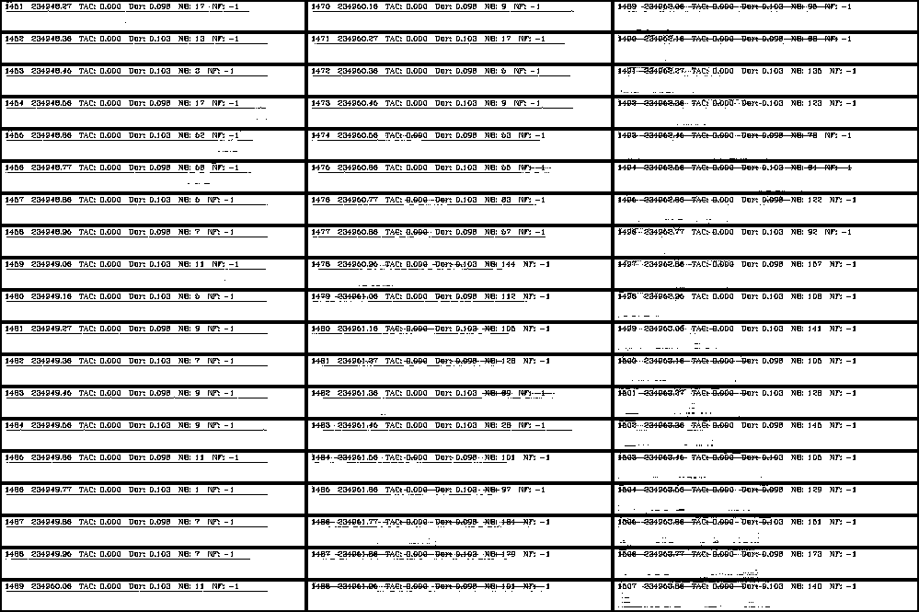

For each page displayed, the user has the option to save a *.ps file.

