Description For Using T28DISPLAY program – Version 1.0

- The “Display Slow Data” option

It is designed to display the one per second data recorded during the STEPS 2000 project. After choosing this option the following window will open:

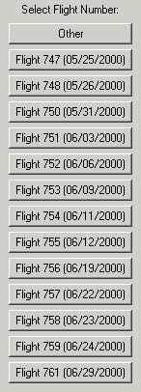 Choose a flight number and a new window opens!

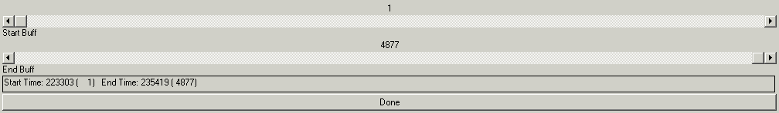

The user can choose the range of buffers to be viewed (or the time interval). A new window asking the number of graphs to be included in the display is opened.

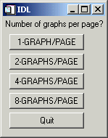

If the user chooses “2-GRAPHS/PAGE”, then a list with all “slow” parameters is listed, and the user is asked to choose the parameters to be displayed.

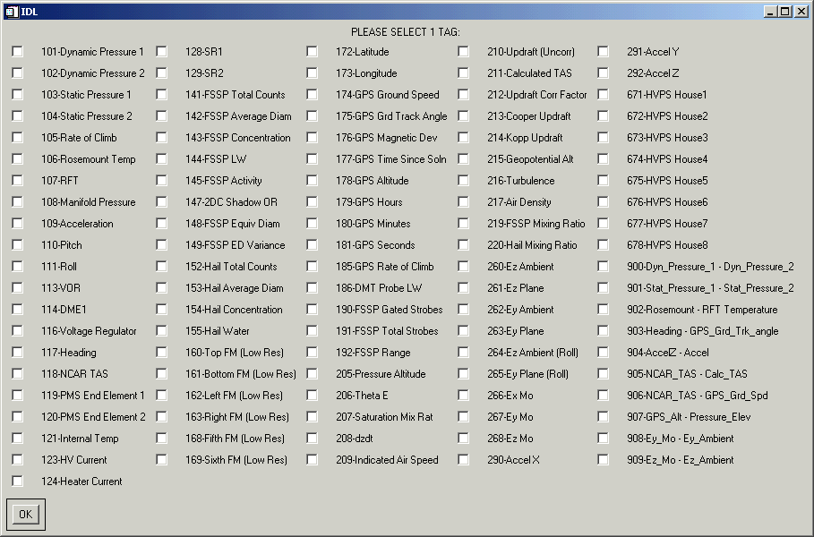

After choosing the tags, the graph is shown as:

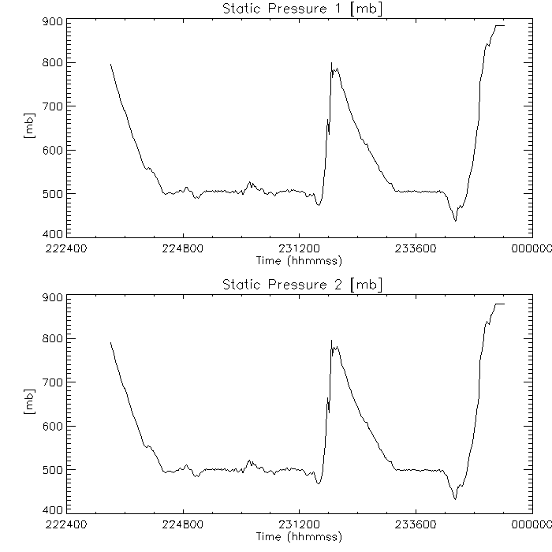

The user is asked if a post script file is to be created: 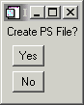 If the answer is “Yes”, the user is asked which orientation the file should be saved: 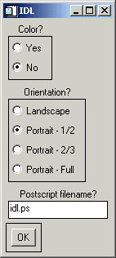 The default name is idl.ps, but the user can choose any desired new name, with the extension “*.ps”. The file is being saved under Psfiles subdirectory.

