Description For Using T28DISPLAY program – Version 1.0

- The “Statistics” option

It is designed to run and display the statistical data for the 2DC, HVPS and HAIL data for the STEPS 2000 project. After choosing this option the following window will open:

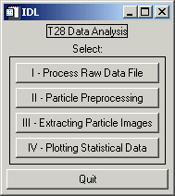

In order to provide the statistic displays, for each flight, the data has to be processed as follows:

- First – Choose “I – Process Raw Data File” , then select probe type:

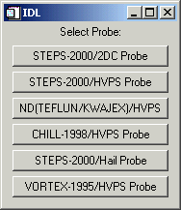

Suppose the user selects to process the 2DC data first (The same procedure should be followed for the HVPS and HAIL data). The user is the asked to choose a flight number. If the flight has been processed before and a .buf file was created then another menu appears - Fnnnpppp.buf exists (nnn=flight number, pppp=probe type). Select:
OK to overwrite the existing file. 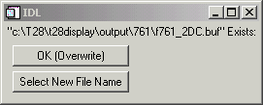
Select New File Name to create a new file. Then type in the new file name.
If the selected flight number has not been processed before (for any probe type), a message appears stating Could not find Fltnnn.dir – creating. Select OK. The directory info from the SEA raw file is extracted and written to a .dir file for future use. The .dir file reduces the processing time on future runs, as it is quicker to read than to extract the directory info from the raw file. While the directory info is being extracted a small window, Reading SEA Directory, is displayed indicating the progress of reading the raw file. A .txt file and an .err file also are created while the directory is being extracted. The .txt file is a copy of all the SEA .txt tables. The .err file is a copy of all info found in the SEA error tags. All these files are saved under the “output” directory, in the corresponding subdirectory for the flight to be processed (e.g. 747, 748, …)
A Summary of SEA Records window is displayed. It shows the number of records of Slow Data (which are one per second), 2DC, Hail and HVPS data, that is found in the raw (or .dir) file. The Text Records refer to the SEA text records used during the flight, and Error Records include possible errors recorded.
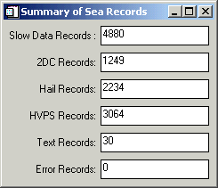
A Plot Buffer Times? menu is displayed. If Yes is selected, a plot
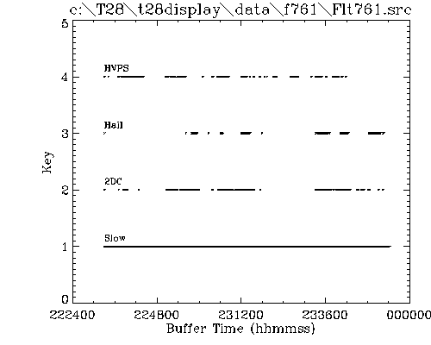
is created showing the times for each buffer type (slow,2DC,HVPS,Hail).
Slow data are extracted from the raw file for each 2D buffer time point. This process can take several minutes so, the first time through, a .slw file is created which contains the extracted slow data. In subsequent runs the slow data is read from the .slw file instead of extracting it from the raw file again. A progress bar is displayed indicating the status of the processing. Currently only 4 slow data quantities are extracted – calculated TAS, static pressure 1, Rosemount temperature, and FSSP LW. These 4 quantities are saved in the .buf file (1 record for each buffer). When the routine calculates the FSSP LW, it displays an editable text widget asking for the location of the FSSP.chn file. Currently the path is set to the fssp.chn file found in the lib directory. To accept the current path/filename, click in the window and press enter.
Seven quantities are plotted which are indicators of the validity of the directory and slow data extraction (Extracted Data).
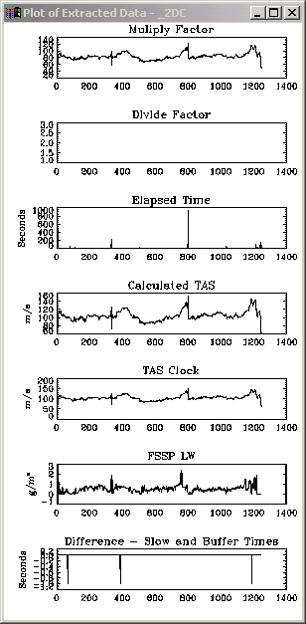
A small menu asks if a PS file should be created (for printing). The quantities plotted are:
Multiply and divide factors – These are SEA quantities that are extracted from the 2D buffers. These 2 values in combination give the probe clock frequency (= (Mult Factor/Div Factor) * 50.0 Hz). Typical values for the STEPS-2000/HVPS are around 50 and 10, and for the STEPS-2000/2DC are around 80 and 1, respectively.
Elapsed time – This is also a SEA quantity extracted from the 2D buffer. It should be a measure of the time it took to fill the 2D buffer and should be close to the sum of interparticle times found in the image buffer. This quantity is always available with the STEPS-2000/2DC but only on the later flights of STEPS-2000/HVPS.
Calculated TAS – An indication of the success of the slow data extraction. Values should range from 70 to 120 m/s.
TAS Clock – Calculated from the multiply and divide factors. Should be close to the Calculated TAS.
FSSP LW – Values should range from 0 to 3 g/m3.
Difference between the slow data times and 2D buffer times – If slow data buffers were found close to the 2D buffer times then these differences should be very small (< 1 sec).
A short but wide window appears that contains 3 sliders (Select Time/Buffer Interval To Process).
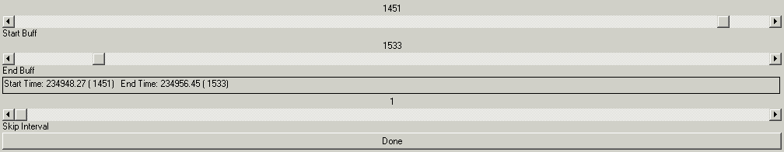
The top slider is for selecting the starting buffer/time for processing. The slider below that is for the ending buffer/time for processing. The bottom slider is for selecting a skip interval (e.g., every 2nd, 3rd, … buffer).
A menu (Select Processing) appears for selecting the type of processing:
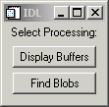
Display Buffers – This option displays the selected 2DC (or HVPS or Hail) image buffers in a 1,2,3 or 4-column format that can then be printed to a PS file.
Find Blobs – This option steps through each selected 2DC (or HVPS or Hail) image buffer and derives quantities for each buffer (a .buf file) and each particle (a .par file). If the probe type is STEPS-2000/HVPS then the charge data for each buffer is extracted (a .chg file). An .ind file also is created which contains the image indices of each occluded pixel in a decoded and scale rectified buffer image. Finally a .log file is created which stores info about any detected buffer anomalies. All these files are saved under “output directory”. The status of the processing is displayed in a window (Buffer Processing) which shows the buffer number, the current decoded (unscaled) image buffer, number of particles in the buffer, etc.
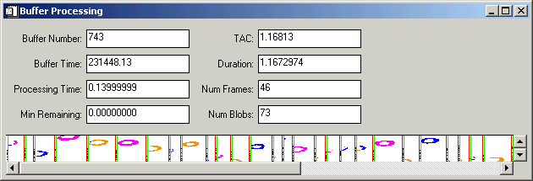

- Second – Choose “II – Particle Preprocessing” , then select probe type:

This is a routine for transforming the particle info file (.par) from particle ordered to quantity ordered (.xpr). That is, in the .par file, every quantity for the first particle is stored first, then every quantity for the second particle is stored second, etc. In the .xpr file, the first quantity for every particle is stored first, the second quantity for every particle is stored second, etc. Extracting particle info from the .xpr file is much faster and requires less memory than doing so from the .par file.
The menu Select Probe Type is displayed.
Each choice indicates both the project and the probe. (Select only the STEPS-2000 choices now)
An IDL file selection dialog appears entitled Please Select a File.
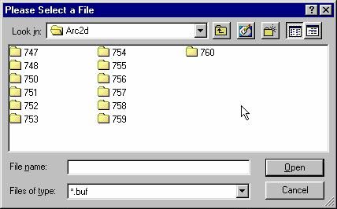
The selected file should be one created by “I – Process Raw Data File” option and have a .par extension. Through this second step, the *.par file is transposed. It can take a couple minutes. The output window indicates the status by displaying the status of the process in 6 steps as 1 of 6, 2 of 6, …. When finished a sample plot
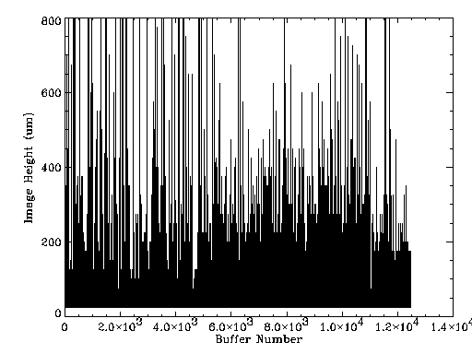
of one quantity (currently the y dimension for the probe) is displayed as an indication of a successful transpose. The size of the .xpr file should be the same as the .par file.

Third – Choose “III – Extracting Particle Images” , then select probe type
This is a routine for extracting particle images from the .ind file (created by “I – Process Raw Data File”) meeting a selected size range and displaying them in a sorted-by-size format.
The menu Select Probe Type is displayed. Each choice indicates both the project and the probe. (Select only the STEPS- 2000 choices now)
An IDL file selection dialog appears entitled Please Select a File. The selected file should be one created by “I – Process Raw Data File” and have a .buf extension.
A short but wide window appears that contains 3 sliders (Select Time/Buffer Interval To Process). The top slider is for selecting the starting buffer/time for processing. The slider below that is for the ending buffer/time for processing. The bottom slider is for selecting a skip interval, which is currently not used.
Another window containing sliders appears entitled Select Size Range.
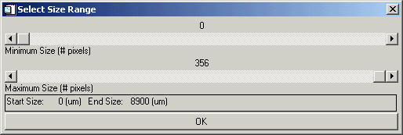
Select the minimum size with the top slider and the maximum size with the bottom slider. Hopefully the sliders provide reasonable ranges and size increments for the selected probe type.
Two windows appear - Scaled Buffer Image
and Extracted Particle Images. The 1st shows the scaled image buffers as the routine searches through them for particles that fall within the selected size range. The 2nd window shows the particles as they are found.
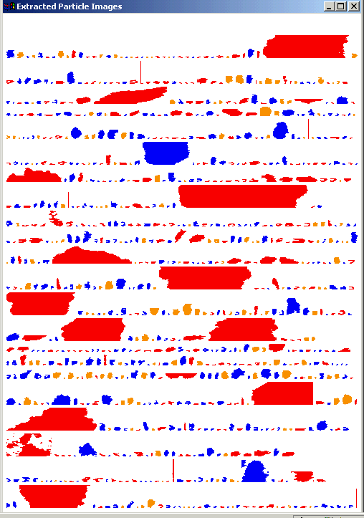
When the selected buffer/time interval has been scanned or the 2nd window is full of particle images (whichever comes first), the extracted particle images are redisplayed sorted from smallest to largest (bottom to top, respectively). They are also color-coded based on a classification scheme developed by Dr. Detwiler.
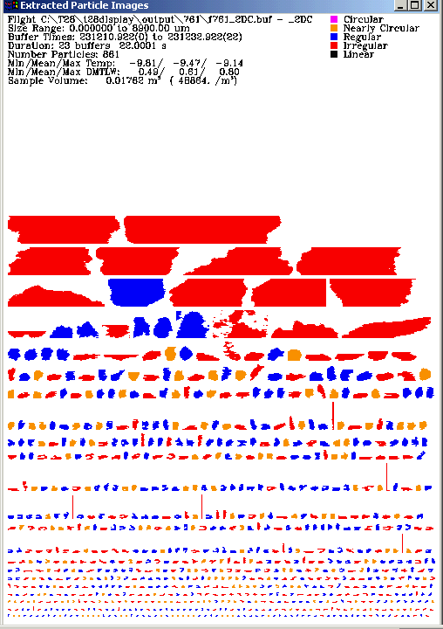
Some ancillary text info also is displayed at the top of the window. A small Create PS File? menu also appears providing an opportunity for making a hardcopy.
A TAC Filtering Plot appears.
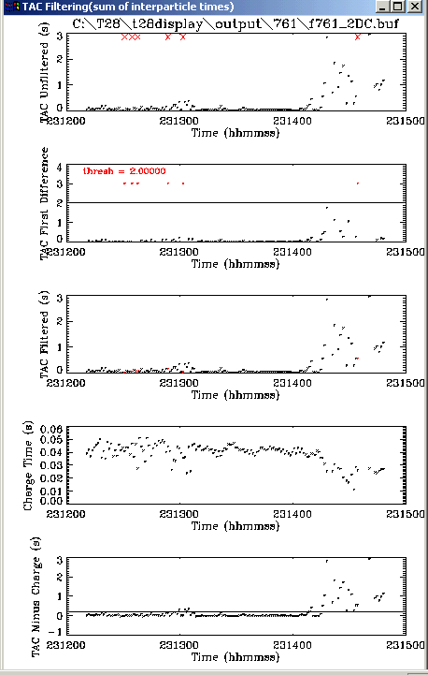
TAC is the sum of interparticle times and is saved in the .buf file. Sometimes this time is unrealistically large as a result of some type of data system error during recording. The sum of TAC values for the selected buffer/time interval is used in sampling volume calculations. If one or more of these large values is included in the sum, a bad number or mass concentration can result. Therefore, a method to detect/filter those large values is used so that they can be replaced with a neighboring value. The filtering is simply done by placing a threshold on the first difference of TAC values. This set of plots shows the steps in that process:
- The 1st plot shows the raw TAC values.
- The 2nd shows the first difference and the threshold. The threshold is set in get_specs.pro (in the Lib subdirectory) for each probe type. If the difference in TAC between 2 successive buffers is less than this threshold the TAC value is considered valid otherwise it is replaced by the nearest TAC value. The disadvantage of applying a simple threshold to the first difference is that in very low hydrometeor concentrations, interparticle times can be unusually large.
- The 3rd plot shows the TAC values after the large values have been replaced (they appear in red).
- The 4th plot shows the calculated charge measuring time. These values will be non-zero only for HVPS-Charge data.
- The 5th plot shows the TAC values after subtracting the charge measuring time. Again the filtered values are shown in red. This set of plots should indicate whether the TAC filtering process is valid. A small menu appears, Create PS File?, which provides an opportunity to print the plot.
==============================================================

Fourth – Choose “IV – Plotting Statistical Data” , then select probe type

This is a routine for plotting data created by the “I – Process Raw Data File” (found in the .buf and .xpr files).
The menu Select Probe Type is displayed. Each choice indicates both the project and the probe. (Select only the STEPS-2000 choices now)
An IDL file selection dialog appears entitled Please Select a File. The selected file should be one created by “I – Process Raw Data File” and have a .buf extension.
A short but wide window appears that contains 3 sliders (Select Time/Buffer Interval To Process). The top slider is for selecting the starting buffer/time for processing. The slider below that is for the ending buffer/time for processing. The bottom slider is for selecting a skip interval, which is currently not used.
A TAC Filtering Plot appears.
TAC is the sum of interparticle times and is saved in the .buf file. Sometimes this time is unrealistically large as a result of some type of data system error during recording. The sum of TAC values for the selected buffer/time interval is used in sampling volume calculations. If one or more of these large values is included in the sum, an invalid number/mass concentration value can result. Therefore, a method to detect/filter those large values is used so that they can be replaced with a neighboring value. The filtering is simply done by placing a threshold on the first difference of TAC values. This set of plots shows the steps in that process. The 1st plot shows the raw TAC values. The 2nd shows the first difference and the threshold. The threshold is set in get_specs.pro for each probe type. The 3rd plot shows the TAC values after the large values have been replaced (they appear in red). The 4th plot shows the calculated charge measuring time. These values will be non-zero only for HVPS-Charge data. The 5th plot shows the TAC values after subtracting the charge measuring time. Again the filtered values are shown in red. This set of plots should indicate whether the TAC filtering process is valid. A small menu appears, Create PS File?, which provides an opportunity to print the plot. The disadvantage of applying a simple threshold to the first difference is that in very low hydrometeor concentrations, interparticle times can be unusually large.
If the .xpr file does not exist a message appears Warning .xpr does not exist - run xpose_par to create it. If you click OK, “II – Particle Processing” step will be run automatically.
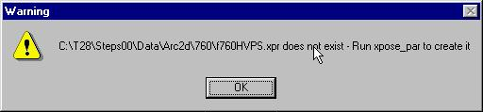
Finally a long menu appears for many different plot choices (Select a Plot).
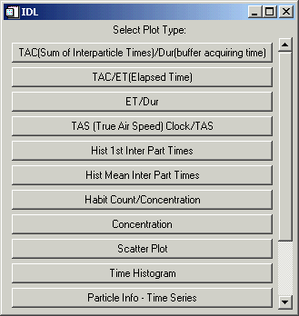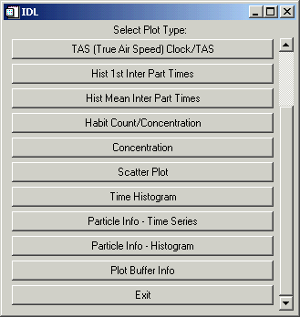
Some plots are intended to be more diagnostic such as comparing TAC values with inter-buffer times or elapsed times. Some are for viewing data contained in the .buf file and others for viewing data in the .xpr (.par) file. Some are in a histogram format and others are in a time sequence.

Glossary

Area – the particle cross-sectional area. ??? is it in um² ?
Area Ratio - one of several measures of roundness. The actual particle cross-sectional area is compared to that of a circle with the same "diameter" as that attributed to the particle. The value is expressed as a percentage.
Area Max - ???
Area Recon – area of the particle based on the reconstructed y dimension.
# Blobs - ?
Blob Number - ?
Bottom Occulted – number of images that hit the bottom of the sample volume.
Buffer Number – SEA buffer number display vs. Time. (noticed some problem in displaying buffer numbers…)
Calc TAS – formula (check code!)
CHI – based on the particle perimeter, estimates the center measure of irregularity for particle. Its value is large for irregular particles and small for circular ones.
Charge Ind - ?
Charge Time [s] – calculated charge measuring time.
Circular – Particle class. These are almost perfectly circular shadows (raindrops, most frequently).
COM X - ???
COM Y - ??
Conc = concentration, number of particles per m³.
Concentration – option under “Statistics – IV Plotting Statistical Data” which allows to select histogram for various parameters.
Date Create - ?? what does the y dimension mean??
Date Edit - ?? is this for changing the habit later??
Diam SD - ??
Div Factor – SEA parameter recorded in each buffer, then used to calculate the TAS.
Dur = duration. It is the time for acquiring a buffer.
Eccentricity – ? (related to ellipse ?)
ET = Elapsed Time. It is the time in microseconds for acquiring a buffer (?)
End Frame -
Equiv Circle - equivalent diameter of a spherical particle having a cross-sectional area equal to that of the particle in question.
Frame Number - ??
Frame Time - ??
Files – various files created during data processing when the “Statistics” option is chosen from the main T28Display menu. All these files are saved under the “output” directory, in the corresponding subdirectory for the flight to be processed (e.g. 747, 748, …):
- *.buf - includes derived quantities for each buffer.
- *.par – includes derived quantities for each particle.
- *.chg – includes charge information for each particle if the probe type is STEPS-2000/HVPS.
- *.ind - this file contains the image indices of each occluded pixel in a decoded and scale rectified buffer image.
- *. log – this file stores info about any detected buffer anomalies.
- *.dir - The directory info from the SEA raw file is extracted and written to a .dir file for future use. The .dir file reduces the processing time on future runs as it is quicker to read than to extract the directory info from the raw file.
- *. txt - The .txt file is a copy of all the SEA .txt tables.
- *.err - The .err file is a copy of all info found in the SEA error tags.
- *.slw - Slow data are extracted from the raw file for each 2D buffer time point. This process can take several minutes so, the first time through, a .slw file is created which contains the extracted slow data. In subsequent runs the slow data is read from the .slw file instead of extracting it from the raw file again. Currently only 4 slow data quantities are extracted – calculated TAS, static pressure 1, Rosemount temperature, and FSSP LW. These 4 quantities are saved in the .buf file (1 record for each buffer).
Habit - Classification of particle based on geometrical appearance.
Habit Count – number of particles for a specified habit.
Holroyd Diam - It is the longest distance through the particle, not being restricted to purely horizontal or vertical distance (e.g., a diagonal).
Holroyd Width – the perpendicular to the line of best fit.
Holroyd Angle – the angle made by the longest distance of the particle with the horizontal line. (? Is this the same with Orientation ???)
Holroyd Sigma - ?? (should it be the same as Linearity ?)
Heyms Diam - The Heymsfield diameter is normally taken to be the greater of the maximum X or Y span of the particle, although sometimes the diameter may be greater if the particle has been reconstructed. This occurs for those particles which were only partially in view.
Hist 1st Inter Part Times – histogram of the filtered Inter Particle Times. (???)
Hist Mean Inter Part Times – histogram of the mean interparticle times for each buffer.(???)
IndInd - ???
Inter-Part Time – time between acquiring a particle and the next one.
Inside Perimeter – inside edge perimeter of the particle.
Irregular – Particle class. Snowflakes, like dendrites and spatials, aggregates, etc., often end up in this category.
Linearity – is the correlation coefficient of the line of best fit (Holroyd)
Linear – Particle class. Columns and needles, typically.
LLX – lower Left x for the particle image
LLY – lower left y for the particle image
Mass - particle mass as computed by Andy Detwiler's best guess empirical algorithm. Units are in nanograms.
Mean Area – mean area of particles recorded for each buffer.
Mass Conc - ???
Mean Diam – mean diameter of the particles recorded in each buffer.
Mass Mean – mean mass value for each buffer. (?)
Mass Total – total mass of the particles recorded in each buffer.
Mass Dens – mass concentration in g/m³
Mult Factor – SEA parameter recorded in each buffer, then used to calculate the TAS.
Max Length – maximum length for the particle, which is given by the Heymsfield diameter.
Max1_ind - ???
Max2_ind - ???
Nearly-circular – Particle class. Not quite perfectly circular (raindrops or graupel).
Num in Frame – ?
# Occluded – ???occluded diodes ????
Orientation – the angle of Holroyd diameter.
Overflow – timing word written following the last slice of a particle and when an overflow period begins.
Outside Perimeter – outside edge perimeter of the particle.
Particle Info – Time Series – option to choose various particle information parameters and create a graph of it as a function of time.
Particle Info – Histogram – option to choose various particle information parameters and create its histogram.
Particle Ptr – ? particle pointer ?
PDA – perimeter times diameter divided by the area of the particle.
PDA Ratio - perimeter x diameter/area. This yields a measure of roundness and regularity of shape. A snowflake, for instance, would have a greater value than a water drop.
Pixel area - ? (not sure how to interpret the graph)
Plot Buffer Info - option to choose various buffer information parameters and create a graph of it as a function of time.
Regular – Particle class. Generally convex, but maybe a little rough or non-circular. (Graupel might often fall in this category.)
Sample Area – sample area for each particle based on its size (?? Is it in m²)
SMass - particle mass assuming a spherical particle with a diameter equal to the Heymsfield diameter. This is perhaps more accurate than Andy's method for liquid particles, but less accurate for solid particles.
SMass Dens – SMass concentration in g/m³
Snow Mass – const * Diameter² (meaningful only if we know we are in snow area)
Scatter Plot - option under “Statistics – IV Plotting Statistical Data” which allows to select the x and y parameters for scatter plots.
Snow Mass Dens – Snow Mass concentration in g/m³.
Streaks – class in the classifying particle scheme. They are considered to be artifacts not an image of a true particle (has length > 6 * height).
Sequence Number - ?
SMass Conc - ?
Snow Conc -
Streak – ???
Start Frame -
TAC – is the sum of the interparticle times and it is saved under *.buf file (output directory)
TAS Clock – Calculated from the multiply and divide factors. It is an air speed based on the probe’s parameters – multiply and divide factors. Should be close to the Calculated TAS.
TAS – is the True Air Speed recorded during the flight.
Time Histogram – display of the parameter as a function of the time it was collected.
Tiny - particle image that has les or equal to 4 pixels (the resolution is not good enough to classify them).
Theta – ?? is this from ellipse fit??
Top Occulted – number of images that hit the top of the sample volume.
URX – upper right x for the particle image
URY – upper right y for the particle image
X Dim – the x dimension for each particle
Y Dim Recon – Y dimension reconstructed, for those particles, which show only part of their image.
Y Dim – the height for each particle





