HW1 Report

R12922194 周家弘

Q:

* Detect motion vectors between trucka.bmp and truckb.bmp.
* Use trucka.bmp as the basis, sample it by an 9×9 , 11×11, 15×15, 21×21, 31×31 block.
* Threshold of search range: 50 pixels. (This is a reference value only!)
* Dimension of truck is 386×386 with 216 bytes of leading header.

Algorithm:

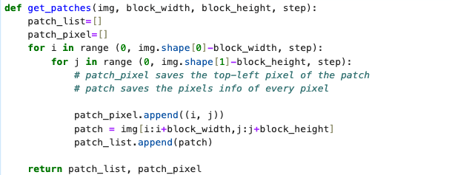

* get_patches() gets patch information according to the block size.
* Blocks in trucka.bmp are closely connected, so the step is the block size while getting truck A patch information.
* Records the patch starting pixel position and all pixel intensities.

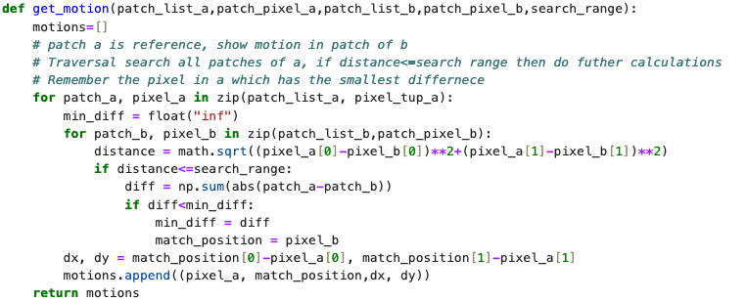

* get_motion() gets motion of patches in truck A with respect to truck B.
* Patch a is reference, show motion in patch of b.
* Traversal search all patches of a, if distance<=search range then do futher calculations
* Remember the pixel in a which has the smallest difference

Result:

