- PCN No.: | QPCN13012
- Subject: | Ordering code process change, add “H” code  for AEC-Q101 qualified product
- To: | All customers involved
- Issued by: | HQ (Headquarters) QRA Owen Wang
- Issue date: | 22-Nov-2013
- Proposed first ship date for change: | 24-Feb-2014
- Affected Product Identification
GPP, TVS & Zener rectifiers, see attached detailed Part-No. list.
- Change Description : (OLD Vs. NEW Comparison)
Old: | New:
- No Standard or AEC-Q101 qualified grade ordering code differentiation. | - With Standard or AEC-Q101 qualified grade ordering code “H” differentiation/see data sheet ordering information
- Reason for Change:
- Further ordering code standardization like former QPCN13004-3 for SKY.

- Anticipated Impact: (form, fit, function, quality or reliability)
1. Product outline: | Not applicable
2. Inner construction changed: | Not applicable
3. Electrical specifications: | Not applicable
4. Reliability performance: | Not applicable
5. Data sheet: | Ordering code change, (see attached sheet)
6. Packing code (order code): | With “H” for AEC-Q101 qualified (see data sheet)
7. Identification/Traceability: | By date code and ordering code

- Qualification plan/result:
Refer to
PPAP | N/A
Comparison report | N/A

- Sample availability Date: | N/A
- Tentative implementation date: | 27-Dec-2013
- Remarks
New datasheet on the website
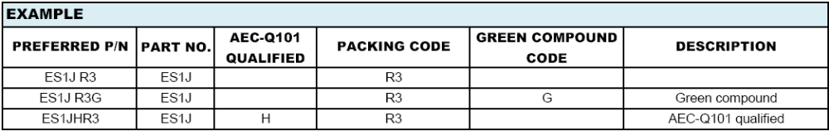
- Customer feedback required latest:  (should we receive no feedback; the change will be deemed as accepted!) | 27-Dec-2013
- Approved by: | Quayer Chen

Customer Approval Form QPCN13012
(Please tick the field what is valid for you!)
We agree with this proposed change and its schedule.
We have objections
We need more information:
We need sample:
Company:
Name:
Address:
Signature: |  | Date:

