SaniPath Exposure Assessment Report

Yuke Wang

05 April, 2018

# Executive Summary

Health Disparities exist where those in the lowest wealth quintile have the least access to improved sanitation facilities and therefore carry greatest disease burden from poor sanitation. To better prioritize sanitation investments and guide intervention strategies to reduce the risk of enteric disease, it is important to assess the contribution that various environmental pathways have on exposure to fecal matter.

To quantitatively evaluate fecal contamination exposure pathways in high-density, low-income neighborhoods in Dhaka, Bangladesh, the SaniPath Exposure Assessment Tool (Emory University, Atlanta, USA) was deployed from 2017-01-01 to 2018-01-07. The exposure pathways of fecal contamination presented in this report include: Drain Water, Produce, Municipal and Piped Water, Ocean Water, Surface Water, Flood Water, Public Latrine, Particulate, Bathing Water, and Street Food.

### {Insert summary sentence about results (ex. The results from this study show that both adults and children are exposed to fecal contamination through multiple pathways)}

Dominant pathways of exposure are determined by comparing the percent exposed and magnitude of exposure for both adults and children in the study neighborhoods. For adults, the dominant pathways in Dhaka, Bangladesh were commonly through Flood Water, Street Food, Produce, Surface Water, Bathing Water, Municipal and Piped Water, Public Latrine, and Drain Water. For children, the dominant pathways in Dhaka, Bangladesh were commonly through Flood Water, Street Food, Produce, Surface Water, Bathing Water, Public Latrine, Municipal and Piped Water, and Drain Water.

Recommendations to reduce exposure to fecal contamination among those living in Dhaka, Bangladesh include:

* Improve drainage systems and reduce environmental contamination by controlling open defecation, improving animal husbandry practices, and by improving access to and quality of public latrines
* Develop evacuation provisions for flood-prone areas
* Educate communities on risk associated with flood water and proper hand hygiene practices
* Increase regulation of wastewater reuse quality and produce quality and transport
* Provide education for shopkeepers and consumers on proper food and hand hygiene practices
* Educate farmers on safe wastewater reuse practices and risk of contamination for crops
* Increase regulation of street vendor licensing, street food hygiene, quality, and handling practices, and implement health safety inspections
* Provide education on proper food and hand hygiene practices for vendors and consumers and educate consumers on highly contaminated foods

# Introduction

Sanitation plays an important role in disrupting the transmission of bacteria, protozoa, viruses, and other pathogens and environmental hazards associated with feces.1 Exposure, defined as oral ingestion of any number of fecal indicator organisms (*E. coli*), can occur indirectly or directly from various environmental sources. Exposure varies person-to-person based on environmental contamination and behavior related to potential transmission routes, or pathways. Pathways of exposure refer to environmental and infrastructural characteristics, such as flooding, surface water, presence of open drains, piped water supply, or public latrines that facilitate transfer of fecal contamination. Determining dominant pathways can help inform sanitation investments towards the exposure pathways that pose the greatest risk.

### {Insert sentences about country and city context (ex. Income, density, tenure status, urban poor housing conditions, city/country challenges)}

### {Insert sentence about country and city improved sanitation access}

### {Optional: sentence about wealth quintiles and sanitation access}

Low coverage and use of sanitation facilities is linked to a greater exposure to fecal pathogens that can contaminate food, water, and surfaces. Unfortunately, this exposure can lead to adverse health outcomes such as diarrhea, helminth infections, gut dysfunction, impaired cognitive development, malnutrition, and stunting.2

### {Optional: Sentences about wealth quintile and diarrhea and malnutrition facts (DHS)}

### {Insert sentence about city growth (population, urban growth rate, wealth quintile population, etc.)}

Studies have demonstrated an association between diarrheal disease, soil-transmitted helminth infections, stunting, and childhood mortality with inadequate sanitation access, quality, and use.3,4,5 In high density urban areas, populations are at an increased risk of exposure to fecal contamination, especially children, due to environmental factors and exposure behaviors.6 Considering the impact of enteric and diarrheal disease among residents in low-income urban areas, it is important to identify exposure pathways and trends across neighborhoods. By examining environmental contamination and behaviors related to environmental pathways, risk of exposure to fecal contamination can be assessed to provide a public health perspective to inform sanitation investments.

# Methodology

The SaniPath Exposure Assessment Tool, which was developed by the Center for Global Safe Water, Sanitation, and Hygiene at Emory University, was used to quantitatively evaluate the pathways of exposure to fecal contamination in urban environments. Environmental samples from public areas susceptible to fecal contamination and household behavioral surveys were collected by a TEAM_NAME in target neighborhoods (Figure 1).

### {Insert sentences about neighborhoods: number, region, demographics, wealth, infrastructure, tenure status, socioeconomic status, wash coverage}.

### {Optional: enter table of neighborhood characteristics} NOTE: Can this be generated? What kind of characteristics?

### {Insert sentences about where the samples were collected from (local market, homes, businesses, etc.)}

All samples were collected from public spaces and not within households. Environmental samples were tested in the laboratory at LAB_NAME within seven hours of collection. All samples were analyzed for E. coli using IDEXX methods. Two to three serial dilutions were used for each sample type, optimized to capture E. coli within the countable range (0 - 2419.6 MPN). A negative control was processed every day alongside sample analyses.

***Figure 1. Map of Data Collection Activities***

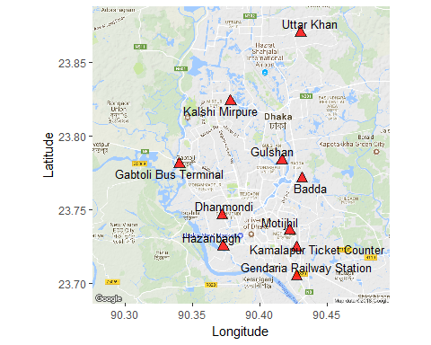

To assess the frequency at which adults and children interact with different pathways, the SaniPath enumeration team conducted behavioral surveys in community meetings, household, and school in English. All households in the neighborhoods were asked to participate in the voluntary survey. The study team surveyed the household member who manages the water supply in the home. **{, which was usually: Insert individualâ€™s characteristics (typically mother, woman, man, etc.)}** Survey participants in households and community meetings were asked about their frequency of contact with environmental pathways. They were then asked to estimate the frequency at which their children came into contact with or ingested aspects of pathways. In school surveys, children were asked about their frequency of contact with environmental pathways and were also asked to estimate the frequency of contact at which their parents came into contact with or ingested aspects of the pathways. Table 1 outlines sample sizes for surveys and environmental samples for each neighborhood.

### *{Insert additional relevant information about sample collection (ex. Micro samples collected but no behavioral info, shared samples btw neighborhoods, etc.) â€“need a warning that if they deviated from the suggested protocol that the results may not be valid.}

***Table 1.1 Survey sample size***

|  |  |  |  |
| --- | --- | --- | --- |
| Neighborhood | Community | Household | School |
| Badda | 5 | 100 | 4 |
| Dhanmondi | 0 | 82 | 3 |
| Gabtoli Bus Terminal | 5 | 100 | 3 |
| Gendaria Railway Station | 5 | 101 | 3 |
| Gulshan | 0 | 65 | 1 |
| Hazaribagh | 4 | 100 | 4 |
| Kalshi Mirpure | 4 | 100 | 5 |
| Kamalapur Ticket Counter | 5 | 100 | 4 |
| Motijhil | 0 | 33 | 4 |
| Uttar Khan | 0 | 42 | 4 |
| Total | 28 | 823 | 35 |

***Table 1.2 Pathway sample types and sample size***

|  |  |  |  |  |  |
| --- | --- | --- | --- | --- | --- |
| Neighborhood | Bathing Water | Drain Water | Flood Water | Municipal and Piped Water | Particulate |
| Badda | 10 | 10 | 10 | 20 | 10 |
| Dhanmondi | 10 | 10 | 10 | 20 | 10 |
| Gabtoli Bus Terminal | 10 | 10 | 10 | 20 | 10 |
| Gendaria Railway Station | 10 | 10 | 10 | 20 | 10 |
| Gulshan | 10 | 10 | 10 | 20 | 10 |
| Hazaribagh | 10 | 10 | 10 | 20 | 10 |
| Kalshi Mirpure | 10 | 10 | 10 | 20 | 10 |
| Kamalapur Ticket Counter | 10 | 10 | 10 | 20 | 10 |
| Motijhil | 10 | 10 | 10 | 20 | 10 |
| Uttar Khan | 10 | 10 | 10 | 20 | 10 |
| Total | 100 | 100 | 100 | 200 | 100 |
| Neighborhood | Produce | Public Latrine | Street Food | Surface Water | Ocean Water |
| Badda | 10 | 10 | 10 | 10 | 0 |
| Dhanmondi | 10 | 10 | 10 | 10 | 0 |
| Gabtoli Bus Terminal | 10 | 10 | 10 | 10 | 0 |
| Gendaria Railway Station | 10 | 10 | 10 | 10 | 0 |
| Gulshan | 10 | 10 | 10 | 10 | 0 |
| Hazaribagh | 10 | 10 | 10 | 10 | 0 |
| Kalshi Mirpure | 10 | 10 | 10 | 10 | 0 |
| Kamalapur Ticket Counter | 10 | 10 | 10 | 10 | 0 |
| Motijhil | 10 | 10 | 10 | 10 | 0 |
| Uttar Khan | 10 | 10 | 10 | 10 | 0 |
| Total | 100 | 100 | 100 | 100 | 0 |

The SaniPath Tool provides information on the frequency of behavior associated with exposure to various environmental pathways and the concentration of fecal contamination in each environmental pathway. The environmental samples are analyzed for presence of *E. coli* as an indicator of fecal contamination. This data is combined with frequency data from behavioral surveys and additional information from the literature (i.e. intake values, duration of exposure, etc.), and analyzed using Bayesian methods. All pathways are analyzed with regard to ingestion of fecal contamination, either direct or indirect. A Monte Carlo simulation is then used to generate risk profiles of exposure to fecal contamination.

Risk profiles, or *people plots*, are displayed in the visuals throughout the following pages. The number of red people in the people plots visually represents the proportion of people who are exposed to the specific pathway. The magnitude of fecal contamination exposure "dose" is indicated by the shade of red, where darker red refers to greater dose of *E. coli*. The dose is considered to be different if there is a greater than tenfold difference between two neighborhoods or pathways.

# Results and Discussion

Risk profiles for environmental exposure pathways were generated for all neighborhoods and all relevant pathways in each neighborhood for adults and children. The SaniPath team has developed an algorithm to determine the dominant fecal contamination pathways for each neighborhoodand age groups. The algorithm is based upon the population exposed to those pathways and the corresponding magnitude of exposure to fecal contamination.

Figure 2 shows the people plots generated for all exposure pathways in Hazaribagh. The highest dose of exposure for Children was seen in Flood Water at 11.981 MPN/Month *E. coli*, with 89.7 percent of Children exposed to fecal contamination. Table 2 shows the dose and percent exposed for adults and children by pathway in Hazaribagh.

***Figure 2: People plots for all exposure pathways in Hazaribagh*** 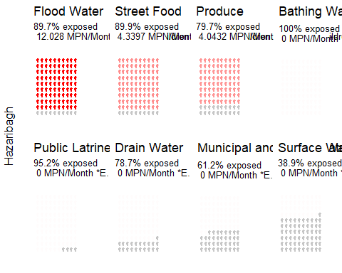

Figure 3 shows the people plots generated for all exposure pathways in Kalshi Mirpure. The highest dose of exposure for Adults was seen in Surface Water at -0.381 MPN/Month *E. coli*, with 41.6 percent of Adults exposed to fecal contamination.

***Figure 3: People plots for all exposure pathways in Kalshi Mirpure*** 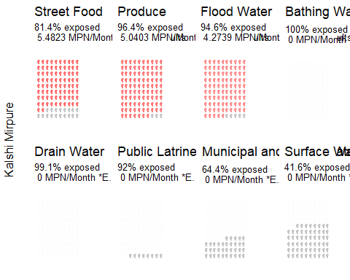

***Table 2. Dose and percent exposed across exposure pathways in Hazaribagh, Dhaka, Bangladesh***

Table 3 shows dominant pathways of exposure for all neighborhoods in the study for adults and children in Dhaka, Bangladesh.

***Table 3. Dominant exposure pathways by neighborhood***

|  |  |  |
| --- | --- | --- |
| Neighborhood | Adults | Children |
| Badda | Produce, Surface Water, Street Food | Surface Water, Street Food, Flood Water, Produce |
| Dhanmondi | Street Food | Street Food |
| Gabtoli Bus Terminal | Surface Water, Flood Water, Produce | Flood Water |
| Gendaria Railway Station | Produce | Produce, Flood Water |
| Gulshan | Produce | Produce |
| Hazaribagh | Flood Water | Flood Water |
| Kalshi Mirpure | Street Food, Produce | Street Food, Flood Water |
| Kamalapur Ticket Counter | Produce | Flood Water, Produce |
| Motijhil | Street Food | Street Food |
| Uttar Khan | Produce, Street Food | Street Food |

***Table 4. 2x2 table***

|  |  |  |
| --- | --- | --- |
|  | High Frequency | Low Frequency |
| **High Dose** | Flood Water* |  |
| **Low Dose** | Street Food Produce Bathing Water Public Latrine Drain Water Municipal and Piped Water | Surface Water |

It is important to consider cumulative exposure across all pathways within neighborhoods when interpreting results from the SaniPath Tool. The number of dominant pathways within a neighborhood as well as the relative contribution to total exposure have important implications on the potential population-level effect of exposure to fecal contamination on the burden of disease. Figures 4 and 5 provide an example of how the relative exposure to fecal contamination by pathways within a neighborhood can impact the total exposure after addressing the dominant pathway of exposure. In scenario 1, produce is the dominant pathway of exposure within the neighborhood. After an investment or intervention that addresses exposure from the produce pathway, total exposure is reduced to only that contributed by open drains, surface water, and drinkign water. In scenario 2, produce, open drains, and surface water are all dominant pathways of exposure to fecal contamination within a neighborhood. After an investment or intervention that addresses exposure from the produce pathway, total exposure remains relatively large due to the contribution from open drains and surface water. This scenario highlights the importance of understanding how the population-level exposure to fecal contamination for individual pathways contributes to total exposure and how cumulative exposure may or may not be reduced to a level that will impact the burden of disease by only addressing individual pathways.

***Figure 4. Scenario 1: Total exposure for a neighborhood with one dominant pathway (* denotes dominant pathway)**\* 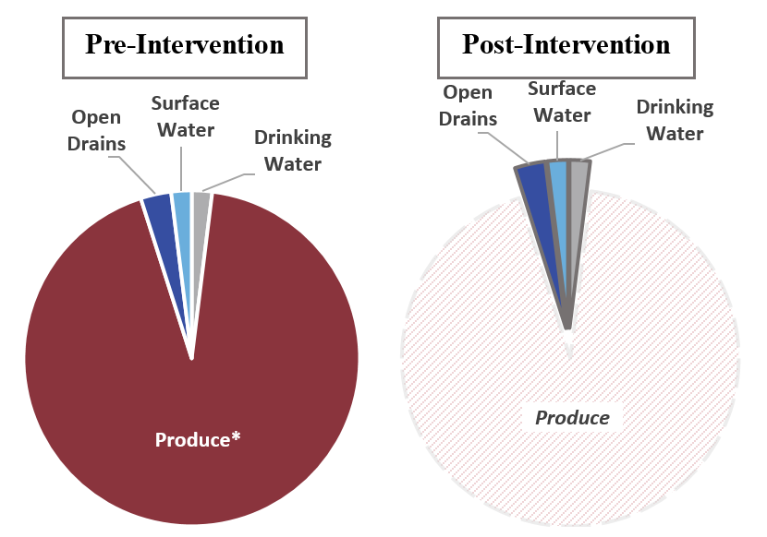

***Figure 5. Scenario 2: Total exposure for a neighborhood with three dominant pathways (* denotes dominant pathway)**\* 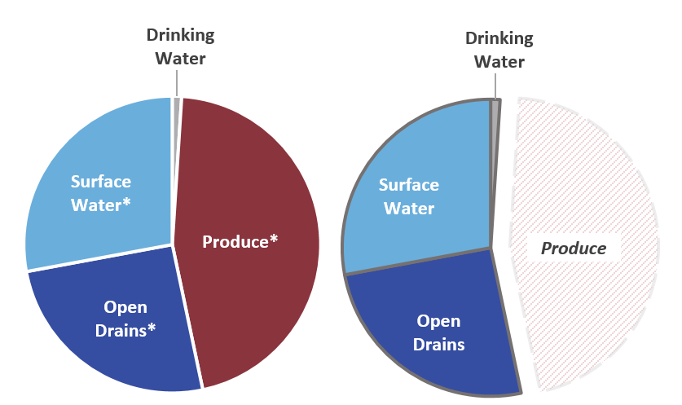

Many communities around the world experience routine flooding during rainy season in areas that lack or have inadequate drainage management systems. In Dhaka, Bangladesh, floodwater was found to be a dominant pathway of exposure to fecal contamination in 6 neighborhoods. Floodwater was found to be highly contaminated and based on reported frequencies of interaction with floodwater, adults were at greater risk of exposure to fecal contamination via ingestion in 6 neighborhoods. Floodwater can interact with open drains, surface water, latrines, wastewater-irrigated soils, feces from open defecation, and other contaminated environmental pathways that can lead to fecally contaminated floodwater. People may walk through floodwater, pick up items in floodwater, or clean their house after flooding and these behaviors can effect their risk of exposure to fecal contamination through this pathway.

Street food is common in the diet of many people in urban areas globally. Street food is food that is prepared and sold on the street, and can be cooked or uncooked. Throughout the study sites in Dhaka, Bangladesh, street food was identified as a dominant exposure pathway of fecal contamination in 5 neighborhoods. Commonly eaten street food in Dhaka, Bangladesh includes UPDATE_ME1 and UPDATE_ME2. Street food was highly contaminated and the reported behaviors of adults in 5 neighborhoods put them at greater risk of exposure to fecal contamination via ingestion of street food. Contamination of street food can occur at many different points such as during preparation, during storage prior to selling, from hands, and from other activities. Behavior that could increase exposure include increased frequency of consumption of street food and improper hand hygiene from the vendor or the consumer.

Produce is an important part of the diet for many people around the world. Produce that does not grow on a tree, does not have a peel or shell and that is eaten raw and uncooked can pose important health risks for those ingesting it. In Dhaka, Bangladesh, produce is a dominant pathway of exposure in 7 neighborhoods. Commonly eaten raw produce in Dhaka, Bangladesh include UPDATE_ME1, UPDATE_ME2, and UPDATE_ME3. in 7 neighborhoods put them at greater risk of exposure to fecal contamination via ingestion of raw produce. Contamination of produce can occur at many steps along the pathway from farm to table. Contamination could be introduced and facilitated via wastewater irrigation practices, lack of produce washing regulations at the farm, during transport to markets, by hands and surfaces in the market, and by hands and surfaces in the household. This study focused only at one specific point along this pathway, specifically at the market vendor, and further research is needed to determine which steps contribute to fecal contamination of raw produce. Behaviors also play a role in exposure, and behaviors that may increase risk of exposure to fecal contamination can include increased consumption of raw produce, lack of handwashing prior to eating, and the absence of produce washing practices. Throughout the study area in Dhaka, Bangladesh, 85% of survey respondents reported washing the produce that they eat raw before consuming it. Washing produce can be an important barrier in the exposure route of fecal contamination however this study did not investigate the impact washing had on contamination since this takes place in the private domain.

# Implications for Saniation Investment

It should be noted again that all samples were collected from the public domain and not at the household level. This was done because government interventions typically focus on improving public facilities and may not be able to influence household-level contamination. Therefore, household sanitation and hygiene practices have not been taken into consideration when generating risk profiles. For example, it is possible that people wash their produce before eating it raw, which, if washed adequately, would reduce the exposure to fecal contamination from produce. However, the SaniPath Tool does not ask questions related to food hygiene, nor does it measure exposure dose after produce is washed. To understand exposure on a household level, further research would be required. Based upon the results of this study, recommendations can be made regarding the most common dominant pathways that were observed (Table 3).

*Table 5. Recommended interventions for Dhaka, Bangladesh*

|  |  |  |
| --- | --- | --- |
| Pathway | Private Domain | Public Domain |
| Flood Water | Education about the risk of contact with dirty flood water | Improve drainage system |
|  | Better hand hygiene practice (education) | Reduce open defecation |
|  |  | improve animal husbandry/control to reduce animal feces |
|  |  | Increase access to quality, affordable public latrines that safely contain feces |
|  |  | Develop provisions to evacuate flood-prone areas |
| Produce | Better food hygiene practice (education) | Increase regulation of wastewater reuse and quality standards |
|  | Better hand hygiene practice (education for shop keepers and consumers) | Provide an enabling environment for formalized markets for safe wastewater reuse in farming |
|  | Education for farmers on safe wastewater reuse practices and on crops at greater risk of contamination | Increased regulation of produce quality and transport |
|  | Promote breastfeeding |  |
|  | Avoid high contaminated food (e.g. street food) |  |
| Street Food | Better food hygiene practice (education) | Increase regulation of street vendor licensing |
|  | Better hand hygiene practice (education for street food vendors and consumers) | Increased regulation of street food hygiene, quality, and handling practices |
|  | Promote breastfeeding | Implement health safety inspections for street food vendor stalls |
|  | Avoid high contaminated food (e.g. street food) |  |

# Strengths and Limitations

The primary strength of the SaniPath exposure assessment is that the results focus on the measurement of risk rather than risk perception and relies on primary data collection â€“ both behavioral surveys and microbiological analysis of environmental samples. The Tool can be adapted to different cultural contexts, employs mobile data collection, and provides automated data analyses and data visualizations. In addition, the unique risk profiles provide information for decision making in a format that is easy to understand by a variety of audiences.

However, this exposure assessment does have limitations. The assessment was deployed cross-sectionally and so it is not able to capture temporal and seasonal variability in contamination or behaviors. The information is only a snapshot of exposure at the neighborhood level and may not be generalizable to the entire city . This assessment also relies on self-reported information about behavior which may be biased due to social desirability or due to adults and children either over- or underestimating the frequency of specific behaviors of children.

In addition to limitations of the SaniPath Tool, there were challenges in-country. **{Insert sentences about challenges in obtaining data (weather, resources, pathway accessibility)}.**

# Conclusion

The deployment of the SaniPath Exposure Assessment Tool in Dhaka, Bangladesh highlighted the roles that environment and behavior play in human exposure to fecal contamination. Behavioral surveys and simple microbiological techniques were used to generate risk profiles for study neighborhoods across environmental pathways, including Drain Water, Produce, Municipal and Piped Water, Ocean Water, Surface Water, Flood Water, Public Latrine, Particulate, Bathing Water, and Street Food. Dominant pathways of exposure varied across neighborhoods and age groups, with dominant pathways for adults including Flood Water, Street Food, Produce, Surface Water, Bathing Water, Municipal and Piped Water, Public Latrine, and Drain Water, and dominant pathways for children including Flood Water, Street Food, Produce, Surface Water, Bathing Water, Public Latrine, Municipal and Piped Water, and Drain Water. Recommendations can be made for potential interventions to reduce exposure to fecal contamination based on behavior and environmental contamination levels in both the public and private domain. Recommendations for to reduce exposure to fecal contamination for adults and children in Dhaka, Bangladesh include:

* Improve drainage systems and reduce environmental contamination by controlling open defecation, improving animal husbandry practices, and by improving access to and quality of public latrines
* Develop evacuation provisions for flood-prone areas
* Educate communities on risk associated with flood water and proper hand hygiene practices
* Increase regulation of wastewater reuse quality and produce quality and transport
* Provide education for shopkeepers and consumers on proper food and hand hygiene practices
* Educate farmers on safe wastewater reuse practices and risk of contamination for crops
* Increase regulation of street vendor licensing, street food hygiene, quality, and handling practices, and implement health safety inspections
* Provide education on proper food and hand hygiene practices for vendors and consumers and educate consumers on highly contaminated foods

# References

1. Jha, A. K., Bloch, R., & Lamond, J. (2012). Cities and flooding: a guide to integrated urban flood risk management for the 21st century. World Bank Publications.
2. Pruss-Unstun, A, Bos, R, Gore, F, and Bartram, J. (2008). Safer water, better health: costs, benefits and sustainability of interventions to protect and promote health. World Health Organization, Geneva
3. Wolf, J., PrÃ¼ssâ€UstÃ¼n, A., Cumming, O., Bartram, J., Bonjour, S., Cairncross, S., Clasen, T., Colford, J.M., Curtis, V., France, J. & Fewtrell, L. (2014). Systematic review: assessing the impact of drinking water and sanitation on diarrhoeal disease in lowâ€and middleâ€income settings: systematic review and metaâ€regression. Tropical Medicine & International Health, 19(8), 928-942.
4. Ziegelbauer, K., Speich, B., MÃ¤usezahl, D., Bos, R., Keiser, J., & Utzinger, J. (2012). Effect of sanitation on soil-transmitted helminth infection: systematic review and meta-analysis. PLoS Med,9(1), e1001162.
5. D. Spears. 2013. How Much International Variation in Child Height Can Sanitation Explain? World Bank Policy Research Working Paper 6351. Washington, DC: The World Bank
6. Hathi, P., Haque, S., Pant, L., Coffey, D., & Spears, D. (2017). Place and Child Health: The Interaction of Population Density and Sanitation in Developing Countries. Demography, 54(1), 337-360.

[SaniPath Website](http://sanipath.org)

[SaniPath Papers](http://sanipath.org)

# Disclaimer

The SaniPath Tool and methods were developed by Emory University in Atlanta, Georgia, USA. The Tool software and protocols are freely accessible to users and may be modified or adapted to fit their interests and context. Emory University does not take responsibility of the quality of results generated if modifications are made to either the data collection protocols or analysis.

The recommendations in this report are broad recommendations to guide users in their thinking and application of this evidence-base to their local context. Emory University does not take responsibility for the appropriateness of recommendations or implementation of programs or policy. This report does not reflect the opinions of the University.

#### *This report asdfl;kadjsf*