Charlie Silkin

13 March 2024

**L’Jarius Sneed and Cornerback Aging Curves**

As NFL teams continue to adjust their rosters and add players in free agency, one player whose status remains in limbo is Kansas City Chiefs’ cornerback L’Jarius Sneed. On March 5th, the Chiefs officially placed the franchise tag on Sneed, ensuring a fully-guaranteed $19.082M salary for the 2024 season; however, with the Chiefs also extending star iDL Chris Jones to a record-breaking contract and limited salary cap space, it is possible the Chiefs [will trade Sneed to a new team that will sign him to a long-term extension](https://twitter.com/JFowlerESPN/status/1762590048879366187). Being a key contributor to back-to-back Super Bowl championships, it’s reasonable to assume Sneed will reset the market for cornerbacks, however, given Sneed’s age and the poor recent history of success for CBs on their second contracts, NFL teams should be wary towards a long-term investment in Sneed.

Below is a table of the top 15 average annual values of CBs who signed a multi-year contract before the 2020 season or later:

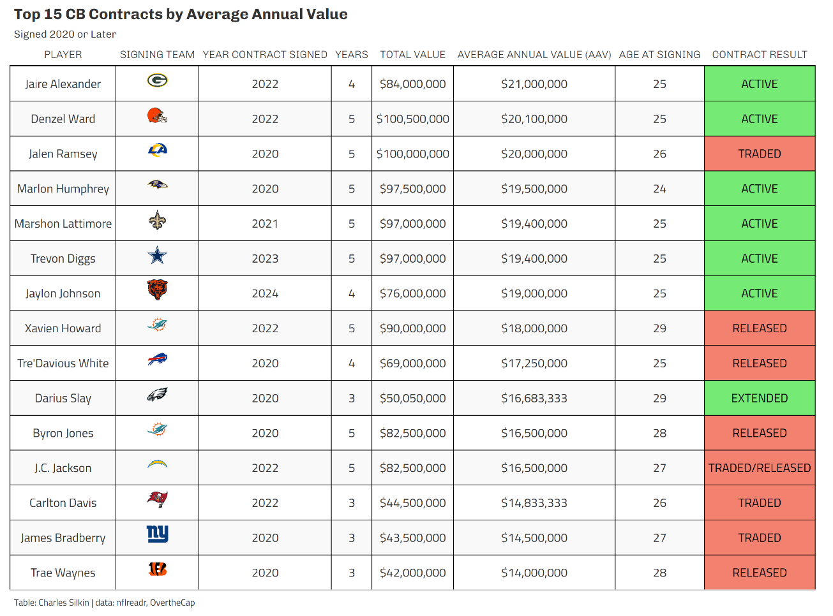

As seen in the table, seven of the fifteen CBs and six of the top seven were 25 or younger when they signed their contracts. Bears CB Jaylon Johnson, who was also franchise tagged, received an extension for 4 years at a $19M AAV this offseason in a higher salary cap environment. Sneed’s current franchise tag salary is already the highest AAV for a cornerback at age 27 or older, and Sneed at 27 will likely have a higher AAV in his contract than Xavien Howard received in 2022 entering his age 29 season.

The bigger story is the contract results of the CBs who signed in their age 26 seasons or later. Of those eight players, seven were either traded or released before their contracts expired, while the Eagles extended Darius Slay to a [new contract with a lower AAV](https://overthecap.com/player/darius-slay/2358). Of course, it’s possible that Sneed becomes an exception and finishes out his next contract, however, that outcome is unlikely based on recent history.

To investigate why teams have moved on from CBs in the middle of their contracts signed at age 27 or order, I analyzed CBs’ PFF coverage grades relative to their age of CBs using data from the 2014 season to present day.

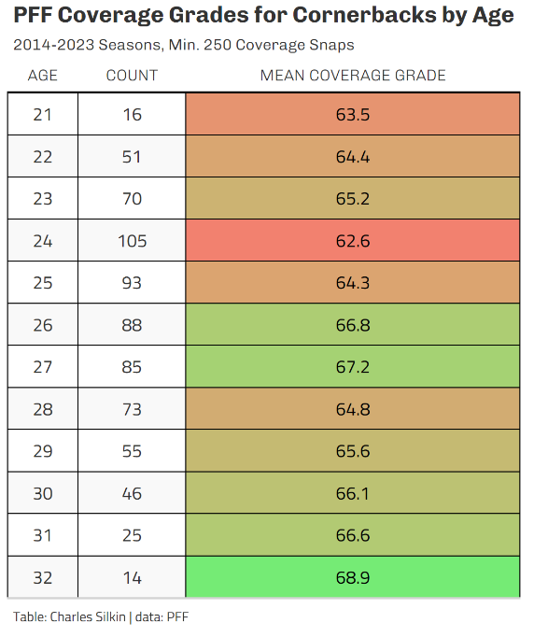

Setting a minimum of 250 coverage snaps played in a given season, I grouped 721 CBs age 32 or younger by age and computed their average PFF coverage grade. As seen in the table, the average coverage grade is highest for CBs in their age 26 and 27 seasons, and the average grade doesn’t meaningfully increase afterwards.

To further study the relationship between age and a cornerback’s ability, I created an aging curve inspired by [FanGraphs’ version for baseball](https://blogs.fangraphs.com/checking-in-on-the-aging-curve/). An aging curve depicts the average change in CBs’ coverage grade over the course of consecutive seasons. To obtain the average change, I first filtered the data to only contain player seasons where they played back-to-back seasons of 250+ snaps (this helps reduce the impact of outliers such as major season-ending injuries). Next, I calculated each player’s change in coverage grade from their age $n$ season to their age $n-1$ season. Finally, I calculated the average coverage grade change (aka delta) grouped by age and graphed the results to visualize the change.

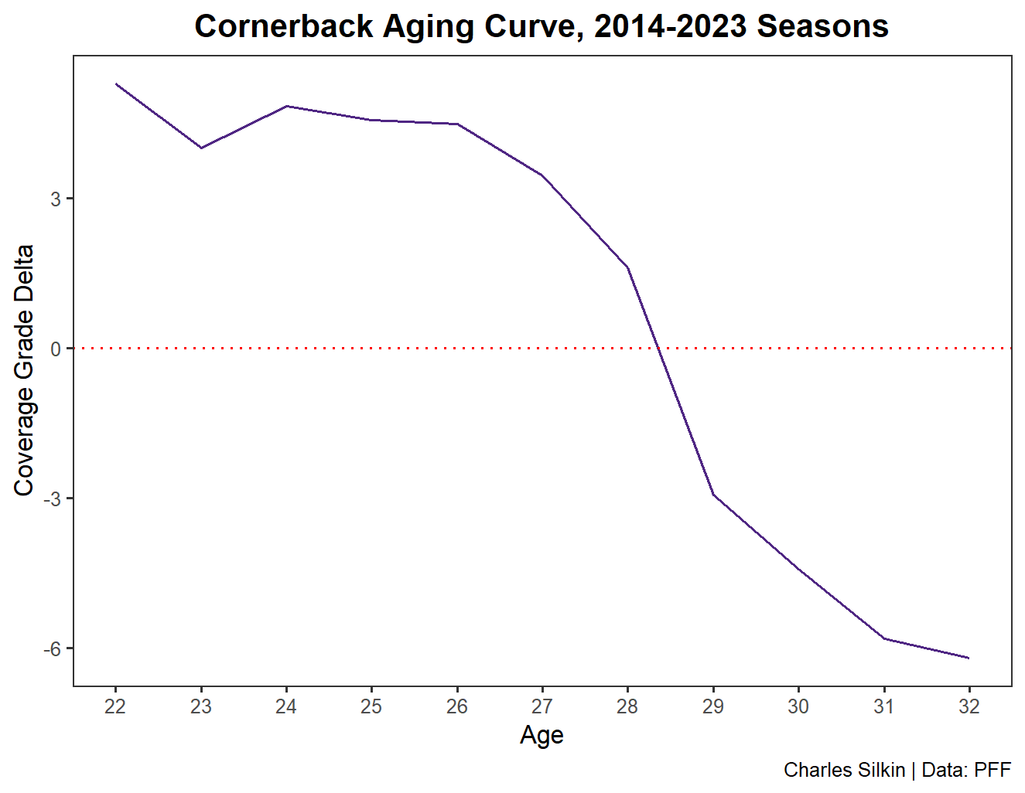

Unlike the previous table, which shows the average grade on an aggregate level, this aging curve spotlights the average change on an individual player level. As seen on the graph, CBs on average are showing a small decline in coverage grade over time starting in their age 25 seasons from their age 24 seasons, with gradually increasing dips before culminating in a severe decline of 4.54 points in their age 29 seasons from their age 28 seasons.

While the previous aging curve does show promising results, it does lack the context of the degree of decline or improvement in play. For example, if a player had an 80 coverage grade in 400 snaps in 2022 and a 76 grade in 600 snaps in 2023, that would be more significant indicator of a decline than if the player had less snaps vs. the previous season. To further my analysis, I calculated a player’s change in coverage grade weighted by their year-to-year change in snap count and visualized the results.

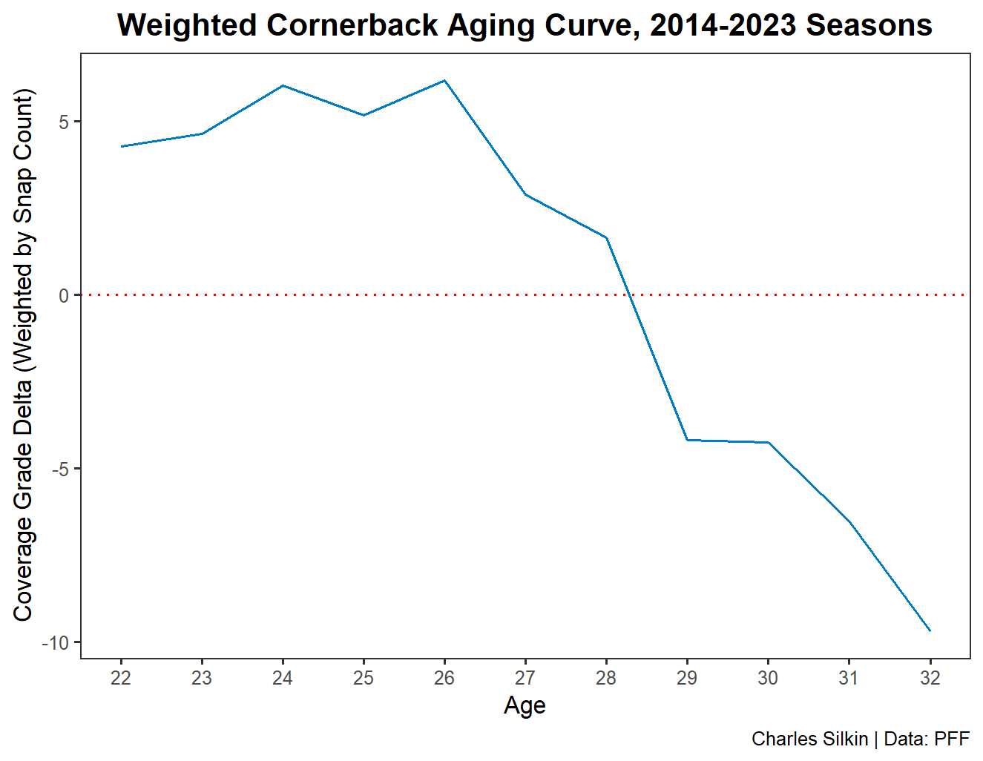

This aging curve highlights two stages of significant decline for CBs: one in their age 27 seasons and a steeper one in their age 29 seasons. Interestingly, when accounting for changes in snap counts, CBs’ coverage grades actually show an increase earlier in their careers, meaning that on average, players are either improving more with an increased snap count or declining less on decreased snap counts, before the opposite happens starting in their age 27 seasons.

In conclusion, it is unlikely that Sneed will be worth the cost a team will pay both to trade for him and to extend him to a contract that would make him one of the highest-paid CBs in the NFL. The 2024 season will be Sneed’s age 27 season, which, as shown in both the aging curves, represents the beginning of a cornerback’s decline in PFF’s coverage grade. Of course, there could be other external factors such as changing teams, defensive schemes, injuries, etc. that could contribute to a decline in performance in addition to age. However, between the aging curves, the contract history for CBs in similar contract situations to Sneed, and the fact that a team will have to trade assets to have the right to sign him in the first place, the odds of Sneed being a worthwhile investment are not favorable.

**---**

**\*code may be furnished upon request\***

**Data References:**

1. <https://nflreadr.nflverse.com/index.html>
2. <https://premium.pff.com>
3. <https://overthecap.com>