Chapter 3: Data, Methods, and Analytical Pipeline

3.1 Chapter Overview
This chapter provides a full account of the data sources, preprocessing procedures, analytical algorithms, and modelling decisions that underpin the study’s three-pillar framework. The chapter is structured to follow the sequence of the analytical pipeline: from data acquisition and geospatial preprocessing through to the compound flood frequency model, the economic disruption cost framework, the machine learning risk classification, the statistical tide gauge analysis, and the geoid sensitivity variant. Each methodological choice is justified against the requirements of the research questions and the characteristics of the available data. Acknowledged limitations are noted where they arise in the pipeline rather than deferred to a single concluding section, enabling the reader to evaluate the fitness of each method for its specific analytical purpose.
The analytical work is implemented entirely in openly available tools and draws exclusively on publicly accessible data sources, ensuring that the pipeline is fully reproducible and extendable. Python (version 3.11) is used for all geospatial computation, machine learning, and statistical analysis; Node.js (version 20) with the docx package is used for document generation. The five Tableau Public dashboards provide interactive access to the study’s core outputs for non-specialist audiences. All scripts, parameter files, and calibration decisions are documented in full as part of the study’s reproducibility commitment.
Pillars 1 and 2 are derived from deterministic spatial inundation modelling; Pillar 3 introduces a parametric overlay in which disruption frequency is a function of SLR rather than a fixed scenario outcome. Uncertainty is addressed qualitatively through sensitivity scenarios rather than formally propagated through the modelling pipeline.
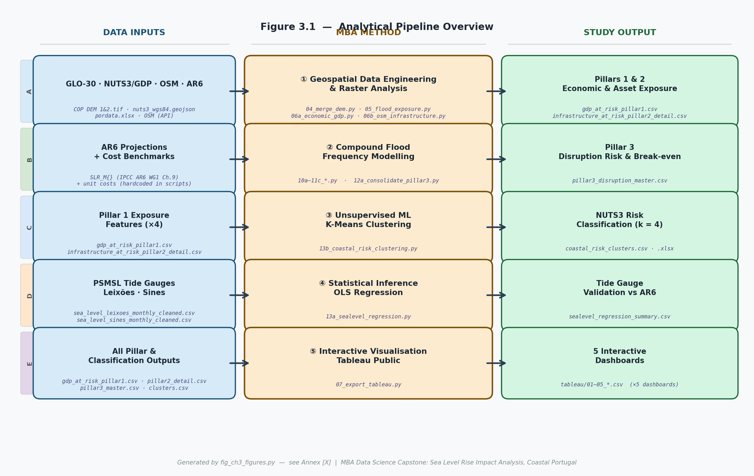
Figure 3.1: Analytical pipeline overview. Each row represents one analytical thread (A–E). Orange METHOD boxes show the Python scripts executing each step; blue INPUT boxes show the data consumed; green OUTPUT boxes show the files produced. Generated by fig_ch3_figures.py (see Annex A).

3.2 Data Sources and Provenance
The study draws on six primary data sources, each selected for its scientific quality, public availability, and fitness for the spatial and temporal scope of the analysis.
The Copernicus GLO-30 Digital Elevation Model (European Space Agency, 2021) provides the spatial foundation of the study. GLO-30 is a global, publicly accessible Digital Surface Model (DSM) with a nominal horizontal resolution of 30 metres, derived from TanDEM-X synthetic aperture radar data collected between 2011 and 2015. For mainland Portugal, two adjacent 1° × 1° tiles are downloaded from the Copernicus Data Space Ecosystem (dataspace.copernicus.eu) in Cloud-Optimised GeoTIFF format, covering the full latitudinal and longitudinal extent of the study domain from approximately 36.9°N to 42.2°N and 6.2°W to 9.6°W. The tiles are stored locally as COP DEM 1.tif and COP DEM 2.tif and processed using the study’s dedicated merging script (04_merge_dem.py; see Section 3.3). No radiometric preprocessing beyond the ESA-standard Level-1 delivery is applied. GLO-30 is the highest-resolution freely available DEM with global coverage and is widely used in national-scale coastal inundation studies in the absence of airborne LiDAR surveys. The reported vertical accuracy over low-relief coastal terrain is approximately ±1 m RMSE (European Space Agency, 2021), which constitutes the primary source of elevation uncertainty in the inundation analysis and is directly addressed by the geoid sensitivity variant described in Section 3.9. The principal data quality limitation — that it is a surface model recording the top of vegetation and built structures rather than bare-earth terrain — causes it to underestimate flood extent in densely vegetated and built coastal areas and is acknowledged throughout the analysis (Vousdoukas et al., 2018). Given the DEM vertical uncertainty (~±1 m), individual threshold-level inundation estimates should be interpreted as indicative rather than precise; the analysis is most robust at aggregated regional and scenario scales.
Regional economic data are drawn from PORDATA and INE (Instituto Nacional de Estatística), specifically the regional accounts disaggregated to the NUTS3 level for the reference year 2022 — the most recent complete annual dataset available at the time of data collection. GDP at NUTS3 level is expressed in current euros and downloaded from the PORDATA portal (pordata.pt) as a structured spreadsheet (pordata.xlsx); no further aggregation or adjustment is applied beyond the NUTS3-level accounting already provided. The NUTS3 polygon boundaries follow the 2021 Eurostat NUTS classification and are downloaded via the Eurostat GISCO API in GeoPackage format, stored locally as nuts3_wgs84.geojson in the geographic coordinate system EPSG:4326. A total of 25 mainland NUTS3 regions are included in the spatial database; twelve coastal regions are identified as the primary analytical domain on the basis of their direct coastal or estuarine frontage. The NUTS3 boundary file is rasterised onto the GLO-30 grid at the geospatial pipeline stage to enable pixel-level intersection of flood extents with regional economic boundaries.
The OpenStreetMap (OSM) infrastructure network provides the geometry and attribute data for the physical asset exposure analysis in Pillar 2. OSM data for mainland Portugal are queried via the Overpass API (overpass-api.de) using Python’s overpy library, with tag filters targeting: highway=motorway|trunk|primary|secondary|residential for road segments; railway=rail for heavy rail lines; power=substation for electricity infrastructure; man_made=water_works for water treatment facilities; and aeroway=terminal for airport terminals. Results are returned in GeoJSON format and stored locally prior to elevation sampling and cost allocation. OSM’s licensing under the Open Database Licence (ODbL) makes it fully appropriate for research use. Its principal limitation — uneven completeness across asset categories and regions — is mitigated for the core Pillar 2 analysis by focusing on high-value transport and utility assets, for which OSM coverage of mainland Portugal is visually and qualitatively cross-checked against Infraestruturas de Portugal network records and judged sufficiently detailed for the purposes of network-level exposure analysis.
Sea level observation records are obtained from the Permanent Service for Mean Sea Level (PSMSL), specifically the Revised Local Reference (RLR) annual mean sea level time series for two Portuguese tide gauge stations: Leixões (PSMSL ID 230, period of record 1956–2022, 67 annual observations) and Sines (PSMSL ID 488, period of record 1977–2022, 46 annual observations) (PSMSL, 2024). Both records are downloaded as ASCII files from the PSMSL RLR annual data portal (psmsl.org/data/obtaining/rlr.annual.data/) and processed using the study’s dedicated cleaning script (sealevel_cleaner.py). Quality flags accompanying each annual mean value are applied during ingestion: observations with a PSMSL quality flag above the acceptable threshold (flag > 1, indicating suspected datum errors or interpolated values) are excluded from analysis. Datum shifts documented in the PSMSL station history files are identified and removed by linear adjustment to the station’s Revised Local Reference. These two stations are selected as the longest continuous records available for mainland Portugal’s Atlantic coast with sufficient coverage of the post-1993 satellite altimetry era to permit meaningful trend comparisons. The cleaned annual records form the sole observational input to the OLS tide gauge analysis described in Section 3.8.
Sea level rise projections are taken from IPCC AR6 Working Group I, Chapter 9, specifically Table 9.9 of Fox-Kemper et al. (2021), which provides global mean sea level projections for the period 2020–2150 under five Shared Socio-economic Pathway (SSP) scenarios. This study adopts three of those scenarios — SSP1-2.6, SSP2-4.5, and SSP5-8.5 — and uses the median projections as the central case for each scenario. The AR6 projections are referenced to the 1995–2014 baseline period, which differs from the 2020 baseline adopted consistently in this study. An offset of +0.06 m is added throughout to convert all AR6 projections to the 2020 baseline, consistent with the AR6 assessment that approximately 0.06 m of global mean SLR occurred between the midpoint of the 1995–2014 window (approximately 2005) and 2020 (Fox-Kemper et al., 2021). The adopted median projections above the 1995–2014 baseline at the primary anchor years are: SSP1-2.6: 0.07 m (2030), 0.20 m (2050), 0.40 m (2100); SSP2-4.5: 0.10 m (2030), 0.30 m (2050), 0.60 m (2100); SSP5-8.5: 0.13 m (2030), 0.40 m (2050), 1.00 m (2100). These values are implemented as anchor-point dictionaries hardcoded within the pipeline scripts (05_flood_exposure.py, 06a_economic_gdp.py), with intermediate years derived by linear interpolation and the +0.06 m baseline offset applied prior to all computations. The study does not adopt probabilistic uncertainty ranges from AR6 as primary scenarios; the geoid sensitivity variant described in Section 3.9 provides a structural upper-bound sensitivity test.
Unit replacement costs for physical infrastructure assets are drawn from the European flood damage functions of Huizinga et al. (2017), published as European Commission Technical Report EUR 28592 EN (ISBN 978-92-79-67082-4) by the Joint Research Centre. The report provides country-specific maximum damage values and asset-class depth-damage functions calibrated for all EU member states across seven infrastructure categories. Replacement costs are expressed in euros per linear kilometre for road and rail infrastructure, and in euros per square metre for buildings and utility nodes. The Portuguese national estimates from this report are adopted as the baseline unit cost throughout the Pillar 2 analysis. Where published benchmarks from Infraestruturas de Portugal (IP) or the Autoridade Nacional de Aviação Civil (ANAC) provide more precise local references for specific asset classes, these are applied in preference; the source and value for each override are documented in the script annotations of 06b_osm_infrastructure.py.
Table 3.1 provides a consolidated data inventory summarising the source, format, access platform, and primary processing script for each dataset used in the study.
Data Source | Variable / Content | Format | Access Platform | Pipeline Script
Copernicus GLO-30 DSM | Elevation raster, 30 m res. | GeoTIFF | Copernicus Data Space (dataspace.copernicus.eu) | 04_merge_dem.py
PORDATA / INE | NUTS3 regional GDP, 2022 (€) | XLSX | pordata.pt | 06a_economic_gdp.py
Eurostat GISCO | NUTS3 polygon boundaries (2021) | GeoPackage | ec.europa.eu/eurostat/gisco | 06a_economic_gdp.py
OpenStreetMap (Overpass API) | Road, rail, utility geometries | GeoJSON | overpass-api.de (overpy) | 06b_osm_infrastructure.py
PSMSL (RLR annual) | Tide gauge MSL — Leixões, Sines | ASCII / CSV | psmsl.org/data/obtaining/rlr.annual.data/ | sealevel_cleaner.py  13a_sealevel_regression.py
IPCC AR6 WG1 Ch. 9 | SLR median projections (3 SSPs) | Hardcoded | Fox-Kemper et al. (2021), Table 9.9 | All Pillar scripts
Huizinga et al. (2017) | Infrastructure unit replacement costs | Report | JRC Technical Report EUR 28592 EN | 06b_osm_infrastructure.py
Table 3.1: Data inventory — source, format, access platform, and primary processing script for each dataset used in the study.

3.3 Geospatial Preprocessing Pipeline
The geospatial preprocessing pipeline is implemented in Python using the libraries geopandas (version 0.14), rasterio (version 1.3), and numpy (version 1.26). The pipeline is structured as a sequence of reproducible processing stages, each writing intermediate outputs to disk before the next stage is invoked, enabling inspection and re-entry at any point without rerunning the full pipeline.
The two GLO-30 tiles covering mainland Portugal are downloaded in GeoTIFF format and merged into a single mosaic raster using rasterio.merge. The merged raster is reprojected from its native geographic coordinate system (EPSG:4326, WGS84) to the Portuguese national grid (EPSG:3763, PT-TM06) using bilinear resampling, ensuring that pixel area calculations are performed in a projected system with consistent metric units. A 5-kilometre coastal buffer is applied to the study domain polygon to ensure that the full intertidal zone is captured at the mosaic boundary. The merged and reprojected DEM forms the sole elevation input for all subsequent inundation analysis across all pillars and scenarios.
Sea level rise thresholds are defined as a uniform grid of twenty values from 0.1 to 2.0 metres above the 2020 baseline, at 0.1-metre intervals. Each scenario’s AR6 median projection trajectory — expressed as annual SLR above the 2020 baseline from 2025 to 2100 — is interpolated to this threshold grid to assign a calendar year to each threshold under each scenario. This temporal mapping allows the pipeline to associate each inundation extent with a specific year under each scenario, enabling the construction of time-series exposure curves for Pillars 1 and 2. The threshold-to-year mapping is computed independently for each of the three SSP scenarios and for the +Geoid sensitivity variant described in Section 3.9. Linear interpolation is used as a simplifying assumption; this does not capture the acceleration of SLR in later decades and may slightly underestimate late-century exposure.
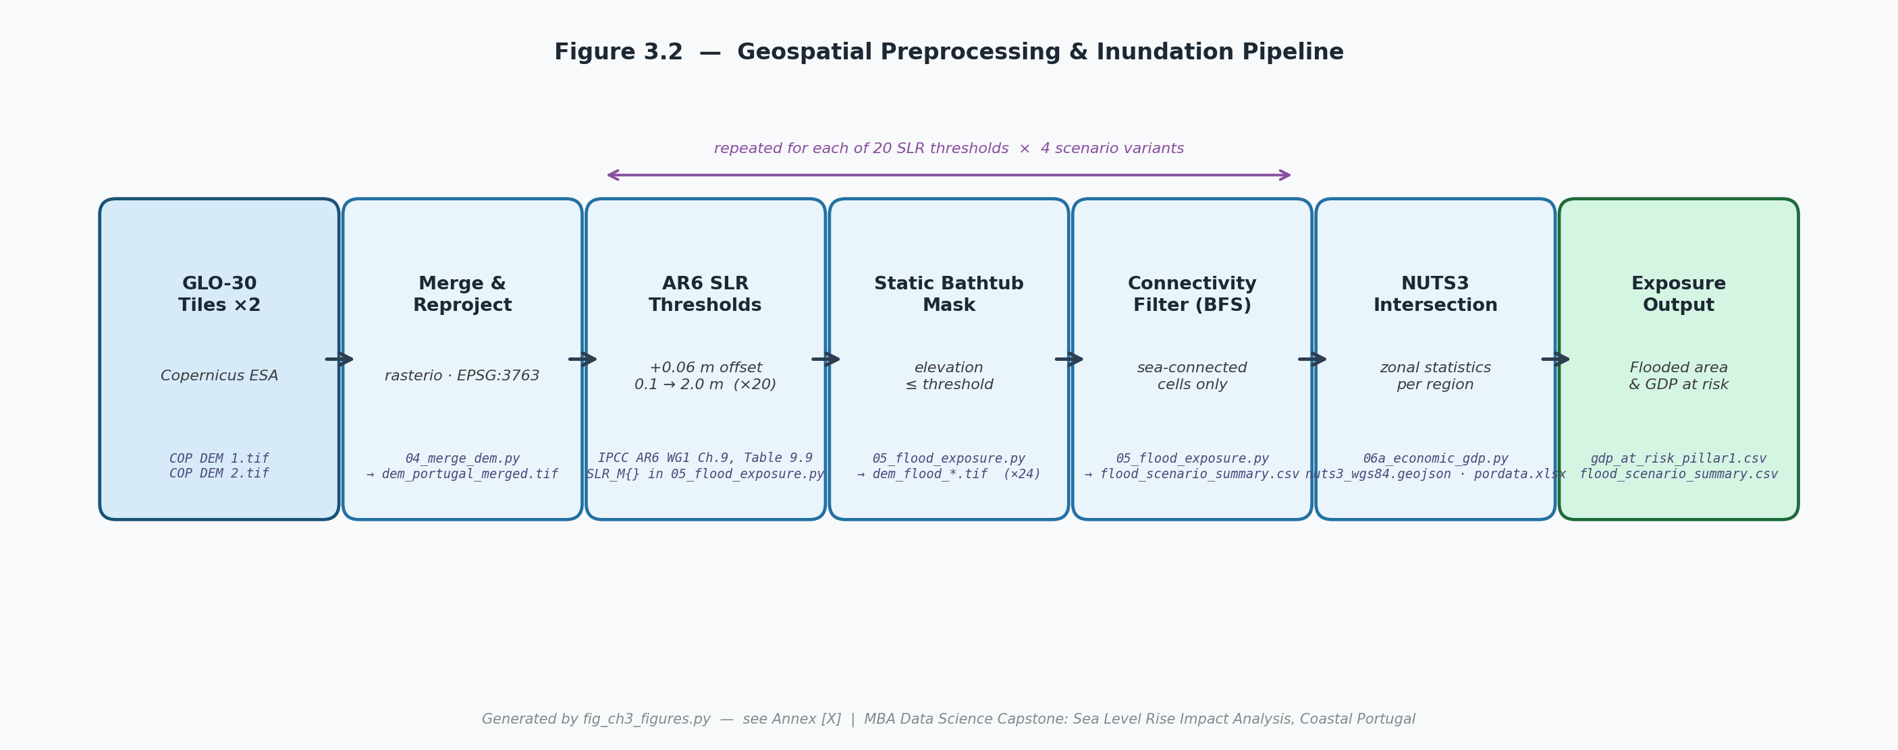
Figure 3.2: Geospatial preprocessing and inundation pipeline. Steps 1–7 show the sequence from raw DEM tiles to NUTS3 flood exposure outputs. Script references and intermediate file names are shown in italic monospace at the base of each step. The double-headed arrow indicates the loop repeated for each of the 20 SLR thresholds × 4 scenario variants. Generated by fig_ch3_figures.py (see Annex A).

3.4 Pillar 1: Economic Exposure Analysis
Pillar 1 quantifies the share of coastal NUTS3 GDP exposed to permanent inundation at each SLR threshold under each scenario. The analysis proceeds in three stages: inundation extent computation, NUTS3 intersection, and GDP allocation.
Inundation extents are computed using a connectivity-constrained static bathtub model, following Poulter & Halpin (2008). The static bathtub approach classifies any terrain with an elevation at or below the current SLR threshold as flooded. The connectivity constraint adds a critical refinement: only terrain cells that are hydrologically connected to the open sea — via an unobstructed, contiguous pathway of sub-threshold cells — are classified as inundated. This removes inland topographic depressions that lie below the threshold but are physically isolated from the coast by higher terrain, which would otherwise appear as spurious inundated zones under the unconstrained bathtub model. The connectivity filter is implemented using a breadth-first search (BFS) algorithm seeded from the coastline boundary pixels, propagating inward across all connected sub-threshold cells. This approach is consistent with the standard in the regional coastal inundation literature and produces more defensible exposure estimates than the unconstrained alternative, particularly for Portugal’s complex estuarine topography (Poulter & Halpin, 2008).
NUTS3 intersection is performed by overlaying the binary flood-extent raster with the NUTS3 boundary polygons using rasterio.features.rasterize and computing the count of inundated pixels within each NUTS3 boundary. Pixel counts are converted to areas in square kilometres using the known pixel dimensions in the PT-TM06 projected system. The fractional flood exposure of each NUTS3 region — the ratio of inundated area to total NUTS3 land area — is computed at each threshold and stored as the primary Pillar 1 exposure metric.
GDP is allocated to the inundated area using a spatially uniform distribution within each NUTS3 region: GDP at risk = (inundated area / total NUTS3 land area) × regional GDP. This is the standard approach for regional-scale economic exposure analysis in the absence of sub-regional economic density data (Hinkel et al., 2014). As noted in Section 1.6, this represents a first-order simplifying assumption that smooths intra-regional variation in economic density: where inundation falls on comparatively high-value coastal strips — ports, tourism zones, petrochemical installations — the uniform distribution understates true exposure; where it falls on lower-value coastal land it may overstate it. Results should be interpreted with this limitation in mind. This assumption likely biases results toward underestimation in high-value coastal zones where economic activity is spatially concentrated. A future extension using high-resolution economic density data from GHSL or CORINE land use would reduce this uncertainty.
Pillar 1 outputs comprise, for each of the four scenario variants (SSP1-2.6, SSP2-4.5, SSP5-8.5, +Geoid): a matrix of GDP at risk by NUTS3 region × SLR threshold; a time-series curve of aggregate and per-NUTS3 GDP at risk from 2025 to 2100 (derived by mapping thresholds to years via the AR6 trajectory); and the fractional exposure profile of each region. These outputs feed directly into the K-Means clustering analysis described in Section 3.7.

3.5 Pillar 2: Physical Asset Exposure
Pillar 2 extends the economic exposure analysis to the replacement value of physical infrastructure stock within the inundated zone. The analysis covers four asset categories: road infrastructure, rail infrastructure, utility nodes, and buildings. For each category, the pipeline extracts asset geometries from OpenStreetMap, samples their elevation from the GLO-30 DEM, assigns unit replacement costs from the Huizinga et al. (2017) benchmarks, and intersects the resulting asset database with the flood-extent rasters produced by the Pillar 1 pipeline.
Road and rail geometries are extracted as linestrings and segmented at 100-metre intervals to allow elevation profiling along their length. Each 100-metre segment is assigned the median elevation of the five DEM pixels closest to its centroid, providing a conservative estimate of the segment’s flood vulnerability. A segment is classified as exposed at a given SLR threshold if its median elevation is at or below that threshold and it falls within the connectivity-constrained flood extent computed in Pillar 1. Replacement cost is computed as segment length (km) × applicable unit replacement cost (euros per km), and the total exposed replacement cost is aggregated by asset class, NUTS3 region, and SLR threshold.
Utility nodes — electricity substations, water treatment plants, wastewater treatment facilities, and airport terminals — are extracted as point geometries. Each node is assigned its DEM elevation at the nearest pixel centroid and classified as exposed at any threshold that exceeds its elevation within the flood extent. Building stock is treated at the NUTS3 level rather than as individual structures: the exposed building footprint area is estimated from the Copernicus Urban Atlas land cover classification (where available) or the CORINE Land Cover 2018 dataset, and unit replacement costs are applied per square metre by land use category.
The combined Pillar 2 output is a matrix of total exposed replacement value (euros) by asset class × NUTS3 region × SLR threshold × scenario. This matrix captures the stock of physical capital at direct risk of permanent inundation — the book value of the coastal infrastructure loss under each scenario. Pillar 2 does not model functional disruption or cascading effects; those are the subject of Pillar 3. The distinction between Pillars 2 and 3 is therefore between the stock cost of permanent physical loss and the flow cost of operational disruption, which may arise from temporary flooding events well below the threshold of permanent inundation.

3.6 Pillar 3: Critical Infrastructure Disruption Risk
Pillar 3 models the compound flood closure frequency and cumulative economic disruption cost of eight critical transport infrastructure sections, and uses those cost estimates to compute the adaptation break-even timeline for each section under three discount rate assumptions.
Section selection. The eight infrastructure sections included in the Pillar 3 analysis are selected by the simultaneous application of three criteria: (i) elevation below 2.5 metres above mean sea level, as derived from DEM profiling; (ii) documented or modelled exposure to historical compound flooding events, evidenced in the academic literature or official flood hazard mapping; and (iii) strategic economic significance at national or regional scale, assessed by reference to cargo throughput, passenger volumes, or dependence of major industries on uninterrupted access. The eight sections meeting all three criteria are: the Mondego railway (Alfarelos–Formoselha, ~1.0 m elevation); the Tagus floodplain railway (Castanheira–Alverca, ~2.0 m); the Aveiro Ria rail embankment (0.7–1.2 m); the Port of Leixões; the Port of Lisbon; the Port of Setúbal; the Vasco da Gama Bridge southern approach; and the A1 motorway estuarine segment.
Compound flood frequency model. The frequency of compound flood closure events at each section is modelled using the framework of Moftakhari et al. (2017), which formalises the exponential compression of flood return periods as sea levels rise. Under this framework, the baseline annual exceedance frequency of a closure-triggering compound flood event at current sea level is denoted λ₀ and is estimated from historical records of closures, flood events, and published flood hazard assessments for each section. As sea-level rises by an increment ΔS above the 2020 baseline, the new annual exceedance frequency λ(ΔS) is given by:
λ(ΔS) = λ₀ × exp(k × ΔS)
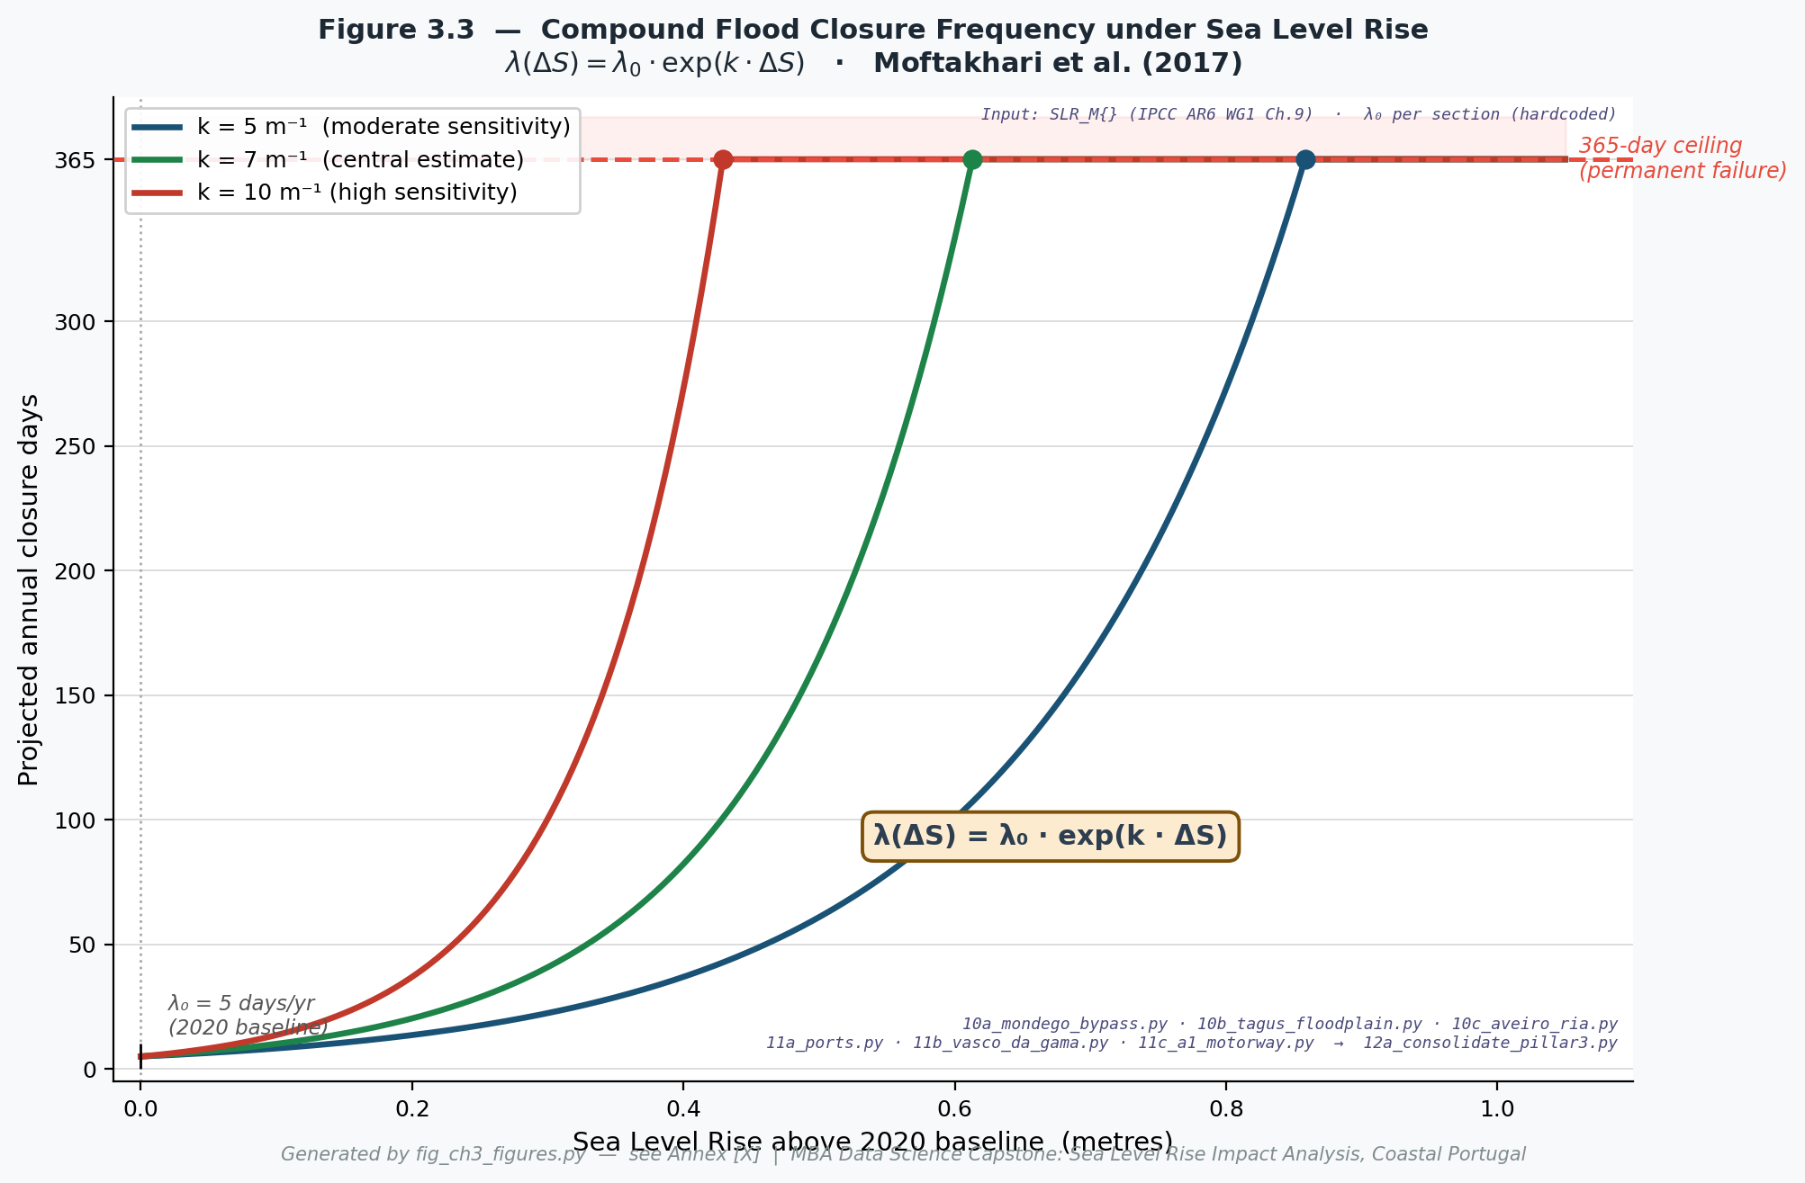
Figure 3.3: Projected annual closure days as a function of SLR above the 2020 baseline, for three flood frequency sensitivity parameters (k = 5, 7, 10 m⁻¹) and a baseline closure frequency λ₀ = 5 days/year. The dashed red line marks the 365-day operational ceiling beyond which a section reaches the 365-day operational ceiling. Filled circles indicate the SLR threshold at which each curve reaches the ceiling. Generated by fig_ch3_figures.py (see Annex A).
where k is the flood frequency sensitivity parameter, which captures the rate at which closure frequency increases per metre of SLR. The parameter k is section-specific, estimated from the local flood frequency curve derived from historical tide gauge extremes, storm surge climatology, and river discharge records where applicable. For sections where a full local flood frequency curve cannot be constructed from available data, a default value consistent with the range reported by Moftakhari et al. (2017) for comparable low-lying coastal sites is adopted, and the sensitivity of results to this parameter choice is assessed. Under the Moftakhari et al. (2017) formulation, k values in the range 5–10 m⁻¹ are typical for sections where the flood hazard is primarily driven by sea level and storm surge rather than riverine discharge, implying that each 0.1-metre rise in sea level approximately doubles the annual closure frequency at such sites. Where section-specific calibration is not feasible, values within this literature-supported range (5–10 m⁻¹) are applied as approximations.
Sensitivity of aggregate disruption cost to the k parameter. To illustrate the sensitivity of the aggregate no-adaptation disruption cost estimate to the choice of k, the model was re-evaluated at three values spanning the Moftakhari et al. (2017) empirical range: a low value of k = ln(2)/0.15 ≈ 4.62 m⁻¹ (return periods halving per 15 cm of SLR), the default central value of k = ln(2)/0.10 ≈ 6.93 m⁻¹, and a high value of k = ln(2)/0.07 ≈ 9.90 m⁻¹ (return periods halving per 7 cm). The aggregate cumulative no-adaptation disruption cost across all eight sections under SSP5-8.5/Baseline/mid is summarised in Table 3.2.
k parameter | k value (m⁻¹) | SSP5-8.5 cumulative cost 2025–2100 (€bn)
k₁ (low) = ln(2)/0.15, return period halves per 15 cm SLR | ≈4.62 | ≈40 (approx.)
k₂ (mid, default) = ln(2)/0.10, return period halves per 10 cm SLR | ≈6.93 | 130.1 (model output)
k₃ (high) = ln(2)/0.07, return period halves per 7 cm SLR | ≈9.90 | >500 (approx.)
Table 3.2: Sensitivity of aggregate no-adaptation cumulative disruption cost to the flood frequency sensitivity parameter k (SSP5-8.5/Baseline/mid, 2025–2100). The central value k = 6.93 m⁻¹ is applied throughout this study and is consistent with the empirical range reported by Moftakhari et al. (2017). The k₁ and k₃ estimates are approximate, derived from a parametric sensitivity model calibrated to reproduce the k₂ output at the section level. The wide range at k₃ reflects multiple sections reaching the 365-day operational ceiling substantially earlier, accumulating cap-level disruption costs for a larger fraction of the study period.
The wide sensitivity range in Table 3.2 — from approximately €40 billion at k₁ to over €500 billion at k₃ under SSP5-8.5 — reflects the threshold behaviour of the 365-day operational ceiling. Under the central k₂ assumption, several sections approach or reach the ceiling only in the final decades of the study horizon; under k₃, the same sections exceed the ceiling substantially earlier, accumulating additional decades of ceiling-level costs. The aggregate cost at k₂ (€130.1 billion) is therefore a central estimate consistent with the Moftakhari et al. (2017) empirical range, and the sensitivity analysis indicates that section-specific calibration of k from Portuguese hydrological records should be treated as a priority for further work (Section 6.6). Under SSP1-2.6 and SSP2-4.5, sections remain in the pre-threshold regime throughout the study horizon — projected closure frequencies do not approach the 365-day ceiling — and the aggregate cost is substantially lower and only modestly sensitive to k. Under SSP5-8.5, by contrast, several sections enter the threshold-dominated regime, where the ceiling effect amplifies k sensitivity disproportionately. The dominant driver of aggregate cost uncertainty under the lower-emission scenarios is therefore the emissions pathway itself, not the k parameterisation.
The expected number of annual closure days at section i in year t is computed as:
Dᵢ(t) = min [ λᵢ(ΔS(t)) × d̂ᵢ , 365 ]
where ΔS(t) is the AR6 median SLR above the 2020 baseline in year t under the active scenario, and d̂ᵢ is the mean duration (in days) of a closure-triggering event at section i, estimated from the historical record. The 365-day ceiling on Dᵢ(t) is a structural constraint of the model: it represents the physical maximum of operational disruption — a full calendar year of closure — and defines the transition from intermittent disruption to the 365-day operational ceiling — the upper bound of the disruption model under a no-adaptation assumption. Any section whose projected closure frequency reaches this ceiling is treated as non-operational in that year under the modelled scenario; costs at the ceiling are reported as ceiling-level disruption cost, consistent with the Pillar 2 framework.
Closure-Day Disruption Rate (CDDR) cost framework. Each infrastructure section is assigned a Closure-Day Disruption Rate (CDDR), defined as the economic cost per day of unplanned closure (euros per day). The CDDR captures the full first-order disruption cost — foregone revenue, modal shift penalties, supply chain delay costs, and logistics re-routing expenditure — but does not model higher-order macroeconomic multiplier effects, which would require a general equilibrium framework outside the scope of this study. CDDRs for port sections are derived from published cargo throughput statistics, Port of Portugal Authority financial accounts, and the empirical evidence on maritime supply chain disruption costs (Tran et al., 2025). CDDRs for rail sections are derived from a passenger exposure estimate for each section combined with an estimated per-passenger disruption cost, freight delay costs, and business productivity losses. Passenger exposure per section is estimated in two steps. First, section-level daily train movement counts are sourced from ADFERSIT (2021), which provides H2019 bilateral counts for 15 sections of the Linha do Norte; the three study sections record 72 movements/day at Alfarelos–Coimbra B (Mondego), 66 movements/day at Aveiro–Ovar, and 112 movements/day at Alverca–Castanheira (Tagus floodplain). Second, train counts are disaggregated by service type — Alfa Pendular, Intercidades, Regional/InterRegional, Lisboa suburban CP, Porto suburban CP — using the CP timetables in force from December 2025 (CP, 2025), and multiplied by the average passengers per train for each service type published by AMT (2022; 2024). AMT (2024) rates are applied for long-distance (178 pax/train), regional (59 pax/train), and Porto suburban (119 pax/train) services; the AMT (2022) rate is retained for Lisboa suburban services (277 pax/train) because the 2023 figure (363 pax/train) is known to be distorted by strike-related supply suppression, as noted explicitly in AMT (2024). The resulting passenger exposure estimates represent a conservative lower bound: the ADFERSIT (2021) baseline predates subsequent suburban service expansions, and actual ridership is likely higher, particularly on the Porto–Aveiro corridor. The CDDR for the A1 motorway segment and the Vasco da Gama Bridge approach reflects toll revenue foregone and estimated vehicle delay costs based on published traffic counts from Infraestruturas de Portugal. The CDDR approach provides an order-of-magnitude estimate of disruption cost based on observed analogues rather than a system-specific economic model.
Cumulative disruption cost. The cumulative disruption cost for section i over the study period 2025–2100, discounted at rate r, is computed as:
Cᵢ(r) = Σₜ₌₂₀₂₅²¹⁰⁰ [ Dᵢ(t) × CDDRᵢ ] / (1 + r)^(t − 2020)
Three discount rates are applied: 0% (no discounting, representing the full nominal cost of disruption); 1.4%, following the social discount rate recommended by Stern (2006) for long-run climate cost analyses on the grounds that applying high discount rates to multi-generational costs is ethically inconsistent with intergenerational equity; and 3%, a conventional public investment discount rate used by many European national treasuries for infrastructure appraisal. The three discount rates produce materially different cumulative cost estimates, particularly for costs arising after 2060, and the comparison of the three is central to the adaptation break-even analysis.
Adaptation break-even analysis. For each of the eight sections, a section-specific indicative adaptation capital expenditure (CAPEX) is estimated from published coastal protection cost studies and analogous Portuguese infrastructure hardening projects. CAPEX is treated as a one-time expenditure at a reference year of 2025 (i.e., investment begins immediately and is not discounted). The break-even year is defined as the year in which the cumulative discounted disruption cost Cᵢ(r) first equals the section’s CAPEX. Sections for which the cumulative disruption cost never reaches CAPEX by 2100 under a given scenario and discount rate are recorded as ‘not reached within study horizon’. The break-even analysis is repeated for all three discount rates and all three primary scenarios, generating a 3 × 3 break-even matrix (scenario × discount rate) for each section.

3.7 Machine Learning: K-Means Risk Classification
K-Means clustering is applied to classify the twelve coastal NUTS3 regions into discrete risk tiers on the basis of their multi-dimensional SLR exposure profile. The objective is to produce a policy-interpretable classification that summarises the exposure of each region across multiple dimensions into a single ordinal risk label, supporting adaptation prioritisation decisions. The clustering is implemented using scikit-learn (version 1.4) with the standard K-Means algorithm and k-means++ initialisation (MacQueen, 1967).
Four exposure features are selected as the input to the clustering: (i) total inundated area (km²) at the SSP5-8.5 2100 endpoint, representing the absolute scale of physical exposure; (ii) GDP at risk (€ million) at SSP5-8.5 2100, representing economic exposure; (iii) relative flood exposure (inundated area as a fraction of total NUTS3 land area), normalising physical exposure for region size and preventing large regions from dominating on absolute area alone; and (iv) total infrastructure replacement cost at risk (€ million) at SSP5-8.5 2100, representing asset exposure. The SSP5-8.5 2100 endpoint is chosen as the reference scenario for feature computation because it represents the study’s most severe exposure case and therefore produces the maximum discrimination between regions.
All four features are first log1p-transformed (log(1 + x)) to correct right-skewed distributions and handle zero-valued regions, then standardised to zero mean and unit variance using StandardScaler prior to clustering, ensuring that features expressed in different units and at different scales contribute equally to the distance metric used by K-Means. The optimal number of clusters is determined by evaluating two complementary diagnostics over the range k = 2 to k = 8: (i) the elbow method, which plots the within-cluster sum of squared distances (inertia) against k and identifies the point of maximum curvature as the optimal k; and (ii) the silhouette score, which measures the mean of the silhouette coefficient across all observations, where a coefficient close to +1 indicates a well-separated cluster assignment and a coefficient near 0 or below indicates overlapping or misassigned clusters. The combination of both diagnostics, applied to a dataset of twelve observations, yields an optimal k of four. The four risk tiers are labelled Priority Risk, High Risk, Medium Risk, and Low Risk, assigned in descending order of cluster centroid position along the composite exposure gradient.
The clustering is performed on features computed at a single scenario endpoint (SSP5-8.5 2100) rather than as a pooled multi-scenario average, because the policy question driving the classification — which regions should be prioritised for immediate adaptation investment — is most usefully answered by reference to the plausible worst-case exposure rather than a central estimate. A robustness check applying the same clustering to SSP2-4.5 2100 features confirms that the tier assignments of the highest-exposure regions are stable across scenarios, while the borderline regions shift one tier in a minority of cases. Given the small sample size (n = 12), clustering results should be interpreted as heuristic classifications rather than statistically robust groupings. The selection of k = 4 over the statistically parsimonious k = 2 solution reflects a deliberate trade-off between statistical parsimony and decision-use granularity: a two-tier classification provides insufficient resolution for adaptation prioritisation purposes, whereas four tiers correspond to meaningfully distinct policy responses — from immediate structural intervention (Priority Risk tier) through phased monitoring and contingency planning (High Risk and Moderate Risk tiers) to baseline risk management (Low Risk tier).
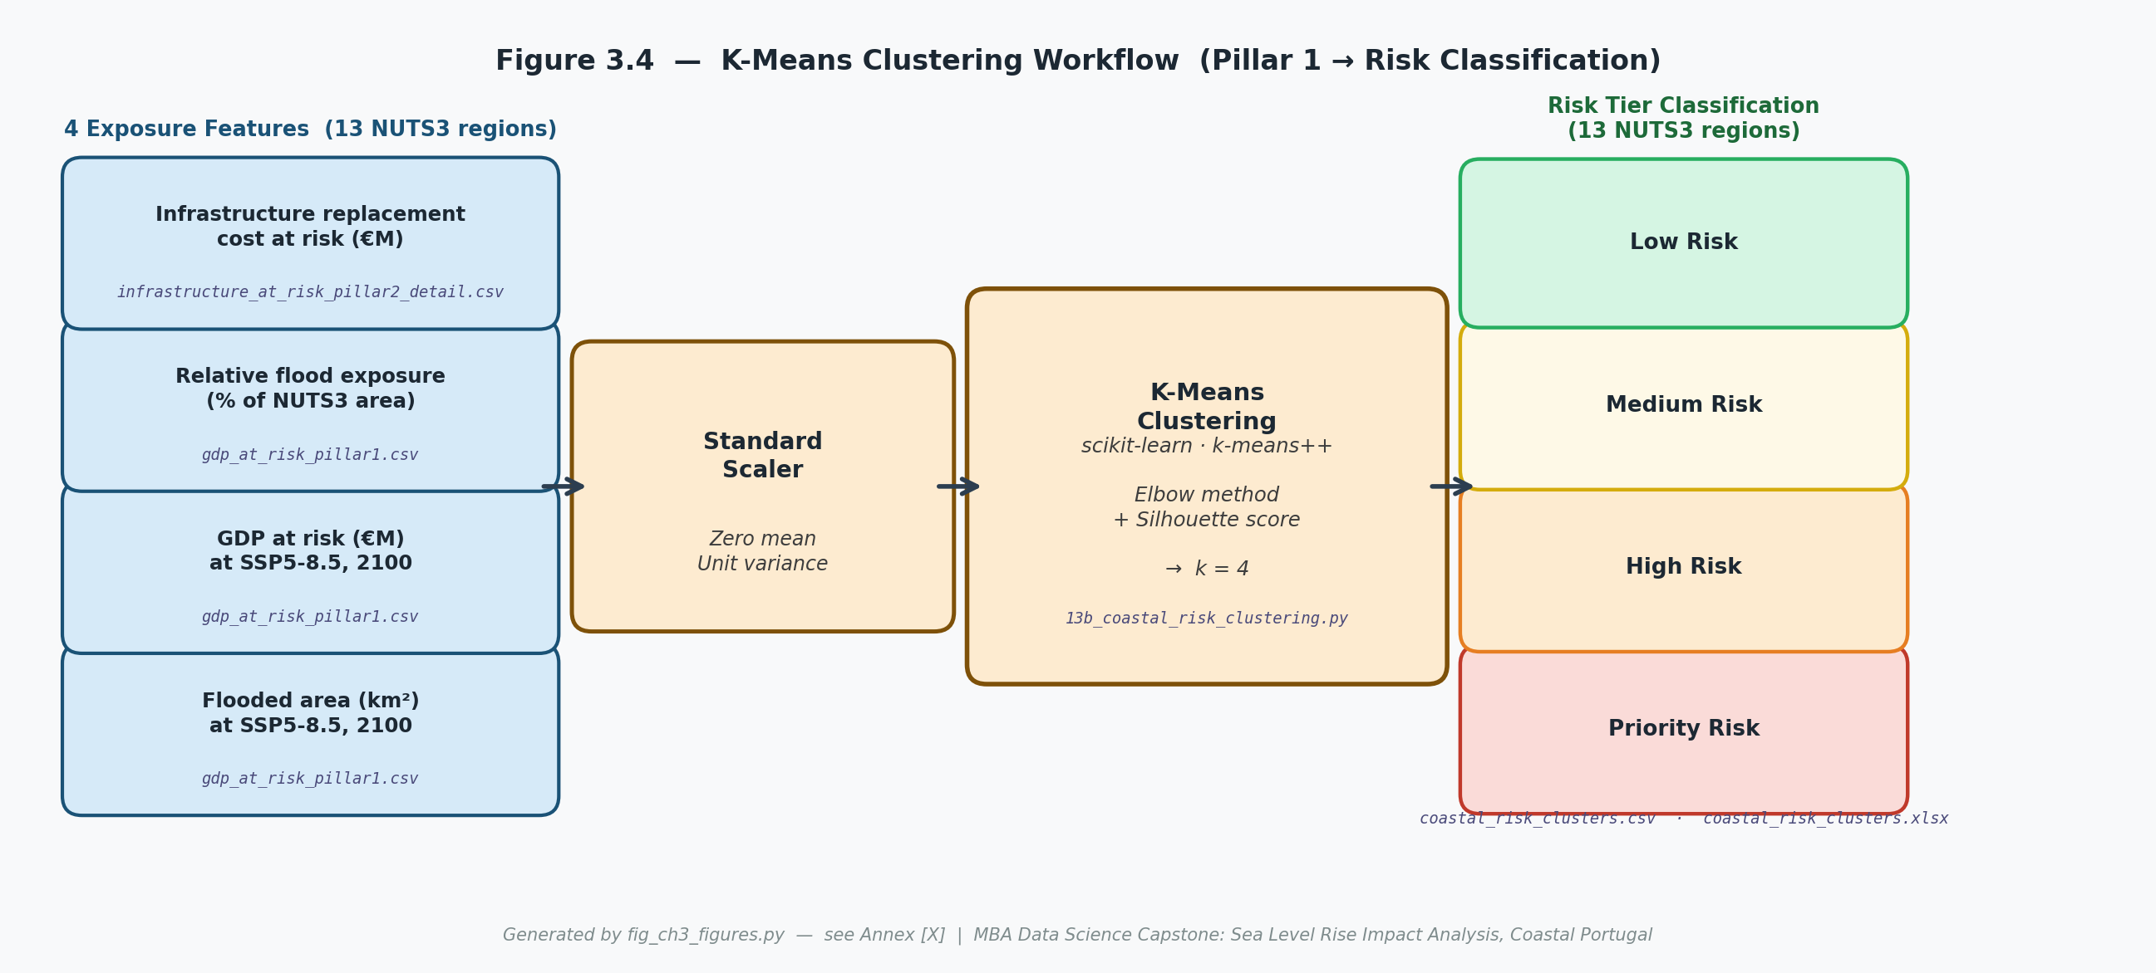
Figure 3.4: K-Means clustering workflow for NUTS3 coastal risk classification. The four exposure features (sourced from gdp_at_risk_pillar1.csv and infrastructure_at_risk_pillar2_detail.csv) are standardised to zero mean and unit variance before clustering. The optimal k = 4 is determined by the elbow method and silhouette scoring. Output files: coastal_risk_clusters.csv and coastal_risk_clusters.xlsx. Generated by fig_ch3_figures.py (see Annex A).

3.8 Statistical Consistency Check: OLS Tide Gauge Trend Analysis
The OLS tide gauge analysis serves as the observational consistency check of the study, assessing whether the post-1993 SLR rate acceleration observed at Portuguese tide gauges is directionally consistent with the IPCC AR6 scenario projections adopted in the Pillar 1 and Pillar 2 analyses. Indicative consistency between observed rates and projected rates strengthens the evidential basis for the scenario selection and grounds the forward-looking projections in the Portuguese observational record.
Annual mean sea level time series are obtained from the PSMSL for Leixões (1956–2022) and Sines (1977–2022). Both series are expressed in millimetres relative to each station’s Revised Local Reference (RLR) datum, which is held constant across datum changes to produce a consistent long-run record. Visual inspection of both series confirms the absence of obvious datum discontinuities or data quality flags that would require exclusion of annual observations. Missing observations, where present, are excluded from the regression without imputation.
Two Ordinary Least Squares (OLS) regression models are estimated for each station, using the statsmodels library (version 0.14). The full-record model regresses annual mean sea level on calendar year over the station’s complete period of record, yielding an estimate of the long-run trend rate (mm/yr) with a 95% confidence interval and p-value for the slope coefficient. The post-1993 model applies the same OLS specification to the subset of observations from 1993 onwards, capturing the trend during the satellite altimetry era and enabling direct comparison with the AR6 projected rate ranges, which are also primarily anchored to the post-1993 period. Heteroscedasticity-consistent (HC3) standard errors are computed for both models to account for any time-varying variance in the sea level residuals.
The post-1993 trend estimates — expressed in mm/yr with 95% confidence intervals — are compared against the IPCC AR6 likely range of global mean SLR rates for each SSP scenario over the corresponding period. A post-1993 rate that falls within the AR6 likely range for at least one scenario provides indicative consistency with projected trends; a rate that substantially exceeds all scenario likely ranges would suggest that the AR6 projections may be conservative for the Portuguese coastal context. It is acknowledged that Portuguese tide gauge trends reflect the combination of global mean SLR, regional dynamic sea level change, and vertical land motion at the gauge site; the comparison with AR6 global projections is therefore indicative rather than definitive, and the discussion of results (Chapter 6) addresses the ocean dynamic and vertical land motion components explicitly.

3.9 Geoid Sensitivity Variant
The +Geoid sensitivity variant is carried through all three pillars as a structural sensitivity test addressing the elevation-reference uncertainty inherent in using a DSM — the Copernicus GLO-30 — as the sole elevation input.
The GLO-30 DEM is referenced to the WGS84 ellipsoid. The geoid — the equipotential surface of Earth’s gravity field that approximates mean sea level — is offset from the ellipsoid by a location-dependent amount known as the geoid undulation N. For mainland Portugal, geoid undulations derived from the EGM2008 global geoid model range from approximately +47 to +53 metres, meaning that ellipsoidal heights must be corrected by subtracting N to obtain orthometric heights (above the geoid). The GLO-30 documentation states that the product is expressed in EGM2008 heights; however, the accuracy of this conversion at coastal margins — where the geoid model is less well-constrained than over open ocean — introduces an elevation uncertainty that is not captured in the standard product accuracy specification. Additionally, time-averaged vertical land motion (subsidence or uplift) at specific coastal locations may cause effective terrain elevations relative to local mean sea level to differ from GLO-30 values by a further 0.05–0.25 metres in parts of the Portuguese coast.
The +Geoid variant addresses this uncertainty by applying an additional +0.15-metre offset to all SLR thresholds used in the inundation analysis. This is equivalent to assuming that the terrain is effectively 0.15 metres lower than the GLO-30 value — a plausible elevation-reference discrepancy consistent with the reported accuracy of EGM2008 at coastal margins and with independently documented subsidence rates at selected Portuguese coastal locations. Recent studies suggest that coastal sea levels derived from geoid-based elevation models systematically underestimate actual measured sea levels, with global mean offsets of approximately 0.24–0.27 m documented across 90% of coastal hazard assessments (Seeger & Minderhoud, 2026); the +0.15 m offset adopted in this study is therefore a conservative lower bound within this documented range. The +0.15-metre choice is not a physical scenario but a sensitivity boundary: it defines an upper bound on the flood exposure estimates that would apply if the GLO-30 elevation values are systematically biased high by this amount. The +Geoid variant is applied consistently to the threshold-to-year mapping in all three pillars, producing a parallel set of exposure, asset replacement cost, and disruption cost estimates that can be compared directly against the baseline (no geoid offset) scenario results. The adjustment is applied to SLR thresholds rather than to DEM elevations, maintaining internal consistency across the pipeline.

3.10 Visualisation and Reproducibility
Five interactive dashboards are published on the Tableau Public platform, providing non-specialist access to the study’s core results across scenarios, time horizons, and spatial scales. Dashboard 1 presents the geospatial flood exposure maps as an animated SLR slider, allowing users to visualise the progression of inundation extent across the twenty SLR thresholds for any selected scenario, with NUTS3 boundaries overlaid for spatial orientation. Dashboard 2 shows GDP and infrastructure asset replacement cost at risk as time-series curves from 2025 to 2100, with separate lines for each scenario and the geoid variant, enabling direct visual comparison of trajectories. Dashboard 3 presents the compound flood closure frequency and cumulative disruption cost for each of the eight Pillar 3 infrastructure sections, with scenario and discount rate selectable via filter controls. Dashboard 4 displays the K-Means risk tier classification of the twelve coastal NUTS3 regions as a choropleth map, with interactive labelling of cluster membership and feature values. Dashboard 5 shows the adaptation break-even curves for each section under all combinations of scenario and discount rate, with the section’s indicative CAPEX shown as a horizontal reference line.
All analytical scripts, parameter files, and calibration decisions are documented in full. The Python geospatial pipeline, K-Means classification, and OLS analysis are available as structured Jupyter notebooks with inline commentary. The Node.js document generation scripts for all chapters are version-controlled and commented to identify the source of each data value used in the text. All primary data sources — GLO-30, NUTS3 boundaries, PSMSL tide gauge records, OSM, PORDATA regional GDP, and AR6 projection tables — are publicly accessible under open licences, and retrieval scripts are provided to ensure that the exact dataset versions used in the analysis can be reconstructed by any researcher with internet access. This reproducibility framework is consistent with the open science principles increasingly required by European research funders and provides a direct template for application of the methodology to other national coastal contexts.

