Chapter 4: Results

4.1 Chapter Overview
This chapter presents the empirical results of the three-pillar analytical framework described in Chapter 3. Pillar 1 — Economic Exposure — quantifies the GDP associated with land that would be inundated at successive sea-level rise (SLR) thresholds, expressed both as a static snapshot (area flooded) and as an economic flow (GDP at risk). Pillar 2 — Asset Exposure — estimates the replacement cost of physical infrastructure — buildings, roads, railways, and utility networks — located within the inundation zone. Pillar 3 — Critical Infrastructure Disruption Risk — applies the compound flood disruption model (Moftakhari et al., 2017) to eight identified vulnerable sections of the national road, rail, and port network, quantifying cumulative economic disruption over the 2025–2100 horizon. Results are presented for three IPCC AR6 scenarios (SSP1-2.6, SSP2-4.5, SSP5-8.5) and, where applicable, for the +0.15 m geoid offset sensitivity variant.
The chapter also presents two supplementary cross-cutting analyses that extend the core pillars: an unsupervised K-Means risk classification of the twelve coastal NUTS3 regions (Section 4.5), and an ordinary least squares (OLS) regression analysis of Portuguese tide gauge records used to assess indicative consistency between observed Portuguese sea level trends and the IPCC AR6 scenario framework (Section 4.6). Interactive visualisation of all results is available via five Tableau Public dashboards; links to each dashboard are provided in the project supplementary materials.
All numerical results reported in this chapter are derived from the analytical pipeline described in Chapter 3. The headline result is that cumulative disruption to critical infrastructure under the high-emissions scenario reaches €130.1 billion (order-of-magnitude estimate under the central k₂ = 6.93 m⁻¹ assumption; mid cost variant, 2025–2100, no adaptation, SSP5-8.5/Baseline), rising to €216.9 billion under the +Geoid sensitivity variant. This figure is scenario- and k-dependent: the full k sensitivity range spans €40 billion (k₁ ≈ 5 m⁻¹) to in excess of €500 billion (k₃ ≈ 10 m⁻¹), as reported in Table 3.2. The central k₂ estimate is used throughout this chapter as the reference no-adaptation baseline against which adaptation investments are evaluated in Chapter 5.

4.2 Pillar 1 — Economic Exposure
Pillar 1 applies the static bathtub inundation model to the Copernicus GLO-30 DEM across the twenty SLR thresholds generated by linear interpolation of IPCC AR6 anchor values (Section 3.3). For each threshold, the model counts pixels at or below the SLR level and intersects them with NUTS3 boundaries to assign GDP at risk using 2022 INE regional GDP data. The static inundation potential is a simplified first-order screening approach; it does not incorporate storm surge or hydrodynamic routing but is appropriate for the regional exposure assessment undertaken here. Results should be interpreted as indicative exposure estimates rather than precise flood boundary delineations.
Table 4.1 summarises flood area and GDP at risk at key horizon years across all three scenarios and both variants. Under the low-emissions scenario (SSP1-2.6), 90.6 km² of coastal land is within the static inundation potential zone by 2100, with €1.16 billion of GDP at risk. Under the high-emissions scenario (SSP5-8.5), this grows to 339.8 km² and €5.30 billion respectively. The geoid offset variant amplifies these figures materially at all horizons: at 2100 under SSP5-8.5, applying the additional +0.15 m threshold increases flood area by 56.4 km² (+16.6%) and GDP at risk by €1.05 billion (+19.8%). The proportional impact of the geoid correction is most pronounced in the near term: under SSP5-8.5 in 2030, where baseline SLR is only 0.13 m, the +0.15 m correction translates to a 153.7% increase in flooded area (from 21.9 to 55.6 km²).
Table 4.1: Static inundation potential (flood area km²) and GDP at risk (€bn) by scenario and year, baseline and +Geoid variants. GDP values are derived from 2022 INE regional GDP data allocated proportionally to flooded pixels within each NUTS3 region. All values reference the 2020 sea level baseline.
Scenario | Year | Baseline  Area (km²) | +Geoid  Area (km²) | Baseline  GDP (€bn) | +Geoid  GDP (€bn) | Δ GDP (%)
SSP1-2.6 | 2030 | 11.3 | 40.9 | 0.12 | 0.50 | +306.7
 | 2050 | 36.5 | 75.5 | 0.43 | 0.95 | +118.1
 | 2075 | 60.9 | 107.2 | 0.75 | 1.41 | +87.6
 | 2100 | 90.6 | 157.0 | 1.16 | 2.03 | +74.8
SSP2-4.5 | 2030 | 16.6 | 48.5 | 0.19 | 0.60 | +215.6
 | 2050 | 60.9 | 107.2 | 0.75 | 1.41 | +87.6
 | 2075 | 107.2 | 176.2 | 1.41 | 2.35 | +66.1
 | 2100 | 176.2 | 234.1 | 2.35 | 3.37 | +43.7
SSP5-8.5 | 2030 | 21.9 | 55.6 | 0.25 | 0.69 | +173.4
 | 2050 | 90.6 | 157.0 | 1.16 | 2.03 | +74.8
 | 2075 | 214.5 | 274.3 | 3.00 | 4.11 | +37.0
 | 2100 | 339.8 | 396.2 | 5.30 | 6.35 | +19.8

Several structural patterns emerge from Table 4.1. First, GDP at risk grows roughly proportionally with flooded area and slightly accelerates at higher SLR thresholds: under SSP5-8.5, the implied GDP density of flooded land (GDP per km²) increases from approximately €11.4 M/km² in 2030 to €15.6 M/km² in 2100, indicating that progressively higher inundation thresholds reach the more economically dense peri-urban and estuarine-fringe zones of Grande Lisboa. This is consistent with the spatial distribution of economic activity within coastal Portugal: the lowest-lying agricultural and tidal land has a lower GDP density than the developed coastal fringe immediately above it, so marginal GDP at risk per additional centimetre of SLR increases rather than decreases as the scenario severity rises.
Second, the geoid correction has a disproportionately large effect in the near term. At 2030, where baseline SLR is only 0.07–0.13 m, the +0.15 m offset more than doubles the effective threshold in all scenarios, producing area increases of 154–261%. By 2075–2100, the additional 0.15 m is proportionally smaller relative to baseline SLR of 0.30–1.00 m, and the incremental area effect narrows to 17–76%. This pattern implies that near-term decisions based solely on the IPCC AR6 baseline trajectories may underestimate the urgency of early adaptation measures in low-lying sections that are already close to the current mean high water mark.
Figure 4.1 provides the spatial context for the SSP5-8.5/2100 scenario — the most exposed outcome — rendered from the technical animation pipeline with a statistics overlay showing the SLR level, inundated area, and the date at which each 30 m pixel first enters the static inundation zone. The figure reveals pronounced spatial heterogeneity: the Tagus and Sado estuaries, the Aveiro Ria system, and the Mondego valley floor account for the bulk of inundation extent, while the elevated limestone and granite terrain of the Alentejo and northern interior coast remains almost entirely unaffected at all scenarios.
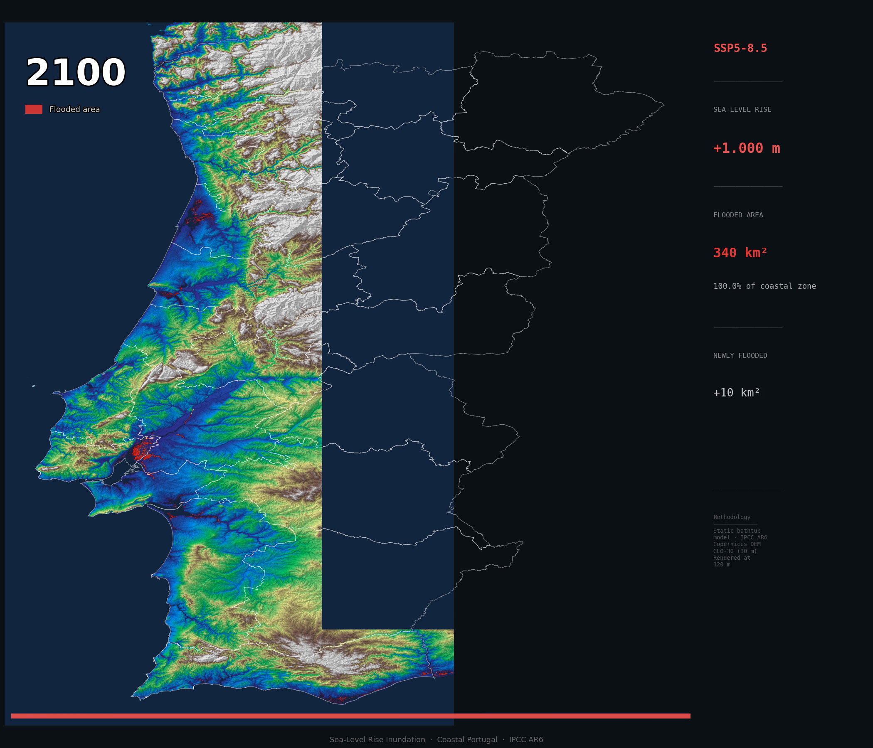
Figure 4.1: Static inundation potential under SSP5-8.5 at the 2100 horizon (SLR = +1.00 m above 2020 baseline). Colours indicate the year in which each 30 m cell first enters the inundation zone under this scenario. 339.8 km² of coastal land is within the static inundation potential zone; GDP at risk = €5.30 billion under baseline assumptions. NUTS3 boundaries overlaid. Generated by 09_flood_animation.py (technical frame).
Grande Lisboa dominates the economic exposure results throughout the analysis. At SSP5-8.5/2100, the region accounts for €4.48 billion of the total €5.30 billion national GDP at risk (84.5%), reflecting the high GDP density within the Tagus floodplain and the relatively low elevation of key industrial and logistics districts south of the Tagus estuary. The Aveiro, Setúbal, and Algarve NUTS3 regions contribute the remaining exposure, with all other coastal regions individually contributing less than €0.05 billion under the baseline scenario. This geographic concentration has direct implications for adaptation prioritisation and is explored further in the risk classification results of Section 4.5.

4.3 Pillar 2 — Asset Exposure
Pillar 2 quantifies the replacement cost of physical infrastructure assets that lie within the static inundation zone identified in Pillar 1. The analysis uses OpenStreetMap road and railway geometry intersected with the Copernicus GLO-30 DEM to identify segments below each SLR threshold, and applies Portuguese construction cost benchmarks (INE 2025) and utility network unit costs to estimate replacement values. Building exposure is derived from an estimated building count within the flooded zone, applying NUTS3 regional average building density (INE Census 2021), a 2.5-storey floor area multiplier, and a unit construction cost of €1,950/m² (INE, 2025), consistent with the methodology described in Section 3.5. All Pillar 2 outputs represent static exposure — the cost to replace assets if permanently inundated — and should be interpreted as an upper-bound structural vulnerability indicator rather than a forecast of actual flood damage.
Table 4.2 presents the total asset replacement cost at 2100 by scenario and asset category. Buildings dominate the exposure in all scenarios, representing more than 99% of total replacement cost at all SLR levels. Roads, railways, and utilities each contribute small but non-negligible amounts, primarily through subsurface utility networks co-located with road infrastructure in low-lying coastal settlements.
Table 4.2: Asset replacement cost by category and scenario at the 2100 horizon (IPCC AR6 baseline). Buildings: INE 2025 construction cost (€1,950/m²) × storey multiplier × NUTS3 floor area assumption. Roads/railways: OSM geometry × unit replacement cost. Utilities: road-length proxy for water, sewage, and electricity infrastructure bundle.
Category | SSP1-2.6  2100 (€bn) | SSP2-4.5  2100 (€bn) | SSP5-8.5  2100 (€bn) | SSP5-8.5  +Geoid (€bn)
Buildings | 20.15 | 40.09 | 82.01 | 94.25
Roads | 0.10 | 0.30 | 0.37 | 0.38
Railways | 0.06 | 0.07 | 0.21 | 0.21
Utilities | 0.08 | 0.14 | 0.25 | 0.26
TOTAL | 20.39 | 40.59 | 82.84 | 95.10

Under SSP5-8.5 at 2100, the total estimated asset replacement cost reaches €82.84 billion (baseline) or €95.10 billion (+Geoid), representing approximately 40% of Portugal’s 2022 GDP. This is a structural vulnerability figure — the total stock of assets that would require replacement if permanently inundated — and should not be confused with expected annual flood damage or with the cumulative disruption costs reported in Pillar 3. Buildings alone account for €82.01 billion, with approximately 99,244 building units within the SSP5-8.5/2100 inundation zone under the baseline scenario (113,941 under +Geoid). The building estimate is sensitive to the assumed storey multiplier: a 50%-low density sensitivity scenario (06b_sensitivity.py) reduces the buildings component by approximately €40 billion, underlining the importance of the building count assumption as the primary source of Pillar 2 uncertainty.
Road infrastructure at risk totals 343.8 km under SSP5-8.5/2100 (replacement cost €372 million), and railway exposure reaches 41.2 km (€206 million). Utility network exposure (€250 million) is estimated as a pro-rata bundle of water, sewage, and electricity infrastructure co-located with exposed road segments. The OSM road and railway segments identified by the spatial analysis have been cross-checked against Infraestruturas de Portugal network records and are judged to provide a sufficiently complete picture for regional-scale screening purposes, though the OSM dataset may underrepresent minor access roads and private tracks in rural coastal areas.
The geoid variant increases total asset exposure by €12.3 billion (+14.8%) at SSP5-8.5/2100 — a proportionally larger sensitivity than the 16.6% area increase reported in Pillar 1, suggesting that the additional inundation zone under the +Geoid variant is concentrated in peri-urban areas around the Tagus estuary, where building densities are above the national coastal average. This asymmetry between area and value sensitivity reinforces the case for treating the geoid variant as a structurally important risk dimension rather than a minor adjustment.

4.4 Pillar 3 — Critical Infrastructure Disruption Risk
Pillar 3 applies the compound flood disruption model to eight infrastructure sections identified as vulnerable through the Stage 1 spatial analysis. The model follows the compound flood frequency framework of Moftakhari et al. (2017), operationalised here as a simplified exponential scaling in which flood return periods are assumed to halve with each additional 10 cm of SLR — a rate consistent with the empirical range they report for low-lying coastal sites. The default decay parameter k = ln(2)/0.10 ≈ 6.93 m⁻¹ is applied where section-specific hydrological records are insufficient to calibrate a site-specific value; this default is consistent with the empirical range reported by Moftakhari et al. (2017). The model translates each section’s baseline flood return period into an annual closure frequency that grows exponentially as sea levels rise. Annual closure days are capped at 365 per section to maintain physical plausibility; once this cap is reached, a section is effectively non-functional under that scenario. It should be noted that this cap represents model saturation — a mathematical ceiling on projected closure frequency — rather than a literal prediction of year-round closure. In practice, infrastructure managers would be expected to implement operational or structural adaptations before this threshold is reached; the 365-day cap should therefore be interpreted as an upper-bound condition under a no-adaptation assumption, not as a physical inevitability. Cumulative disruption costs are summed annually from 2025 to the reporting year without NPV discounting, providing a transparent nominal cost estimate that is directly comparable across sections and scenarios.
Two structural features of the disruption model determine the character of the results presented in this section. First, all Pillar 3 results are generated under a no-adaptation baseline assumption: no structural or operational intervention is modelled, and disruption accumulates unimpeded as sea levels rise. This framing is deliberate — it establishes the maximum plausible cost against which adaptation investments are evaluated in Chapter 5 — but it should not be read as a forecast of likely outcomes. Second, the compound flood mechanism means that disruption costs are threshold-driven rather than proportional to SLR. Small increments in sea level produce disproportionately large increases in closure frequency once a section approaches its critical elevation threshold, generating the convex cost profiles visible across all high-emissions scenarios. Risk is therefore not linearly distributed across the 2025–2100 horizon: a substantial share of cumulative cost accrues in the final two decades of the study period, when SLR under SSP5-8.5 begins to intersect the critical elevation thresholds of the more elevated sections.
The eight sections span three infrastructure types — railway, port, and road — and are distributed across the principal coastal corridors of mainland Portugal. Section-specific parameters (elevation, baseline return period, closure duration, and daily disruption rate) were derived from the Stage 1 DEM and OSM analysis and from the hydrological and transport economics literature. Table 4.3 provides the parameter summary for all eight sections.
Table 4.3: Pillar 3 section parameters. Elevation: DEM-sampled minimum section elevation (m above 2020 MSL). RP₀: baseline (2020) flood return period (years). Closure days: expected consecutive closure days per flood event. Disruption Metric (mid): mid-estimate disruption cost (€/day for rail and road sections; CDDR % for ports); LOW = ×0.50; HIGH = ×1.75 of mid. †Port sections apply the Cargo Daily Disruption Rate (CDDR) framework at 3–5% of throughput value per disruption day rather than a fixed €/day figure; the — in the Closure Days column reflects that port disruption duration is operationalised through throughput loss, not discrete closure events.
Section | Type | Elev.  (m) | RP₀  (yr) | Closure  Days | Disruption  Metric (mid)
Mondego (Alfarelos–Formoselha) | Railway | 1.0 | 4 | 5.0 | €1,000,000
Tagus (Castanheira–Alverca) | Railway | 2.0 | 10 | 4.0 | €1,500,000
Aveiro Ria (Zone A+B) | Railway | 0.7–1.2 | 3–7 | 3.5–6.0 | €1,200,000
Port of Leixões | Port | 3.0 | 20 | — | CDDR (3–5%)
Port of Lisbon | Port | 2.7 | 10 | — | CDDR (3–5%)
Port of Setúbal | Port | 2.5 | 12 | — | CDDR (3–5%)
Vasco da Gama Bridge (south) | Road | 1.5 | 8 | 1.5 | €1,800,000
A1 Motorway (Azambuja sector) | Road | 2.5 | 20 | 2.5 | €2,500,000

4.4.1 Railway Network
The three railway sections on the Linha do Norte — the spine of the Portuguese national rail network — represent the highest concentration of vulnerability in the Pillar 3 analysis. ADFERSIT (2021) records approximately 730 train movements per day using at least part of the Linha do Norte, with section-level counts ranging from 66 at Aveiro–Ovar to 112 at the Tagus floodplain corridor; the Portuguese Government (2022) and ADFERSIT (2021) confirm that approximately 90% of the country’s rail freight trains operate at least partially on this corridor. All three sections are served by identical long-distance services (Alfa Pendular, up to 11 daily return services, 301 seats; Intercidades, approximately 7 daily return routes), meaning a closure at any section suspends the full Lisbon–Porto intercity corridor.
The Mondego section (Alfarelos–Formoselha, km 240–244) occupies approximately 3 km of track through the Mondego floodplain at an elevation of approximately 1.0 m above MSL. The current flood return period is estimated at 4 years based on the documented history of periodic inundation at this site. Each closure event is expected to last approximately 5 days. The base DDR of €1,000,000/day reflects costs associated with approximately 7,100 passengers per day requiring alternative transport — derived from 72 section-level train movements per day (ADFERSIT, 2021) multiplied by AMT (2022, 2024) average occupancy rates by service type — together with freight delay costs and business productivity losses. The compound flood model projects that by mid-century under SSP5-8.5, annual closure days at the Mondego section will exceed 30 days, rising to the 365-day physical cap by 2089 under baseline conditions. Cumulative disruption cost from 2025 to 2100 under SSP5-8.5/Baseline/mid is €13.31 billion.
The Tagus floodplain section (Castanheira do Ribatejo–Alverca, km 37–47) is a 10 km corridor through the Tagus alluvial valley at approximately 2.0 m elevation. The higher baseline elevation relative to the Mondego section translates to a longer initial return period (10 years), but the section’s proximity to the Lisbon metropolitan area amplifies the economic cost of each closure: the DDR of €1,500,000/day reflects the Mondego baseline plus an additional €450,000/day contribution from a passenger base approximately four times larger than Mondego: the section records 112 train movements per day (ADFERSIT, 2021), of which approximately 80 are Lisboa suburban services; applying AMT (2022, 2024) average occupancy rates by service type yields approximately 27,000 passengers per day, of whom roughly 22,000 are commuters on the Sintra/Azambuja suburban line. Compound flooding driven by coincident storm surge, elevated Tagus river discharge, and high spring tides has a documented history of catastrophic inundation at this site (Fernández-Nóvoa et al., 2024), and its frequency is projected to increase exponentially with SLR (Moftakhari et al., 2017). Cumulative disruption cost under SSP5-8.5/Baseline/mid is €13.37 billion.
The Aveiro Ria section (approximately km 251–275) is the most exposed of the three railway sections, producing the largest individual cumulative cost (€30.00 billion) of any section in the analysis. The section is modelled as two distinct sub-zones: Zone A (elevation ≈1.2 m, RP₀ = 7 years) and Zone B (elevation ≈0.7 m, RP₀ = 3 years), reflecting the gradient of coastal exposure along the Ria de Aveiro shoreline. The Zone B corridor is at risk of barrier breach of the Barra–Costa Nova coastal barrier under sufficiently large SLR, which is modelled as a binary threshold event that transitions Zone B to a 365-day permanent closure regime (Lopes et al., 2011). The combined Zone A+B DDR of €1,200,000/day reflects the Porto suburban commuter premium: the Aveiro section lies 60 km from Porto Campanhã and, applying AMT (2022, 2024) occupancy rates to the 66 section-level train movements per day recorded by ADFERSIT (2021), carries approximately 8,800 passengers per day — roughly 1,700 more than the Mondego section. This figure is considered a conservative lower bound: the ADFERSIT (2021) baseline predates subsequent suburban service expansions on the Porto–Aveiro corridor, and actual daily ridership — driven primarily by commuter traffic between Aveiro and Porto — is likely higher than the methodology-derived estimate. The 24 km section length (versus 3 km at Mondego) also raises combined Zone A+B expected costs. Annual closure days under SSP5-8.5/+Geoid reach the combined cap (730 days/year across both zones) well before 2100. Total cumulative cost under SSP5-8.5/Baseline/mid is €30.00 billion.
The 2026 storm season provides supporting empirical context for the model’s section selection. Storm Kristin (January 2026), followed by storms Leonardo and Marta, flooded the Mondego section (Alfarelos–Formoselha) on multiple occasions, suspending Alfa Pendular and Intercidades services for the full Lisbon–Porto corridor (The Portugal Post, 2026). The Tagus section (Castanheira–Alverca) was also suspended on 5 February 2026 due to floodplain inundation (Renascença, 2026). The combined economic footprint included 48-hour supply chain delays across northern and central Portugal, with an emergency infrastructure repair budget of approximately €400 million discussed by the Portuguese government (The Portugal Post, 2026b). Infraestruturas de Portugal subsequently confirmed it was investigating elevation of the Mondego track as part of a €35 million reinforcement programme (Renascença, 2026). These events are consistent with the model’s section geography and suggest that the MID daily disruption rate is plausible as an order-of-magnitude estimate; they do not constitute a formal quantitative validation of the compound flood model.

4.4.2 Port Network
Three of Portugal’s principal commercial ports — Leixões, Lisbon, and Setúbal — are included in the Pillar 3 analysis. Sines, the fourth major port, is excluded because its quay infrastructure sits at 5–7 metres above MSL, well above the maximum scenario SLR of 1.15 m (SSP5-8.5/+Geoid/2100), and flooding would only affect ancillary landside facilities under the most extreme combined conditions. Under high emissions, Sines may consequently serve as a relative resilience asset for cargo diversion from affected facilities.
Port disruption cost is estimated using the Cargo Daily Disruption Rate (CDDR) framework, which applies a daily disruption penalty as a fraction of cargo throughput value rather than directly valuing cargo at risk. This approach is preferred over a cargo value method because most cargo is delayed rather than lost during a port disruption, and the Suez Canal blockage evidence suggests that a rate of 3–5% of throughput per day is the appropriate measure of combined economic penalty (Tran et al., 2025). Adaptation options for ports are evaluated in Chapter 5 on a savings-based break-even basis, comparing adaptation CAPEX against the present value of avoided disruption cost.
The Port of Leixões (quay elevation approximately 3.0 m, RP₀ = 20 years) is Portugal’s largest container port and the primary northern Atlantic gateway. Its higher quay elevation provides a longer delay before disruption onset compared to the Lisbon and Setúbal ports, but its elevation of 3.0 m remains within the SSP5-8.5/+Geoid exposure envelope. Cumulative disruption cost under SSP5-8.5/Baseline/mid is €10.47 billion, rising to €24.0 billion under +Geoid. Adaptation investment options for this section are evaluated in Chapter 5.
The Port of Lisbon (quay elevation approximately 2.7 m, RP₀ = 10 years) is the largest contributor to port disruption cost in the analysis, reflecting its lower elevation and the high economic value of cargo transiting the Tagus estuary gateway. Cumulative disruption cost under SSP5-8.5/Baseline/mid is €27.28 billion, rising to €43.1 billion under +Geoid. Note that the Tagus barrier programme evaluated for the Tagus railway section would simultaneously provide significant protection to the Port of Lisbon landside infrastructure, representing a shared infrastructure investment opportunity discussed further in Chapter 5.
The Port of Setúbal (quay elevation approximately 2.5 m, RP₀ = 12 years) serves an economically distinctive cargo mix, with AutoEuropa (Volkswagen) export vehicles and JIT (just-in-time) manufactured goods representing an estimated 45% of cargo value. Cumulative disruption cost under SSP5-8.5/Baseline/mid is €17.69 billion, rising to €29.0 billion under +Geoid. Adaptation investment options for this section are evaluated in Chapter 5.
Across all three ports, cumulative disruption cost under SSP5-8.5/Baseline totals €55.45 billion (mid), rising to €96.17 billion under +Geoid. The port network thus represents the largest single sectoral contributor to total Pillar 3 disruption cost, accounting for 42.6% of the €130.1 billion no-adaptation SSP5-8.5/Baseline headline figure.

4.4.3 Road Network
Two road sections are included in the Pillar 3 analysis, both located in the Tagus valley corridor south of Lisbon: the Vasco da Gama Bridge south approach and the A1 Motorway Azambuja sector.
The Vasco da Gama Bridge south approach is modelled from the Tagus Natural Reserve crossing to the interchange at Montijo (road elevation approximately 1.5 m, RP₀ = 8 years). Only the south approach is modelled; the north approach runs on an elevated viaduct and is not flood-vulnerable. A DDR of €1,800,000/day reflects the high traffic volume on this key Lisbon bypass route. Cumulative disruption cost under SSP5-8.5/Baseline/mid is €7.08 billion, rising to €11.6 billion under +Geoid. Adaptation investment options for this section are evaluated in Chapter 5.
The A1 Motorway Azambuja sector was subject to DEM and OSM geographic verification, which corrected an initial estimate of ~35 km of vulnerable road to approximately 12 km across two sub-sections: Section 1 (Aveiras de Baixo–Azambuja, km 45–55, ~8.0 km, elevation 2.4–4.9 m MSL) and Section 2 (north of Azambuja, km 55–58, ~3.2 km, elevation 3.4–5.0 m). The modelled section crown elevation of 2.50 m is consistent with the DEM-sampled lowest point of 2.4 m. The A1 carries approximately 55,000 vehicles per day at the Azambuja section (approximately 30% HGV), justifying the DDR of €2,500,000/day (Infraestruturas de Portugal, 2023). The higher elevation (2.50 m vs 1.50 m for VdG) and longer return period (RP₀ = 20 years vs 8 years) delay the onset of significant disruption, but the higher DDR and longer section produce a cumulative cost under SSP5-8.5/Baseline/mid of €10.91 billion, rising to €22.2 billion under +Geoid. Adaptation investment options for this section are evaluated in Chapter 5.

4.4.4 Aggregate Cross-Section Comparison
Table 4.4 summarises cumulative disruption costs and annual disruption costs at 2100 for all eight sections under SSP5-8.5/Baseline/mid, together with the cross-scenario totals. The headline figure is a cumulative disruption cost across all sections from 2025 to 2100, assuming no adaptation investment, of €130.11 billion (SSP5-8.5/Baseline/mid). Under the +Geoid sensitivity variant this rises to €216.9 billion. The uncertainty range spans approximately €65 billion (LOW estimate) to €227 billion (HIGH estimate) for the SSP5-8.5/Baseline scenario, reflecting the DDR uncertainty bands across all sections.
Table 4.4: Cumulative disruption cost 2025–2100 and annual disruption cost at 2100, all sections, SSP5-8.5/Baseline/mid. Annual figures at 2100 reflect the modelled compound flood frequency at SLR = +1.00 m, capped at 365 days/year per section. The Aveiro Ria section is modelled as two independently capped sub-zones (Zone A and Zone B), each with a separate 365-day annual ceiling; the annual cost of €876 M/yr reflects the combined Zone A+B total, with both zones independently reaching their cap under SSP5-8.5. Cross-scenario totals (final three rows) are summed across all eight sections.
Section | Type | Cumul. 2100  (€bn) | Annual 2100  (€M/yr)
Aveiro Ria (Zone A+B) | Railway | 30.00 | 876
Lisbon port | Port | 27.28 | 1,278
Setúbal port | Port | 17.69 | 913
Tagus floodplain | Railway | 13.37 | 548
Mondego | Railway | 13.31 | 365
Leixões port | Port | 10.47 | 922
A1 Azambuja | Road | 10.91 | 960
VdG south approach | Road | 7.08 | 365
ALL SECTIONS (SSP5-8.5/Baseline/mid) | All | 130.11 | 6,227
ALL SECTIONS (SSP5-8.5/+Geoid/mid) | All | 216.88 | —
ALL SECTIONS (SSP2-4.5/Baseline/mid) | All | 21.49 | —
ALL SECTIONS (SSP1-2.6/Baseline/mid) | All | 5.93 | —

Several cross-cutting findings emerge from Table 4.4. First, the Aveiro Ria section is the single largest cost contributor at €30.0 billion — exceeding even the Port of Lisbon (€27.3 billion) — primarily because both Zone A and Zone B reach the 365-day closure cap independently under SSP5-8.5, doubling the effective annual ceiling. This result is sensitive to the barrier breach assumption: without the binary breach threshold for Zone B, Aveiro’s cumulative cost would be materially lower. The binary transition is a stylised threshold condition; in reality, degradation of the Barra–Costa Nova coastal barrier would likely be progressive rather than instantaneous, with partial operational continuity plausible during an intermediate phase. The Aveiro Ria cumulative cost estimate should accordingly be interpreted as an upper-bound scenario for this section under a no-adaptation assumption. A progressive degradation model would produce a lower cost trajectory, with the final total depending on the rate of barrier deterioration and the timing of any adaptive intervention. Second, the port network collectively accounts for €55.45 billion (42.6% of the total), the railway network for €56.68 billion (43.6%), and the road network for €17.99 billion (13.8%). Third, the cross-scenario contrast is stark: SSP2-4.5 cumulative costs (€21.5 billion) are only 16.5% of SSP5-8.5 costs (€130.1 billion), while SSP1-2.6 costs (€5.9 billion) are only 4.6% of the high-emissions scenario. This non-linearity reflects the exponential structure of the compound flood model: at lower SLR levels, most sections remain far from their physical capacity cap, and annual costs grow roughly proportionally to flood frequency; at higher SLR levels, sections begin hitting the cap and costs flatten at their sectoral maximum. The scenario contrast therefore substantially understates the true convexity of the risk function at intermediate SLR levels.

4.5 Unsupervised Risk Classification
A K-Means unsupervised clustering algorithm is applied to the twelve coastal NUTS3 regions included in the analysis to produce a data-driven risk tier classification that integrates all four Pillar 1 and Pillar 2 exposure dimensions simultaneously. The four features used are: flooded pixels at SSP5-8.5/2100 (flood extent proxy), GDP at risk at SSP5-8.5/2100 (economic exposure), fraction of total NUTS3 area flooded (relative flood intensity), and total infrastructure replacement cost at SSP5-8.5/2100 (asset exposure). Features are log1p-transformed (log(1 + x), which handles zero-valued regions and corrects right-skewed distributions) and standardised using z-score normalisation before clustering.
Elbow analysis and silhouette score assessment indicate a statistical optimum of k = 2 clusters; however, k = 4 is selected on the basis that two clusters would produce a binary ‘Lisboa vs rest’ classification with limited policy utility. Four clusters provide actionable granularity, separating the high-exposure regions into meaningful tiers while preserving statistical coherence (silhouette score at k = 4 = 0.414). This calibration decision is documented explicitly in the analysis script. Given the small sample size (n = 12), clustering results are interpreted as heuristic risk tiers rather than statistically robust groupings.
Table 4.5 presents the four risk tiers with their constituent NUTS3 regions and cluster-level feature values. Figure 4.2 shows the clustering output as a scatter plot of GDP at risk versus infrastructure value, with clusters colour-coded by risk tier.
Table 4.5: K-Means risk tier classification of coastal NUTS3 regions (SSP5-8.5/2100, k = 4). GDP at risk and infrastructure values are the actual regional values used as clustering features. Fraction flooded is expressed as a percentage of total NUTS3 land area.
Risk Tier | NUTS3 Region(s) | GDP at Risk  (€bn) | Infra Value  (€bn) | Fraction  Flooded (%)
Priority Risk | Grande Lisboa | 4.478 | 65.31 | 5.93
High Risk | Região de Aveiro | 0.301 | 7.44 | 3.46
 | Península de Setúbal | 0.196 | 5.72 | 1.48
 | Algarve | 0.112 | 5.45 | 0.94
Moderate Risk | Região de Coimbra | 0.047 | 0.90 | 0.51
 | Lezíria do Tejo | 0.045 | 0.50 | 0.98
 | Área Metropolitana do Porto | 0.039 | 0.82 | 0.10
 | Alentejo Litoral | 0.020 | 0.29 | 0.63
 | Oeste | 0.012 | 0.24 | 0.18
 | Alto Minho | 0.008 | 0.08 | 0.19
 | Cávado | 0.007 | 0.11 | 0.08
Low Risk | Região de Leiria | <0.001 | <0.001 | <0.01

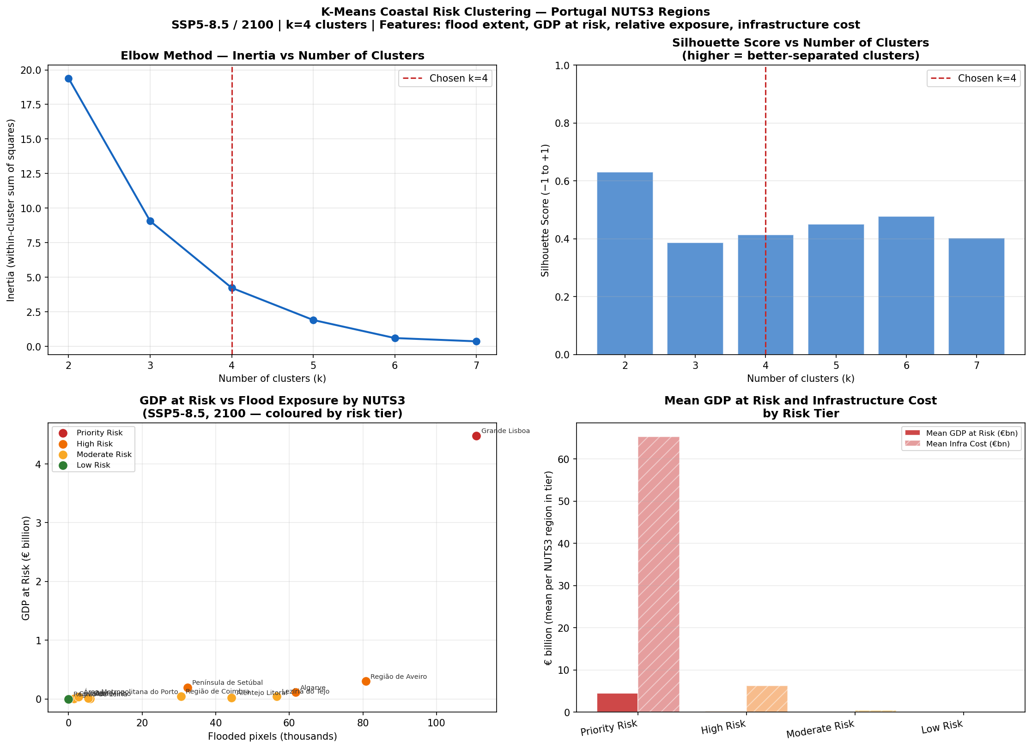
Figure 4.2: K-Means risk tier classification of twelve coastal NUTS3 regions (SSP5-8.5/2100, k = 4). Horizontal axis: GDP at risk (€bn); vertical axis: total infrastructure replacement cost (€bn). Cluster colour: red = Priority Risk, orange = High Risk, yellow = Moderate Risk, green = Low Risk. Log1p transformation applied to both axes for visualisation. Generated by 13b_coastal_risk_clustering.py.
The clustering output reveals a clear one-to-two order-of-magnitude separation between Grande Lisboa (Priority Risk) and all other regions on both the GDP and infrastructure dimensions. Grande Lisboa’s €65.3 billion infrastructure replacement cost is approximately 8.8 times that of the nearest High Risk region (Aveiro, €7.4 billion), and its GDP at risk of €4.48 billion is nearly 15 times that of Aveiro (€0.30 billion). This extreme concentration reflects the density of economic activity and built infrastructure in the Tagus estuary floodplain and is consistent with Lisboa’s status as the dominant urban agglomeration in Portugal.
The High Risk cluster (Aveiro, Setúbal, Algarve) groups three regions that share a combination of elevated infrastructure stock (largely from tourism and industrial assets along the coast) and non-trivial absolute GDP exposure. All three face meaningful exposure across both economic and physical asset dimensions, though their absolute scale is an order of magnitude below Lisboa. Porto Metro (Área Metropolitana do Porto) is classified as Moderate Risk rather than High Risk despite its large total GDP (€39.7 billion) because the vast majority of that GDP is located on elevated granite terrain well above any SLR scenario; only €0.039 billion (0.1% of regional GDP) is at risk at SSP5-8.5/2100. This finding illustrates an important structural feature of Portugal’s coastal topography: northern coastal regions are largely protected by natural elevation, while the low-lying southern estuarine systems bear the disproportionate share of exposure.
Região de Leiria stands alone as the Low Risk cluster, with only 23 flooded pixels at SSP5-8.5/2100 — fewer than any other coastal region by two orders of magnitude. This reflects the limestone cliffs and elevated terrain of the Leiria coastal zone, which provides a natural barrier against inundation even under the most extreme scenario considered.

4.6 Tide Gauge Consistency Check
An ordinary least squares (OLS) linear regression is applied to tide gauge records from two Portuguese PSMSL stations — Leixões (Porto) and Sines (Alentejo coast) — to provide an empirical consistency check of the IPCC AR6 scenario framework against observed Portuguese sea level trends. The analysis uses annual mean sea level records from the PSMSL RLR dataset, derived from monthly observations and excluded where fewer than six months of data are available in a given year (quality flag ≤ 1). Separate OLS regressions are fitted for the full available record and the satellite era (1993–2022). The Leixões record extends from 1956, with a caution note that pre-1965 data may be subject to datum uncertainty (see Section 3.8).
Table 4.6 presents the regression results. All four trend estimates are statistically significant at p < 0.01. The post-1993 trends for both stations (Leixões +3.16 mm/yr; Sines +5.06 mm/yr) are 3–5 times faster than the full-record trends, consistent with the accelerating global sea-level rise documented in the IPCC AR6 synthesis. For comparison, the IPCC AR6 SSP2-4.5 median trajectory implies a near-term rate of approximately 3–4 mm/yr over the 2020–2030 period, directly bracketed by the two post-1993 station trends.
Table 4.6: OLS linear regression results for Portuguese PSMSL tide gauge stations. Slope in mm/yr. 95% confidence intervals derived from OLS standard errors. R² and p-value from standard OLS statistics. All four trends are significant at p < 0.01.
Station | Period | n (years) | Slope (mm/yr) | 95% CI (mm/yr) | R² | p-value
Leixões | 1956–2022 | 67 | +0.96 | [+0.29, +1.63] | 0.147 | 0.006
Leixões | 1993–2022 | 30 | +3.16 | [+1.49, +4.83] | 0.467 | 0.001
Sines | 1977–2022 | 46 | +3.31 | [+2.72, +3.89] | 0.779 | <0.001
Sines | 1993–2022 | 30 | +5.06 | [+3.86, +6.26] | 0.759 | <0.001

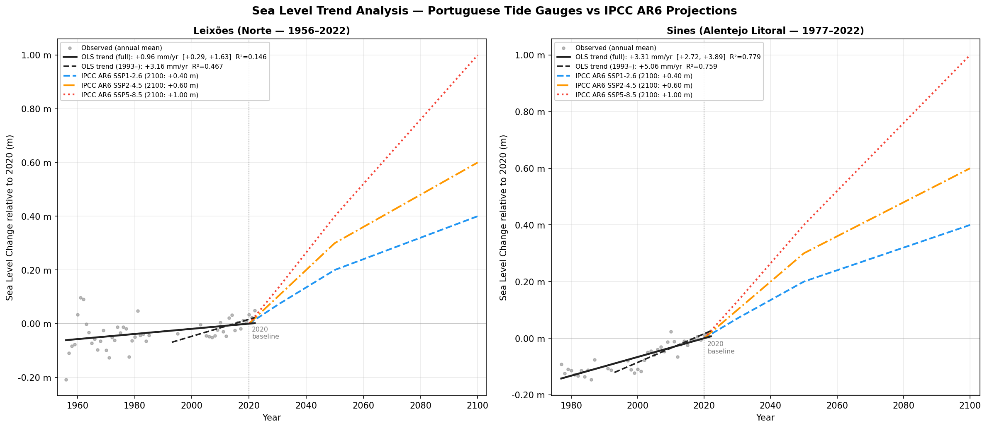
Figure 4.3: OLS linear regression of annual mean sea level at Leixões (1956–2022) and Sines (1977–2022) PSMSL stations. Regression lines shown for full record (blue) and satellite era (1993–2022, red). IPCC AR6 SSP scenarios overlaid for comparison (SSP1-2.6: green; SSP2-4.5: yellow; SSP5-8.5: orange). Post-1993 acceleration is consistent with the AR6 near-term projected rates. Generated by 13a_sealevel_regression.py.
The acceleration from full-record to post-1993 trends is consistent with the IPCC AR6 conclusion that global mean SLR accelerated during the satellite altimetry era and is expected to continue accelerating under all emissions scenarios (Fox-Kemper et al., 2021). The Sines post-1993 trend of +5.06 mm/yr sits at the high end of the observed range for the North Atlantic–Iberian coast, and may reflect interannual variability associated with the North Atlantic Oscillation (NAO) in addition to the secular trend. The confidence interval for the Leixões post-1993 trend is wider (±1.67 mm/yr) than for Sines (±1.20 mm/yr), reflecting the shorter continuous high-quality record at the northern station.
Importantly, these observational trends provide indicative consistency with the IPCC AR6 projected trajectories and support the use of the selected AR6 scenarios as a plausible planning framework; they do not constitute a calibration of the model to local conditions. The dissertation uses the IPCC AR6 global mean projections as the primary SLR inputs, as is standard practice in national-scale coastal risk assessments. The tide gauge results are presented as an independent empirical check that the AR6 trajectories are not inconsistent with the Portuguese observational record.

4.7 Chapter Summary
This chapter has presented the full results of the three-pillar sea-level rise impact analysis for coastal Portugal. The key quantitative findings are as follows.
Under Pillar 1, GDP at risk grows from €0.12–€0.25 billion across scenarios in 2030 to €1.16–€5.30 billion by 2100 under the baseline IPCC AR6 trajectories, with the geoid variant adding €0.44–€1.05 billion of additional exposure. The geoid correction has its largest proportional impact in the near term, where it can increase flood area by 150–261% relative to the baseline scenario, with implications for the timing of adaptation investments.
Under Pillar 2, building exposure dominates asset replacement costs, which reach €20.4 billion (SSP1-2.6), €40.6 billion (SSP2-4.5), and €82.8 billion (SSP5-8.5) by 2100. The building cost estimate is the principal uncertainty driver, with a 50% density sensitivity scenario reducing total Pillar 2 costs by approximately €40 billion. Road, railway, and utility exposure is small in proportional terms but represents substantial absolute replacement values at the network level.
Under Pillar 3, the headline result is a cumulative disruption cost of €130.1 billion (SSP5-8.5/Baseline/mid, 2025–2100, no adaptation), rising to €216.9 billion under the +Geoid sensitivity variant. The port network and railway network each contribute approximately 42–44% of the total, with the Aveiro Ria, Port of Lisbon, and Port of Setúbal sections constituting the three largest individual contributors. Cross-scenario contrasts are highly non-linear: SSP2-4.5 cumulative costs (€21.5 billion) are 16.5% of SSP5-8.5 costs, while SSP1-2.6 costs (€5.9 billion) are only 4.6%, reflecting the exponential structure of the compound flood disruption model.
The K-Means risk classification identifies Grande Lisboa as a Priority Risk tier with a dominant €65.3 billion infrastructure exposure that is an order of magnitude larger than any other coastal region. Three High Risk regions (Aveiro, Setúbal, Algarve) form a coherent second tier with significant infrastructure assets and non-trivial economic exposure. The OLS tide gauge consistency check indicates that the post-1993 acceleration in observed Portuguese sea level trends (+3.16 to +5.06 mm/yr) is broadly consistent with the IPCC AR6 near-term projected rates, providing indicative consistency with the scenario framework.
Chapter 5 proceeds to evaluate the adaptation investment case by examining when, and at what cost, protective measures at each of the eight Pillar 3 sections achieve positive return on investment relative to the disruption costs quantified above.

