Chapter 1: Introduction

1.1 Background: Sea Level Rise as a Global Economic Challenge
This dissertation is submitted in partial fulfilment of the requirements of the MBA in Data Science program by Universidade Autónoma de Lisboa. It applies the core methods of that program — extraction, transformation and data analysis, machine learning, statistical inference, and interactive visualization — to a policy-relevant question of national significance: quantifying the macro-economic and infrastructure cost of sea-level rise on coastal mainland Portugal. Sea level rise (SLR) is one of the most consequential physical consequences of anthropogenic climate change. Global mean sea level rose at an average rate of approximately 1.3 mm/yr throughout the twentieth century before accelerating to 3.7 mm/yr in the satellite altimetry era (1993–2018), driven by the thermal expansion of ocean water and accelerating mass loss from the Greenland and Antarctic ice sheets (Fox-Kemper et al., 2021). The Sixth Assessment Report of the Intergovernmental Panel on Climate Change (IPCC AR6) projects that, under a high-emission scenario consistent with continued heavy fossil fuel dependence (SSP5-8.5), global mean SLR above the 2020 baseline could reach 0.63–1.02 meters by 2100, with low-probability, high-impact ice sheet contributions potentially exceeding 1.5 meters. Even under an optimistic mitigation scenario (SSP1-2.6), projected SLR of 0.32–0.62 meters implies a fundamental and sustained shift in the physical boundary conditions governing coastal land use, infrastructure design, and economic planning.
The economic implications of this trajectory are substantial. Globally, low-elevation coastal zones host approximately 10% of the world’s population and a disproportionate share of national economic output, trade infrastructure, and critical service networks (Nicholls & Cazenave, 2010). Hinkel et al. (2014) estimated that, without adaptation, annual global coastal flood losses could reach USD 100,000 billion by 2100 under a high-end SLR scenario — a figure that reflects not merely direct damage to physical assets but the broader disruption of supply chains, trade flows, and productive capacity. In the European context, Vousdoukas et al. (2018) projected that coastal flood damages in EU member states could rise from approximately €1.25 billion per year in 2000 to between €93 and €961 billion per year by 2100, depending on emission scenario and the degree of adaptive response. These projections establish that the economic cost of SLR is not a distant or marginal concern: it is a material and accelerating economic risk that requires quantification at national scale to inform timely adaptation investment.
Critical transport infrastructure — ports, railways, and motorways — is disproportionately concentrated in coastal and estuarine zones, reflecting centuries of trade-oriented settlement patterns. Such infrastructure is designed for operational lifespans of 50 to 100 years and therefore faces compounding SLR exposure through the latter half of the century. The economic consequences of disruption extend well beyond direct physical damage: compound floods — driven by the coincidence of elevated sea levels, storm surge, tidal forcing, and river discharge — that temporarily close key transport nodes generate supply chain interruptions, production losses at dependent industries, and modal-shift costs that can substantially exceed the replacement value of the inundated asset (Moftakhari et al., 2017). As sea levels rise, the return period of such events compresses exponentially, transforming what are today decadal disruptions into annual or semi-annual occurrences within the study horizon.
Despite broad scientific consensus on the physical trajectory of SLR, the translation of that trajectory into nationally-specific economic cost estimates — the form of evidence most directly actionable by infrastructure managers and policy-makers — remains incomplete for much of the world, including Portugal. Without credible, nationally-grounded estimates of the cumulative cost of inaction relative to the capital expenditure required to protect critical assets, timely adaptation investment cannot be efficiently prioritized, sequenced, or justified to funders, policy-makers and citizen alike. This study is motivated by, and directed at, filling that evidential gap for coastal mainland Portugal.

1.2 The Portuguese Coastal Context
Portugal’s Atlantic coastline extends approximately 943 kilometers along the western and southern margins of the Iberian Peninsula, encompassing exposed rocky headlands, barrier-beach systems, complex estuarine environments, and low-lying alluvial floodplains. Of the 25 mainland NUTS3 regions, twelve have direct coastal or estuarine exposure of economic and infrastructural significance and form the spatial domain of this study. These twelve regions collectively account for the large majority of Portugal’s national GDP and host the country’s most strategically critical transport infrastructure — including its three major commercial ports, the Atlantic spine of its national rail network, and the primary north-south motorway corridor.
The Portuguese coastal economy is structured around maritime trade. The three commercial port sections modelled in this study — the Port of Leixões, the Port of Lisbon, and the Port of Setúbal — collectively handled approximately 32 million tonnes of cargo in 2024 (Governo de Portugal, 2024), together constituting critical nodes for containerized trade, vehicle exports, and liquid bulk logistics along Portugal’s Atlantic seaboard. The Auto Europa/Volkswagen production complex at Setúbal operates on a just-in-time supply chain acutely dependent on uninterrupted port access — illustrating precisely why the study extends beyond quantifying the physical destruction of assets (Pillar 2) to modelling the economic cost of temporary operational disruption (Pillar 3): even closures lasting days can trigger supply chain penalties that materially exceed the immediate cost of flood damage. Several sections of the national rail and road networks traverse terrain that is already marginally above the mean high-water mark: the Tagus floodplain railway (Castanheira–Alverca) at approximately 2.0 meters above mean sea level, and the Aveiro Ria rail embankment at 0.7–1.2 meters (author's analysis; European Space Agency, 2021). The Mondego railway (Alfarelos–Formoselha), while situated at approximately 4–9 meters above mean sea level and therefore outside the direct inundation envelope, is exposed through a distinct fluvial-tidal mechanism: rising sea levels progressively constrain drainage at the Mondego estuary, compounding the frequency of river flood events at the section. The Tagus floodplain and Mondego valley have a documented history of catastrophic flood events causing widespread infrastructure disruption (Fernández-Nóvoa et al., 2024), and compound flooding driven by coincident storm surge, elevated river discharge, and high spring tides is projected to increase exponentially in frequency as sea levels rise (Moftakhari et al., 2017). In southern Portugal, two further sections of the Linha do Algarve are exposed to coastal and estuarine flood risk: the Faro–Olhão coastal section, running at low elevation along the margin of the Ria Formosa lagoon, and the Portimão/Arade estuary section, which crosses the tidal Arade river mouth. The A14 motorway Mondego crossing is similarly exposed to the fluvial-tidal backwater mechanism that constrains drainage at the Mondego estuary.
Observational records at Portuguese tide gauges document a clear and accelerating historical trend: post-1993 SLR rates at Leixões (+3.16 mm/yr) and Sines (+5.06 mm/yr) substantially exceed their full-record means, consistent with the global acceleration documented in IPCC AR6 (as estimated in Section 3.8; PSMSL, 2024; Fox-Kemper et al., 2021). Portugal’s national spatial planning framework — the Programa Nacional da Política de Ordenamento do Território (PNPOT, DGT, 2019) — identifies coastal erosion and sea-level rise as priority challenges for long-term territorial management, and the national climate change adaptation strategy (ENAAC, APA, 2020) establishes a framework for sectoral adaptation planning. However, neither framework has been supported by a national-scale, multi-pillar economic quantification of the cost of inaction across the full suite of coastal transport infrastructure — the gap this study is designed to address.
Figure 1.1 illustrates the scale of the challenge. Generated directly from this study’s geospatial analysis pipeline using the Copernicus GLO-30 Digital Elevation Model, it shows the static inundation potential of coastal mainland Portugal under the high-emission scenario (SSP5-8.5) at 2100 — the study’s worst-case endpoint. The red inundated zones concentrate around the Tagus and Sado estuaries in the south, the Ria de Aveiro in the center, and the Lima and Minho River mouths in the north: precisely the corridors where the national rail network, the three major commercial ports, and the A1 motorway are most exposed. Unlike simpler elevation-thresholding approaches, the connectivity-constrained inundation model restricts flooding to terrain with an unobstructed hydrological pathway to the sea, removing spurious inland artefacts and producing a more defensible estimate of coastal exposure (Poulter & Halpin, 2008).
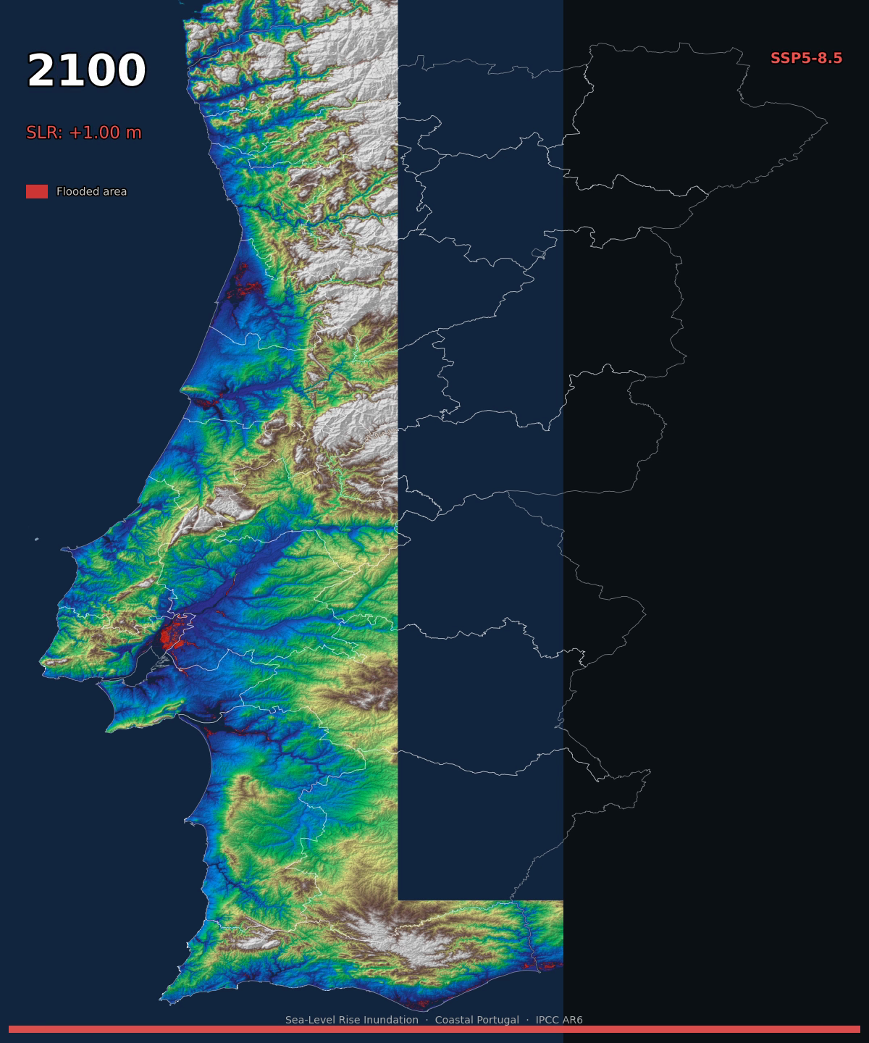
Figure 1.1: Coastal mainland Portugal — static inundation potential under the high-emission scenario (SSP5-8.5) at 2100, with sea-level rise of +1.00 m above the 2020 baseline. Red areas indicate terrain exposed to inundation; the elevation gradient (green to brown) shows the terrain profile of non-inundated land. Generated directly from the study’s geospatial analysis pipeline using the Copernicus GLO-30 DSM and a connectivity-constrained static bathtub inundation model.

1.3 Research Aim and Questions
The aim of this study is to quantify the economic and infrastructure impact of sea-level rise on coastal mainland Portugal under three IPCC AR6 scenarios across the period 2025–2100, and to determine the conditions under which targeted adaptation investments break even against projected cumulative disruption costs. The study pursues this aim through an integrated three-pillar analytical framework — Economic Exposure, Asset Exposure, and Critical Infrastructure Disruption Risk — applied consistently across all scenarios and a geoid-offset sensitivity variant, and grounded in the IPCC AR6 risk assessment framework of hazard, exposure, and vulnerability.
Three interrelated research questions operationalize this aim:
Research Question 1: What share of coastal Portugal’s GDP and physical infrastructure stock is exposed to permanent inundation at each SLR threshold from 0.1 to 2.0 meters above the 2020 baseline, and how does this exposure vary across NUTS3 regions and scenarios?
Research Question 2: For ten critical sections of coastal transport infrastructure, how frequently will compound flood events cause temporary closure as sea levels rise under each scenario, and what is the cumulative economic cost of that disruption across the period 2025–2100?
Research Question 3: At what points in time and under which scenarios does the capital expenditure required to protect each infrastructure section break even against the cumulative disruption cost avoided — and how sensitive is this break-even analysis to the choice of discount rate?
Each research question maps directly to one of the study’s three analytical pillars. Research Question 1 is addressed by Pillars 1 and 2, which quantify economic and physical asset exposure through static inundation analysis of the Copernicus GLO-30 Digital Elevation Model at the NUTS3 scale. Research Question 2 is addressed by Pillar 3, which applies the compound flood frequency framework of Moftakhari et al. (2017) to translate scenario-specific SLR trajectories into section-level annual closure frequency and cumulative disruption cost. Research Question 3 is addressed by the adaptation break-even analysis embedded within Pillar 3, which compares cumulative disruption costs against indicative protection capital expenditure across three discount rate assumptions.

1.4 Analytical Framework
The study is structured within the IPCC AR6 Working Group II risk assessment framework, which conceptualizes climate risk as a function of three interacting components: hazard, exposure, and vulnerability (Ara Begum et al., 2022). Hazard refers to the progressive rise of sea level above the 2020 baseline under each scenario. Exposure refers to the economic output, infrastructure stock, and operational systems located within terrain subject to inundation. Vulnerability refers to the propensity of exposed systems to be adversely affected, shaped by the physical characteristics of the infrastructure, its elevation relative to sea level, its functional dependencies, and the economic consequences of operational disruption. The interaction of these three components, mediated by the capacity for adaptation, determines the overall risk profile of each section and region.
The three-pillar analytical structure operationalizes this framework as a coherent progression from physical hazard measurement through economic exposure quantification to dynamic operational risk assessment:
- Pillar 1 — Economic Exposure — quantifies the annual GDP of coastal NUTS3 regions lying below progressively higher SLR thresholds, capturing the intersection of hazard and economic exposure;
- Pillar 2 — Asset Exposure — extends this to the replacement value of physical infrastructure stock (buildings, roads, railways, and utility networks) within the inundated zone;
- Pillar 3 — Critical Infrastructure Disruption Risk — models the compound flood closure frequency and cumulative disruption cost of ten specific transport infrastructure sections, enabling the adaptation break-even analysis that addresses Research Question 3. The Pillar 3 model applies a 365-day-per-year ceiling on projected annual closure days: any section whose modelled closure frequency reaches that ceiling has transitioned from intermittent disruption to permanent operational failure, and costs beyond that threshold are reported accordingly.
The three pillars are applied under a common set of scenarios and to a common spatial domain, ensuring internal consistency throughout.
The choice of the IPCC AR6 framework as the primary methodological scaffold is justified on three grounds: its scientific pedigree as the internationally accepted standard for climate impact assessment; its internal consistency, ensuring that the three pillars constitute a logically integrated progression rather than parallel analyses; and its direct alignment with the SSP scenarios used to parameterize the SLR projections, avoiding inconsistencies that arise when impact models are applied outside the framework within which the driving data were developed.

1.5 Data Science Methods and Analytical Tools
This study is explicitly a data science dissertation: it applies computational, statistical, and machine learning methods to a large, multi-source dataset to answer questions that cannot be addressed through traditional analytical methods alone. The four core data science components of the study are as follows.
First, geospatial data engineering and raster analysis. The study’s spatial foundation is a Python pipeline (geopandas, rasterio, numpy) that ingests two adjacent Copernicus GLO-30 DEM tiles covering mainland Portugal, merges them into a single raster, and applies a connectivity-constrained static bathtub inundation algorithm at twenty SLR thresholds across three scenarios and the geoid sensitivity variant. The IPCC AR6 median projections are referenced to the 1995–2014 baseline; an offset of +0.06 m is applied throughout to convert these projections to the 2020 baseline used consistently across the study. The pipeline intersects the resulting flood extent rasters with NUTS3 boundary polygons to compute flooded area and exposed economic value at each threshold. A separate sub-pipeline processes the OpenStreetMap infrastructure network (roads, railways, utility nodes) to extract asset geometries, sample their elevation from the DEM, and assign unit replacement costs from published infrastructure valuation data. This geospatial pipeline is the technical backbone of Pillars 1 and 2.
Second, unsupervised machine learning. K-Means clustering (scikit-learn) is applied to classify the twelve coastal NUTS3 regions into relative risk tiers based on four multi-dimensional exposure features: flooded pixel count, GDP at risk, relative flood exposure (fraction of total NUTS3 area flooded), and infrastructure replacement cost exposed. The optimal number of clusters is determined using two complementary diagnostics — the elbow method (within-cluster inertia versus k) and silhouette scoring — following standard practice in the spatial risk classification literature (MacQueen, 1967). The resulting risk tier labels (Priority Risk, High Risk, Moderate Risk, Low Risk) provide a policy-interpretable classification of regional SLR exposure that supports adaptation prioritization decisions.
Third, statistical inference. Ordinary Least Squares (OLS) regression (statsmodels) is applied to annual mean sea level time series from PSMSL tide gauge records at Leixões (1956–2022) and Sines (1977–2022), estimating long-run and post-1993 trend rates with 95% confidence intervals and p-values. The post-1993 trend estimates are then compared against the IPCC AR6 projected rate ranges for each SSP scenario, providing an observational consistency assessment of the scenario projections against Portuguese tide gauge data. This consistency assessment grounds the forward-looking projections in the observational record and strengthens the evidential basis for the scenario selection.
Fourth, interactive data visualization. Tableau Public is used to build five interactive dashboards presenting the study’s core results — flood exposure maps, GDP and asset exposure time series, compound disruption cost trajectories, K-Means risk tier classifications, and adaptation break-even curves — enabling non-technical stakeholders to explore findings interactively across scenarios, time horizons, and geoid variants. The dashboards are publicly accessible, extending the study’s policy reach beyond the dissertation itself. Together, these four components demonstrate the application of the MBA Data Science curriculum to a real-world, high-stakes analytical problem. The detailed parameterization of each component — including model calibration decisions, threshold selections, sensitivity variants, and full algorithm specifications — is reserved for Chapter 3.

1.6 Scope and Delimitations
The spatial scope of the study encompasses the twelve coastal NUTS3 regions of mainland Portugal, selected on the basis of their direct coastal or estuarine exposure to SLR-driven inundation. The Portuguese Atlantic islands — the Azores and Madeira — are excluded: their distinct island geomorphology, volcanic topography, and separate administrative, infrastructure, and climate exposure systems require a dedicated methodology that falls outside the scope of this study. Interior mainland NUTS3 regions are included in the spatial database but record negligible flood exposure under all scenarios and are treated as non-exposed.
The infrastructure scope of the Pillar 3 analysis covers ten critical transport sections — rail, port, and road — selected on the basis of three criteria applied in combination: elevation below 2.5 meters above mean sea level (or exposure to fluvial-tidal backwater mechanisms that extend flood risk to higher elevations); documented or modelled exposure to historical compound flooding; and strategic economic significance at national or regional scale. The ten sections are: the Mondego railway (Alfarelos–Formoselha), the Tagus floodplain railway (Castanheira–Alverca), the Aveiro Ria rail embankment, the Faro–Olhão coastal section of the Linha do Algarve, the Portimão/Arade estuary section of the Linha do Algarve, the Port of Leixões, the Port of Lisbon, the Port of Setúbal, the A14 motorway Mondego crossing, and the A1 motorway estuarine segment. Three infrastructure assets were considered but excluded from the scope: the Port of Sines, whose deep-water berths sit above the compound flood envelope modelled in this study; Faro Airport, whose runway elevation of approximately 7.3 meters above mean sea level places it outside the sea-level rise envelope across all scenarios through 2100; and the Vasco da Gama Bridge southern approach, which could not be consistently validated against the raise_requirements framework applied to all other sections.
Three IPCC AR6 scenarios are adopted: SSP1-2.6 (low emissions), SSP2-4.5 (intermediate), and SSP5-8.5 (high emissions). A fourth variant — the +Geoid sensitivity case, applying an additional +0.15 meter offset to test the effect of a plausible elevation-reference mismatch — is carried through all pillars as a model sensitivity rather than a physical scenario. The study period runs from 2025 to 2100, capturing the full non-linear SLR trajectory including the post-2050 acceleration phase that generates the most severe infrastructure impacts.
The spatial analysis employs a static bathtub inundation model, a standard approach at regional scale (Poulter & Halpin, 2008). The model does not simulate storm surge propagation, wave run-up, or hydrodynamic routing; results represent estimates of static inundation potential rather than dynamically confirmed flood extents. GDP is distributed uniformly within each NUTS3 region, which is a standard simplification at this spatial scale; this represents a first-order simplifying assumption that smooths intra-regional variation in economic density, and results should be interpreted accordingly. The Copernicus GLO-30 is a Digital Surface Model (DSM) rather than a bare-earth terrain model, causing it to underestimate flood extent in densely built coastal areas. These limitations are fully acknowledged and addressed in the discussion of findings.

1.7 Significance and Contribution
The study’s primary significance is policy-oriented. By translating physical SLR projections into cumulative economic disruption costs in nominal terms, and by comparing those costs against indicative adaptation capital expenditure at multiple discount rates, the study produces outputs directly actionable by infrastructure managers, national planning authorities, and investment decision-makers. In the Portuguese context, where the PNPOT and ENAAC identify coastal infrastructure as a strategic priority but lack nationally-specific economic quantification of the cost of inaction, this study provides the evidential foundation for more targeted adaptation planning.
The study’s academic contribution lies in the integration of static exposure assessment (Pillars 1 and 2) with dynamic operational disruption modelling (Pillar 3) within a single coherent framework applied consistently across scenarios, regions, and infrastructure sections. The simultaneous deployment of machine learning (K-Means clustering), statistical inference (OLS regression), and compound flood frequency modelling within the same study grounds the forward-looking projections in the observational record and provides a richer evidential basis than any single method achieves independently.
The study also makes a methodological contribution to reproducibility. The full analytical pipeline is implemented in openly available tools (Python, Node.js) using publicly accessible data sources (Copernicus GLO-30, OpenStreetMap, PSMSL, PORDATA). All scripts, parameters, and calibration decisions are documented in full, enabling direct replication and extension of the methodology to other national contexts facing comparable coastal infrastructure risk — a contribution with growing relevance as nationally-specific SLR impact assessment becomes a policy imperative across Atlantic-facing Europe.

1.8 Dissertation Structure
This dissertation is structured in six chapters. The present chapter has introduced the study’s motivation, context, research questions, analytical framework, data science methods, and scope.
Chapter 2 situates the study within the existing academic literature, reviewing the science of global and regional SLR, the IPCC AR6 risk assessment framework, coastal inundation modelling approaches, compound flood frequency models, economic frameworks for infrastructure disruption costs, the specific vulnerabilities of the Portuguese coastal context, geoid corrections and relative sea level, machine learning in spatial risk classification, and statistical methods for sea level trend detection.
Chapter 3 describes the data sources, analytical pipeline, and methodological decisions underpinning each of the three pillars, including the parameterization of the compound flood model, the CDDR cost framework, the K-Means clustering procedure, and the OLS tide gauge trend analysis.
Chapter 4 presents the results of all three pillars: GDP exposure by NUTS3 region and scenario; physical asset stock exposure; compound flood closure frequency trajectories and cumulative disruption costs by section and scenario; the K-Means risk tier classification of coastal NUTS3 regions; and the OLS-based consistency assessment of the AR6 scenario projections against observed Portuguese tide gauge records. Interactive versions of the key results visualizations are accessible via the Tableau Public platform.
Chapter 5 presents the adaptation cost-benefit analysis, including section-specific break-even timelines under three discount rate assumptions (0%, 1.4% following Stern (2007), and 3%) and the NPV sensitivity framework.
Chapter 6 synthesizes the findings across the three pillars, discusses them in the context of the literature reviewed in Chapter 2, acknowledges the study’s limitations and boundary conditions, draws policy implications for coastal infrastructure adaptation planning in Portugal, and identifies directions for future research.

