**Task 2 :**

Please make a project in which you implement a function that calculates an oriented bounding box around a point set in 3d using principal component analysis. Use only cmake, libeigen and the C++ standard libraries.

**Given :**

Point set in 3D

**Output :**

Oriented Bounding Box

**Approach :**

Principal Component Analysis

Use CMAKE, libeigen and C++ standard libraries

**Background :**

PCA finds an orthogonal basis that best represents given data set.

Application: Finding tight bounding box. n axis-aligned bounding box: agrees with the axes.

For finding oriented bounding box – we simply compute the bounding box with respect to the

axes defined by the eigenvectors. The origin is at the mean point m.

NOTE : Eigenvalues are always non-negative. Eigenvalues indicate the variance of the data.

**Steps :**

1. Plot random points in 3D Space

2. Find mean of points

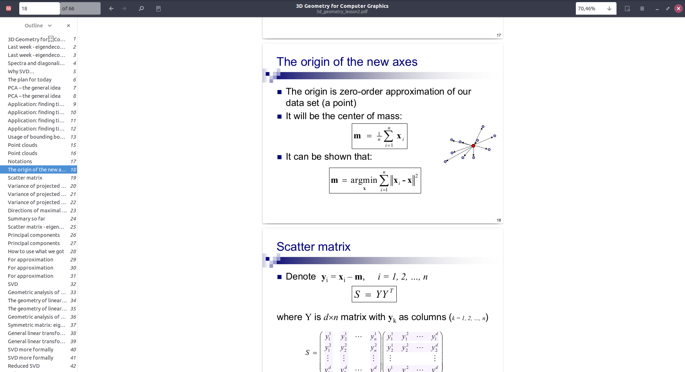

3. Computer Scatter Matrix

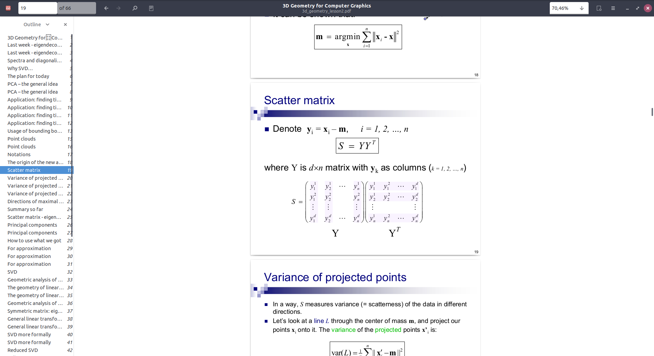

4. Calculate direction of maximum variance – eigen values. Eigen decomposition of scatter matrix. Eigenvectors that correspond to big eigenvalues are the directions in which the data has strong

components (= large variance).

5. Compute axes of bounding box

6. Compute Bounding box w.r.t. bounding box with respect to the axes defined by the eigenvectors. The origin is at the mean point m. Size of the bounding boz is defined by the farthest points in each direction

**References :**

<https://hewjunwei.wordpress.com/2013/01/26/obb-generation-via-principal-component-analysis/>

<http://www.open3d.org/docs/release/cpp_api/classopen3d_1_1geometry_1_1_oriented_bounding_box.html>

<http://fe.math.kobe-u.ac.jp/icms2010-dvd/CGAL/doc_html/cgal_manual/Principal_component_analysis/Chapter_main.html>

<https://docs.opencv.org/master/d1/dee/tutorial_introduction_to_pca.html>