SPACE | TRANSPORT: | Aircraft : | LCA
Last Updated : August 19, 2002
Please be patient while this page loads
LCA is the world's smallest, light weight, multi-role supersonic combat aircraft. It has been designed to meet the requirements of Indian Air Force as its frontline multi-mission single-seat tactical aircraft.
It is India's second indeginous fighter, the first one being the 1960's HF-24(Hindustan Fighter) 'Marut'. 129 Marut fighters were manufactured. Marut had limited supersonic capability (It could go supersonic in dives). The LCA will be the first supersonic combat aircraft to be built and flown in India itself. Interestingly, the requirements of both LCA and HF-24 and very similar. India had previously attempted to build a supersonic fighter : the HF-73, a development of the Marut. HF-73 was to use engines with more power. The project was cancelled after a crash.
LCA can be inducted starting 2008 into the Indian Air Force (IAF) in limited numbers, though 'full-scale' induction won't happen anytime before 2010. Further delays are expected. Most critics put the date of induction between 2012 and 2015.
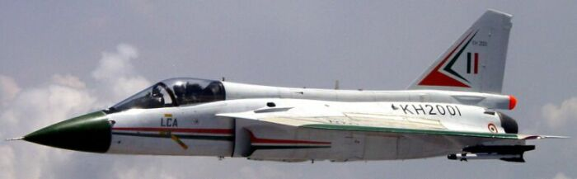
The idea for this plane was born in 1983. It's development has been an extremely painful process. The Indians had to develop most of the workings themselves, with some 'hand holding' by foreign firms. The US sanctions following their nuclear blasts only worsened the situation.
If the LCA succeeds, India may go ahead with development of the MCA, a stealthy twin-engined jet.
Please see our LCA Image Gallery for hi-res pictures.
[Development Plan] [Why India needs it] [Rivals] [The Airplane] [Timeline] [Stats] [Agency List]

Development Plan
On 4th January 2001, India's 'Light Combat Aircraft' or LCA flew for the first time. The maximum speed achieved was 400 kph and the maximum altitude was 3,000 m. The 18 min long test flight was performed by Wing Commander Rajiv Kothiyal. This plane was the LCA TD-1 and was given the serial number 'KH2001'. 'KH' stands for Kota Harinarayana - Director of ADA while 'TD' stands for Technology Demonstrator. LCA TD-1 was powered by a General Electic F404-F2J3 turbofan.
No official name has been given to the LCA as yet, but it will probably get a HF-X designation. The word is 'LCA' is used in the same way 'ATF' is for F-22 Raptor.
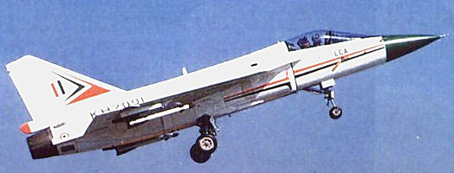
Before the design is ready for induction, 5 Prototype Vehicles [PVs] will be constructed along with the 2 TDs. TD-1 and TD-2 are already flying. TD-2 flew after an agonising wait of 5 years after its roll-out in 1995. It completed its first block of 12 flights in June 2001 and was sent for modification before the next block of flights. TD-2 flew first on 6th June 2002. The 8th and 9th LCA prototypes built will be Naval version.
TD Vehicles, as the name itself suggest, are basically to prove the concept and test only the fundamental technology involved. PVs will be the final design, though minute changes should be possible still. LCA Prototype Vehicles will be lighter by an impressive 200 kg than TD-1. TD-2 itself was lighter than the TD-1. Work is under progress on the PVs. These are expected to be weaponised. PV-1 is expected to fly by the end of 2002. PV-5 will be a trainer and hence will be twin seat.
TD-2 specifically incorporates the following changes as compared to TD-1:
- An indigenous Head Up Display (HUD) replaces the imported HUD. The new HUD, developed by CSIO, Chandigarh, has a larger field of view, three times the brightness, higher redundancy and is noiseless since the design does not call for a cooling fan.
- An indigenous single LRU Integrated Communication System (INCOM) replaces a three LRU INCOM in LCA-TD1. The new INCOM developed by HAL , Hyderabad is a second generation software based system with significant weight saving (17 Kg), reduced volume(43% of original volume), and improved system performance and reliability.
- A marginal reduction in empty weight of aircraft.
- Longer flight duration with increased useable fuel.
- Reduced noise levels in cockpit with improved ECS design. Cockpit noise was an unexpected problems initially encountered in TD-1.
Delays that have plagued the program since its inception, and they are expected to hinder plans even in the future.
If all goes well, LCA will go supersonic after atleast 100 hrs of flight testing. A minimum of 2000 flying hrs is needed to certify it ready for production. The first flight of TD-2 signalled the completion of the first 12 hrs. The development phase involving two technology demonstrators is estimated to have cost Rs. 21.88 billion.

Why India needs the LCA
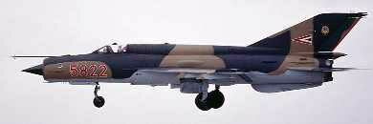
The IAF heavily relies on the 1950's design MiG-21 to maintain its numbers, if not its effective force. The LCA was essentially envisioned as a replacement for it. Delays in LCA's development have caused a lot of problems - The MiGs are old, and unforgiving - pilots are losing their lives each year. Such is its reputation, that it is now called 'the flying coffin' in the pilot's mess.
Part of the problem also arose from the fact that the IAF had to rely on the sub-sonic Kiran jet trainer for pilot's training for last 15 years of the 20th Century. The junior pilots had to jump right from the Kiran to the bisonic MiG. IAF's MiG-21Us are aeging too and limits the performance of these aircraft. It is not surprising that most deaths were those of young pilots. Only recently did the Government decide to acquire Hawk AJTs [Advanced Jet Trainer] from Britain. However, even after intense negotiations an agreement could not be worked out and acquisition of an AJT has been postponed to the unforseeable future.
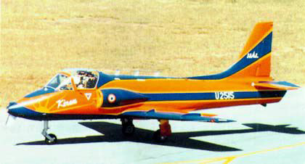 | 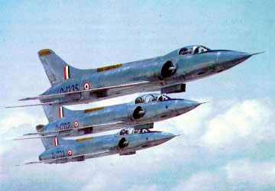
During the decade 1990-2000 the IAF lost 172 MiG series aircraft in crashes, much more than its losses in wartime operations.During the two wars with Pakistan in 1965 and 1971 as well as the Kargil border conflict of 1999, the Indian Air Force lost a total of 115 aircraft. From 1995-2000 alone, the losses due to aircraft involved in accidents amounted to Rs 2.74 billion. During the same period, 52 pilots lost their lives in accidents. India has paid a very heavy price for LCA delays.
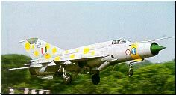
An $340 million upgrade program was started in 1996. These new aircraft are called MiG-21-93 in Russia and MiG-21UPG in India. While some will be upgraded in Russia, most upgradation will be done in India itself. The deal was meant to be completed within two years but the first two upgraded MiG-21-93 jets were only delivered to India in December 2000. The first 2 upgraded MiGs done in India were shipped to the IAF in May 2001. These new aircraft have a mix of French, Israeli, Indian and Russian equipment. It is claimed that the fighters are equivalent to any 4th Generation fighter, with the ability to lock on to 8 different targets at once. The upgrading of the 125 MiG-21s is now slated for 2005, with the implementation of the plan expected to enable the IAF to extend the life of the jets uptil 2015.
Apart from the MiG-21, LCA will also replace MiG-23 and MiG-27, also in service with the IAF.
Will the LCA itself be obsolete by 2015? Certainly not considering India's main rivals, China and the Pakistan fly aircraft like the Chinese F-7(a copy of MiG-21). Other Chinese fighters include the FC-1 (Fighter China 1) and the J-10(F-10 for foreign markets).

Rivals
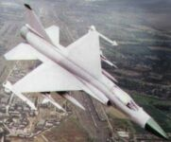
FC-1 is based on the MiG-33 which was rejected by the Soviet Air Force. MiG-33 was a single engined version of MiG-29. Pakistan hopes to buy 150 of them to replace most of its existing air force while the Chinese Air Force does not want to purchase it. Lastest reports say that FC-1 may never enter production - Russia has refused to supply the powerful RD-93 engine. Pakistan has given the FC-1 the 'Super-7' designation.
FC-1 has not been flown. Chengdu is working on it though, and models have been displayed at many exhibitions. While FC-1 design itself is not very advanced, the fact is that China will buy many avionics components from outside and hence has the capability of getting the FC-1 into active service much before the LCA. However, recent reports suggest that it might now be replaced by a different design : J-7MF (a Chinese MiG-21 upgrade).
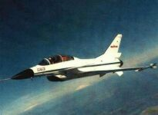
The J-10 started off as a chinese attempt at reverse engineering a Pakistan bought US F-16. However, it ended up being a modification of Israel's Lavi (Young Lion) multirole fighter. Lavi program was cancelled in 1987 in Israel due to political reasons. A J-10 crash in 1995 forced a shift manufacturing plans till atleast 2005 (flights resumed in 1998). The J-10 is believed to be powered by 122.6kN (27,650 lb) Saturn AL-31F turbofans with afterburners.
Interestingly, both LCA and J-10 are due to serve on indigenous Indian and Chinese aircraft carriers, both set to sail by 2010.
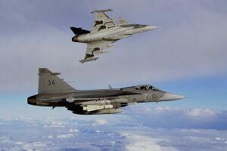
Two other contemporary aircraft began in the same period (1982/83): the European Eurofighter Typhoon and Swedish Jas-39 Gripen. The eurofighter first flew in March 1994 while Gripen took off in December 1988. Gripen joined squadron in 1998(making it the first new 4th generation fighter of the world) while Eurofighter will in 2002. Both faced problems with their digital flight control systems which enable the inherently unstable delta-wing aircraft to fly by using computers to command its flight control surfaces and provide unusual moaneuverability to the jets. Both are being promoted in the foreign markets. JAS-39 has already been chosen by the South African Air Force as their backbone. It is infact regarded as a direct competition to the LCA.
Indians have boldly claimed that the "LCA has more advanced technology than JAS- 39 Gripen and as much advanced technology as the Typhoon." And if it does, then it needs to be proved on the ground and in flight.

The Airplane
LCA has a double delta wing configuration with no tailplanes or foreplanes and features a single vertical fin. The LCA is constructed of aluminium-lithium alloys, carbon-fibre composites, and titanium. It's design has been configured to match the demands of modern combat scenario such as speed, acceleration, maneuverability and agility. Other features of the design include Short takeoff and landing, excellent flight performance, safety, damage-tolerant design, reliability and maintainability.
According to current estimates, the LCA will cost about $17-$20 million and efforts are being made to bring down the cost to $15 million. At this price the LCA has considerable bang for buck value. In comparison, a Su-30 fetches $35 million per piece for Russia, while France's Rafale cost $70+ million.
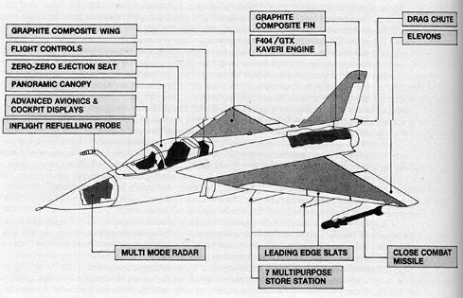
It integrates modern design concepts and the state-of-art technologies such as relaxed static stability, flyby-wire Flight Control System, Advanced Digital Cockpit, Multi-Mode Radar, Integrated Digital Avionics System and a Flat Rated Engine.
Around 70% of the jet is to be made in India itself. The rest will have to be imported for sometime. No mistake must be made with regards to LCA's modernity and design. It is truly advanced and has all the necessary equipment and more.
A naval carrier based version of LCA is also being developed. This version will feature a strengthened undercarriage and sturucture, additional leading edge control surfaces (in the area where the wing joins the fuselage) and lowered nose for better visibility. News reports suggest that US help has been sought for the LCA Navy. The 8th and 9th LCA prototypes built will be Naval version.
[Airframe] [Glass Cockpit] [Radar] [Flight control and software] [Weapons] [Engine] [Stealth Features]
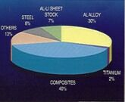
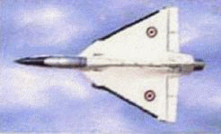
Air Frame
Among the most significant breakthrough is the use of advance carbon composites for more than 40% of the LCA air frame, including wings, fin and fuselage. Apart from making it much lighter, there are less joints or rivets making the aeroplane more reliable. Fatigue strength studies on computer models optimise performance. National Aerospace Laboratory (NAL) has played a lead role. Materials include Aluminium - Lithium alloys , Titanium alloy and Carbon compositites. Composities for wing (skin , spars and ribs ) fuselage (doors and skins), elevons, fin, rudder, airbrakes and landing gear doors.
The skin of the LCA measures 3 mm at its thickest with the average thickness varying between 2.4 to 2.7 mm. BAe was consulted. The fin for the LCA is a monolithic honeycomb piece. No other manufacturer is known to have made fins out of a single piece. The cost of manufacture reduces by 80 per cent from Rs 2.5 million in this process. This is contrary to a subtractive or deductive method normally adopted in advanced countries, when the shaft is carved out of a block of titanium alloy by a computerized numerically controlled machine. A 'nose' for the rudder is added by 'squeeze' riveting.
A striking feature of the LCA is its small size. It is much smaller than even the JAS-39, which a ~1m longer. An effort was made to reduce the number of individual composite parts to the minimum and hence keep the plane light.
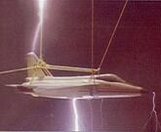
The use of composites results in a 40 per cent reduction in the total number of parts (if the LCA were built using a metallic frame): For instance, 3,000 parts in a metallic design would come down to 1,800 parts in a composite design. The number of fasteners has been reduced to half in the composite structure from 10,000 in the metallic frame. The composite design helped to avoid about 2,000 holes being drilled into the airframe. Though the weight comes down by 21 per cent, the most interesting prediction is the time it will take to assemble the LCA -- the airframe that takes 11 months to build can be done in seven months using composites.
When lightning strikes the LCA, four metal longerons stretching from end to end, afford protection. In addition, all the panels are provided with copper mesh. One out of five is 'bonding' bolt with gaskets to handle Electr-Magnetic Interference. Aluminum foils cover bolt heads while the fuel tank is taken care of with isolation and grounding.
LCA is expected to be highly maneuverable by virtue of its double delta wing and relaxed static unstability of its Fly-By-Wire system.
Flight Control and Software and Other Avionics
The LCA uses advanced digital fly-by-wire technology which essentially employs computers to optimise the aircraft's performance. Foreign companies were consulted. Infact, LCA avionics were first flight tested on a US F-16XL.
Witout the automatic flight control, the LCA will not be flyable, due to the Delta wing's inherent instability. As more and more flights are conducted, the software is updated to allow the aircraft to do more complex maneuvours.
To combat the threat of obsolescence in the LCA Programme, a concerted effort has been made to introduce an Open-architecture Avionics system which permits hardware scalability and upgradability to state-of-the-art technology levels with reusability of the software.
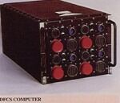
LCA Avionics architecture is configured around a three bus system (MIL-STD-1553B) in a distributed environment. The heart of the system is a 32-bit Mission Computer (MC) which performs mission oriented computations, flight management, reconfiguration / redundancy management and in-flight system self-tests. In compliance with MIL-STD-1521 and 2167A standards, Ada language has been adopted for mission computer software.Accurate navigation and guidance is realised through RLG based Inertial Navigation System (INS) with provision for INS / Global Positioning System (GPS) integration. Jam resistant radio commumication system with advanced Electronic Warfare (EW) environment. In the EW suite, Electromagnetic and Electroptic receivers and jammers provide the necessary "soft-kill" capability.
The digital FBW system of the LCA is built around a quadruplex redundant architecture to give it a fail op-fail op-fail safe capability. It employs a powerful Digital Flight Control Computer (DFCC) comprising four computing channels, each powered by an independent power supply and all housed in a single line replaceable unit (LRU). The system is designed to meet a probability of loss of control of better than 1x10-7 per flight hour. The DFCC channels are built around 32-bit microprocessors and use a safe subset of Ada language for the implementation of software. The DFCC receives signals from quad rate, acceleration sensors, pilot control stick, rudder pedal, triplex air data system, dual air flow angle sensors, etc. The DFCC channels excite and control the elevon, rudder and leading edge slat hydraulic actuators. The computer interfaces with pilot display elements like multifunction displays through MIL-STD-1553B avionics bus and RS 422 serial link.
For maintenance the aircraft has more than five hundred Line Replaceable Units (LRUs), each tested for performance and capability to meet the severe operational conditions to be encountered.
- Mission Computer(MC): MC performs the central processing functions apart from performing as Bus Controller and is the central core of the Avionics system. The hardware architecture is based on a dual 80386 based computer with dual port RAM for interprocessor communication. There are three dual redundant communication channels meeting with MIL-STD-1553B data bus specifications. The hardware unit development was done by ASIEO, Bangalore and Software Design & Development by ADA.
- Control & Coding Unit (CCU): In the normal mode, CCU provides real time I/O access which are essentially pilot's controls and power on controls for certain equipment. In the reversionary mode, when MC fails, CCU performs the central processing functions of MC. The CCU also generates voice warning signals. The main processor is Intel 80386 microprocessor. The hardware is developed by RCI, Hyderabad and software by ADA.
- Display Processors (DP): DP is one of the mission critical software intensive LRUs of LCA. The DP drives two types of display surfaces viz. a monochrome Head Up display (HUD) and two colour multifunction displays (MFDs). The equipment is based on four Intel 80960 microprocessors. There are two DPs provided (one normal and one backup) in LCA. These units are developed by ADE, Bangalore
- Mission Preparation & Data Retrieval Unit (MPRU): MPRU is a data entry and retrieval unit of LCA Avionics architecture. The unit performs mission preparation and data retrieval functions. In the preparation mode, it transfers mission data prepared on Data Preparation Cartridge (DPC) with the help of ground compliment, to various Avionics equipment. In the second function, the MPRU receives data from various equipment during the Operational Flight Program (OFP) and stores data on Resident Cartridge Card (RCC). This unit is developed by LRDE, Bangalore.
- USMS Electronic Units: The following processor based digital Electronics Units (EU) are used for control and monitoring, data logging for fault diagnosis and maintenance.
  - Environment Control System Controller (ECSC)
  - Engine and Electrical Monitoring System Electronics Unit (EEMS-EU)
  - Digital Fuel Monitoring System Electronics Unit (DFM-EU)
  - Digital Hydraulics and Brake Management System Electronics Unit (DH-EU)
- V/UHF Equipment: V/UHF equipment is a secure jam resisant airborne radio communication set which provides simplex two way voice and data communication in the VHF and UHF frequency bands. This unit is developed by HAL, Hyderabad.
- Multi Function Keyboard (MFK): MFK is an interfce for pilot dialogue concerning certain selected equipment of Avionics system. It comprises LCD panel, alphanumeric keys, push buttions for power ON / OFF and LEDs indicating power ON / OFF status of certain Avionics equipment. This unit is developed by BEL, Bangalore.
- Head Up Display (HUD): HUD is of conventional type with a Total Field of View (TFOV) of 24 degrees circular. A Change Coupled Device (CCD) based camera is mounted on the HUD for recording purposes. HUD dsplays various navigation and weapon related data. This unit is developed by CSIO, Chandigarh.
- Colour Multi Function Displays (MFDs): LCD based colour MFDs hava a useful screen area of 125 mm x 125 mm. They have soft keys around their periphery for interaction with the systems. This display provides various aircraft system pages and navigation pages in addition to RADAR & FLIR display.
Digital fly-by-wire Flight Control System is another advanced feature of LCA. The unstable configuration of LCA demands a highly efficient Integrated Flight Control System (IFCS) to fly the aircraft. Control law resident in the flight control computer synthesises inputs from pilot's stick and rudder pedals with flight parameters from inertial and airdata measurements to generate commands to the actuators that move various control surfaces. The design of the control law is evaluated susing real-time flight simulator for acceptable flight handling qualities. The IFCS ensures stability, agility, manoeuvrability and carefree handling over the entire operating envelope of LCA. The Digital Flight Control Computer (DFCC) is the heart of IFCS, and uses a quadruplex redundant system to achieve high reliability and safety.
Independent Verification and Validation (IV&V) activity is an integral part of the Software development process. From requirement specification to final testing, IV&V ensures correctness, consistency, completeness and adherence to MIL standards of the software.
The flight control system along with all the associated software is tested and validated at the iron-bird rig.
The Cockpit
Its new-generation glass cockpit has the latest avionics systems for pilot comfort and efficiency. No tangle of dials and switches. Multi-function digital displays provide information of all vital parameters with the click of a button. Critical information is flashed on the head-up display. Aeronautical Development Establishment (ADE) and NAL were major partner in these developments.
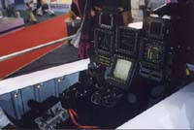
Two Multi Function Displays present required information to the pilot. Critical information required in close combat situations is flashed onto the Head Up Display. Hands on Throttle and Stick (HOTAS) concept ensures availability of every control needed during a critical combat situation, right under the fingers of the pilot. The Environmental Control System (ECS) is designed to give a high degree of comfort to the pilot and to provide adequate cooling to all onboard electronic systems. The compressed air for pressurisation of cockpit, radar and fuel tank is also supplied by ECS.
ADA has also tied up with India's National Institute of Design (NID), Ahemdabad to bring in the elements of ergonomics and modular design. The aim is to help build the aircraft in such a manner that it has more standardised units or dimensions allowing increased flexibility. The NID design team for this project will be lead by Dr S Ghosal who is the director of NID's Bangalore centre.
Weapons
The LCA has a choice of seven pylons three under each wing and one under its fuselage to carry a wide range of armoury. It is designed to be a precision launch platform with air-to-air missiles and air-to-ground weapons, including laser guided bombs. A total of 4000 kg can be carried. Plenty of work to be done. It is expected that the R-73 (AA-12 Archer) will be integrated into the PV-1.
LCA will be armed with a Gasha Gsh-23mm gun. The R-73 will be directed by a Helmet Mounted Sight (HMS) ensuring quick action. It is not clear what medium range AAMs it will carry - the IAF currently operates the Matra Super 530D, R-27RE1 and RVV-AE(R-77) BVR missiles. The choice depends a lot on the radar, unlike dogfight missiles which are usually heat seeking. For example, IAF has integrated both Magic-2 and R-60MK with the MiG-21. A range of weapons, from Russia, West or India will be made available.
A total of 7 hardpoints will be available: 3 on each wing plus one under the fuselage.
As the name itself suggests, LCA's delivery capacity will not be high compared to say the Su-30, but it can carry as much as the MiG-2ML, which the IAF's primary Close Air Support (CAS) fighter. Hence even with LCA's multi-role capability the IAF will need a 'bigger' fighter - the Su-30MKI Super Flanker has already been picked as its frontline fighter for the first Quater of the 21st Century (Su-30MKI Info and pictures).
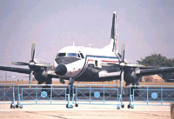
Radar
The multi-mode radar is to take care of detection, tracking, terrain mapping and delivery of guided weapons. The track-while-scan feature keeps track of multiple targets (maximum 10) and also allows simultaneous multiple target engagement. Pulse-Doppler gives the look-down shoot-down capability. Ground mapping feature, frequency agility and other ECCM techniques make the radar truly state-of-the-art.
The antenna is a light weight (less than 5 kg), low profile slotted waveguide array with a multilayer feed network for broad band operation. The salient technical features are: two plane monopulse signals, low side lobe levels and integrated IFF, and GUARD and BITE channels. The heart of MMR is the signal processor, which is built around VLSI-ASICs and i960 processors to meet the functional needs of MMR in different modes of its operation. Its role is to process the radar receiver output, detect and locate targets, create ground map, and provide contour map when selected. Post-detection processor resolves range and Doppler ambiguities and forms plots for subsequent data processor. The special feature of signal processor is its real-time configurability to adapt to requirements depending on selected mode of operation.
To be jointly developed by State owned HAL and Electronics Radar Development Establishment (ERDE) the project has run into major delays and cost escalations.
Two Avro aircraft - HS748M have been modified for the purposes of testing the radar. The idea of doing these tests on an Avro is that these planes can fly for a longer time and hence collect a lot more data.
PV-2 is planned to be equipped with the Radar and Fire Control System (FCS).
Engine & Fuel System
Kaveri engine is a two-spool bypass turbofan engine having three stages of transonic low pressure compressor driven by a single-stage low pressure turbine. The core engine consists of six-stage transonic compressor driven by single-stage cooled high pressure turbine. The engine is provided with a compact annular combustor with airblast atomisers. The aerothermodynamic and mechanical designs of engine components have been evolved using many in-house and commercially developed software for solid and fluid mechanics.
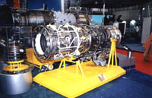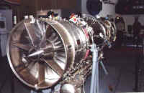
Kaveri three-stage transonic fan, designed for good stall margin and bird strike capability, handles an air mass flow of 78 kg/s and develops a pressure Combustion Chamber Liner ratio of 3.4. The six-stage variable capacity transonic compressor of Kaveri develops a pressure ratio of 6.4. The variable schedule of inlet guide vanes and two rows of stator is through FADEC control system to open the stator blades in a predetermined manner. High intensity low UD ratio annular combustor of Kaveri engine incorporates air blast injection of fuel for uniform outlet temperature profile and reduced carbon emission.
Kaveri high pressure turbine is provided with an efficient cooling design incorporating augmented convection-cum-film cooling for the vanes and combination cooling for the rotor blade to handle up to 1700 K turbine entry temperature. Kabini engine comprising high pressure compressor, combustor and high pressure turbine has undergone high altitude test at facilities abroad successfully demonstrating the flat rating concept of Kaveri engine assembly and in particular the combustor high altitude ignition and stability performances.
Kaveri engine has been specifically designed for Indian environment. The engine is a variable cycle-flat-rated engine in which the thrust drop due to high ambient, forward speed is well compensated by the increased turbine entry temperature at the spool Kabini altitude test speed. This concept has been already demonstrated with high temperature and pressure condition in DRDO's High Mach Facility. Kaveri engine is controlled by Kaveri full authority digital control unit {KADECU), which has been developed and successfully demonstrated at DRDO's test bed.
Kaveri
Air-mass flow | 78 kg/s
By-pass ratio | 0.16
Overall pressure ratio | 21.5
Turbine entry temperature | 1487-1700 K
Maximum dry thrust | 52 kN (5302 kg)
Maximum dry SFC | 0.78 kg/hr/kg
After burner maximum power thrust | 81 kN (8260 kg)
After burner maximum power SFC | 2.03 kg/hr/kg
Thrust-to-weight ratio | 7.8
Currently, the protoypes are powered by the US made GE F404 engine. India's Defence Research and Development Organisation [DRDO] had purchased 11 F404 engines for the LCA project in the 1990s but further collaboration with the engine's manufacturers is no longer possible due to sanctions imposed by the US in the wake of India's nuclear tests of 1998. The US sanctions against India have now been lifted by the Bush Administration. Another lot of 40 engines were ordered but it is not clear whether the deal has been signed on the dotted line.
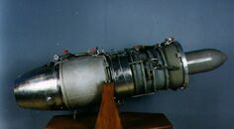
The HF-24 Marut could not achieve its full potential due to the abscence of a suitable powerplant. Currently, the only Jet Engine developed completely in India remains the one used in the Lakshya drone.
The State owned Gas Turbine Research Establishment [GTRE] was to indigenously develop the Kaveri engine to power the LCA. But there have been major slippages in all the milestones apart from cost overruns of Rs 380 crore. It is difficult work but is finally getting underway.
It was initially expected that a LCA (PV-1) with a Kaveri engine will fly in 2002 - it now seems unlikely it will. GRTE has made four Kaveri engines and one of these, the K4, will be sent to Russia [which has inexpensive testing facilities] for high-altitude tests in the second half of 2001. The test-bed is a Tupolew Tu-16 bomber. These airborne tests will allow Indian scientists to study the functioning of the engine in flight. Some 80 hrs of airborne testing and around 1000 hrs of ground testing had been completed by February 2001. Atleast 1000 hrs of flight testing are needed for air-worthiness certification.
The Jet Fuel Starter [JFS] GTSU-110 is indigenous and has the capability to provide in flight starting of the LCA main engine up to an altitude of 6 km. It has been successfully tested at Leh, which has the world's highest altitude airport.
It is now clear that the LCA will be inducted initially with GE engines and later be upgraded with the Kaveri. It is now certain that atleast the first couple of PVs will be powered by the F404.
Fuel tanks are integrated into the fuselage and wings. For extended range, additional 800 lt / 1200 lt fuel tanks are carried at midboard / inboard wing stations and also at centreline station under the fuselage. The inflight refuelling probe further extends the range and endurance.
The GE F404 is a rather popular engine: F/A-18 Hornet, F-117 Nighthawk and even the famed B-2 Stealth bomber is powered by (Four) F404s! The JAS-39 too is powered by a modification of the F404 made by Volvo. When the Rafale prototype first flew, it too had the GE F404 engines. The Rafale has entered service with the M88 and infact the M88 has been offered to India. Now that the sanctions are gone, it is unlikely that either the M88 or the other european counterpart EJ200 (used in the Eurofighter and perhaps later in the JAS-39) will ever be seen in the LCA. Snecma however, is collaborating with GTRE to develop the Kaveri.
Stealth Features
Stealth is an important feature for all new combat aircraft coming up. LCA does not have any stealth charactristics like in F-117 or F-22, but considering its small size, tail-less design and simple delta wing config, a GE-404 engine(atleast for now) - which is also used in the F-117 - it should be stealthier that atleast a MiG-21 or MiG-23/27. It is also expected that LCA will get DRDO developed Radar-absorbent paint. Composites are inherently stealthier than metal.

Timeline
Note: Rs 1 crore = Rs 10 million, $1 = Rs 47
1985: LCA launched with a time frame of 10 years after the Union cabinet sanctioned Rs 560 crore for the project in 1983. Aeronautical Development Agency to be the nodal agency.
1988: ADA prepares project definition phase (PDP) after consulting MBB, France, on some aspects.
1990: Air HQ finds PDP deficient in crucial parameters. Expert committee formed to resolve deadlock. It is agreed that two technology demonstration aircraft to be built before investments cleared for production.
1993: After three years of uncertainty, Phase 1 is sanctioned at a cost Rs 2,188 crore. Milestones include a roll out of first aircraft by 1995 and first flight by 1996.
1995: Roll out does happen but there are serious doubts as to whether the first flight would occur as major problems bedevil flight control systems as well as mastery over composites.
1998: With the aircraft far from ready, the US sanctions after Pokhran tests cause setbacks in flight control technologies and systems integration.
1999: Low speed and high speed taxi trials are done. But flight trials delayed because of minor fire caused by overheating valve near cockpit.
2001: First flight on January 4. More flights follow, including one on Feb 9 at Aero India 2001 [Bangalore, February 7 to 11]. It completes it's first block of tests on June 2.
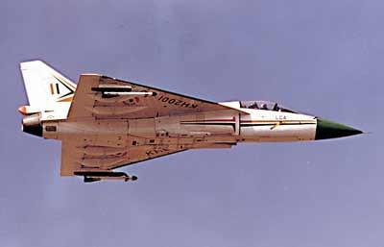
- Within 10 days after the first flight, both MiG and Sukhoi Bureaus expressed desire for joint LCA manufacture. Deputy Prime Minister[Russia] Ilya Klebanov too brought up this issue during his visit to India. They also offered to co-operate with India to develop a 5th Generation fighter(LFI). Other 5th gen aircraft include USA's ATF F-22 Raptor and Joint Strike Fighter [JSF].
- LCA completed its first batch of tests in 12 flights instead of 15 - ahead of schedule - on June 2, 2001. TD-1 was subsequently sent for further modifications including advanced flight controls software as well as extended range of flight endurance.
- For TD-1's block of first 12 flights:
Max Velocity: 610 km/h(0.71 Mach)
Max Altitude: 8 km
Max Angle of Attack: 18 degrees
- Aeronautical Development Agency (ADA) and Hindustan Aeronautics Limited (HAL) signed a Memorandum of Understanding (MOU) for Limited Series Production of Indian LCA. 8 aircraft are to be delivered by 2006.
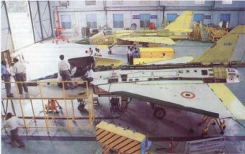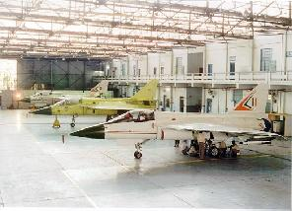
2002: The TD-2 (KH2002) flies for 30 mins on 6.jun.2002. It is piloted by Wing Commander Tarun Banerjee.
- India now has 4 pilots who have flown the LCA. Wing Commander Kothiyal flew the first six on TD-1, Wg. Cdr. Nambiar piloted the TD-1 on the next six flights. Wg. Cdr. Banerjee flew the TD-2 on its first 4 flights. "I think it's going to be an aircraft that our fighter pilots are going to love", he remarked after the first one. Sqd Ldr Sunith Krishna flew for the first time in the LCA on the TD-2's 5th flight.
- Following TD-2's first flight, Kota Harinarayan left ADA for a stint at the Indian Institute of Science (IISc), Bangalore. M.B.Verma took over as Programme Director.
Along with the LCA, India is also developing aircraft like Saras, a 14 seater civilian turboprop aeroplane, Hansa trainer and Intermediate Jet Trainer [IJT]. The sub-sonic IJT, whose first flight should take place in 2002, will replace the aged Kiran jet trainers. IJT shares some 100 parts with the LCA. The IAF has placed orders for 225 such aircraft which cost $5 million a piece.
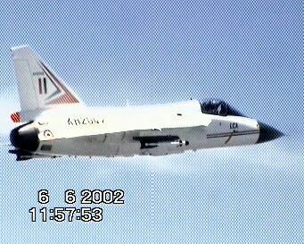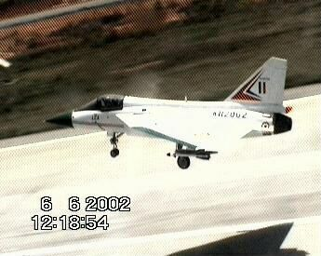
TD-2 during its first flight (Right). TD-2 raised its undercarriage on this flight unlike the TD-1.
These are vidcaps from the Mirage-2000TH chase plane that is employed on every LCA flight.
For more vidcaps of this flight, click here
Total number of LCA TD-1 (KH2001) flights (Last Flight June 2, 2001) : 12
Total number of LCA TD-2 (KH2002) flights (Last Flight August 17, 2002) : 5
  Stats
  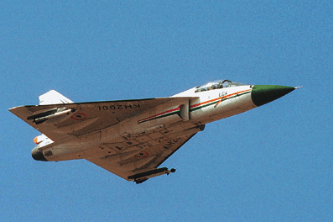
  Length : | 13.2 m
  Height : | 4.4 m
  Wingspan : | 8.2 m
  Weight : | 5.5 ton
  Max. Speed : | Mach 1.8
  Propulsion : | GE-F404 F2J3 18,097 lbs  GTRE GTX-35VS Kaveri 20,200 lbs
  Armament : | 7 stations, 4 ton
  Altitude : | 50,000 ft
  Fuel capacity: | 3000 L
  Flight Record
  TD-1 (KH2001)
  1. | January 4, 2001 | 18 min  3100 m  (wheels down)
  2. | January 30, 2001 | 52 min
  3. | February 3, 2001 | 23 min
  4. | February 9, 2001  (Aero India 2001) | ~20 min  4000 m  560 kmph
  5. | 2001
  6. | 2001
  7. | March 20, 2001
  8. | 2001
  9. | 2001
  10. | 2001
  11. | May 31, 2001
  12. | June 2, 2001
  TD-2 (KH2002)
  1. | June 6, 2002 | 28 min  600 kmph
  2. | July 6, 2002 | 30 min
  3. | July 9, 2002 | 30 min
  4. | July 26, 2002 | ~60 min(?)
  5. | August 17, 2002 | 26 min  Pilot: Sqdn Ldr Sunith Krishna
The development effort for the LCA is lead by ADA. Apart from govt labs and agencies, many educational institutes and private companies also have a role. A list of some of the government agencies involved in the LCA and MCA projects:
- Aeronautical Development Agency (ADA)
- Aeronautical Defense Establishment (ADE)
- Defense Research and Development Organisation (DRDO)
- Hindustan Aeronautics Limited (HAL)
- National Aerospace Laboratries (NAL)
- Gas Turbine Research Establishment (GTRE)
- National Test Flight Centre (NTFC), Hosur (near Bangalore)
- Electronic Radar Development Establishment (ERDE)
- Council for scientific and Industrial Researh(CSIR)
Some of the people associated with LCA development:
- ADA Programme Director: M.B.Verma
- Programme Director,NFTC: Air Marshal Philip Rajkumar
- Project Director,General Systems: K.G. Vivek
- K.V.L.Rao, Project Director,Propulsion Systems
- T.G.Pai, Project Director,Technology Development, LCA Navy
- M.B.Verma, Project Director, General System
- Director-General, Aeronautical Development Agency (ADA): Vasudeva Aatre
- Test/Chase Pilots: Wing Commander Rajiv Kothiyal, Wing Commander R Nambiar, Wing Commander Banerjee
- Director, National Institute of Advanced Studies: Roddam Narasimha(chairman of the committee that reviewed the LCA in 1990)
- HAL Chairman: C.G. Krishnadas Nair
- NID LCA Team Leader: Dr S Ghosal
- Head of Advanced Composites Unit,NAL: M.Subba Rao
- Director-General (CSIR): Dr R.A Mashelkar
Also See :
Aircraft | : | MCA
Spacecraft | : | AVATAR
Gallery | : | LCA
Gallery | : | Su-30MKI

Do check out these hand-picked links before go to your favorite search engines!
bharat-rakshak.com/MONITOR/ISSUE3-5/sainis.html: An all round discussion on LCA's cost-effectiveness and comparison of the projct to others including Mirage-2000 and F-16.
bharat-rakshak.com/MONITOR/ISSUE3-5/sukumar.html: LCA: Imapact On Indian Defense - a look into the LCA from the Air Force's point of view.
vayu-sena.tripod.com/interview-kothiyal1.html: Interview with Test Pilot Wing Commander Rajiv Kothiyal
stratmag.com/issueFeb-15/page03.htm: "LCA: India's aeronautical industry at the cross-roads" - a discussion + "Dreams lighten in LCA" - composites in the aircraft.
users.senet.com.au/~wingman/lca.html: A description of the events leading to LCA's first flight.
bharat-rakshak.com/IAF/History/Aircraft/Marut1.html: "Building India's Jet Fighter" - the story of HF-24
bharat-rakshak.com/IAF/History/Aircraft/Marut2.html: "The Maruts At War" - the HF-24 took active part in the 1971 Indo-Pak War
drdo.org: Defence Research and Development Organisation
ada.gov.in: Aeronautical Development Authority
cmmacs.ernet.in/nal/: National Aerospace Authority
hal-india.com: Hindustan Aeronautics Limited
The Kavrei, Kabini, Avro, LCA Cockpit pictures used here are all © bharat-rakshak.com

Mail ST at spacetransport@yahoo.com . Your suggestions are welcome.
[ Home ] | [ Aircraft ] | [ Explore Space ] | [ Space Stations] | [ Spacecraft Tech ] | [ Spacecraft ] | [ X-Prize ]

This site is best viewed in Internet Explorer 5.5+ and Netscape 6+.
© Space Transport | Top

