1. Prepare files

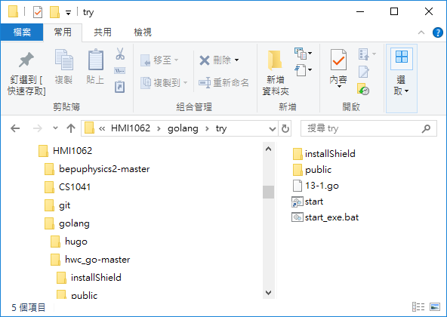

1. go run 13-1.go 🡺 OK

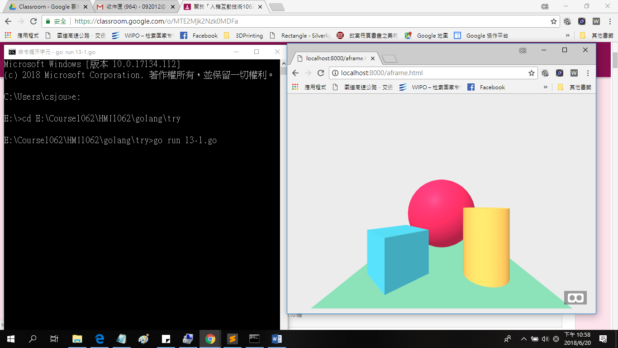

1. go build -o main.exe 13-1.go
2. 7zr.exe 解壓縮後直接執行
3. start E:\\Course1062\\HMI1062\\golang\\try\\main.exe (Background running)
4. "C:\\Program Files (x86)\\Google\\Chrome\\Application\\chrome.exe"

--app=http://localhost:8000/aframe.html (啟用 chrome.exe @ aframe.html or others)