Microsoft Word Author Guidelines for CVPR Proceedings

External Prior Guided Internal Prior Learning for Real Noisy Image Denoising
Paper ID 1047

Abstract

Most of existing image denoising methods use some statistical models such as additive white Gaussian noise (AWGN) to model the noise, and learn image priors from either external data or the noisy image itself to remove noise. However, the noise in real-world noisy images is much more complex than AWGN, and it is hard to be modeled by simple analytical distributions. Therefore, many state-of-the-art denoising methods in literature become much less effective when applied to real noisy images. In this paper, we develop a robust denoiser for real noisy image denoising without explicit assumption on noise models. Specifically, we first learn external priors from a set of clean natural images, and then use the learned external priors to guide the learning of internal latent priors from the given noisy image. The proposed method is simple yet highly effective. Experiments on real noisy images demonstrate that it achieves much better denoising performance than state-of-the-art denoising methods, including those designed for real noisy images.

Introduction

Image denoising is a crucial and indispensable step to improve image quality in digital imaging systems. In particular, with the decrease of size of CMOS/CCD sensors, noise is more easily to be corrupted and hence denoising is becoming increasingly important for high resolution imaging. In literature of image denoising, the observed noisy image is usually modeled as y=x+n, where x is the latent clean image and n is the corrupted noise. Numerous image denoising methods [1, 2, 3, 4, 5, 6, 7, 8, 9, 10, 11, 12, 13] have been proposed in the past decades, including sparse representation and dictionary learning based methods [refs], nonlocal self-similarity based methods, [refs
low-rank based methods, neural network based methods [8], and discriminative learning based methods [refs]..
Most of the existing denoising methods [refs] mentioned above assume noise n to be additive white Gaussian noise (AWGN). Unfortunately, this assumption is too ideal to be true for real-world noisy images, where the noise is much more complex than AWGN [14, 15] and varies by different cameras and camera settings (ISO, shutter speed, and aperture, etc.). According to [15], the noise corrupted in the imaging process [is signal dependent and comes from five main sources: photon shot, fixed pattern, dark current, readout, and quantization noise. As a result, many advanced denoising methods in literature becomes much less effective when applied to real-world noisy images. Fig. 1 shows an example, where we apply some representative and state-of-the-art denoising methods, including CBM3D [4], WNNM [10], MLP [8], CSF [11], and TRD [13], to a real noisy image (captured by a Nikon D800 camera with ISO is 3200) provided in [14]. One can see that these methods either remain the noise or over-smooth the image details on this real noisy image.
There have been a few methods [14, 17, 18, 19, 20, 21, 22, 23] developed for real noisy image denoising. Almost all of these methods follow a two-stage framework: first estimate the parameters of the assumed noise model (usually Gaussian or mixture of Gaussians (MoG)), and then perform denoising with the estimated noise model. Again, the noise in real noisy images is very complex and hard to be modeled by explicit distributions such as Gaussian and MoG. Fig. 1 also shows the denoised results of two state-of-the-art real noisy image denoising methods, Noise Clinic [21, 22] and Neat Image [24]. One can see that these two methods do not perform well on this noisy image either.
This work aims to develop a robust solution for real noisy image denoising without explicitly assuming certain noise models. To achieve this goal,

we propose to first learn image priors from external clean images, and then employ the learned external priors to guide the learning of internal latent priors from the given noisy image. The flowchart of the proposed method is illustrated in Fig. 2. We first extract millions of patch groups from a set of high quality natural images, with which a Gaussian Mixture Model (GMM) is learned as the external prior. The learned GMM prior model is used to cluster the patch groups extracted from the given noisy image, and then a hybrid orthogonal dictionary (HOD) is learned as the internal prior for image denoising. Our proposed denoising method is simple and efficient, yet our extensive experiments on real noisy images clearly demonstrate its better denoising performance than the current state-of-the-arts.

Related Work
2.1. Internal vs. External Prior Learning
Image priors are playing a key role in image denoising [1, 3, 7, 12, 25]. There are mainly two categories of prior learning methods. 1) External prior learning methods [refs] learn priors (e.g., dictionaries) from a set of external clean images, and the learned priors are used to recover the latent clean image from noisy images. 2) Internal prior learning methods [refs] directly learn priors from the given noisy image, and the image denoising is often done simultaneously with the prior learning process [3, 26]. It has been demonstrated [refs] that the external priors learned from natural clean images are effective and efficient for image denoising problem, but they are not adaptive to the given noisy image so that some fine-scale image structures may not be well recovered. By contrast, the internal priors are adaptive to content of the given image, but the learning processing are usually slow. In addition, most of the internal prior learning methods [refs] assume AWGN noise, making the learned priors less robust for real noisy images.
In this paper, we use external priors to guide the internal prior learning. Our method is not only much faster than the traditional internal learning methods, but also very effective to denoise real noisy images.

2.2. Real Image Denoising

In the last decade, researchers proposed many methods [17, 18, 19, 20, 21, 22, 23, 14] for real image denoising problem. In [17], Portilla proposed to use scale mixture of Gaussians to estimate the noise covariance matrix and latent clean images in wavelet domain. The work of Rabie [18] modeled the noisy pixels as outliers which are removed via Lorentzian robust estimator. Liu et al. [19] proposed to use “noise level function” to estimate the noise and then use Gaussian conditional random field to obtain the latent clean image. Gong et al. [20] models the noise by mixed l1 and l2 norms and remove the noise by sparsity prior in the wavelet transform domain. Later, Lebrun el al. proposed a multiscale denoising algorithm called “Noise Clinic” [21, 22]. This method generalizes the NL-Bayes model [27] to deal with blind noise and achieves state-of-the-art performance. Recently, Zhu et al. proposed a Bayesian model [23] which approximates and removes the noise via low-rank mixture of Gaussians. However, these methods largely depends on the modeling of noise in real noisy images which is hard to be modeled by explicit distributions. Besides, the parametric estimation of the Gaussian or MoG distribution is often time consuming. (这一段写得有问题。)

External Prior Guided Internal Prior Learning

In this section, we first describe the learning of external prior, and then describe in detail the guided internal prior learning. Finally, the denoising algorithm with the learned priors is presented.

Learn External Patch Group Priors
The nonlocal self-similarity based patch group (PG) [ref] has proved to be a very effective unit for image prior learning. In this work, we also extract PGs from natural clean images to learn priors. A PG is a group of similar patches to a local patch.
In our method, each local patch is extracted from a RGB image with patch size p × p × 3. We search the M most similar patches to this local patch (including the local patch itself) in a WxW local region around it. Each patch is stretched to a patch vector 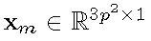 to form the PG 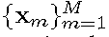. The mean vector of this PG is 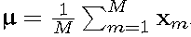, and the group mean subtracted PG is defined as 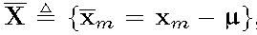 .
Assume we extract a number of N PGs from a set of external natural images, and the n-th PG is
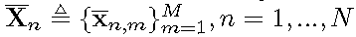. A Gaussian Mixture Model (GMM) is learned to model the PG prior. The overall log-likelihood function is
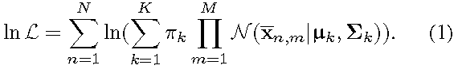
The learning process is similar to the GMM learning in [12, EPLL]. Finally, a GMM model with K Gaussian components is learned, and the learned parameters include mixture weights 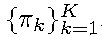, mean vectors 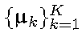, and covariance matrices 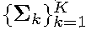. Note that the mean vector of each cluster is naturally zero, i.e., 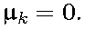
To better describe the subspace of each Gaussian component, we perform singular value decomposition (SVD) on the covariance matrix:
The eigenvector matrices 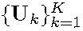 will be employed as the external orthogonal dictionary to guide the internal dictionary learning in next sub-section. In Figure 3 (a) and (b), we illustrate an external clean image and one orthogonal dictionary learned via GMM on PGs of the external clean image. The singular values in Sk reflect the significance of the singular vectors in Uk. They will also be utilized as prior weights for weighted sparse coding in our denoising algorithm.

Guided Internal Prior Learning
After the external PG prior is learned, we employ it to guide the internal PG prior learning for a given real noisy image. The guidance lies in two aspects. One is that the external prior can guide the subspace assignment of internal noisy PGs, while the other is that the external prior could guide the orthogonal dictionary learning of internal noisy PGs.

3.2.1. Internal Subspace Assignment
Given a real noisy image, we extract N (overlapped) local patches from it. Similar to the external prior learning stage, for the n-th local patch we search its M most similar patches around it to form a noisy PG, denoted by 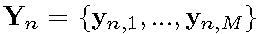. Then the group mean of Yn, denoted by , is subtracted from each patch by , leading to the mean subtracted noisy PG 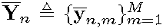.
The external GMM prior models basically characterize the subspaces of natural high quality PGs. Therefore, we project the noisy PG Yn into the subspaces of and assign it to the most suitable subspace based on the posterior probability:
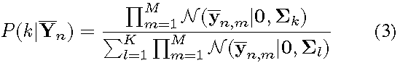
for k = 1; :::;K. Then Y_{n} is assigned to the component with the maximum A-posteriori (MAP) probability maxk P(k|Yn).

3.2.2 Guided Orthogonal Dictionary Learning
Assume we have assigned all the internal noisy PGs 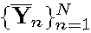
to their corresponding most suitable subspaces in 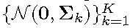. For the k-th subspace, the noisy PGs assigned to it are 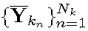,where 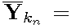
. We propose to learn an orthogonal dictionary D_{k} from each set of PGs with the guidance of the corresponding external orthogonal dictionary Uk (Eqn. (2)) to characterize the internal PG prior. The reasons that we learn orthogonal dictionaries are two-fold. Firstly, the PGs are in a subspace of the whole space of all PGs; therefore, there is no necessary to learn a redundant over-complete dictionary to characterize it, while an orthonormal dictionary has naturally zero mutual incoherence. Secondly, the orthogonality of dictionary can make the encoding in the testing stage very efficient, leading to an efficient denoising algorithm (please refer to sub-section 3.3 for details).
We let the orthogonal dictionary D_{k} be e 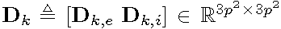, where
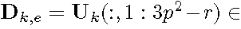
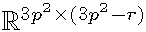is the external sub-dictionary and it includes the first r most important eigenvectors of Uk, and the internal sub-dictionary Dk,I is to be adaptively learned from the noisy PGs 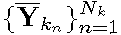. The rationale to design D_{k} as a hybrid dictionary is as follows. The external sub-dictionary Dk,E is pre-trained from external clean data, and it represents the kth latent subspace of natural images, which is helpful to reconstruct the common latent structures of images. However, Dk,E is general to all images and it is not adaptive to the given noisy image. Some fine-scale details specific to the given image may not be well characterized by Dk,E. Therefore, we learn an internal sub-dictionary Dk,I to supplement Dk,E. In other words, Dk,I is to reveal the latent subspace adaptive to the input noisy image, which cannot be effectively represented by Dk,E.
For notation simplicity, in the following development we ignore the subspace index k for and D_{k}, etc.
The learning of hybrid orthogonal dictionary D is performed under the following weighted sparse coding
framework:
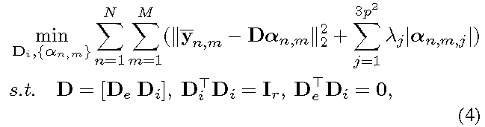
where an,m is the sparse coding vector of the m-th patch yn,m in the n-th PG Yn and an,m,j is the j-th element of an,m.
λj is the j-th regularization parameter defined as
where S_{k}(j) is the jth singular value of diagonal singular value matrix S_{k} (please refer to Eqn. (2)) and ε is a small positive number to avoid zero denominator. Noted that DE = 0 if r = 3p² and DE = Uk if r = 0. The dictionary D = [DE DI] is orthogonal by checking that:
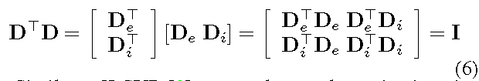
We employ an alternating iterative approach to solve the optimization problem (4). Specifically, we initialize the orthogonal dictionary as D⁽⁰⁾ = Uk and for t = 0, 1,…, T-1, we alternatively update α_{n,m} and D as follows.

Updating Sparse Coding Coefficients: Given the orthogonal dictionary D^{(t)}, we update each sparse coding vector α_{n,m} by solving
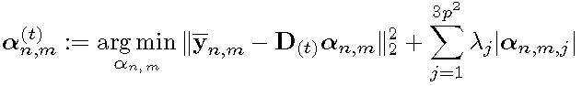
Since dictionary D^{(t)} is orthogonal, the problems (7) has a closed-form solution:
whereλ 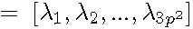 is the vector of regularization
parameter and sgn(*) is the sign function, means element-wise multiplication. The detailed derivation of Eq. (8) can be found in the supplementary file.

Updating Internal Sub-dictionary: Given the sparse coding vectorsα_{n,m}^{(t)}
we update the internal sub-dictionary by solving
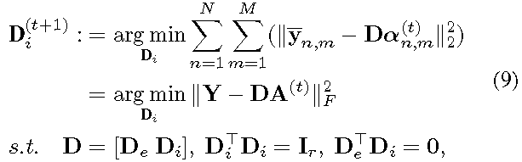
where A^{(t)}=… The sparse coefficient matrix can be written as 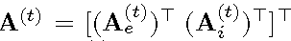,
where the external part 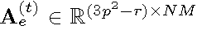
and the internal part 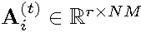 represent the coding coefficients of Y
over external sub-dictionary DE and internal sub-dictionary DI ,
respectively.
According to the Theorem 4 in [28], the problem (9) has a closed-form solution 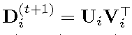, where 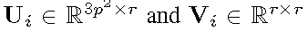 are the orthogonal matrices
obtained by the following SVD
The orthogonality of internal dictionary D(t+1)i can be
checked by

In Figure 3 (c) and (d), we illustrate a denoised image by our proposed method and one internal orthogonal dictionary learned from PGs of the given noisy image.

The Denoising Algorithm
The denoising of the given noisy image can be simultaneously done with the guided internal dictionary learning process. Once we obtain the solutions

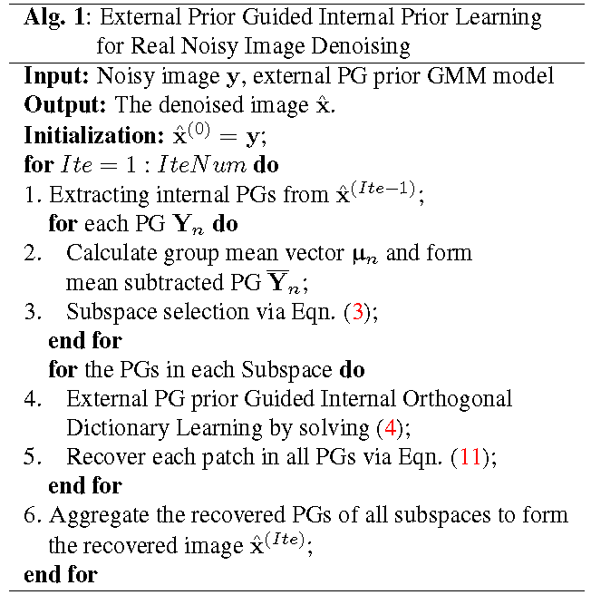
of sparse coding vectors 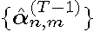 in Eq. (8) and the orthogonal dictionary 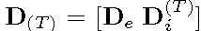 in Eqn. (9), the latent clean patch of a noisy patch y_{n,m} in PG Yn is reconstructed as
where is the group mean of Yn. The latent clean image is then reconstructed by aggregating all the reconstructed patches in all PGs. We perform the above denoising procedures for several iterations for better denoising outputs. The proposed denoising algorithm is summarized in Alg. 1.

Experiments
We evaluate the performance of the proposed algorithm on real-world noisy images [refs] in comparison with state-of-the-art denoising methods [4, 5, 8, 10, 11, 13, 14, 21, 22, 24].

Implementation Details

Our proposed method has two stages: the external prior learning stage and the external prior guided internal prior learning stage. In the first stage, we set p = 6 (the patch size), M = 10 (the number of similar patches in a PG), W = 31 (the window size for PG searching) and K = 32 (the number of Gaussian components in GMM. We learn the external GMM prior with 3.6 million PGs extracted from the Kodak PhotoCD Dataset (http://r0k.us/graphics/kodak/), which includes 24 high quality color images.

In the second stage, we set r = 54 (the number of atoms in the external sub-dictionaries); that is, we let the external sub-dictionary have the same number of atoms as the internal sub-dictionary to be learned. Our experiments show that setting r between ?? and ?? will lead to very similar results. For other parameters, we set λ= 0.001 (the sparse regularization parameter), T = 2 (the number of iterations for solving problem (4)), and IteNum = 4 (the number of iterations for Alg.1). All parameters of our method are fixed to all experiments, which are run under the Matlab2014b environment on a machine with Intel(R) Core(TM) i7-5930K CPU of 3.5GHz and 32GB RAM.

The Testing Datasets
We evaluate the proposed method on two real noisy image datasets, where the images were captured under indoor or outdoor lighting conditions by different types of cameras and camera settings.
The first dataset is provided in [22], which includes 20 real noisy images collected under uncontrolled outdoor environment. Since there is no “ground truth” of the noisy images, the objective measures such as PSNR cannot be computed on this dataset.
The second dataset is provided in [14], which includes noisy images of 17 static scenes. The noisy images were collected under controlled indoor environment. Each scene was shot 500 times under the same camera and camera setting. The mean image of the 500 shots is roughly taken as the “ground truth”, with which the PSNR can be computed. Since the image size is very large (about 7000x5000) and the 17 scenes share repetitive contents, the authors of [14] cropped 15 smaller images (of size 512x521) to perform experiments. To more comprehensively evaluate the proposed methods, we cropped 60 images of size 500 x 500 from the dataset for experiments. Some samples are shown in Figure 4. Note that the noise in our cropped 60 images is different from the noise in the 15 images cropped by the authors of [14] since they are from different shots.

Comparison among external, internal, and guided internal priors
To demonstrate the advantages of external prior guided internal priors, in this section we perform real noisy image denoising by using external priors (denoted by “External”), internal priors (denoted by “Internal”), and the proposed guided internal priors (denoted by "Guided Internal"), respectively. For the “External” method, we utilize the full external dictionaries (i.e., r =108 in Eqn. (5)) for denoising. For the “Internal” method, the overall framework is similar to the method of [9]. A GMM model (with K = 32 Gaussians) is directly learned from the PGs extracted from the given noisy image without using any external data, and then the internal orthogonal dictionary is obtained via Eqn. (2) to perform denoising. All parameters of the
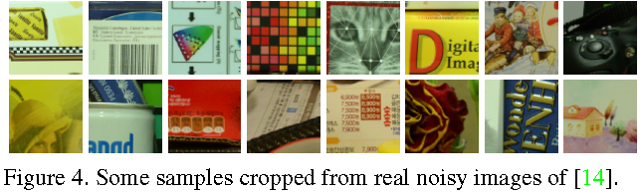
Figure 2-3: Denoised images of the real noisy image “Nikon D800 ISO 3200 A3” from [14] by different methods. The images are better
viewed by zooming in on screen.

"External" and "Internal" methods are tuned to achieve their best performance.
We compare the three methods mentioned above on the 60 cropped images from [14]. The average PSNR and run time are listed in Table 1. It can be seen that "Guided Internal" prior achieves better PSNR than both “External” and “Internal” priors. In addition, the “Internal” method is very slow because it involves online GMM learning, while the "Guided Internal" method is only a little slower than the “External” method. Fig. 2 and Fig. 3 show the denoised images of two noisy image by the three methods. We can see that the “External” method is good at recovering large-scale structures (see Fig. 2) while the “Internal” method is good at recovering fine-scale textures (see Fig. 3). By utilizing external priors to guide the internal prior learning, our proposed method can effectively recover both the large-scale structures and fine-scale textures.

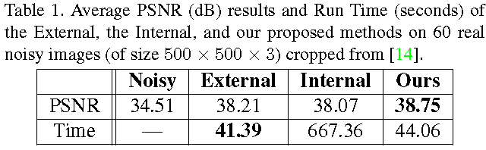

Comparison with State-of-the-Art Denoising Methods
We compare the proposed method with state-of-the-art image denoising methods, including CBM3D [4], WNNM [10], MLP [8], CSF [11], TNRD [13], Noise Clinic (NC) [21], Cross-Channel (CC) [14], and Neat Image (NI) [24]. Among them, CBM3D, WNNM, MLP, CSF and TNRD are designed based on Gaussian noise model, and they need to know the noise level for denoising. We use the method in [29] to estimate the noise level for them. All the other parameters in these methods are set as the default ones. Since WNNM, MLP, CSF and TNRD are designed for grayscale images, we use them to denoise the R, G, B channels separately for color noisy images.
Like our method, the NC is a blind image denoising method which does not need any noise prior. The NI is a commercial software for image denoising, which has been embedded into Photoshop and Corel PaintShop [24]. The code of CC is not released but its results on the 15 cropped images are available at [ref]. Therefore, we only compare with it on the 15 cropped images from [14].

4.4.1. Results on Dataset [22]
Figure 1: Denoised images of the real noisy image “Nikon D800 ISO 3200 A3” from [14] by different methods. The images are better
viewed by zooming in on screen.

Since there is no “ground truth” for the real noisy images in dataset [22], we only compare the visual quality of the denoised images by different methods. (Note that method CC [14] is not compared since its code is not available.) Fig. 5 shows the denoised images of “Dog”. It can be seen that CBM3D and WNNM tend to over-smooth much the image while remaining some noise caused color artifacts. MLP and TNRD are likely to remain many noise-caused color artifacts across the whole image. These results demonstrate that the methods designed with Gaussian noise model are not effective for real noise removal. Though NC and NI methods are specifically developed for real noisy images, their performance on noise removal is not very satisfactory. In comparison, our proposed method recovers much better the structures and textures (such as the eye area) than the other competing methods.
More visual comparisons on dataset [22] can be found in the supplementary file.

4.4.1. Comparison on the Second Dataset [14]

The real noisy images in the second dataset [14] have corresponding “ground truth” images. On this dataset, we firstly perform comparison on the 15 cropped images used in [14]. The compared method are BM3D [4], WNNM[10], MLP [8], CSF [11], TRD [13], Noise Clinic (NC) [21], and
Cross-Channel (CC) [14]. The PSNR values are listed in Table 2. As we can see, on most (9 out of the 15) images captured by different cameras and camera settings, our proposed method obtains better PSNR values than the other methods. Noted that, though in [14] a specific model is trained for each camera and camera setting, our proposed general method still gains 0.28dB improvements on PNSR over [14]. We also compare the visual quality of the denoised images by the competing methods. Figure 6 shows the denoised images of a scene captured by Canon 5D Mark 3 at ISO = 3200 by the competing methods. More visual comparisons can be found in the supplementary file. We can see that BM3D, WNNM, NC, NI, and CC would either remain noise or generate artifacts, while MLP, TRD are likely to over-smooth the image. By combining the external and internal priors, our proposed method preserves edges and textures better than other methods.
To evaluate the compared methods on more samples, we then perform denoising experiments on the 60 smaller images cropped from the 17 images provided in [14]. The average PSNR results are listed in Table 3 (the code of [14] is not available so that it is not compared). The numbers in red color and blue color are the best and second best results, respectively. It can be seen that our proposed method achieves much better PSNR results than the other methods. The improvement of our method over the second best method (TRD) is 1dB. Due to the space limitations, the visual comparisons are provided in the supplementary file.
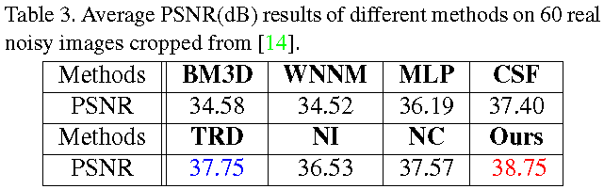
Figure 0: Short captions should be centred.
Figure 0: Short captions should be centred.

Conclusion and Future Work
Image priors are important for solving image denoising problems. The external priors learned from external clean images are generally effective to most images, while the internal priors learned directly from the noisy image are adaptive to the given image but would be biased by the complex noise in real noisy images. In this paper, we demonstrates that, once unifying both the priors in external clean images and internal noisy images, we can achieve much better while still efficient performance on real image denoising problem. Specifically, the external patch group (PG) priors learned on natural clean images can be used to guide the subspace selection and orthogonal dictionary learning of internal noisy PGs from given noisy images. The experiments on real image denoising problem have demonstrated the powerful ability of the proposed method. In the future, we will speed up the proposed algorithm and evaluate the proposed method on other computer vision tasks such as image super-resolution.

