Microsoft Word Author Guidelines for ICCV Proceedings

Multi-channel Weighted Nuclear Norm Minimization for Real Color Image Denoising
Paper ID 572

Abstract

The noise structures among the R, G, B channels of real images are quite different due to the preprocessing steps in digital camera pipelines. This makes the real image denoising problem much more complex than traditional grayscale image denoising. In this paper, we propose a multi-channel optimization model for real color image denoising. Specifically, we introduce a weighting matrix into the data term to process adaptively each part of R, G, B channels in the joint patches concatenated by corresponding patches in these channels. In the regularization term, we employ the weighted nuclear norm to exploit the non-local self similar property. The proposed multi-channel weighted nuclear norm minimization (MC-WNNM) model is much more complex than the standard WNNM model. To solve this new problem, we reformulate the MC-WNNM model into a linear equality-constrained problem and solve it under the alternating direction method of multipliers (ADMM) framework. Each alternative updating step has closed-form solution and the convergence results are given. Experiments on benchmark datasets demonstrate that the proposed model outperforms state-of-the-art denoising methods on synthetic as well as real-world noisy images.

Introduction
Image denoising is an important problem in enhancing the image quality in computer vision systems. The traditional grayscale image denoising problem aims to recover the clean image x from the noisy observation y=x+n, where n is often assumed to be additive white Gaussian noise (AWGN). Most image denoising methods in this field either employ the non-local self similarity (NSS) of natural images [1-7] or learn generative or discriminative denoisers from paired natural clean images and synthetic noisy images [8-12]. Among these methods, the weighted nuclear norm minimization (WNNM) method achieves excellent denoising performance by exploiting the NSS property via low rank regularization.
The real color image denoising problem is not a trivial extension from single channel (grayscale image) to multiple channels (color image). The reason is that the noise in standard RGB (sRGB) space, though could be modeled as AWGN, are with different variances for different channels [13] due to the on-board processing steps in digital camera pipelines [14, 15]. This makes the real color image denoising problem much more complex. Directly applying the denoising methods for grayscale images to each channel of color images separately would obtain bad performance [16]. There are several work [14, 16-20] proposed specifically for color image denoising. The method [17] first transforms the color images into the luminance/chrominance space such as YCbCr before denoising, but this would make the noise distribution more complex in color images. The methods of [16, 20] process the joint patches concatenated by the corresponding patches in R, G, B channels and treat equally the patches in different channels. This would generate false colors or artifacts [16]. The methods of [14, 18, 19] ignore the non-local self similarity property of natural images, and their performance would be largely depressed [2, 7].
In order to deal with the R, G, B channels in color images more effectively, different noise properties of different channels should be considered in solving real color image denoising problem. Besides, due to its expressive denoising performance, the WNNM model [7] is employed to exploit the NSS property of natural images. In this paper, we proposed a multi-channel WNNM (MC-WNNM) model for real color image denoising. By introducing a weighting matrix to the WNNM model, the proposed MC-WNNM model no longer has closed-form solutions and more challenging to solve. By reformulating the proposed MC-WNNM model into a linear equality-constrained program with two variables, the relaxed problem can be solved under the alternating direction method of multipliers (ADMM) [21] framework. Each variable can be updated with closed-form solution [7, 22]. We also give the convergence results with detailed proof to guarantee a rational termination of the proposed algorithm.

- Related Work

  - Weighted Nuclear Norm Minimization

As an extension to the nuclear norm minimization (NNM) model [23], the weighted nuclear norm minimization (WNNM) model [7] is described as
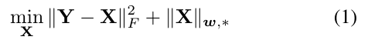
where 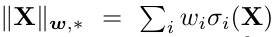 is the weighted nuclear norm of matrix X, and is the weight vector, is the i-th singular value of matrix X. According to the Corollary 1 of [24], the problem (1) has closed-form solution if the weights are non-decreasing

where is the singular value decomposition [25] of Y and 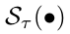 is the generalized soft-thresholding operator with weight vector w:

Though having achieved excellent performance on grayscale image denoising, the WNNM model would generate false colors or artifacts [16], if being directly extended to real color image denoising by processing each channel separately or joint vectors concatenated by multiple channels. In this paper, for real noisy image denoising, we propose a multi-channel WNNM model which preserve the power of WNNM and be able to process the differences among different channels.

  - Real Color Image Denoising

During the last decade, several denoising methods are proposed for real color image denoising [17-20]. Among them, the CBM3D [17] first transform the RGB image into luminance-chrominance space (e.g., YCbCr) and then apply the famous BM3D method [2] on each channel separately with the patches being grouped only in the luminance channel. In [18], the authors proposed the ``Noise Level Function'' to estimate and remove the noise for each channel in natural images. However, the methods processing each channel separately would achieve inferior performance than processing jointly these channels [16]. The methods of [19, 20, 26] perform real color image denoising by concatenating the patches in R, G, B channels into joint vectors. However, the concatenation would treat each channel equally and ignore the different noise properties among these channels. The method in [14] models the cross-channel noise in real noisy image as a multivariate Gaussian and the noise is removed by the Bayesian nonlocal means filter [27]. The commercial software Neat Image [28] estimates the noise parameters from a flat region of the given noisy image and filters the noise correspondingly. But these methods [14, 28] ignore the non-local self similarity property of natural images [2, 7].
In this paper, we introduce a weighting matrix which add different weights to different channels for color image denoising. The proposed multi-channel method can effectively solve the problem of different noise structures among different channels.

- Color Image Denoising via Multi-channel Weighted Nuclear Norm Minimization

  - The Problem

The color image denoising problem is to recover the clean image x_{c} from its noisy version y_{c}= x_{c} + n_{c}, where c={r, g, b} is the index of R, G, B channels and n_{c} is the noise in c-th channel. Given a noisy color image y_{c}, each local patch of size pxpx3 is extracted and stretched to a patch vector 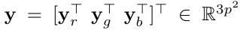, where 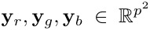 are corresponding patches in R, G, B, channels. For each local patch y, we search the M most similar patches to it (including y itself) by Euclidean distance in a WxW local region around it. We stack the M similar patches column by column to form a noisy patch matrix 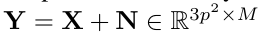, where X and N the corresponding clean and noise patch matrices.

According to [13], the noise in standard RGB (sRGB) space, though could be modeled as additive white Gaussian (AWGN), are with different variances for different channels. Therefore, it is problematic to directly apply denoising methods to the joint vectors concatenated by corresponding patches of the R, G, B channels. To validate this point, in Fig. 1, we show the clean image “kodim23” taken from the Kodak PhotoCD dataset, its degraded version generated by adding synthetic additive white Gaussian noise (AWGN) to each channel of “kodim23”, and the denoised image by applying WNNM [7] on the joint vectors concatenated from R, G, B channels of the degraded image. The standard derivations of AWGN added to the R, G, B channels are 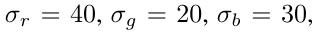respectively. The input standard derivation of the noise for the concatenated WNNM method is set as the Root Mean Square (RMS) of those in each channel, i.e., 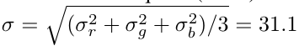. From Fig. 1, one can see that the concatenated WNNM method treating each channel equally would remain some noise in the R and B channel, while over-smoothing the G channel of the degraded image. Hence, if the patches of different channels are treated adaptively in the concatenated vectors, the degraded color images would be recovered with better visual qualities.

In order to process each channel differently while still exploiting the joint structures of the color images, in this paper, we introduce a weighting matrix $\mathbf{W}$ to the concatenated WNNM method. The weights $\bm{w}$ for the singular values of $\mathbf{X}$, then the proposed multi-channel WNNM (MC-WNNM) model is

In [24] and this paper, the weight vector $\bm{w}$ is set as 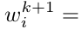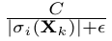where 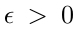 is a small number to avoid zero numerator. Note that if , the proposed MC-WNNM model will be reduced to the concatenated WNNM model as a special case. The setting of the weighting matrix W and the solution of the proposed
MC-WNNM model will be introduced in the next subsections.

  - The Setting of Weighting Matrix W

For simplicity, in this paper, we assume the noise are independent among the R, G, B channels and i.i.d. in each channel. Assume the noisy patch matrix Y= 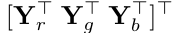, where 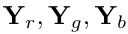 are matrices of similar patches in R, G, B channels, respectively. The corresponding clean matrix 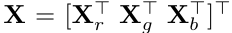
, where are similarly defined. Therefore, the weighting matrix W is diagonal and can be determined under the Bayesian framework:

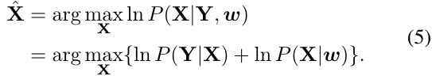

The log-likelihood term is characterized by the
statistics of noise, which is assumed to be channel-wise independent white Gaussian with standard deviations 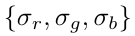
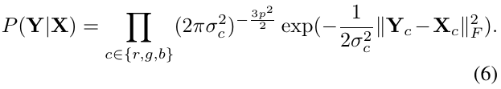

We assume that the matrix X follows the following distribution
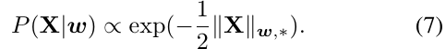
Putting (7) and (6) into (5), we have
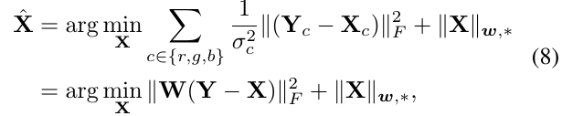
Where
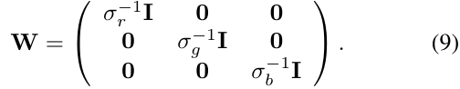
where is the identity matrix. Hence, the weighting matrix W is determined to contribute equal weights for the pixel values in the same channel, while different weights for those in different channels. The experimental (which will be introduced later) results have already demonstrated that this form of weighting matrix have already generated the best denoising performance on synthetic and real noisy images in benchmark datasets.

  - Optimization

The proposed MC-WNNM model could not be solved in an analytical form while the original WNNM model [24] could. In the WNNM model, when the weights on singular values are non-descending, the weighted nuclear norm proximal operator [24] can have global optimum with closed-form solution. However, such property is not valid for the multi-channel WNNM model. The reason is that the weighting matrix W is added to the rows of matrix X instead of its singular values. Besides, the elements in W is not in a non-descending order with respect to the singular value of X. This makes the proposed model more difficult to solve when compared to the original WNNM model.
By introducing an augmented variable Z, the MC-WNNM model is reformulated as a linear equality-constrained problem with two variables X and Z:
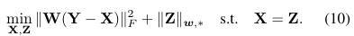

Since the objective function is separable across the two variables, the problem (10) can be solved under alternating direction method of multipliers (ADMM) framework. We can derive its augmented Lagrangian function:
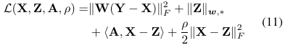
where A is the augmented Lagrangian multiplier and
is the penalty parameter. We initialize the matrix variables X₀, Z₀, and A₀ to be zero matrix of suitable size. By taking derivative of the Lagrangian function L with respect to the variables X and Z and setting the derivative function to be zero, we can alternatively update the ADMM algorithm iteratively as follows:
- Update X while fixing Z and A:
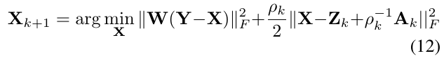
This is a standard least squares regression problem with closed-form solution:
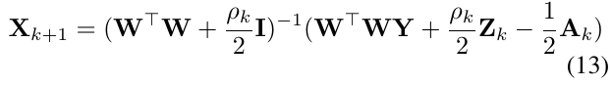
- Update Z while fixing X and A:
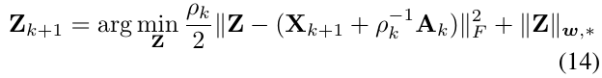
According to the Theorem 1 in [24], given the 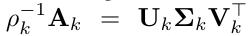be the SVD of 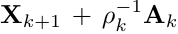
, where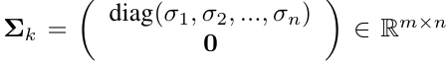then the global optimum of the above problem is 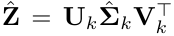, where 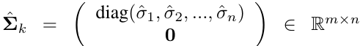and 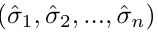 is the solution to the following convex optimization problem:
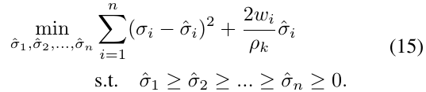
According to the Remark 1 in [24], the problem above has closed-form solution
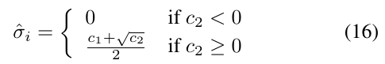
where