**CS5720**

**Neural Networks & Deep Learning - ICP-2**

**Name: Sai Krishna Reddy Chevutukur**

**#700: 700743830**

**Username: SXC38300**

**Github Link**: <https://github.com/csk17/NNDL_ICP2>

**Question 1:**

Solution:

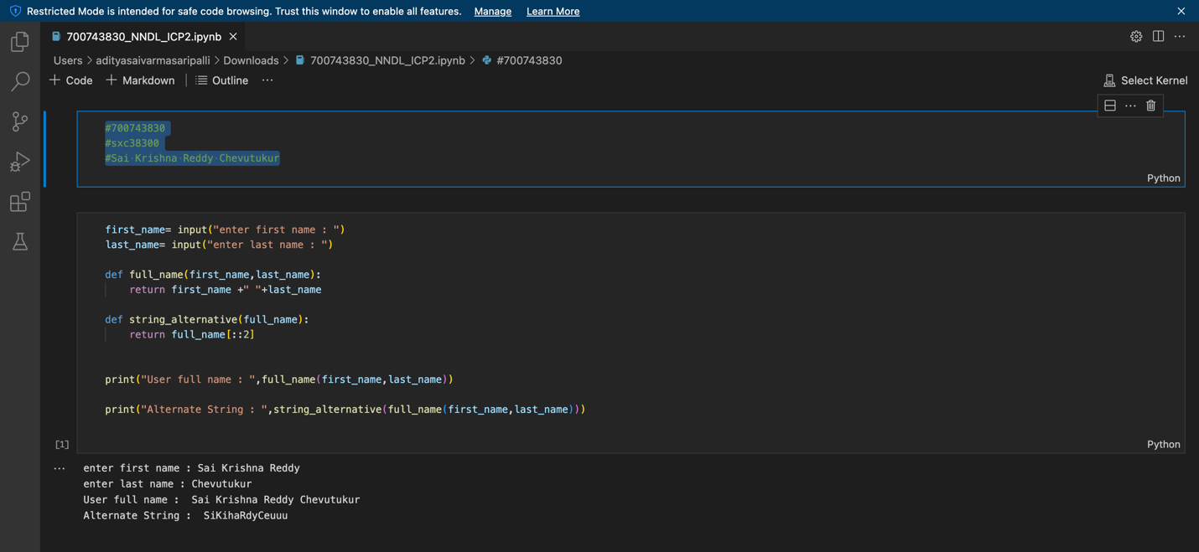

* Here, we are entering both the first and last name using user input.
* We are combining both the first and last name by defining the function named full_name.
* Now, the string_alternative function is defined for splitting the full_name with [::2].
* Now, printing the alternative string.

Question 2:

Solution:

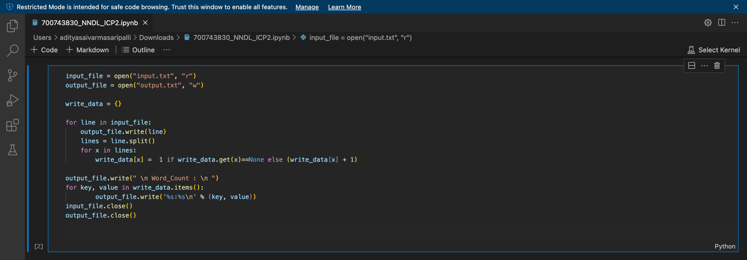

* We are creating an input file as input.txt in read mode.
* We initially write the data in it.
* Now, we need to split the lines in the input file.
* We supposed to write the data in that input file by using the write() function.
* After all this we need to close the file by using close() function.

Question 3:

Solution:

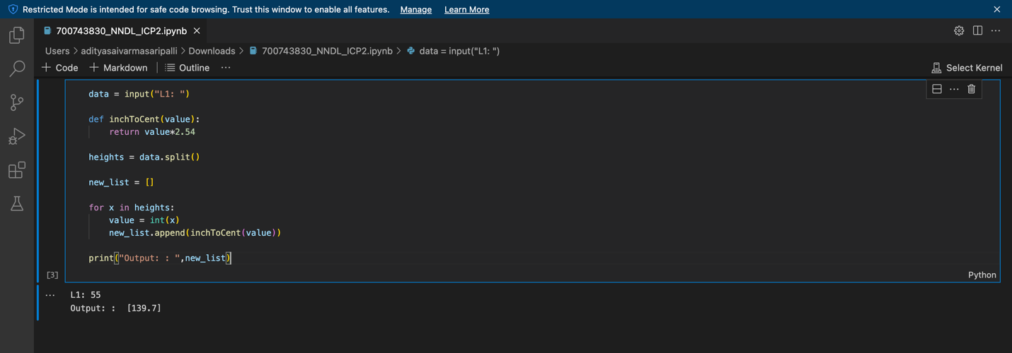

* In this one we need to convert the inches to centimeters.
* So, we are defining the inchToCent function to return the value with *2.54 from the user input list.
* Now, print the output.