TCS Agentic AI
High-Level & Low-Level Design
──────────────────────────────
Agent on Every Cluster — AI-Native Multi-Cluster Platform
Architecture: MCP Hub + Spoke with Three-Tier Fabric
Date: June 15, 2026
Audience: Architects · Platform Engineers · Reviewers
Classification: Internal — Architecture Document

Table of Contents
1. System Overview
2. High-Level Design (HLD)
2.1 System Context Diagram
2.2 Logical Layers
2.3 Agent on Every Cluster Model
3. Component Inventory
3.1 Frontend (Console)
3.2 Backend (MCP Server)
3.3 Data Stores
4. Technology Stack
5. Low-Level Design (LLD)
5.1 Three-Tier Communication Fabric
5.2 Request Flow — AI Chat on a Spoke
5.3 Per-Tool Invocation (invokeOrDirect)
5.4 Cluster Registration Flows
5.5 Cross-Cluster Correlation Engine
5.6 MCP Operational Modes
6. Data Model
7. Deployment Topology
8. Security & Isolation Design
9. Design Decisions & Rationale

1. System Overview
TCS Agentic AI lets a single operator manage a fleet of OpenShift/Kubernetes clusters through one console — running AI-driven chat, dashboards, audit, and autonomous remediation identically on every cluster, hub or spoke.
The platform is split into two planes and runs the same MCP server image on every cluster (the only difference is one environment variable, MCP_MODE):
Plane | Where | What Runs
Management Plane | Hub cluster, deployed once | React console + Control Plane MCP server + PostgreSQL + Redis
Data Plane | Every cluster (including hub) | One stateless MCP server pod (MCP_MODE=spoke) with the full toolset, executing live against its own cluster

KEY PROPERTY
▶ Same image everywhere — one artifact to build, scan, and ship
▶ Identical capabilities — AI Chat, fix proposals, lifecycle cards render identically on hub and spokes
▶ Differentiated by MCP_MODE env var only — hub / spoke / control / standalone

2. High-Level Design (HLD)

2.1 System Context Diagram
The system context shows how the platform operator interacts with the Hub, which manages a fleet of spoke clusters via the three-tier communication fabric.
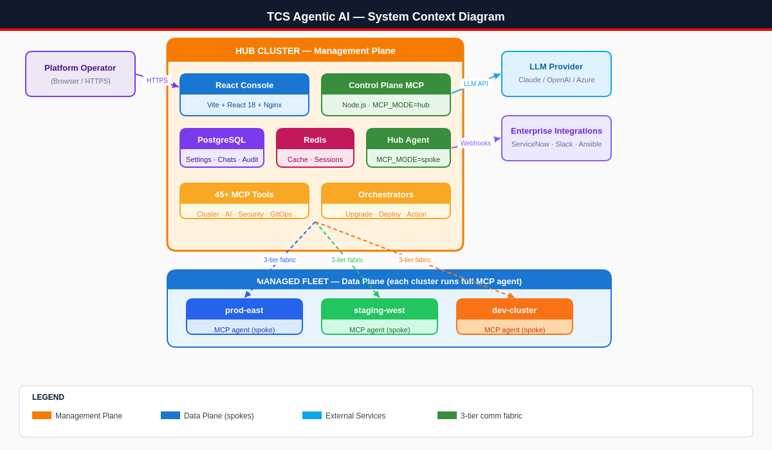
Figure 1: System Context — Hub Management Plane + Spoke Data Plane + External Services

2.2 Logical Layers
The architecture is organized into five logical layers:
Layer | Components | Responsibility
Presentation | Views (Dashboard, AI Chat, Audit, AI Intelligence), Zustand stores, TanStack Query | User interface, state management, cluster-keyed data fetching
API | Universal Request Router (src/index.js), Auth & RBAC, Cluster-Context Router | HTTP handling, authentication, per-request cluster routing via AsyncLocalStorage
Services | Chat / NLU / Reasoning, Orchestrators, Intelligence, 45+ MCP Tools | Business logic — AI reasoning, multi-step workflows, tool execution
Communication | Spoke Proxy, Direct Access, Agent Bridge (SSE) | Three-tier fabric connecting hub to every spoke cluster
Persistence | PostgreSQL, Redis, In-memory registries | Durable state, caching, fast lookups

2.3 Agent on Every Cluster Model
Every cluster is a full peer: it runs the complete MCP server with all 45+ tools and executes scans, log reads, metrics, and AI reasoning locally. The hub is simply the peer that also hosts the console, database, and fleet-wide orchestration.
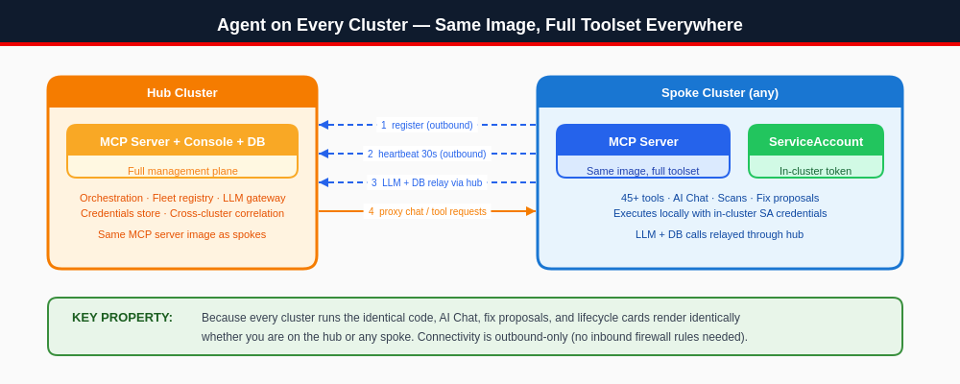
Figure 2: Agent on Every Cluster — Same Image, Full Toolset, Outbound-Only Connectivity
- Connectivity is outbound-only — spokes dial the hub, no inbound firewall rules needed on managed clusters
- LLM API keys + DB credentials stay on the hub — spokes relay through /api/llm/relay and /api/db/query
- A spoke failure affects only that cluster; hub and other spokes keep working

3. Component Inventory

3.1 Frontend (Console)
Location: console/ — built with Vite, served by Nginx (console/Dockerfile).
Component | Files | Responsibility
App Shell | src/App.jsx, src/main.jsx | Header, 4-tab nav, back pill, brand, routing
Views | src/views/*.jsx | Dashboard, AI Chat, Audit, AI Intelligence, AI Hub, Cluster Picker
Widgets | src/components/widgets/*.jsx | 19 dashboard widgets (health, nodes, pods, operators, alerts, risk, capacity, topology, heatmap, etc.)
Components | src/components/*.jsx | Login overlay, Settings panel, Agent registry, Command palette, Toast stack, User mgmt
State Stores | src/store/*.js | Zustand: authStore, clusterStore, chatStore, themeStore, toastStore, viewStore, healthHistoryStore
Data Layer | src/hooks/useClusterQuery.js, src/api/client.js | TanStack Query wrapper — keys every query to active cluster; API client injects cluster context
Design System | src/design/ | Shared tokens + components: StatusDot, SeverityBadge, ExpandableSection, ConfirmDialog, ActionCard, ProgressTimeline

The 4 primary tabs (per CLAUDE.md design contract):
Tab | View | Highlights
Dashboard | DashboardView.jsx | 16+ live widgets
AI Chat | ChatView.jsx + ChatTokens.jsx | Conversation, fix proposals, ServiceNow & upgrade cards
Audit | AuditView.jsx | Compliance trail, CIS scoring, change requests
AI Intelligence | IntelligenceView.jsx | Risk predictions, anomaly detection, knowledge base, cross-cluster correlation

3.2 Backend (MCP Server)
Location: src/ — Node.js 20 ESM, no web framework (raw http server). Entry point: src/index.js (~6,500 lines).
Module Group | Location | Responsibility
Entry / Router | src/index.js | HTTP server, universal request routing, cluster-context resolution, all REST endpoints
Chat & AI | src/services/chat-api.js (~17k lines), nlu*.js, reasoning.js, task-planner.js | NLU, tool selection, agentic loop, rich-card responses
Orchestrators | src/services/upgrade-orchestrator.js, deployment-orchestrator.js, action-workflow.js | Multi-step workflows with cluster-context wrapping
Communication Fabric | src/services/spoke-proxy.js, agent-bridge.js, cluster-credentials.js, openshift-client.js | The three tiers (Spoke Proxy, Direct Access, Agent Bridge)
Intelligence | src/services/cross-cluster-correlation.js, predictive-intel.js, proactive-agent.js, incident-rag.js | Multi-cluster correlation, predictions, RAG, learning
Tools | src/tools/*.js (45+ files) | Cluster, pods, nodes, security, compliance, GitOps, Velero, KubeVirt, network, etc.
Platform | src/platform/*.js | Distro detection, K8s client, intent router, provider adapters
Integrations | src/services/integrations.js, notifications.js, chatops.js | ServiceNow, Slack, Teams, PagerDuty, Ansible, webhooks
Persistence | src/utils/db.js, cache.js, state-store.js | PostgreSQL pool, Redis cache, state abstraction
Security | src/security/command-validator.js, guardrails.js, safety.js, redaction.js, auth.js | Command validation, guardrails, secret redaction, auth/RBAC

3.3 Data Stores
Store | Type | Holds
PostgreSQL | Persistent (StatefulSet PVC) | Settings, chat history, audit log, change requests, incidents, knowledge base, cluster_credentials, cluster_snapshots, silenced_alerts
Redis | Cache | Sessions, hot dashboard data, rate-limit counters
In-memory registries | Process memory (rebuilt from DB on boot) | _connectedAgents, _spokes, _channels (SSE), credential cache

4. Technology Stack

4.1 Frontend
Concern | Technology | Version
UI Framework | React | 18.3
Build Tool | Vite | 6.0
Server State | TanStack Query | 5.62
Client State | Zustand | 5.0
Runtime Serving | Nginx (Alpine) | 1.27
Typography | Inter (UI), SF Mono / Fira Code (code) | —

4.2 Backend
Concern | Technology | Version
Runtime | Node.js (ESM) | ≥ 20
HTTP Layer | Native http (no framework) | —
MCP | @modelcontextprotocol/sdk | 1.12
K8s Client | @kubernetes/client-node | 1.4
Database | PostgreSQL via pg | 8.13
Cache | Redis via ioredis | 5.4
HTTP Client | undici | 6.21
Validation | zod | 3.24
YAML / Docs | js-yaml, docx, mammoth | —
Container | node:20-alpine, non-root UID 1001 | —

5. Low-Level Design (LLD)

5.1 Three-Tier Communication Fabric
The hub reaches every remote cluster through a priority waterfall. Tier 1 (full spoke agent) is the intended steady state; Tiers 2–3 are graceful degradation paths.
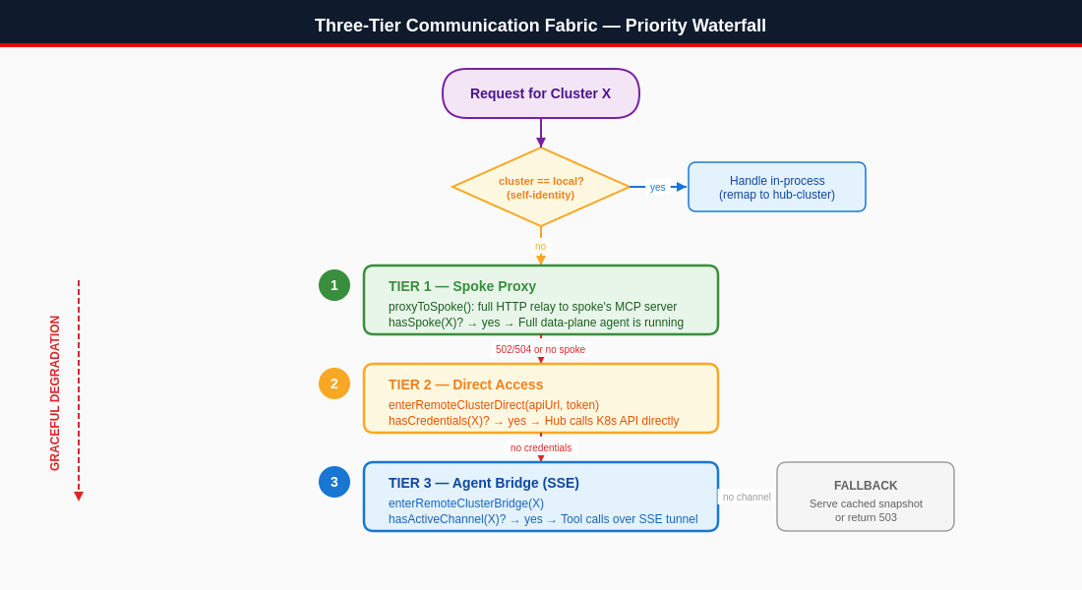
Figure 3: Three-Tier Communication Fabric — Priority Waterfall with Graceful Degradation
Tier | Mechanism | Module | When It's Used
1 — Spoke Proxy | HTTP relay to spoke's MCP server | spoke-proxy.js (hasSpoke, proxyToSpoke) | Cluster runs a full MCP agent pod (primary state)
2 — Direct Access | Hub calls K8s API with stored apiUrl + token | cluster-credentials.js, openshift-client.js | Cluster registered via dashboard, agent not yet deployed
3 — Agent Bridge | SSE reverse tunnel for tool requests | agent-bridge.js (hasActiveChannel, invokeAgentTool) | Spoke behind NAT, cannot expose an HTTP URL

Routing context is set per-request via AsyncLocalStorage in openshift-client.js, so every downstream ocpGet/ocpFetch automatically targets the right cluster without threading parameters through every function.

5.2 Request Flow — AI Chat on a Spoke
The following sequence shows how a user query on a spoke cluster flows through the system:
Chat Request Sequence: "Show pods on prod-east"
End-to-end flow through hub proxy to spoke execution
① User types query in Console
② Console → POST /api/chat?cluster=prod-east → Hub MCP
③ Hub performs self-identity check (CLUSTER_NAME vs cluster)
④ Hub: hasSpoke(prod-east)? → yes → proxyChatToSpoke()
⑤ Spoke runs full toolset locally (in-cluster SA token)
⑥ Spoke → invokeOrDirect → get_pods (live K8s API call)
⑦ Spoke → LLM reasoning (relayed via hub) → structured response
⑧ Hub returns identical rich JSON (cards, fix proposals) → Console renders

5.3 Per-Tool Invocation (invokeOrDirect)
When the spoke is unavailable and the cluster is reached via Tier 2 or 3, chat tools resolve through invokeOrDirect() in chat-api.js:
Condition | Action | Example
hasActiveChannel(X)? | invokeAgentTool over SSE | Tool call relayed through reverse SSE tunnel
hasCredentials(X)? | withClusterDirect → K8s REST call | get_pods → GET /api/v1/namespaces/NS/pods
Neither available | Return null → fall back to cached data | Serve last known cluster_snapshots from DB

Direct-access tool mapping:
get_pods → GET /api/v1/namespaces/{ns}/pods
get_logs → GET /api/v1/namespaces/{ns}/pods/{name}/log
list_resources → GET /apis/{apiGroup}/{version}/{kind}
describe → Full GET + field extraction

5.4 Cluster Registration Flows
Two paths to register a cluster:
Path A — Dashboard Direct Registration
User enters name + apiUrl + token/kubeconfig via ConnectClusterModal
① POST /api/hub/clusters — user submits cluster credentials
② Connectivity test: GET /api/v1/namespaces?limit=1
③ Store in cluster_credentials DB + _connectedAgents
④ Generate agent YAML for full upgrade (deploy to become Tier 1)

Path B — Spoke Self-Registration (full agent)
Agent pod boots with MCP_MODE=spoke and self-registers to hub
① POST /api/spoke/register { clusterName, spokeUrl }
② registerSpoke → _spokes + _connectedAgents
③ Heartbeat every 30s → POST /api/spoke/heartbeat
④ Receives LLM relay config back from hub

Registration endpoints:
Endpoint | Method | Purpose
/api/hub/clusters | POST | Dashboard registration → stores credentials, tests connectivity
/api/spoke/register | POST | Spoke self-registers its HTTP URL
/api/spoke/heartbeat | POST | 30s liveness + version; self-heals registry after restart
/api/agent/report | POST | Agent pushes periodic cluster snapshot
/api/agent/channel | GET (SSE) | Opens the Tier-3 reverse tunnel
DELETE /api/agent/:name | DELETE | Removes cluster from all registries (agents, spoke, credentials, snapshot)

5.5 Cross-Cluster Correlation Engine
src/services/cross-cluster-correlation.js detects incidents that span clusters — something no single-cluster tool can see.
Signal Sources:
- Cluster snapshots DB (pods, operators, nodes, events)
- Live proactive insights (in-memory anomalies)
- incident_history DB (last 1 hour)

Scoring rules:
Rule | Score Boost | Description
Same issue type | +50 | Both clusters have the same issue category
Similar symptoms | +30 | Symptoms text partially matches
Same operator | +40 | Identical operator affected across clusters
Same namespace | +20 | Issue in same logical namespace
Within 10 minutes | +30 | Strong temporal correlation
Within 30 minutes | +10 | Moderate temporal correlation

A pair scoring ≥50 forms a correlation group. The "Investigate" button triggers on-demand LLM root-cause analysis across the correlated clusters.
Example: CrashLoopBackOff on prod-east at 10:02 + same image failing on staging-west at 10:04 → surfaced as one correlated incident ("likely bad image push").

5.6 MCP Operational Modes
A single MCP server image supports four operational modes, controlled by one environment variable:
Mode | Role | Behavior
hub (default) | Central management | Receives registrations, proxies, runs orchestrators, serves console
spoke | Remote full agent | Registers to hub, serves data-plane locally, relays LLM/DB through hub
control | Stateless control plane | No direct K8s access — requires agent pods for all cluster data
standalone | Single cluster | No federation; everything local

6. Data Model

6.1 Key PostgreSQL Tables
Table | Purpose | Notable Columns
cluster_credentials | Tier-2 direct-access creds | cluster_name (PK), api_url, token, platform, display_name, updated_at
cluster_snapshots | Latest report per cluster (warm boot) | cluster, report (JSON), reported_at
incident_history | Historical incidents for correlation/RAG | cluster, issue_type, issue_signature, resource_name, namespace, severity, occurred_at
silenced_alerts | Per-cluster alert silences | name, namespace, cluster, silenced_at, expires_at
settings, chats, audit, CRs, KB | Platform state | Per-feature schemas

6.2 In-Memory Registries
Rebuilt from PostgreSQL on boot:
Registry | Structure | Keyed By | Used For
_connectedAgents | Map | cluster name | Cluster cards + latest report snapshot
_spokes | Map | cluster name | Tier-1 HTTP proxy URL + health
_channels | Map | cluster name | Tier-3 SSE response + tool registry + pending requests
credential cache | Map | cluster name (lowercase) | Fast Tier-2 lookups

6.3 Connection-Type Derivation
The cluster card badge shows how the hub currently reaches a cluster:
connectionType = hasCredentials(cluster) ? "direct"
: hasActiveChannel(cluster) ? "agent"
: "spoke"

7. Deployment Topology
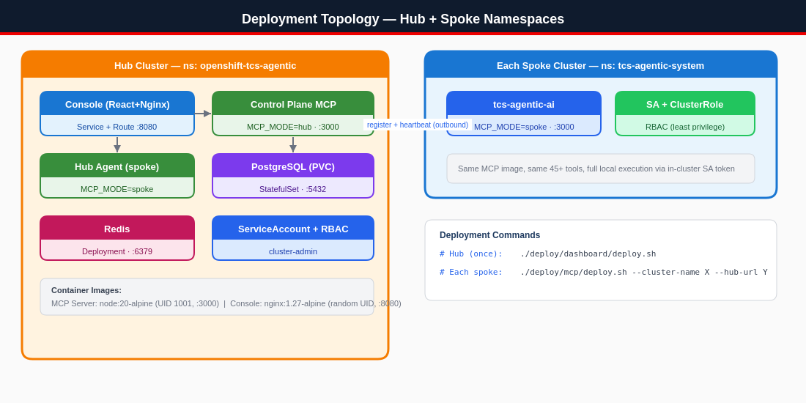
Figure 4: Deployment Topology — Hub and Spoke Kubernetes Namespaces
Deployment commands:
Step | Command | Runs
Management bundle (once) | ./deploy/dashboard/deploy.sh | Console + Control Plane + PostgreSQL + Redis
Cluster agent (every cluster) | ./deploy/mcp/deploy.sh --cluster-name <name> --hub-url <url> | One stateless MCP spoke pod

Container images:
Image | Base | User | Port
MCP Server | node:20-alpine | non-root UID 1001 | 3000
Console | nginx:1.27-alpine | random OpenShift UID (writes to /tmp) | 8080

8. Security & Isolation Design
Concern | Design
Connectivity | Outbound-only from spokes → hub. No inbound firewall holes on managed clusters.
Credential Isolation | LLM API keys + DB credentials stay on the hub. Spokes relay LLM/DB calls through /api/llm/relay and /api/db/query. No secrets leave the hub.
In-cluster Auth | Each spoke uses its own ServiceAccount token (in-cluster) scoped by a least-privilege ClusterRole generated per platform.
Blast-radius Containment | A spoke failure affects only that cluster; hub and other spokes keep working.
Command Validation | src/security/command-validator.js + guardrails.js + safety.js validate/guard every mutating action.
Secret Redaction | redaction.js scrubs secrets from logs and LLM prompts.
AuthN/AuthZ | auth.js — password + token login (LoginOverlay), RBAC in Settings.
Per-cluster Isolation | Frontend keys all queries + chat state to the active cluster (useClusterQuery, chatStore); backend scopes via ?cluster= + X-Cluster-Context.
Self-healing | Heartbeats re-register spokes after hub or spoke restarts; registries rebuild from PostgreSQL on boot.

9. Design Decisions & Rationale
# | Decision | Rationale
1 | Same image on every cluster (MCP_MODE switch) | Guarantees identical capabilities and identical UI on hub and all spokes; one artifact to build, scan, and ship.
2 | Three-tier waterfall (proxy → direct → bridge) | Full-agent spokes are ideal, but the platform still delivers value the instant a cluster is registered with just a token (Tier 2) and works through NAT (Tier 3).
3 | Outbound-only registration | Matches ArgoCD / RHACM / Rancher; avoids inbound firewall changes — the #1 enterprise onboarding blocker.
4 | AsyncLocalStorage for cluster context | Per-request routing without threading a cluster param through thousands of lines; downstream ocpFetch "just works."
5 | Credentials + snapshots in PostgreSQL | Warm boot (dashboards have data immediately), survives hub restarts, single source of truth rebuilt into in-memory registries.
6 | LLM/DB relay through hub | Keeps all secrets centralized; spokes never hold API keys or DB credentials.
7 | Cross-cluster correlation | A differentiator no single-cluster tool offers — turns fleet-wide noise into one root-caused incident.
8 | Raw Node http (no framework) | Minimal dependency surface, smaller image, full control over the universal router and SSE channels.

— End of Document —
TCS Agentic AI — HLD/LLD Architecture Document
Generated by TCS KubeNexus AI Platform

