TCS Agentic AI
Multi-Cluster Network Architecture
──────────────────────────────
SNO Hub + 3-Node Agent Cluster Connectivity
Prepared for: Network Engineering Team
Date: May 28, 2026
Classification: Internal — Infrastructure

Table of Contents
1. Executive Summary
2. Current Environment
3. Architecture Overview
4. Architecture Diagram
5. Network Connectivity Requirements
6. Firewall Rules Matrix
7. DNS Requirements
8. TLS / Certificate Requirements
9. Agent Communication Protocol
10. Deployment Topology
11. Bandwidth & Performance
12. Security Considerations
13. Validation & Testing Plan

1. Executive Summary
This document outlines the network architecture and connectivity requirements for extending the TCS Agentic AI platform from a Single Node OpenShift (SNO) deployment to a multi-cluster configuration.
KEY FACTS
■ Hub Cluster: SNO at 10.131.71.72 — runs TCS Agentic AI MCP Server
■ Agent Cluster: 3-node at 10.131.73.21-23 — runs lightweight monitoring agent
■ Key Ports: TCP 3000 (Hub API), TCP 6443 (K8s API), TCP 443 (HTTPS Route)
■ Protocol: Standard HTTP/HTTPS over TCP — no VPN, no message queues, no special infrastructure

2. Current Environment

2.1 SNO Hub Cluster (Existing)
Parameter | Value
Cluster Type | Single Node OpenShift (SNO)
Node IP | 10.131.71.72
Role | MCP Hub — central management plane
Namespace | openshift-mcp
MCP Server Pod Port | 3000 (MCP_SERVER_PORT)
Exposed via | OpenShift Route (HTTPS, TLS edge termination)
Components | MCP Server, Dashboard, AI Chat, Multi-Cluster Hub, PostgreSQL

2.2 3-Node Agent Cluster (New)
Parameter | Value
Cluster Type | 3-Node OpenShift Cluster (HA)
Control Plane / Master | 10.131.73.21
Worker Node 1 | 10.131.73.22
Worker Node 2 | 10.131.73.23
Role | Managed Agent — reports cluster state to Hub
Agent Namespace | openshift-mcp-agent
Agent Pod Port | 8080 (health/status endpoints)
Kubernetes API | https://api.<cluster>:6443

3. Architecture Overview
The multi-cluster architecture follows a Hub-and-Spoke model. Communication is agent-initiated (outbound). The Hub never initiates connections to the agent pod.
- Hub (SNO): Runs the TCS Agentic AI MCP Server. Hosts the unified dashboard, AI chat, and all management tools.
- Agent (3-Node): Runs a lightweight agent pod that scans the local cluster every 60 seconds and pushes reports to the Hub via HTTP POST.
- All communication uses standard HTTP/HTTPS over TCP. No VPNs, message queues, or special protocols required.

4. Architecture Diagram
The following diagram shows the high-level architecture with all components, communication paths, ports, and protocols.
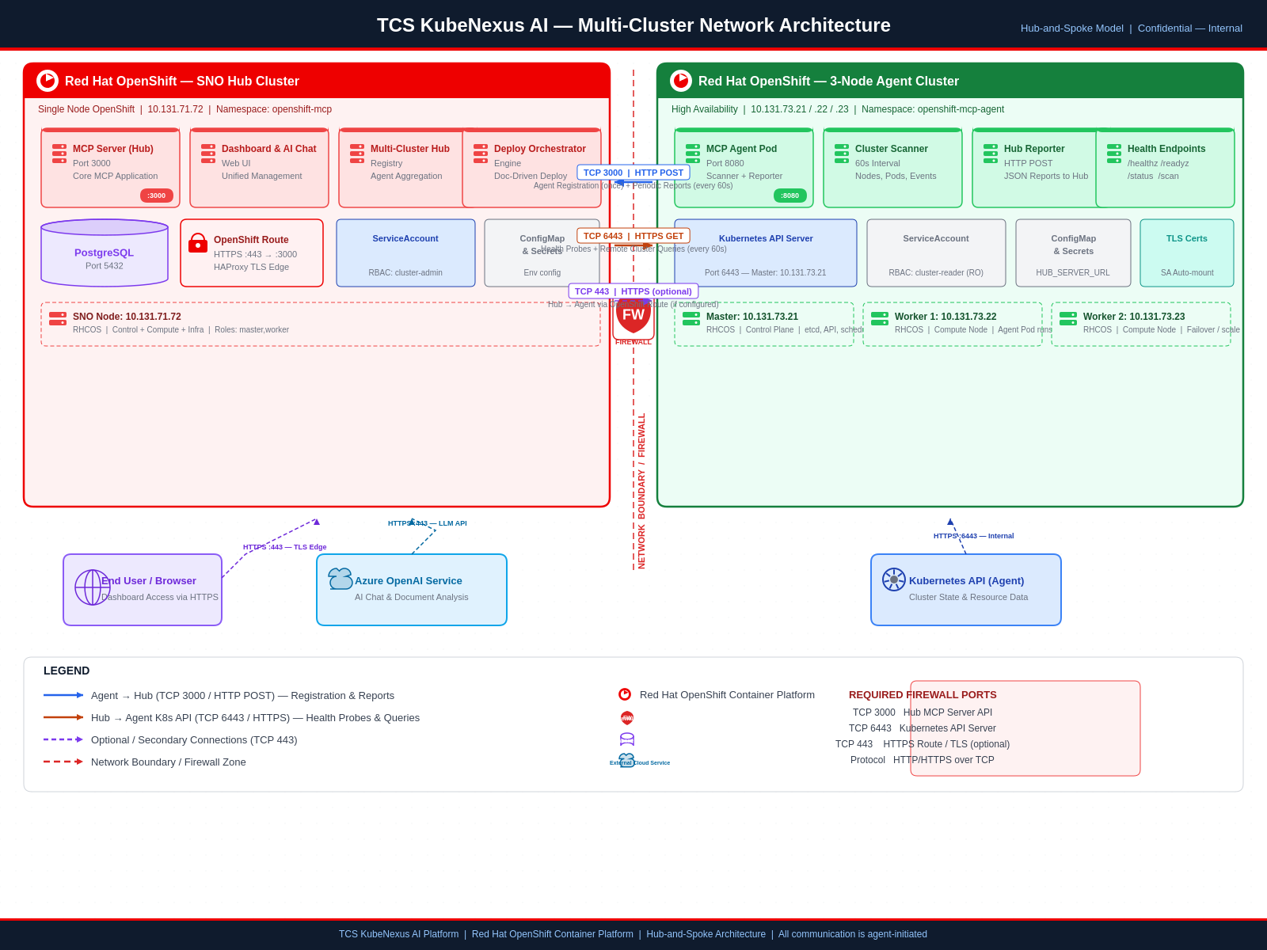
Figure 1: Hub-and-Spoke Multi-Cluster Architecture — SNO Hub + 3-Node Agent Cluster

5. Network Connectivity Requirements
All flows use TCP protocol. The following table lists all required network paths between the two clusters.

5.1 Primary Flows (Required)
# | Source | Destination | Port | Protocol | Direction | Purpose
1 | Agent Pod (10.131.73.x) | Hub SNO (10.131.71.72) | 3000/TCP | HTTP | Agent → Hub | Agent registration & periodic reports
2 | Hub SNO (10.131.71.72) | K8s API (10.131.73.21) | 6443/TCP | HTTPS | Hub → Agent | Health probes & remote cluster queries
3 | Agent Pod (10.131.73.x) | K8s API (10.131.73.21) | 6443/TCP | HTTPS | Internal | Agent scans local cluster API

5.2 Optional Flows
# | Source | Destination | Port | Protocol | Direction | Purpose
4 | Agent nodes (10.131.73.x) | Hub Route (10.131.71.72) | 443/TCP | HTTPS | Agent → Hub | If agent uses HTTPS Route URL
5 | Browser (User) | Hub Route (10.131.71.72) | 443/TCP | HTTPS | External → Hub | Dashboard access
6 | Hub (10.131.71.72) | External LLM API | 443/TCP | HTTPS | Hub → Internet | Azure OpenAI for AI chat features

6. Firewall Rules Matrix
Apply the following firewall rules at the network boundary between the two cluster networks.

6.1 Required Rules
Rule ID | Source IP/CIDR | Destination IP | Port | Protocol | Action | Description
FW-01 | 10.131.73.21  10.131.73.22  10.131.73.23 | 10.131.71.72 | 3000 | TCP | ALLOW | Agent nodes → Hub MCP Server
FW-02 | 10.131.71.72 | 10.131.73.21 | 6443 | TCP | ALLOW | Hub → Agent K8s API server
FW-03 | 10.131.73.21  10.131.73.22  10.131.73.23 | 10.131.71.72 | 443 | TCP | ALLOW | Agent → Hub via OpenShift Route
FW-04 | 10.131.71.72 | 10.131.73.21 | 443 | TCP | ALLOW | Hub → Agent K8s API (if port 443)

6.2 CIDR-Based Alternative
Rule ID | Source CIDR | Destination CIDR | Port(s) | Protocol | Action
FW-ALT-01 | 10.131.73.0/24 | 10.131.71.0/24 | 3000, 443 | TCP | ALLOW
FW-ALT-02 | 10.131.71.0/24 | 10.131.73.0/24 | 6443, 443 | TCP | ALLOW

7. DNS Requirements
Record Type | Hostname | Resolves To | Required By
A / CNAME | mcp-hub.apps.<sno-domain> | 10.131.71.72 (or Route VIP) | Agent cluster
A | api.<agent-domain> | 10.131.73.21 | Hub (remote K8s API)
A | *.apps.<agent-domain> | 10.131.73.21 or LB VIP | Hub (optional)
Note: If using IP-based connectivity, set HUB_SERVER_URL=http://10.131.71.72:3000 in the agent deployment.

8. TLS / Certificate Requirements
Connection | TLS Required | Certificate Source | Notes
Agent → Hub (:3000) | Optional (recommended) | OpenShift Route cert | HTTP if on trusted network; HTTPS via Route preferred
Hub → K8s API (:6443) | Yes (mandatory) | Agent cluster CA cert | Hub uses service account token + CA
Browser → Hub Route | Yes | OpenShift ingress cert | Standard HTTPS dashboard access
Agent → Local K8s API | Yes | Auto-mounted SA cert | Agent auto-detects /var/run/secrets/...

9. Agent Communication Protocol

9.1 Registration (One-Time on Startup)
POST /api/agent/register
Host: <HUB_SERVER_URL>
Content-Type: application/json
{
"clusterName": "production-3node",
"platform": "openshift",
"agentVersion": "1.0.0",
"capabilities": ["scan","events","metrics","openshift"]
}

9.2 Periodic Reports (Every 60 Seconds)
POST /api/agent/report
Timeout: 15 seconds
{ "clusterName": "production-3node",
"report": {
"nodes": { "total": 3, "ready": 3 },
"pods": { "total": 45, "running": 42 },
"deployments": { "total": 12, "available": 12 },
"events": { "warnings": 2, "recent": [...] }
} }

9.3 Connection Failure Handling
- If the agent cannot reach the Hub, it retries on the next scan interval (60s). No data is lost.
- If the Hub cannot reach the agent's K8s API, cluster status changes to 'unreachable' after 5 minutes.
- Agent registration is automatically re-sent if the Hub restarts.
- No persistent connection is maintained — all communication is stateless HTTP request-response.

10. Deployment Topology

10.1 Hub Deployment (SNO)
Component | Namespace | Type | Replicas | Port | Notes
MCP Server | openshift-mcp | Deployment | 1 | 3000 | Main application pod
PostgreSQL | openshift-mcp | StatefulSet | 1 | 5432 | Optional — chat history, audit
Route | openshift-mcp | Route | — | 443→3000 | TLS edge, 600s SSE timeout
Service | openshift-mcp | Service | — | 3000 | ClusterIP service

10.2 Agent Deployment (3-Node)
Component | Namespace | Type | Replicas | Port | Notes
MCP Agent | openshift-mcp-agent | Deployment | 1 | 8080 | Scanner + reporter
ServiceAccount | openshift-mcp-agent | SA | — | — | Cluster-reader RBAC
ClusterRoleBinding | — | CRB | — | — | Binds SA to cluster-reader role

10.3 Agent Environment Variables
Variable | Value | Description
HUB_SERVER_URL | http://10.131.71.72:3000 | Hub API endpoint the agent reports to
CLUSTER_NAME | production-3node | Unique name for this cluster in the Hub
CLUSTER_PLATFORM | openshift | Platform type
SCAN_INTERVAL | 60 | Seconds between cluster scans
LOG_LEVEL | info | Agent log verbosity
PORT | 8080 | Agent health endpoint port

11. Bandwidth & Performance Requirements
Metric | Value | Notes
Report payload size | 5–50 KB per report | Depends on cluster size (pods, events)
Report frequency | Every 60 seconds | Configurable via SCAN_INTERVAL
Bandwidth (sustained) | ~1–5 KB/s | Minimal — small JSON payloads
Health probe size | < 1 KB per probe | Simple GET request + response
Connection duration | < 1 second per request | Stateless HTTP, no persistent connections
Max concurrent connections | 1 per agent cluster | Sequential request-response
Network latency tolerance | < 15 seconds RTT | Agent report timeout is 15s

12. Security Considerations
- All agent-to-hub communication can be encrypted via HTTPS (OpenShift Route TLS edge termination).
- Agent uses a Kubernetes ServiceAccount with cluster-reader permissions only — cannot modify resources.
- Hub stores cluster tokens in-memory and optionally in PostgreSQL. Tokens are never exposed in API responses.
- Agent pods run as non-root (UID 1001) with read-only filesystem.
- No inbound ports need to be opened on the agent cluster for agent communication — agent initiates all connections.
- No VPN, service mesh, or special network infrastructure is required.

13. Validation & Testing Plan
After firewall rules are applied, validate connectivity with the following tests:
# | Test | Command (run from source) | Expected
1 | Agent → Hub (:3000) | curl -v http://10.131.71.72:3000/healthz  (from any agent node) | HTTP 200 OK
2 | Agent → Hub Route | curl -kv https://mcp-hub.apps.<domain>/healthz  (from agent node) | HTTP 200 OK
3 | Hub → Agent K8s API | curl -k https://10.131.73.21:6443/version  (from SNO node) | JSON with K8s version
4 | DNS resolution | nslookup mcp-hub.apps.<domain>  (from agent node) | Resolves to 10.131.71.72
5 | TCP port check | nc -zv 10.131.71.72 3000  (from agent node) | Connection succeeded
6 | TCP port check | nc -zv 10.131.73.21 6443  (from SNO node) | Connection succeeded
7 | End-to-end | Deploy agent pod → check Hub dashboard | Cluster appears in UI

— End of Document —
Generated by TCS Agentic AI Platform

