Motion Planning Standard Search Algorithm Report

Name- Chinmay Kate
mail id – cskate@wpi.edu

Question 1)

Advantages and Disadvantages of 4 different Sampling Methods.

- Uniform Sampling-
Adv- 1) As Samples are uniformly distributed it captures entire map for connectivity and finding path from start to goal is really easily.

Disadv- 1) As it doesn’t captures narrow passage and samples around the obstacles so this may not find more optimal path.

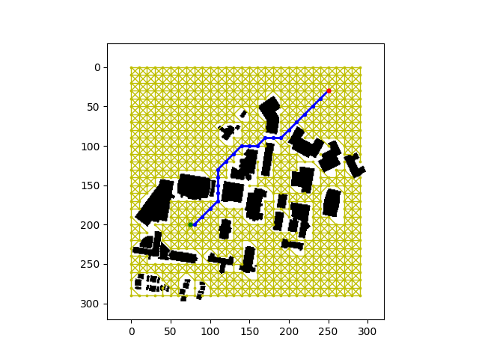
- Random Sampling
Adv- 1) As it generated random points, it may capture some of the narrow passage and points around the obstacles.
Disadv- 1) As it generates random samples may not capture all narrow passage and points around obstacles. Also it will be less optimal compared to rest.

- Gaussian Sampling

Adv- 1) It samples points around the edges of the obstables and thus provides good connectivity while finding roadmaps.

Disadv- 1) It may not capture all narrow passages and deviation of sampling needs to increase to capture good connectivity.
- Bridge Sampling

Adv- 1) It is most efficient among all this as it captures all the narrow passages and thus provides good connectivity.

Disadv-1) It still not is optimal and the path is not smooth.

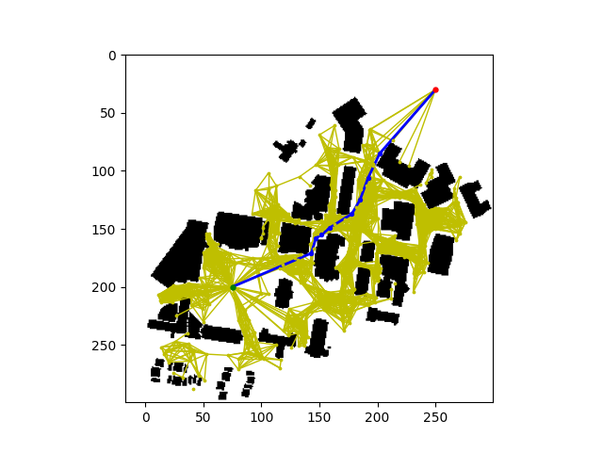

- RRT
RRT builds the tree where it samples random points with the bias and closest nodes gets connected to form the tree.

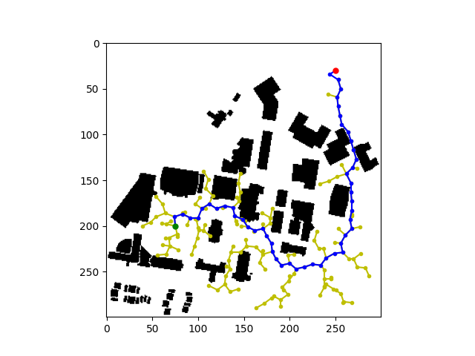

- RRT*
In RRT* same process is followed by rewiring where rewiring is done to the new points based on the cost and fixed radius from new point to the start node. Also neighbours are rewired.

Main Difference is the rewiring which improves the efficiency in the path and gives more optimal than the RRT.

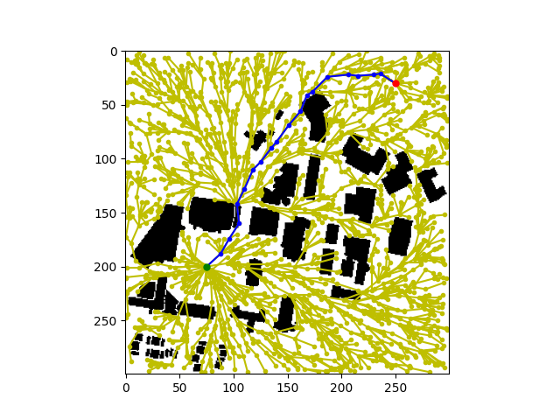

Difference in PRM and RRT

Single and multi query planning refers to the number of planning tasks you are about to execute. That means, the number of different paths you want to plan, given an unchanging environment.
PRM constructs a graph-structure (roadmap) of the free configuration space. Instead of exploring the c space every time you plan a path like RRT does, PRM is able to use the generated roadmap multiple times as long as the environment it is based on does not change.

References

Prof Jane Li Slides

