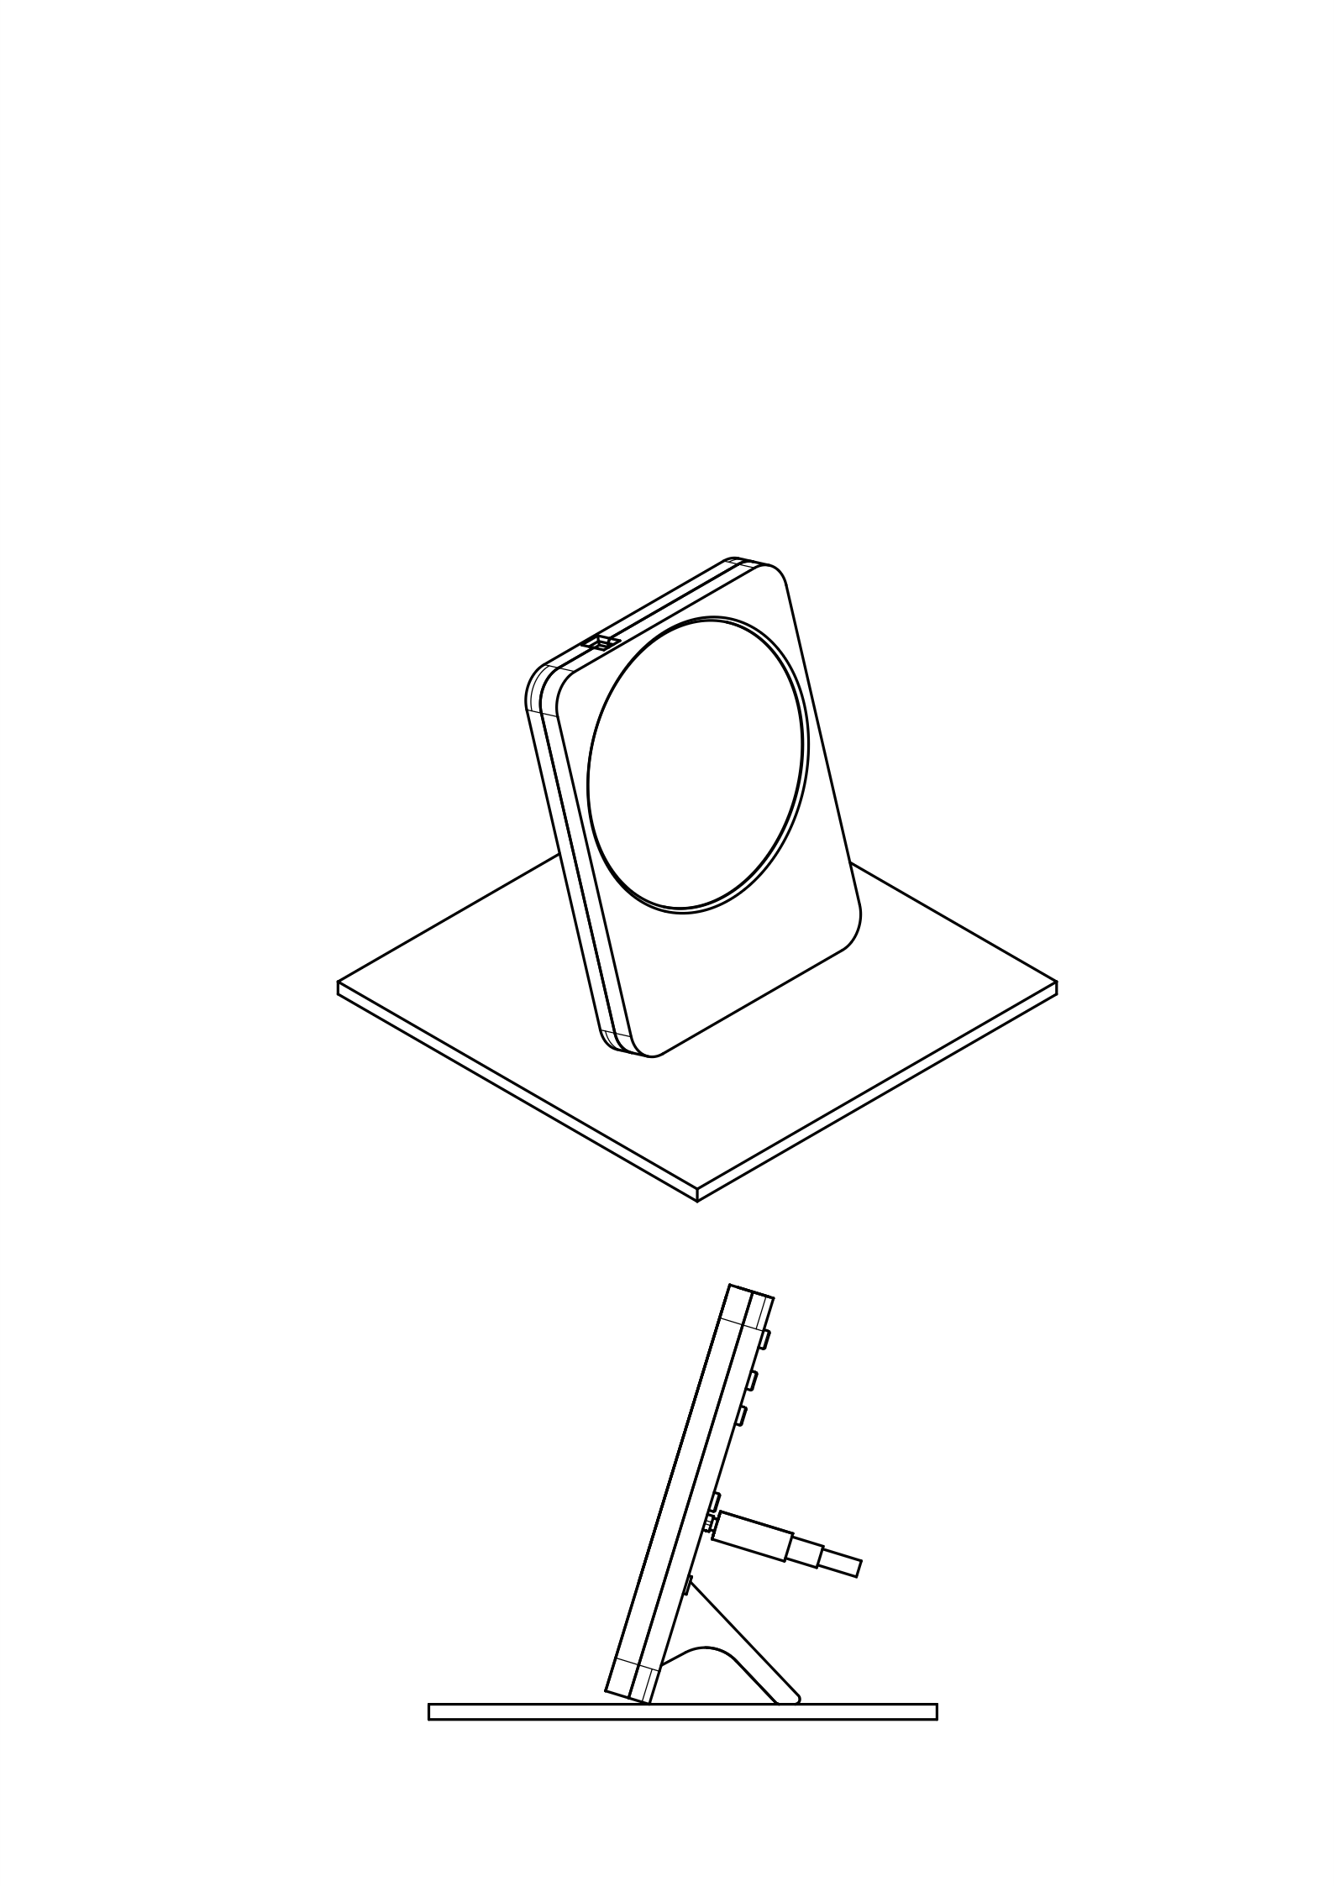
Clock Monsieur
Instructions

