# Project 2 Does the Stock Market Affect Housing Prices

**Members:**

* Edwin Brown
* Shane Kramer

**GitHub Repository:**

* <https://github.com/UC-Berkeley-I-School/Project2_Brown_Kramer.git>

**Primary Datasets:**

* S&P/Case-Shiller 10-City Composite Home Price Index <https://fred.stlouisfed.org/series/SPCS10RSA>
* [NASDAQ Composite](https://finance.yahoo.com/quote/%5EIXIC/history?period1=34560000&period2=1617062400&interval=1d&filter=history&frequency=1d&includeAdjustedClose=true)
* yFinance – Python library for retrieving historical data from Yahoo API
  + Dow Jones Industrial Average = “yf.download("^IXIC", start="1987-01-01", end="2020-01-01")”
  + S&P 500 = yf.download(”^GSPC ", start="1987-01-01", end="2020-01-01")”
  + Nasdaq = yf.download(”^IXIC ", start="1987-01-01", end="2020-01-01")”

**Initial Plots, Figures or Tables:**

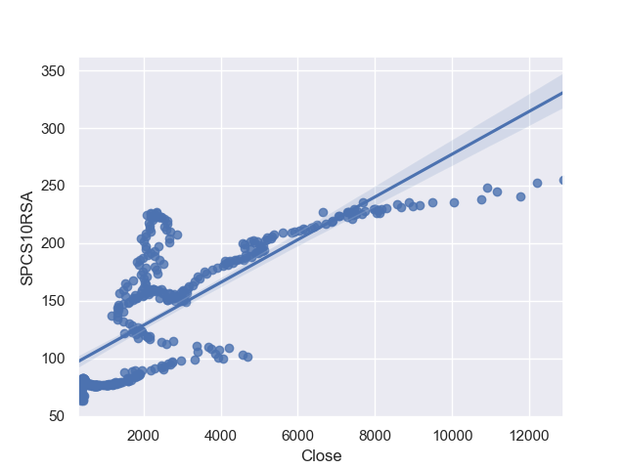**NASDAQ Closing Price in $ VS Case Shiller 10 City Composite Housing Index (Unitless)**

**Some of the variables**

* Dates from 1987-01-01 to 2021-01-01 (**Jan 2000 = 100)**
* Case Shiller 10 City Composite Housing Index
* Stock Market Index Open, High, Low, Close, ADJ Close, and Volume
  + NASDAQ
  + Dow Jones Industrial Averages
  + S&P 500
* Supporting Data
  + 30 year mortgage and jumbo mortgage rates (%)
  + 10 year treasury rates (%)
  + Dates of US Recessions (Dates)
  + Consumer Sentiment Index (**Q1 1996 = 100)**
  + Home Ownership Rates (%)
  + Recession probabilities (%)
* We will explore Major Indices closing prices with the Case Shiller 10 city Composite Housing index. If correlations are found, we will look for supporting information from supplemental data. Consumer Sentiment, Mortgage Rates, Recession Probabilities. To see if they provide further insight into the correlations.

**Supplemental datasets**

* 30 year Mortgage Rates <https://fred.stlouisfed.org/series/MORTGAGE30US>
* 30 year Jumbo Mortgage Rates <https://fred.stlouisfed.org/series/OBMMIJUMBO30YF>
* 10 year Treasury Constant Maturity Rate <https://fred.stlouisfed.org/series/DGS10>
* Consumer Sentiment <https://fred.stlouisfed.org/series/UMCSENT>
* Consumer Price Index for All Urban Consumers: All Items US City Average <https://fred.stlouisfed.org/series/CPIAUCSL>
* Smoothed U.S. Recession Probabilities [Smoothed U.S. Recession Probabilities (RECPROUSM156N) | FRED | St. Louis Fed](https://fred.stlouisfed.org/series/RECPROUSM156N)
* [Dates of U.S. recessions as inferred by GDP-based recession indicator (JHDUSRGDPBR) | FRED | St. Louis Fed](https://fred.stlouisfed.org/series/JHDUSRGDPBR)
* [Homeownership Rate for the United States (RSAHORUSQ156S)](https://fred.stlouisfed.org/series/RSAHORUSQ156S)

**What you plan to cover in the final report and how you plan to organize it.**

Does the Stock Market Value affect the housing prices? Compare Case Shiller 10 City Composite index to compare three major stock market indices (NASDAQ, DJIA, S&P500). We may want to include the 20 city composite and perhaps the national index to see if that makes a difference in correlations. Look for correlations within the data. Preliminary examination appears to show that for some ranges of prices there is, in fact, a correlation in the data. It might be useful separate out the ranges where the correlation appears strong or weak and look for other indicators which might explain the relation, or lack thereof. For example, in the NASDAQ plot. There are two distinct areas of potential correlation. Does any of our supporting data explain these?

We will organize the report starting with correlations of the major indices, if potential correlations are found these ranges will be isolated and we will examine if any of the correlating data supports these correlations or lack thereof.