**Trello Link:** https://trello.com/invite/b/v9hy6kEb/ATTIb886206d07d15629d17896594b86ba7597BA93B3/bp8-capstone-project

Home Page

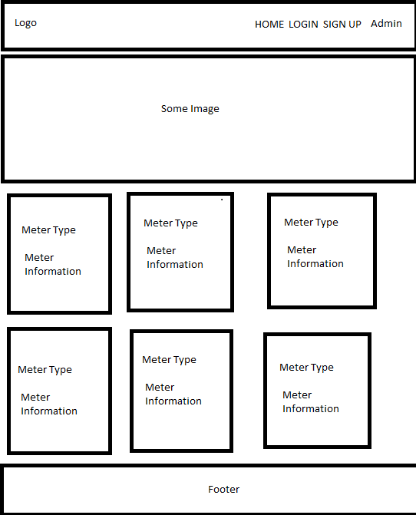

Shipping Address Name:

Street: City: Zip:

Qty:

Meters:

Select Configuration:

Purchase Order:

Customer Name: Secure Water

Customer Number: 1111W

Pricing Tier: Elite 50%

Shipping Address:

Secure Water

123 rd

Atlanta, Ga 30128

1. Qty: 2 Meter Type Price Delete/Update
   * + - 1. Configurations

1. Qty: 1 Meter Type Price Price Delete/Update
   * + - 1. Configurations

Customer Number: Auto Assigned

Enter Customer Name:

Enter Customer Phone:

Enter Customer Address:

Enter Customer Email:

Enter Customer Tier: (Associate, Premium, Elite)

Customer Password:

Database Tables:

