|  |  |
| --- | --- |
| **Name:** | **LIM CHEE SENG** |
| **Email:** | **Lim_chee_seng.mpa.gov.sg** |

**Question 1**

In your own words explain the 4 sub constraints in REST’s Uniform Interface. Give an everyday example to illustrate each of the constraint.

There are four guidelines principle of Uniform Interface are:

* **Resource-Based:** Individual resources are identified in requests. For example: API/users.
* **Manipulation of Resources Through Representations:** Client has representation of resource and it contains enough information to modify or delete the resource on the server, provided it has permission to do so. Example: Usually user get a user id when user request for a list of users and then use that id to delete or modify that particular user.
* **Self-descriptive Messages:** Each message includes enough information to describe how to process the message so that server can easily analyses the request.
* **Hypermedia as the Engine of Application State (HATEOAS):** It need to include links for each response so that client can discover other resources easily.

**Question 2**

What is the difference between the following HTTP methods?

1. POST, PUT and PATCH

POST is typically used for resource creation while PUT is used for resource updates. While this is fine in most cases it can be also viable to use PUT for resource creation. PATCH is an alternative for resource updates as it allows partial updates.

1. GET and HEAD

GET - To request a representation/data from the specified resource

HEAD - is identical to GET except that the server MUST NOT return a message-body in the response. The metainformation contained in the HTTP headers in response to a HEAD request SHOULD be identical to the information sent in response to a GET request.

**Question 3**

You have a monolithic web application for managing warehouses. The application exposes the following end points

* /warehouses – list of all warehouses
* /warehouse/<warehouse_id> – returns the warehouse’s details
* /warehouse/<warehouse_id>/inventories – inventory list for the warehouse
* /inventories – list of all the inventories
* /inventory/<inventory_id> – inventory detail
* /inventory/<inventory_id>/report – generate a report

Describe how you can scale this application

M1

M2

M3

DB

1. By duplication

By cloning more application servers hosting the business logic

M1

M2

M3

M1

M2

M3

DB

1. By functional decomposition

By breaking business modules into discrete microservices architecture

M3

M2

M1

DB (M3)

DB (M2)

DB (M1)

1. By data partitioning

By congregating semantically related data under various DB warehouse all linked by a smartlogic algorithm to retrieve relevant information across the databases.

M3

M2

M1

DB (M3)

DB (M2)

DB (M1)

**Question 4**

Study the top headlines REST API from newsapi.org. Answer the following questions

1. List the different ways you can present the API key when performing an invocation

You can attach your API key to a request in one of three ways:

* Via the apiKey querystring parameter.
* Via the X-Api-Key HTTP header.
* Via the Authorization HTTP header. Including Bearer is optional, and be sure not to base 64 encode it like you may have seen in other authentication tutorials.

1. Construct a URL to get 30 technologies headlines from Japan

GET https://newsapi.org/v2/top-headlines?country=jp&category=technology&pageSize=30

1. What is the status code if an incorrect API key is used?

401 - Unauthorized. Your API key was missing from the request, or wasn't correct.

1. How long will the result be cached?

3 min

**Question 5**

Study the following entity-relationship diagram

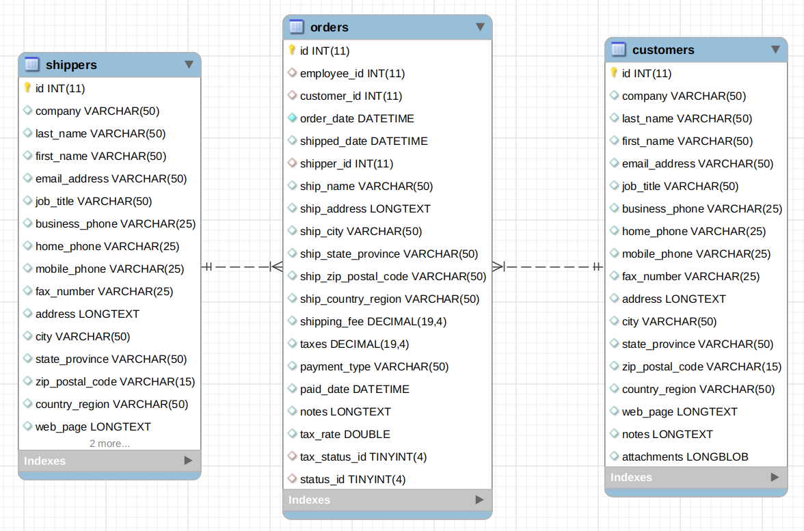

Both customer and shippers has a one to many relationships with orders.

Answer the following questions.

1. Design one or more API endpoints to return a list of customers and a single customer

GET /api/customers

GET /api/customer/{id}

GET /api/customer?search={search terms}

GET /api/customers?offset=10&limit=20

1. What are some criteria and how might you might include in your endpoint (wrt Q5a)?

fieldset

pagination

filtering

searching

1. Show a sample output of a customer’s list as a result of performing a GET on the resource. (wrt Q5a)

{

“customer”: [{

“id”: “1234”,

“company”:”ABC Pte Ltd”,

.........

}]

}

1. How do you provide flow control or pagination support (wrt Q5a)?

Introduce throttling for flow control with offset and limit parameters for pagination support.

**Question 6**

You have deployed a service to encode video viz. convert AVI to mp4, etc. Subscribers of your service uploads their video to the service; after conversion the converted video is returned to the subscriber (assume that the conversion time is short).

You charge the subscribers based on the 2 criteria.

1. Subscription rates based on the cumulative video sizes: 500GB, 1TB, 1.5TB, etc. A subscriber who subscribe to the 500GB package can upload a maximum amount of 500GB videos.
2. Charge the subscribe based on their ingress and egress traffic viz. the upload and downloads of the videos.

Design an API for this encoding service to give your subscribers control over their encoding process.

You can ignore authentication.

Rate limiting can be done. Based on how much data have transfered over 1 hour, when the limit is exceeds can provide a message in http to indicate to the user to upgrade to next available range and based on compression.

**Submission**

Copy this Word document to your repository and commit it.

git add .

git commit -m ‘worksheet01’

git push origin master