Txt Calculations

Software Requirements Specification (SRS)

Team Members:
Connor Small

Jasen Simedru

Chris Warren

Nick Kahlor
Revision History

Date | Revision | Description | Author
10/23/2017 | 1.0 | Initial Version | Connor
10/25/2017 | 1.1 | Added File Parser Class | Nick
10/27/2017 | 1.2 | All Functions working | Nick
10/28/2017 | 1.3 | All GUI components working | Connor
10/28/2017 | 1.4 | Help section finished | Jasen
10/30/2017 | 1.5 | Multiple file Support | Chris
10/30/2017 | 1.6 | Phase 1 final | All
11/3/2017 | 2.0 | Minor changes to backend work | Chris
11/4/2017 | 2.1 | Minor GUI enhancements | Connor
11/5/2017 | 2.2 | Phase 2 final | All
11/13/2017 | 3.0 | Added GUI components and support for combing files/removing punctuation | Connor
11/21/2017 | 3.1 | Added combine functionality and removing punctuation fuctionality | Chris, Nick
11/26/2017 | 3.2 | Phase 3 final | All

Table of Contents

- Project Overview 1
  - Overview 1
- Use Cases 2
  - Use Case Diagram 2
  - Use Case Scenarios 2
- Test Plan 3
  - Test Cases 3
- Project Plan 4
  - Plan for the First Deliverable 4
  - Plan for the Second Deliverable 4
  - Plan for the Third Deliverable 4

Project Overview

Overview
The purpose of this program is to import text document and run some basic calculations. The program will have a text field where the user will input the .txt file name in. The button next to it will import the file and verify that it exists. Once the file in imported, it will show the user a preview in the text field. The user may then use any of the buttons and perform calculations. There is also a feature to combine two of the files you have inputted.

Use Cases

Use Case Diagram
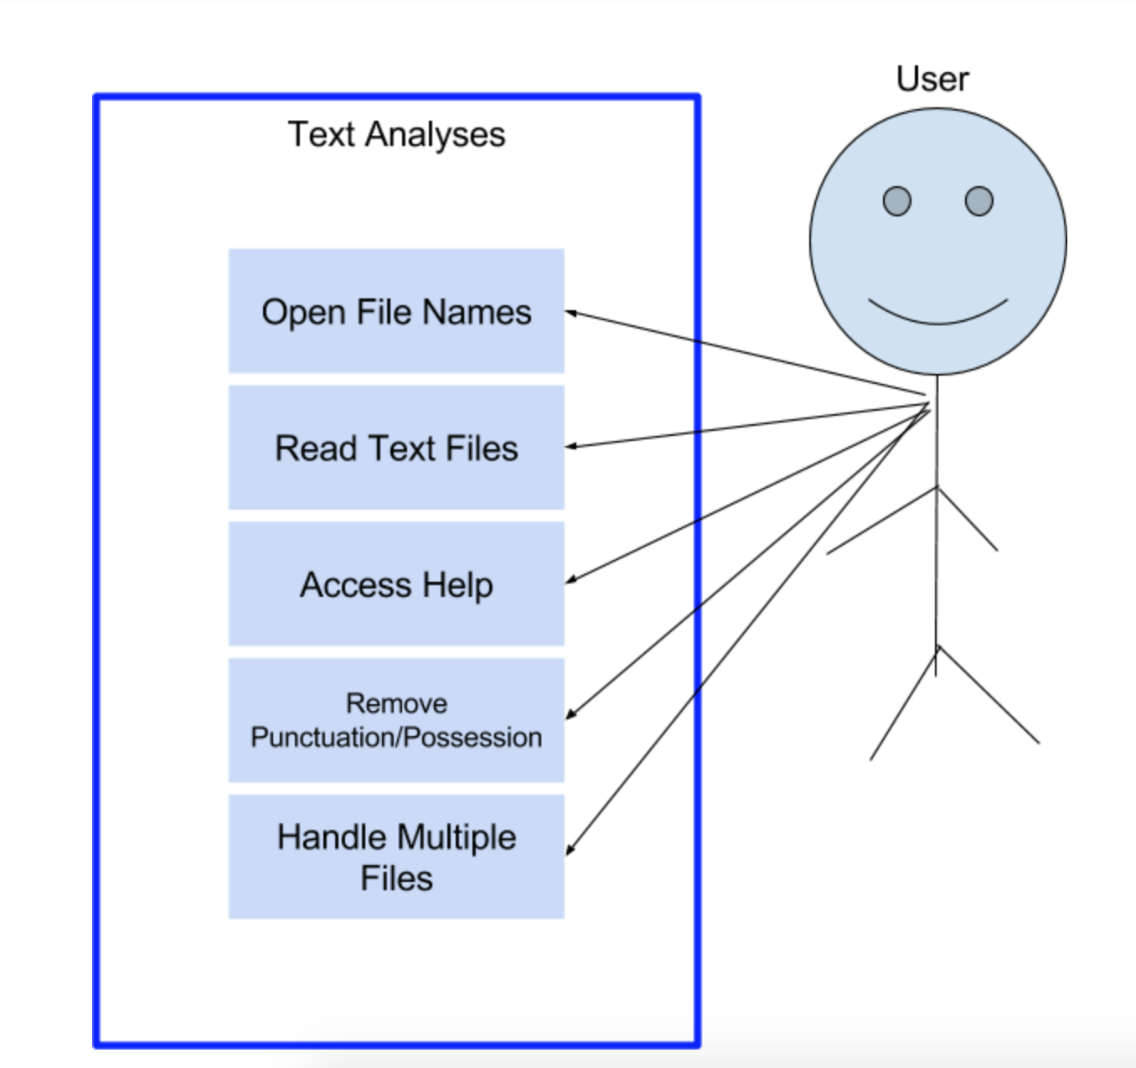

Use Case Scenarios
- As a user, I want to open and validate file names so I can analyze them further.

- User will input file name
- Program will check to see if it exists
- If filename exists, the program will open the file
- If it does not exist, it will display error in the output screen “error, file doesn't exist”

- As a user, I want to read text from a file so I can calculate various statistics (# of lines, blank lines, spaces, words; average chars/line and word length; and most common words.
- User will select a file, and an operation to perform
- Program will perform selected calculation
- Calculation is displayed on the output screen

- As a user, I want to access a help section so I can get help performing various tasks.
  - User will request help using help command
  - A menu for help will be displayed
  - User will select a help option
  - Directions for help will be displayed

- As a user, I want to remove punctuation and possession so I can process the file as a collection of alphanumeric characters.
  - User will select the remove punctuation button
  - Punctuation will be removed
  - File will be shown without punctuation

- As a user, I want to handle multiple files so I can find the averages across all files.
- User will request the history of all files processed.
- A list of all files processed will be displayed by name and date.
- User will request reporting information across all the files.
- An average of the statistics will be displayed across all files.

Test Plan

Test Cases

 | Feature | Description | Possible Input | Expected Output
1 | Upload File | Click on the Browse button and choose a file from directory. | Text File | Success message
2 | Upload File | Click on the Browse button and choose a file from directory. | Binary File | Error message: Only text files are accepted.
3 | Calculations | Click various calculation buttons | Various buttons | Correct number to be outputted to text pane
4 | Combine files | Select two files and combine them into one | Two input files | One combined file
5 | Remove Punctuation | Select the remove punctuation button | button | All punctuation is then removed

Project Plan

Plan for the First Deliverable
Specify the plan for the first deliverable including the list of tasks with a description, assignment of tasks to team members, etc.

 | Task | Description | Assignment
1 | Documentation | Create all documents related to the project | Connor
2 | GUI | Create the GUI and implement all necessary Jcomponents | Connor
3 | Insert File and verify validity | Have the program take in the file name and try to find the file. If the file is found, it will be imported and previewed. If not, it will display an error. | Connor
4 | Run Calculations | The following calculations will be made when the button is clicked: (# of lines, blank lines, spaces, words; average chars/line and word length; and most common words) | Nick
5 | Help section | Create a menu where the user can go for help | Jasen
6 | Handle multiple files | Be able to import, store and run calculations on multiple files | Chris

Plan for the Second Deliverable
 | Task | Description | Assignment
1 | Documentation | Update Documentation | All
2 | GUI | Update and add any necessary components | Connor
3 | Fix the backend issue of importing files | Change the program to sore files as files rather than strings. | Chris

Plan for the Third Deliverable

 | Task | Description | Assignment
1 | Documentation | Update Documentation | All
2 | GUI | Update and add any necessary components. Make the UI a little more eye pleasing. Add components to combine files | Connor
3 | Combine Files | Add functionality to combine files. User will select two files and it will be made into one. | Chris
4 | Remove Punctuation | The user will have the option to remove all punctuation from the files | Nick

