**Supplementary Figure 1. Histogram of JC values produced by the GCM, shown in Figure 1 (above), versus histogram of PCC values produced by the WGKS algorithm in Figure 2.**

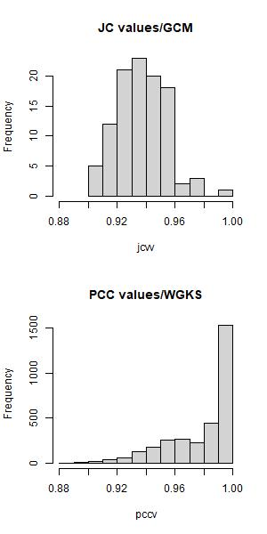

**Supplementary Table 1. Range of Jaccard Coefficient Values and Pearson Correlation values calculated by the GCM and the WGKS algorithm, depicted in Supplementary Figure 1 above.**

|  |  |  |  |  |
| --- | --- | --- | --- | --- |
|  | **min** | **mean** | **mode** | **max** |
| GCM | 0.902 | 0.937 | 0.937 | 1 |
| WGKS | 0.882 | 0.978 | 0.989 | 1 |