**Supplementary File**

**Molecular Baraminology Pipeline using R Studio**

**Supplementary Figures**

Supplementary Figure 1. R Workshop Download page at the CRAN website (cran.r-project.org)

Supplementary Figure 2. Download options for Mac users

Supplementary Figure 3. Starting a new project in R Studio online.

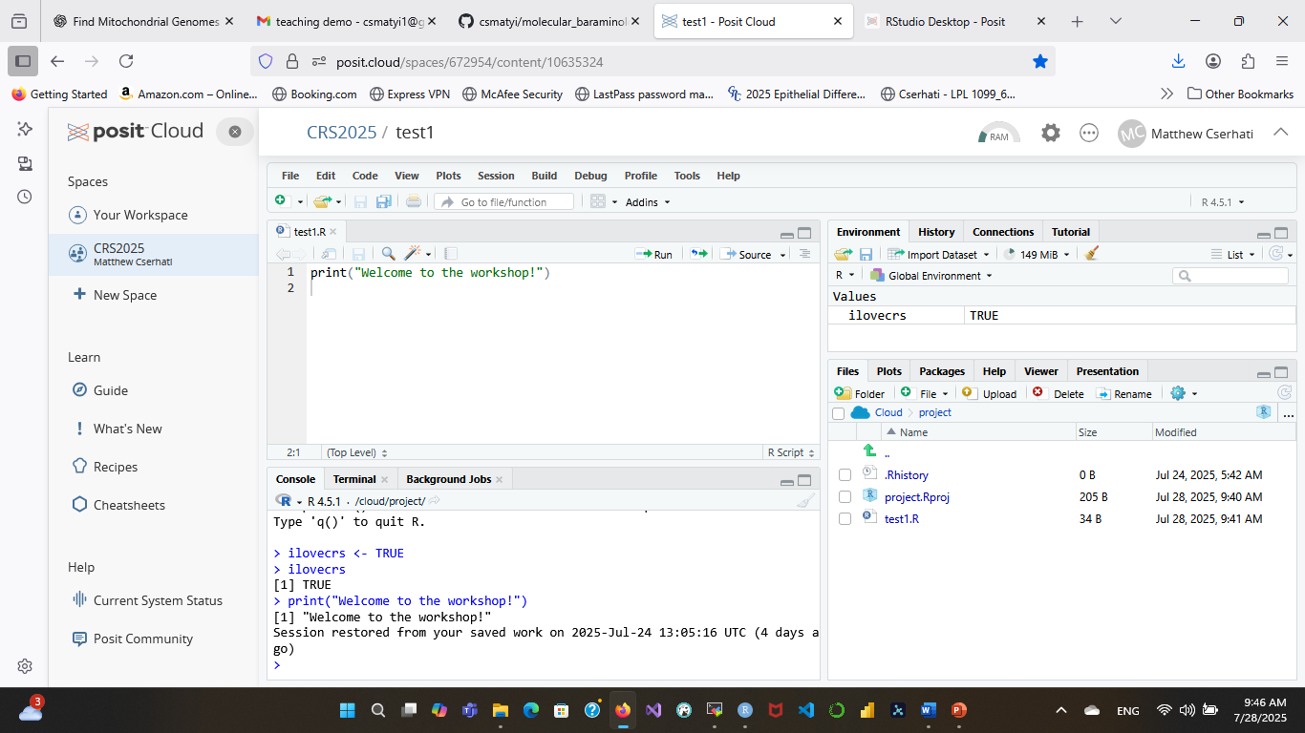

Supplementary Figure 4. The R Studio workspace. Top left: code space where code is written and executed. Bottom left: console, where the result of code execution can be seen. Top right: environmental variables and code history. Bottom right: Folder-like structure containing code, images, scripts, and other necessary files.

**Supplementary Tables**

**Supplementary Table 1.** Parameters included in the heatmap function in the molecular baraminology pipeline code.

|  |  |  |
| --- | --- | --- |
| **Parameter name** | **description** | **Value** |
| x | Matrix that is being plotted | mx_hm |
| symkey | Will the legend (if present) be symmetrical around 0? | TRUE/FALSE |
| symbreaks | Are the breaks in the color code symmetrical around 0, or do they range from a minimum to a maximum value? | TRUE/FALSE |
| scale | Should the values be centered and scaled either according to rows or columns? | Row/col/none |
| dendrogram | Will a dendrogram be plotted around the heatmap? | TRUE/FALSE |
| Rowv | Determines how the row dendrogram should be calculated | TRUE/FALSE |
| Colv | Determines how the column dendrogram should be calculated | TRUE/FALSE |
| col | What color palette should the heatmap have? | clr |
| RowSideColors | Vector containing the names of colors that appear in the bars denoting the different clusters | clus_clrs_vec |
| breaks | The name of the numerical vector showing the boundaries between color levels | myBreaks |
| border_color | The color of the heat map’s border | NA/color name |
| na.color | What color should any missing value be? | i.e. white |
| margin | The upper and lower + left and right margins of the canvas | c(x,y) |
| cexRow | Character expansion for row labels (y-axis font size) | decimal number |
| cexCol | Character expansion for column labels (x-axis font size) | decimal number |
| key | Show color key | TRUE/FALSE |
| trace | Show a tracer line on the top of the heatmap to visualize trends | row, column, both, none |
| lmat | A 2x2 matrix that shows where the major components of the heatmap are placed | 1: heatmap body, 2: row dendrogram, 3: col dendrogram, 4: color key |
| lhei | The relative height of each row in the layout | c(heatmap+row dendrogram, col dendrogram+key) |
| hclustfun | A function describing how the rows and columns should be clustered | See value of clusmeth |
| labCol | Applies text formatting to column labels | Formatting function |
| labRow | Applies text formatting to row labels | Formatting function |

Supplementary Table 2. List of Xenarthran species for example analysis

|  |
| --- |
| **Species name** |
| Acratocnus ye |
| Bradypus pygmaeus |
| Bradypus torquatus |
| Bradypus tridactylus |
| Bradypus variegatus |
| Cabassous centralis |
| Cabassous chacoensis |
| Cabassous tatouay |
| Cabassous unicinctus |
| Calyptophractus retusus |
| Chaetophractus vellerosus |
| Chaetophractus villosus |
| Chlamyphorus truncatus |
| Choloepus didactylus |
| Choloepus hoffmanni |
| Cyclopes didactylus |
| Dasypus hybridus |
| Dasypus kappleri |
| Dasypus novemcinctus |
| Dasypus pilosus |
| Dasypus sabanicola |
| Dasypus septemcinctus |
| Dasypus yepesi |
| Euphractus sexcinctus |
| Megalonyx jeffersonii |
| Megatherium americanum |
| Monodelphis domestica |
| Mylodon darwinii |
| Myrmecophaga tridactyla |
| Nothrotheriops shastensis |
| Parocnus serus |
| Priodontes maximus |
| Tamandua mexicana |
| Tamandua tetradactyla |
| Tolypeutes matacus |
| Tolypeutes tricinctus |
| Zaedyus pichiy |