Bacterial assemblage in Mediterranean salt marshes: disentangling the relative importance of seasonality, zonation and halophytes
**Authors**
Miguel Camacho-Sanchezª 0000-0002-6385-7963 miguelcamachosanchez@gmail.com
María Camachoª 0000-0001-6669-4736 mariag.camachomartinez@juntadeandalucia.es
Susana Redondo-Gómez^{b} 0000-0002-5280-9325 susana@us.es
Enrique Mateos-Naranjo^{b} 0000-0001-6276-5664 emana@us.es
**Affiliations**
ªInstituto Andaluz de Investigación y Formación Agraria, Pesquera, Alimentaria y de la Producción Ecológica (IFAPA), Centro Las Torres, 41200, Alcalá del Río, Sevilla, Spain
^{b}Departamento de Biología Vegetal y Ecología, Facultad de Biología, Universidad de Sevilla, Sevilla, Spain
*correspondence: miguelcamachosanchez@gmail.com

Supplementary Material SM1
ASVs present in the blank and removed for downstream analysis.

 | TotalAbundance | phylum | class | order | family | genus
ASV191 | 1 | Proteobacteria | Alphaproteobacteria | Rhizobiales | NA | NA
ASV7065 | 11 | Proteobacteria | Gammaproteobacteria | Enterobacterales | Enterobacteriaceae | Escherichia-Shigella
ASV19527 | 1 | Cyanobacteria | Cyanobacteriia | Chloroplast | NA | NA

Supplementary Material SM2
OTU table. Table with filtered ASV counts per sample.

(given the large size of the 4898 ASVs found, this table has been uploaded in a single CSV file)

Supplementary Material SM3
Rarefaction curves for all samples.

Supplementary Material SM4
Results from linear mixed models evaluating the effect of season and halophytes (zonation and rhizosphere) on alpha diversity.

 | Shannon ~ season |  |  | Shannon ~ species * rhizosphere
Predictors | Estimates | CI | p | Estimates | CI | p
(Intercept) | 6.39 | 6.16 – 6.62 | <0.001 | 6.10 | 5.72 – 6.47 | <0.001
season [summer] | -0.19 | -0.48 – 0.10 | 0.206
season [autumn] | -0.35 | -0.67 – -0.04 | 0.027
season [winter] | -0.55 | -0.86 – -0.24 | 0.001
species  [Atriplex_portulacoides] |  |  |  | 0.15 | -0.29 – 0.59 | 0.498
species  [Salicornia_ramosissima] |  |  |  | -0.22 | -0.76 – 0.33 | 0.432
species  [Spartina_densiflora] |  |  |  | 0.23 | -0.20 – 0.67 | 0.294
species  [Spartina_maritima] |  |  |  | -0.42 | -0.86 – 0.02 | 0.059
rhizosphere [rhizosphere] |  |  |  | -0.15 | -0.59 – 0.29 | 0.501
species  [Atriplex_portulacoides]  * rhizosphere  [rhizosphere] |  |  |  | 0.03 | -0.59 – 0.65 | 0.926
species  [Salicornia_ramosissima]  * rhizosphere  [rhizosphere] |  |  |  | 0.46 | -0.29 – 1.22 | 0.230
species  [Spartina_densiflora] *  rhizosphere [rhizosphere] |  |  |  | 0.19 | -0.42 – 0.81 | 0.537
species  [Spartina_maritima] *  rhizosphere [rhizosphere] |  |  |  | 0.75 | 0.13 – 1.37 | 0.017
Random Effects
σ² | 0.11 |  |  | 0.10
τ₀₀ | 0.01 _{species} |  |  | 0.05 _{season}
ICC | 0.10 |  |  | 0.32
N | 5 _{species} |  |  | 4 _{season}
Observations | 36 |  |  | 36
Marginal R² / Conditional R² | 0.253 / 0.324 |  |  | 0.242 / 0.486

Supplementary Material SM5: Beta diversity. Dimensions 3 and 4 from a MDS using weighted UniFrac distances.

Supplementary Material SM6
Dendrogram clustering samples according to their weighted UniFrac distances.

Supplementary Material SM7
Effect of the rhizosphere (A) and season (B) on selection of community assembly on the marsh soils studied. In the x-axis we have represented the difference between the observed β-mean nearest taxon distance (βMNTD) in pairwise comparisons and the averaged permuted βMNTD. The dispersion bars correspond to the standard deviation of permuted βMNTD. Each data point has been colored red if βMNTD was significant.

A

B
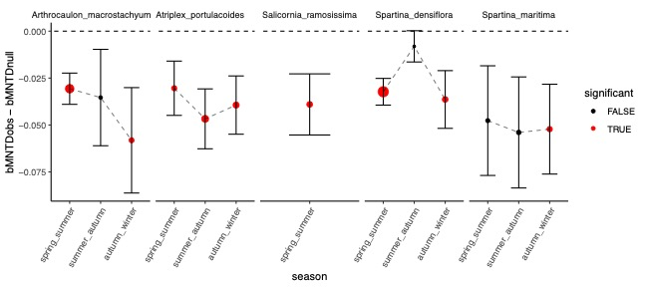

Supplementary Material SM8
CSV with results from the DeSeq2 analysis revealing the log2-fold change in abundances of families for multiple contrasts and their associated p-values.

Supplementary Material SM9
Families with significant differential relative abundances (adjusted p-values) for any of the conditions for each environmental factor: species plot (A), rhizosphere (B) and season (C).

SM9.A: halophyte plot
SM9.B: rhizosphere
SM9.C: season

Supplementary Material SM10
Results from the FAPROTAX analysis describing the relative abundance of the metabolic functions associated to the bacterial community in each soil. The light/dark paired colors correspond to non-rhizospheric/rhizospheric soil in each halophyte plot.
