**Data Science: A Global Presence**

The field of data science evolves every day, demanding an ever curious, determined mind of those who choose data science as a profession. Technology, mathematics, and business acumen are deeply rooted in the field and are constantly changing fields that require skilled and rapidly fluid individuals. Trying to pin point a true definition of the field of data science is a challenge as it means different things to different sectors of the professional arena in both the public and private sectors. Data science has humble beginnings, first arriving on the lips of academic researchers in the early 2000s, during the heat of the dot-com bubble. During this time, Professor William S. Cleveland published the academic paper “Data Science: An Action Plan for Expanding the Technical Areas of the Field of Statistics.”. In his paper, Cleveland accurately and systematically outlines a perfect marriage between statistics, modeling data, computing systems, tooling for analysts, and theory derived from evaluating the resulting process he calls “data science”.[1] Cleveland alludes to a process where data is analyzed with the objective of deriving direct value and implementing that value into the respective organization. To add to Cleveland’s robust and accurate assessment, outside of pure technical skills (which are undoubtedly a necessity), a structured analytical framework to which problems are processed with the goal of determining an approach that meets business or research questions is essential within the process of data science. To summarize, data science is an interdisciplinary field that uses scientific approaches, methods, statistical evaluation, algorithms and systems to conduct thorough analysis to answer questions and derive concise strategical insights for decision makers. This definition will indisputably change over time but seems to be robust enough for the time being.

Looking at the state of the field nearly twenty years after Cleveland’s groundbreaking work, many of the necessities and challenges outlined by Cleveland continue to drive the field forward. Big data processing, data privacy, increasing need for technically trained individuals, and auditing the entire data science process from aggregation to black box machine learning algorithms remain critical research and business obstacles for the field of data science for the current and next generations of data scientists to wrangle and answer. Data science no longer remains an obscure corner of computer science research in academia. On January 29th, 2019, the heads of the US Intelligence Community (IC) testified before the Senate Intelligence Committee on global threats to the United States. In their joint assessment, the dangers presented by leveraging and weaponizing big data from global threat actors such as China and Russia were highlighted followed by a call to service to data scientists and data analysts echoed by each respective IC leader. The now global impact data science has in everyday governmental, business, and academic operations emphasizes the continued growth of the field and need for talented, motivated individuals.

The cutting edge, constantly changing and challenging elements of the field is what brought me to this program here at Syracuse, and the everchanging obstacles will continue to fuel my professional growth. Throughout the course of the Masters’ in Applied Data Science at Syracuse University, certain learning objectives are laid out to ensure the quality of students coming out of the program to meet and exceed expectations of their employers or future academic endeavors. These learning outcomes include but are not limited to:

* Describing a broad overview of the major practice areas in data science
* Collect and organize data
* Identify patterns in data via visualizations, statistical analysis, and data mining
* Develop alternative strategies based on data
* Develop a plan of action to implement the business decisions derived from the analyses
* Demonstrate communication skills regarding data and its analysis for mangers, IT professionals, programmers, statisticians, and other relevant professionals in their organization
* Synthesize the ethical dimensions of data science practice

Through 36 credits, and several different projects, these learning outcomes were obtained and will serve as a fantastic base for a career in data science and analytics to be built upon. While the course load unquestionably suffices for a strong starting point, side projects will remain a key aspect for any individual to remain sharp and knowledgeable on the advancements in the field. The following sections of the paper will highlight a cohesive portfolio of work that aims to display effectively meeting the previously listed learning objectives to attain approval towards my continued progress in the field of data science.

**Data Quality is Essential**

Data is everywhere one looks. As an aspiring data professional, the amble amount of data to hone and practice skills on allows for the creation of infinite problem sets. While it is easy to go to numerous websites and download pre-structured, tabular data, it is much more challenging to build a dataset from scratch using numerous techniques. In Text Mining, taught by Dr. Yu, the final project revolved around analyzing a corpus of text. To build knowledge of data collection practices, I built a web scraper using the open source Python tool Scrapy.[2] The goal of my project was to collect album reviews from the website Pitchfork.com, a globally renowned music review company.

By building a corpus of album reviews coupled with author, music genre, overall rating and date, overall trends based on certain authors, and sentiment analysis, key takeaways could be extracted from the data. By taking the unstructured data from a website and giving it a tabular layout using a scraping tool, analysis is more efficient to conduct. By structuring and organizing the data, the entire data science and analysis pipeline becomes reproducible, giving an individual or an organization ease of access into the data for analysis. Also, a key part of this process is the cleaning of data, especially when it is being pulled directly from a website. Often, website data will have numerous special characters, spaces, and punctuation throughout text fields, making it essential that a tool like Pandas or Tidyverse is used to ensure and optimize data quality as well. Below, an example of the data has been displayed.[3][4]

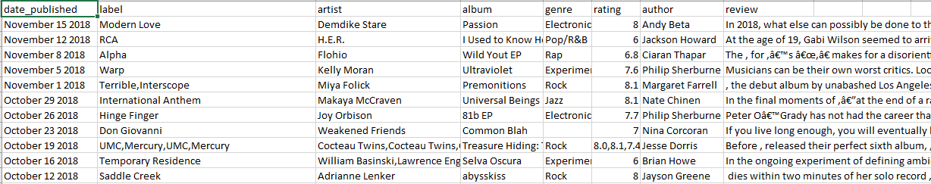

Figure 1 By making a tabular data structure, analysis and interaction with key data science packages becomes feasible.

Stock price analysis is one of the most common applications of data analysis and science, as the data is readily available for anyone who is interested via several different options. During my time in Data Analysis and Decision Making, taught by Professor Chernobai, my team and I chose to analyze Amazon’s stock price. Instead of using Amazon’s internal financial indicators, I took it upon myself to research and find external forces outside of the company that could potentially influence Amazon’s stock price movement. In doing this, we attempted to break the conventional analysis structure by finding unique variables to include in our dataset. Using Amazon as our dependent variable, we sought out 15-20 independent variables that would then be used to conduct regression analysis to analyze and predict Amazon’s stock price. Using a combination of competitors, economic measures, and ETFs, we were able to construct a data set looking at the monthly percent change between all our selected variables, approximately 120 observations and 20 variables. We were also strategic in our time frame we chose to use, dating back to 2007 to quantify both bearish and bullish market conditions within the dataset. By using percent change, our regression analysis outcomes were accurate and insightful, allowing us to further validate later portions of our analysis which will be discussed in the coming sections. Below, an example of the data has been displayed.

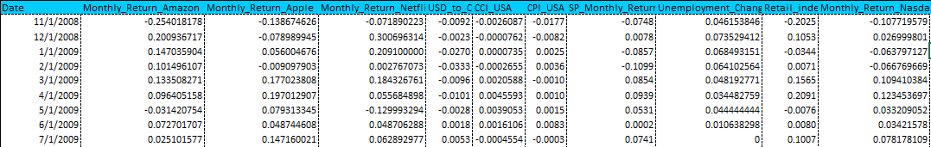

Figure 2 Enforcing data structure and organization is an essential part of any data workflow.

In both Text Mining and Data Analysis and Decision Making, the importance of data collection, organization, and cleaning were essential in beginning both individual and team-oriented workflows, improving the quality of the result. This idea of clean or “tidy” data was explored thoroughly by the researcher Hadley Wickham in his article titled “Tidy Data”. Wickham states that roughly 80 percent of data analysis is consumed during the cleaning and organization process, with no real research on optimizing the clean process itself. Wickham goes onto define the very data structure that the R programming language is centered around, consisting of observations and variables, universalizing what “tidy” data should look like moving forward.[5] This paper has had ripple effects throughout the entire data analytics field, even inspiring the likes of Wes McKinney to develop Pandas, bringing much of the same speed and assurance of data cleanliness to the Python programming language as well. With Wickham’s creation of the tidyverse and McKinney’s Panda’s, data analysis has been catapulted into the future as much of the workflow is now centered around visualization and analysis, allowing for grander and meaningful analysis to occur at an advanced rate.

**Exploring the Data**

With a clean, tidy dataset, taking a deep dive to identify key patterns, trends, and to display analysis through visualizations is a skill that will remain at the top of data scientist resume’s for years to come. Communicating clearly what can be sometimes complex theoretical work is an important piece of displaying findings to the audience because without thorough understanding of the work being done, the work is often not trusted fully. This is the main reason exploratory data analysis and data visualization should always be a sharp tool in any data scientist’s skillset. When working through the Pitchfork project for Text Mining, analysis was conducted using the tidytext packing in R, allowing for easy grouping of different categorical variables, such as music genre, to see the how sentiment scores and word importance differed across the data.[6] Looking at the visualization below, genres are represented in their graph with different colors allowing for the visual to easily read by the viewer. This 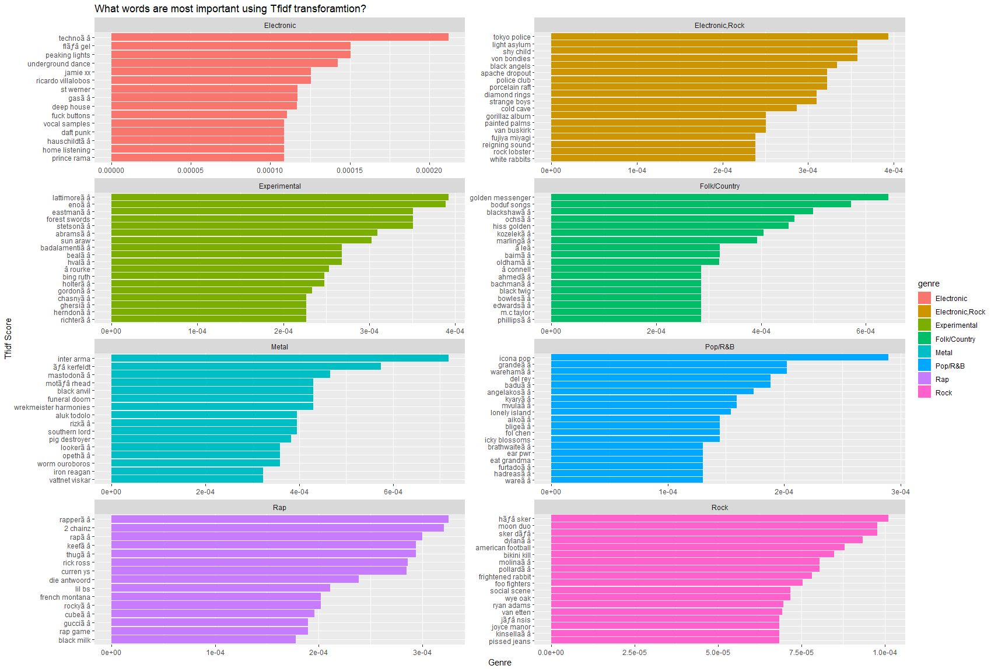visual aims to display the most important words using TFIDF scoring.

Exploring the data through visualizations is extremely important as well, using statistical methods such as histograms, regression analysis, and scatter plots to explore the relationships between two variables. This approach was used extensively during my Amazon Stock Price Analysis, as we created visualizations that aimed to demonstrate a linear relationship between our selected variables. By creating an almost dashboard like layout to our slides for our presentation, our audience could make key takeaways in a small amount of time about the message we were portraying, with minimal explanation. When looking at a problem or dataset with an attempt to explore the nature of the data, the use of histograms allows for detection out outliers, if the data is skewed to the left or right, obtaining mean, standard deviation, and median, covariance, and correlation will give the analyst and the audience a sound idea of linear or non-linear relationships between two or more variable. This ensures quality of model fitness coupled with statistically reinforcing ideas and hypotheses that are being worked with. On the next page, a snapshot is taken from the presentation, displaying our quick visualizations for the audience.

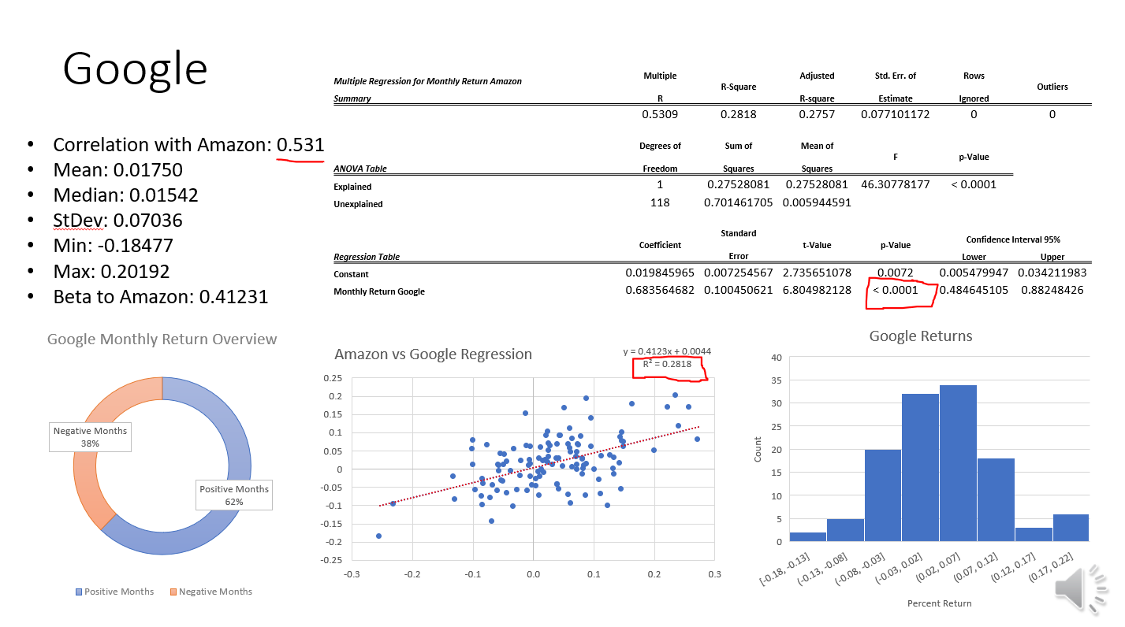

**Actionable Insight and Implementation**

One of the most important skills any analyst or data scientist maintains is taking complex outputs from in-depth analysis an transforming findings into actionable insight and implementable strategy for a company to derive value from.

**Ethics**

Focus on current events and how you see the landscape developing with sources.

**Conclusion**

1. <https://www.jstor.org/stable/1403527?read-now=1&seq=3#page_scan_tab_contents>
2. <https://docs.scrapy.org/en/latest/>
3. <https://pandas.pydata.org/pandas-docs/stable/>
4. <https://www.rdocumentation.org/packages/tidyverse/versions/1.2.1>
5. <https://vita.had.co.nz/papers/tidy-data.pdf>
6. <https://cran.r-project.org/web/packages/tidytext/index.html>