|  |
| --- |
| Videocon  Full CWE Compliance |
|  |
|  |
|  |

|  |  |
| --- | --- |
| Videocon | Total pages: 8 |
| **Full CWE Compliance** | **EDCS-11412080** Rev. 0.01, 29 September 2016 |

|  |  |  |  |  |
| --- | --- | --- | --- | --- |
| Owner: | Eddy Resnick |  | Reviewers: | Amos Shaked Yonatan Mizrahi |
| Author: | Eddy Resnick |  |

Contents

1 Preface 4

1.1 Applicability 4

1.2 Terminology 4

2 Changes To The Headend 5

2.1 Alter ECMS_SC configuration 5

2.2 Setting CWE level 5

3 Testing CWE 6

3.1 CWE Diagnostics 6

3.2 Verify the ECM 6

4 Deployment Plan 8

List of Tables

Table 2 Terminology 4

List of Figures

**No table of contents entries found.**

Do Not Delete this Paragraph, or any of the headings OR fields above!

# Preface

This document describes the steps to enable and test control word encryption (CWE) at Videocon.

## Applicability

ECMS_SC 4.3.11

## Terminology

Table  2 provides a short glossary of any terms crucial to the understanding of this document, and lists the acronyms and abbreviations used in the document.

Table 1 Terminology

|  |  |
| --- | --- |
| Term | Definition |
| CWE | Control word encryption |
| ECM | Entitlement control message |
| STB | Set top box |

# Changes To The Headend

## Alter ECMS_SC configuration

The file skeleton_groups.cfg must be altered to allow for the CWE flag to be generated in the ECM.

* + 1. Note From the comments in the skeleton_groups.cfg file:
    2. ;c2_signal_additional_flag. bitmask: supported values are 0x00-0x03
    3. ;used for setting bits in C2
    4. ;0 - do not set any bits for signalling presence of additional flags
    5. ;0x01 - set bit in flags2 to signal presence of flag3
    6. ;0x02 - set bit in flags3 to signal presence of flag4
    7. ;0x03 - both 0x01&0x02.

To make the changes follow the steps below on each installation where ecms_sc is running:

# cd /opt/nds/ecms_sc/etc

# vi skeleton_groups.cfg

;Change the value of c2_signal_additional_flag=0x03

## Setting CWE level

The CWE level can be set per channel by putting a 0, 1 or 2 in the cell of the SSR database cell CAP.CA_SCHED_CONTROL.CWE_LEVEL. If this cell is left with NULL (no value) then the CWE level is set by the value in the ecm_builder.cfg file. The current relevant values are:

NBOOL CWE_SUPPORTED = TRUE

USHORT CWE_LEVEL = 1

NBOOL CWE_OVERRIDE = FALSE

USHORT CWE_OVERRIDE_LEVEL = 0

If the CWE_LEVEL cell is going to be left blank then make sure that the level is properly set in the ecm_builder.cfg before it is restarted. Please set CWE_LEVEL=0 in the ecm_builder.cfg to begin which will make sure that all services begin with a known value and are viewable without CWE.

**REMEMBER:** Restart the ecms_sc after making changes to the configuration files:

# nds_service nds_ecms_sc restart

* + 1. Note Changing the CWE_LEVEL cell in the SSR database does not require a restart of the ecms_sc.

# Testing CWE

There are a number of indicators that will show that CWE is currently working and they should all be tested.

## CWE Diagnostics

On an STB that is **not** an MStar HD 6666-RF STB you should be able to see video on a service that is encrypted and has CWE level set to 2. You can verify that the STB is using CWE by going to the diagnostic screen on the STB:

Menu 🡪 Info 🡪 Diagnostics

Go to the 2nd screen and look for line with CWE where it should show the values **Y Y Y**. For example:

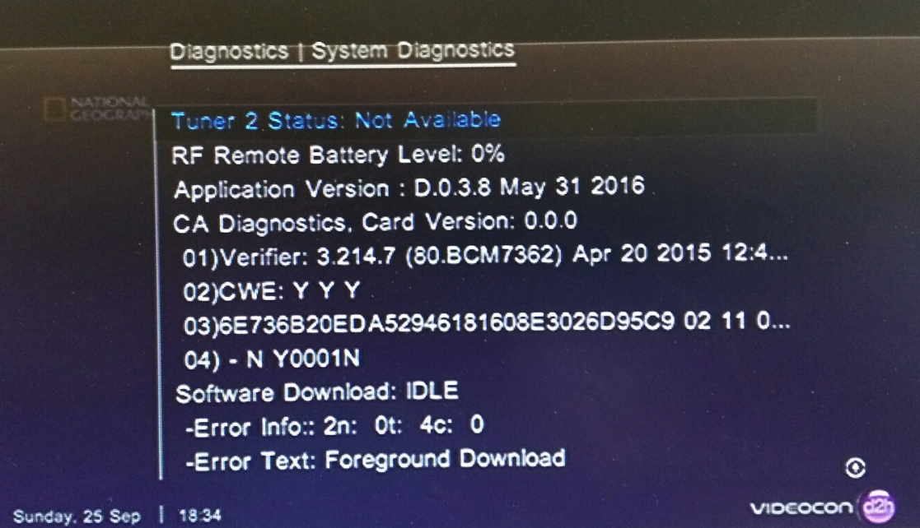

On an MStar HD 6666-RF that is running the previous code you may see a black screen even if the diagnostics are correct. On an MStar HD 6666-RF STB with the new code then video should be viewable.

## Verify the ECM

It is important to verify that the ECM that is being created for the test service is using CWE level 2 and that the ECM is formed correctly:

* + - * 1. Extract the clear ECMs from the log file:

# cd /opt/nds/ecms_sc/log

# grep ‘Clear ecm’ ecms_sc.`date +"%Y%m%d"`.log

Find the ECM for the service that you are interested in:

* + - * 1. Look for the service in hexadecimal in position 17-20 of the ECM. For example, looking for service ID 0x0004:

0000010B681963E40004 . . .

Parse the ECM to verify that the service is using CWE level 2:

* + - * 1. Find the 0x90 action:

. . . 901BC001C20840681963E4404002 . . .

Inside the 0x90 action is the 0xC2 which describes program related activity:

. . . 901BC001C20840681963E4404002 . . .

Verify that the flag byte 2 and 3 have bit 6 set and that flag 4 is set for CWE level 2:

. . . C20840681963E4404002 . . .

Flag byte 2 = 40 (01000000)

Flag byte 3 = 40 (01000000)

Flag byte 4 = 02

# Deployment Plan

The following are steps that can be used to deploy CWE at the customer site.

Deploy the new image for the MStar STB which solves the driver issue for CWE.

On the test system, follow these steps:

* + - * 1. Edit the ecm_builder.cfg and skeleton_groups.cfg in the ecms_sc/etc directory as described in section ‎2.1 “Alter ECMS_SC configuration”. Specifically:

skeleton_groups.cfg: c2_signal_additional_flag=0x03

ecm_builder.cfg: CWE_LEVEL=0

Restart the ecms_sc:

# nds_service nds_ecms_sc restart

Perform a factory reset on the test STB(s) to clear the previous CWE details.

Define the CWE level directly in the SSR table CAP.CA_SCHED_CONTROL.CWE_LEVEL as 0, then 1 and then 2. Re-instantiate the event on that test service in table CAP.CA_INST_RQST by changing the STATUS cell to 0, saving the change (redisplay of the table will show it returns to status 5) after each change of the CWE_LEVEL field. Watch the ECM change the value in “flag byte 4” and note the behavior of CWE on the STBs:

|  |  |  |  |  |
| --- | --- | --- | --- | --- |
| CWE level | Description | ECM flag byte 4 | CWE diagnostics | STB results |
| 0 | No CWE | 0x00 | N Y Y | Video |
| 1 | CWE “if you can” | 0x01 | Y Y Y | Video |
| 2 | Forced CWE | 0x02 | Y Y Y | Video |

On the live system, follow these steps:

* + - * 1. Edit the ecm_builder.cfg and skeleton_groups.cfg in the ecms_sc/etc directory as described in section ‎2.1 “Alter ECMS_SC configuration”. Specifically:

skeleton_groups.cfg: c2_signal_additional_flag=0x03

ecm_builder.cfg: CWE_LEVEL=0

Restart the ecms_sc:

# nds_service nds_ecms_sc restart

Set the CWE level in CAP.CA_SCHED_CONTROL.CWE_LEVEL as 1 and then re-instantiate the event in CAP.CA_INST_RQST on that service.

Note the behavior on the STB

Move that service to CWE level 2 and re-instantiate the event.

Note the behavior on the STB

Continue these steps for each service.