# **Microsoft Word Exercise 1: Introduction to Word**

**In this exercise you will practice:**

* Opening and closing Microsoft Word
* Navigating the Ribbon, the Home tab and different Groups
* Highlighting text with the mouse or keyboard
* Using common keyboard keys
* Using Copy and Paste commands
* Changing Font and Font Size
* Making text Bold, Italic, and Underlined



1. **Click the start menu**. Find and click the Microsoft Office folder, then click Word
2. Microsoft Word should open. **It should look like this:**

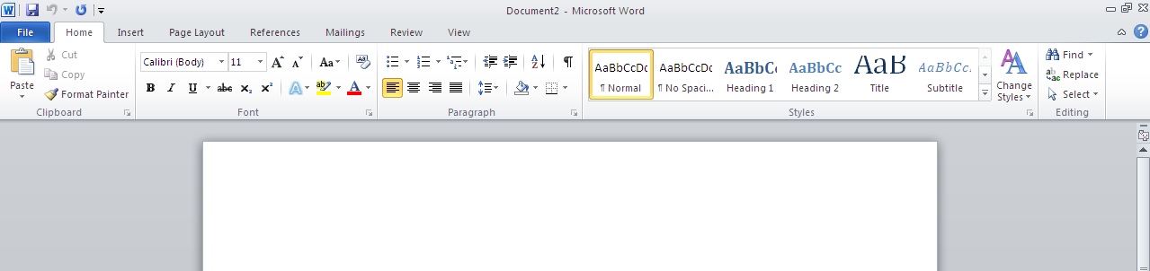

1. Type**: The quick brown fox jumped over the lazy dog.**

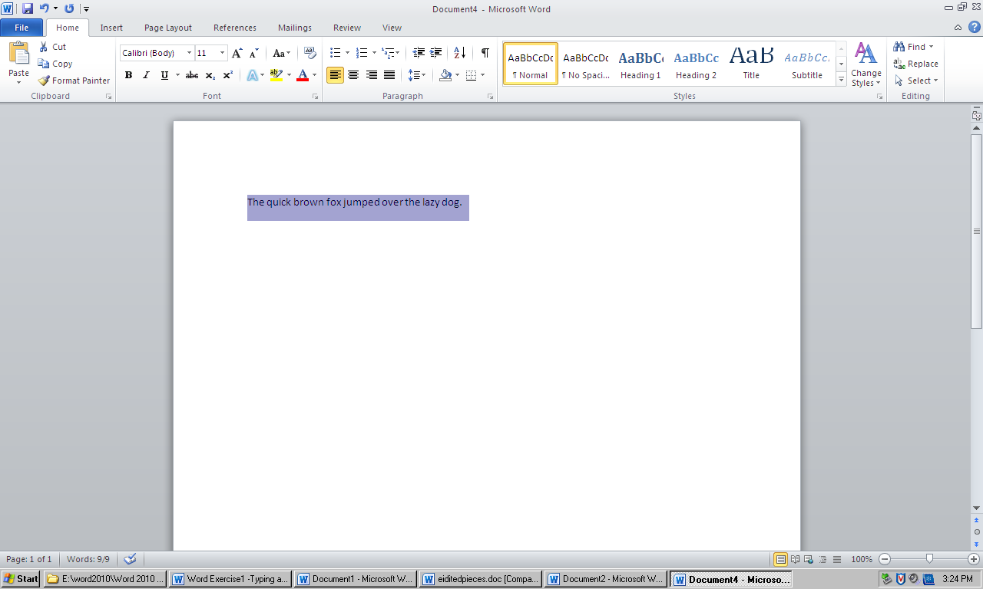

1. **Click** **and Drag** over the sentence fromright to left. This is called **highlighting** or selecting text. When the sentence is highlighted, take your finger off the mouse.
2. **Click anywhere on the page to remove the highlighting**. Practice highlighting with the mouse again. You can start highlighting at the beginning or end of the sentence.
3. You can also highlight text with the keyboard. Click **before: The quick brown…** Hold down the **Shift key on the keyboard**. Press the **right arrow key** until all the letters are highlighted.

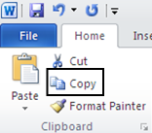

1. On the **Home tab** in the **Clipboard group**, click the **Copy command**. The copy command tells the computer to remember the text you have highlighted so you can use it again.
2. Click **after: …the lazy dog.** to put the cursor there, and press **Enter** on the keyboard. The cursor will move down below the sentence.
3. On the **Home tab** in the **Clipboard group**, click the **Paste command**. A second sentence should appear. The paste command tells the computer to put the text you copied where the cursor is.

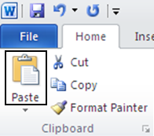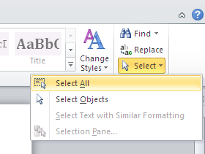

1. On the **Home tab** in the **Editing group,** click **Select**, and then click **Select All** from the list that appears. This is the best way to highlight *all* the words on the page.
2. Click the **Copy command** to copy both sentences.

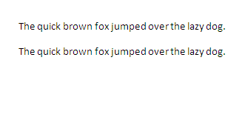

1. Click in the white space below the sentences to put your cursor there.
2. Click the **Paste command**. Two more sentences should appear.

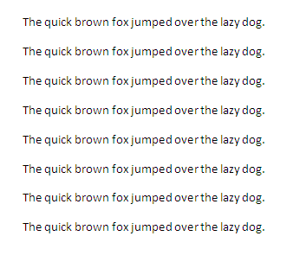

1. Click **Select** in the **Editing group**, and then click **Select All** to highlight the four sentences.
2. Click the **Copy command** to copy all the sentences.
3. Click in the white space below the sentences to put your cursor there.
4. Click the **Paste command**. Four more sentences should appear. Your document should look like this:
5. **Highlight the 2nd sentence.** You can do this by clicking and dragging with the mouse or by pressing and holding the shift key on the keyboard and using the arrow keys.
6. On the **Home tab** in the **Font group** click the arrow next to **Calibri** to open the Font dropdown menu. This shows a list of different fonts.

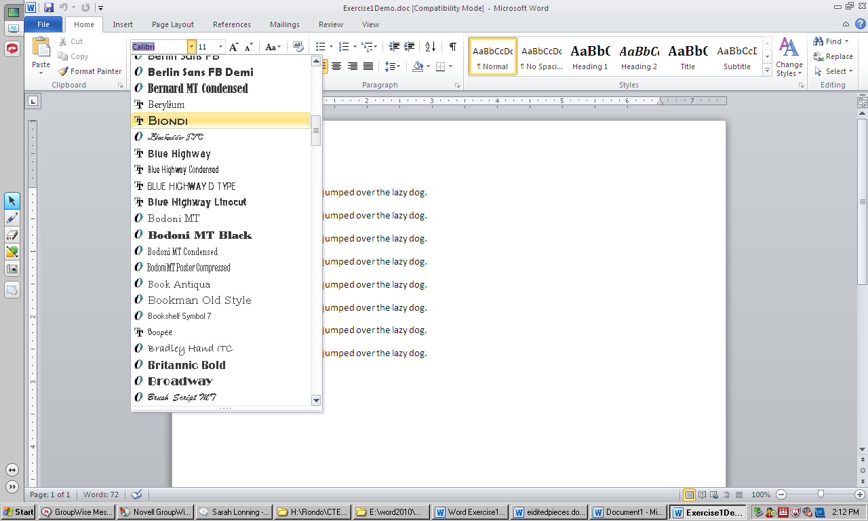

1. In the Font dropdown menu, click on Biondi**.** You will need to scroll down the list to find it. The fonts are listed in alphabetical order.
2. Click anywhere on the document to clear the highlighting, and **look at the way the second sentence changed**. It looks different because you changed the Font.
3. **Highlight the 3rd sentence.**
4. On the **Home tab** in the **Font group** click the arrow next to **11** to open the Font Size dropdown menu. This shows a list of font sizes.
5. In the Font Size dropdown menu, click on **24** from the list. Click anywhere to clear the highlighting, and look at the way the third sentence changed. The text is bigger, because you changed the Font Size.
6. **Highlight the 4th sentence.**

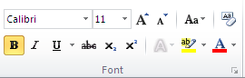

1. On the **Home tab** in the **Font group,** click the **Bold command**. This will make the text a little wider.
2. **Highlight the 5th sentence.**

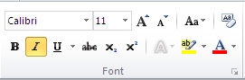

1. On the **Home tab** in the **Font group,** click the **Italic command.** This will make the text slant to the right.
2. **Highlight the 6th sentence.**

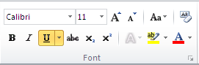

1. On the **Home tab** in the **Font group,** click the **Underline command.** This will make a line appear under the text.
2. Click at the **end of the 8th sentence** to put your cursor there.
3. **Press the Backspace key** on the keyboard until the sentence disappears. The Backspace key erases text to the left of the cursor.
4. Click at the **beginning of the 7th sentence** to put your cursor there.
5. **Press the Delete key** on the keyboard until the sentence disappears. The Delete key erases text to the right of the cursor.

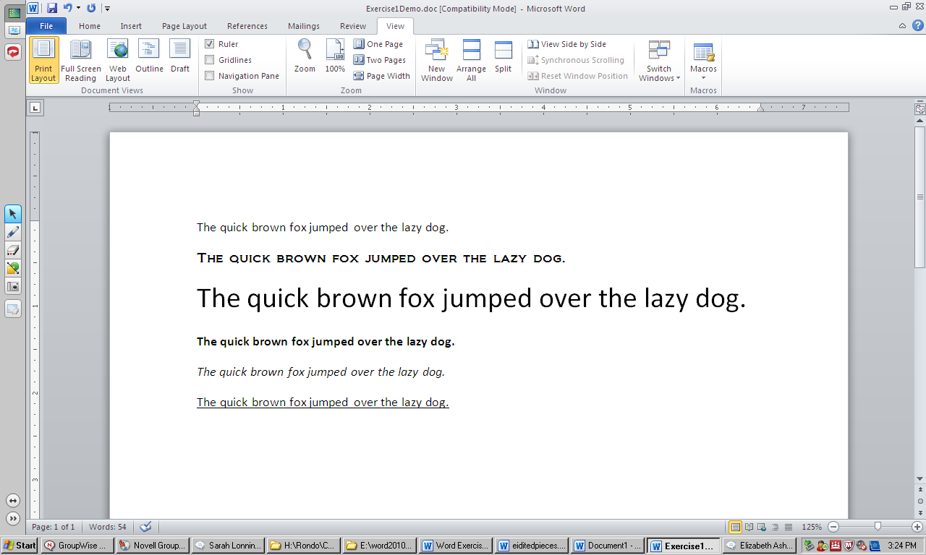

1. Have the instructor check your work. Your document should look like this:
2. **Click the X** in the top right corner of the window to close Microsoft Word.

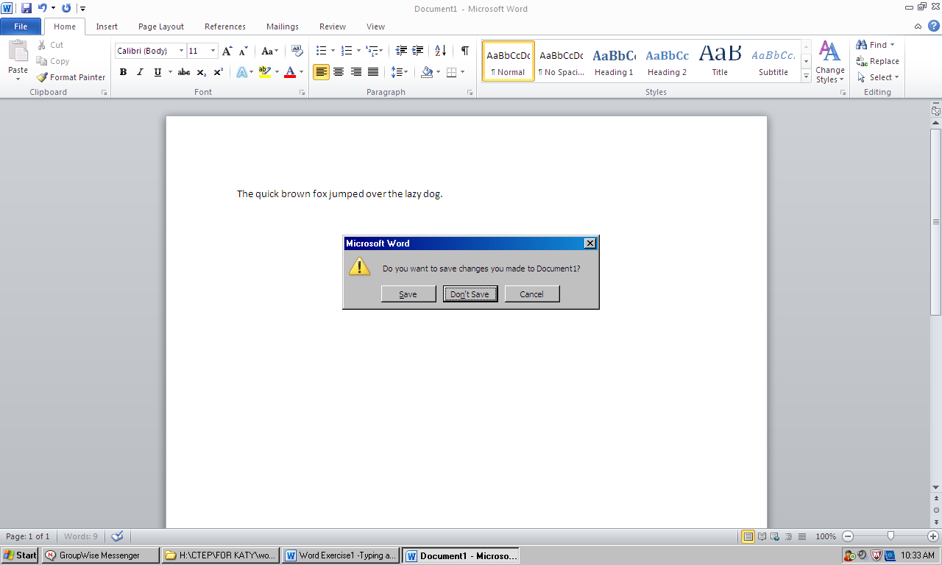

1. A box will appear to ask: Do you want to save changes you made to Document1? Click **Don’t Save.**