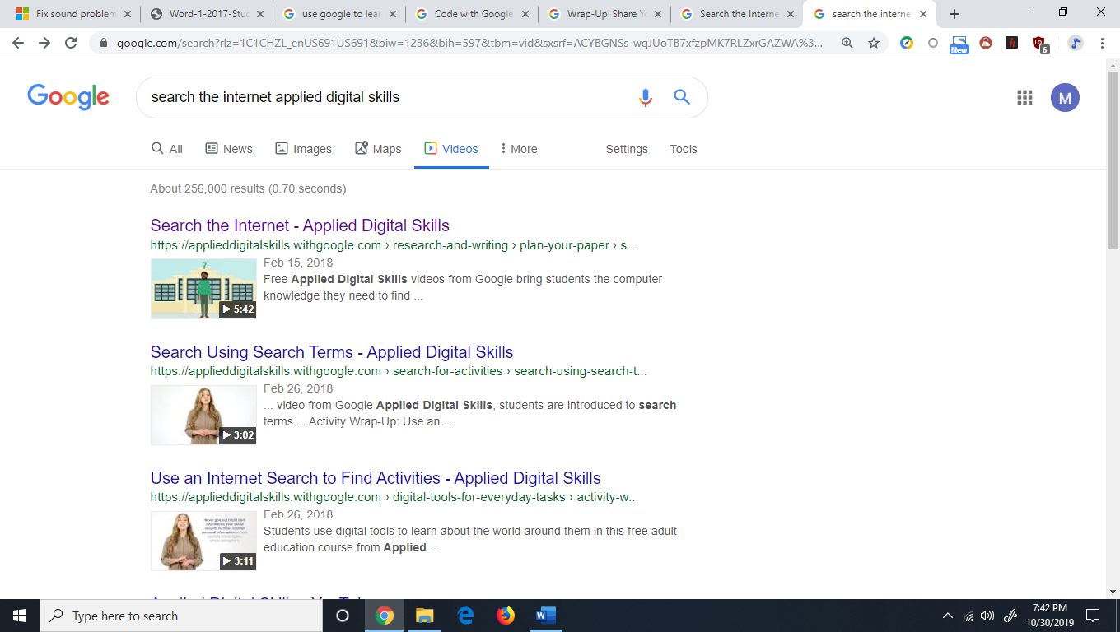

1. Open an internet browser and type “Search the internet applied digital skills” in the address bar (If you don’t see the movie click on 2.) Videos (you may have to click 3.) [more] to get to videos)

Grab headphones and watch this video. It should be 5:42 long. (Raise your hand if you can’t find it)

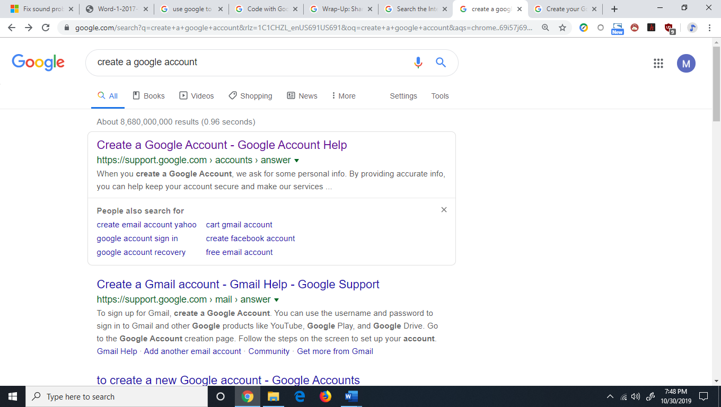

After watching the video, type create a google account into your address bar.

Click the page that matches the image above (Create a google account – Google Account Help)

Click the blue Create A Google Account button and follow the directions. Ask for help if you are stuck!!  
Make sure to have a Google account created BEFORE NEXT WEEKS CLASS! ASK FOR HELP IF YOU ARE STUCK!!!!