CoordCom

Руководство по устранению неисправностей

Оглавление

1 Introduction 3

2 System Center Operations Manager 4

2.1 Basic overview of SCOM 4

2.1.1 Alerts 4

2.1.2 Rules 5

2.1.3 SCOM Notification Groups 6

3 Windows tools 7

3.1 Computer Management 7

3.1.1 Event Viewer 8

3.1.2 Device Manager 8

3.1.3 Disk Management 8

3.1.4 Services 8

3.2 Network Connections 9

3.3 Task Manager 10

3.4 Command Prompt 11

3.4.1 ping [ip address] 11

3.4.2 Ipconfig 11

3.4.3 tracert [ip address] 11

3.4.4 mem 11

3.4.5 route 11

3.4.6 W32TM 11

3.5 Regedit 11

3.6 Remote Shutdown 11

3.7 Remote Desktop 12

3.8 perfmon 13

3.9 Active Directory 14

3.9.1 Active Directory Tools 15

3.10 DNS 20

3.11 Cluster Administrator 21

3.12 Microsoft SQL Server Management Studio 22

3.13 New Query in Microsoft SQL 23

3.14 SQL Server Profiler 24

4 CoordCom Tools 25

4.1 Overview 25

4.1.1 CoordCom System Services 25

4.1.2 CoordCom CXE System Services 28

4.1.3 CoordCom Work Station 28

4.2 CoordCom Software Supervisor 29

4.3 CoordCom Business Administrator Program 29

4.4 Operator Program 30

4.4.1 Creating Dump Diagnostic File 31

4.5 Trace Viewer 31

4.5.1 Trace Setup 32

4.6 Education Simulator 32

4.7 CXE Commands and Services 33

4.7.1 TxAlarm 33

4.7.2 showcx95 34

4.7.3 showclks 34

4.7.4 CXE Services 35

5 Process Description 36

5.1 Processes Generated by Incoming Telephony Call 36

5.2 Processes Generated by Incoming SIP Call 37

5.3 Processes Supporting External Communication 39

5.3.1 Following trace log files are recommended to supply to CoordCom support 39

5.4 Processes Supporting Automatic Alarm 40

5.4.1 Following trace log files are recommended to supply to CoordCom support 40

5.5 Processes Supporting Address Information 41

5.5.1 Following trace log files are recommended to supply to CoordCom support 41

5.6 Processes Supporting Incoming Security Alarm 41

5.6.1 Following trace log files are recommended to supply to CoordCom support 42

5.7 Processes Supporting External Analog Radio Call 43

5.7.1 Following trace log files are recommended to supply to CoordCom support 44

5.8 Processes Supporting External Digital Radio 44

5.8.1 Digital Radio Call 44

5.8.2 Digital Radio Short Message and Status Change 46

5.9 Processes Supporting Startup of Client 47

5.9.1 Following trace log files are recommended to supply to CoordCom support 47

5.10 Processes Supporting Position Query to a Unit 48

5.10.1 Following trace log files are recommended to supply to CoordCom support 48

5.11 Processes Supporting Positioning from Case 49

5.11.1 Following trace log files are recommended to supply to CoordCom support 49

5.11.2 Processes Supporting Positioning a Resource from Map Client 49

5.11.3 Processes Supporting Positioning a Resource 50

5.11.4 Following trace log files are recommended to supply to CoordCom support 51

5.11.5 Processes Supporting Incoming Mobitex Alarm 52

5.11.6 Following trace log files are recommended to supply to CoordCom support 53

5.12 Processes Supporting Outgoing E-mail 53

5.12.1 Following trace log files are recommended to supply to CoordCom support 54

5.13 Processes Supporting Outgoing SMS Minicall 54

5.13.1 Following trace log files are recommended to supply to CoordCom support 55

5.14 Processes Supporting Case Management 56

5.14.1 Following trace log files are recommended to supply to CoordCom support 56

6 Questions and Answers 57

6.1 Installation 57

6.2 CoordCom Work Station 57

6.2.1 Operator 57

6.2.2 Telematic 58

6.2.3 Networking 58

6.2.4 Sound 59

6.2.5 CoordCom Business Administrator 60

6.2.6 CoordCom Workstations 61

6.2.7 Active Directory Group Policies 61

6.3 Server 61

6.3.1 Network 61

6.3.2 CXE 61

6.3.3 ISUP 64

6.3.4 ISDN 65

6.3.5 Voice Message Server VOM 65

6.4 External Communications 65

6.4.1 Radio 65

6.4.2 SMS 65

6.4.3 E-mail 65

6.4.4 FAX - GFI FAXmaker Solution 66

6.4.5 Text Telephone 66

6.5 Database 66

6.6 General Networking 67

7 Appendix 68

7.1 Troubleshooting Windows Flowchart 68

7.2 Basic CoordCom-Sound Troubleshooting Flowchart 69

7.3 Event ID Information 70

8 Reference List 71

1. Introduction

This document describes tools and methods for trouble shooting a CoordCom™System, hereafter referred to as CoordCom in this document. It has also someQ&A for the most common questions.

This document assumes that the reader is an experienced in administratingWindows Servers and clients. For maintaining Microsoft Active Directory,Cluster Administration, System Center Operations Manager (SCOM) and so on, please read manufacturer manual. You will also need some basic skill in maintaining and operating CoordCom.

Information in this document, including URL and other Internet Web site references, is subject to change without notice. Unless otherwise noted, the example companies, organizations, products, domain names, e-mail addresses, logos, people, places and events depicted herein are fictitious, and no association with any real company, organization, product, domain name, e-mail address, logo, person, places or events is intended or should be inferred.

Ericsson CoordCom is based on Microsoft Windows platform and will use all available tools and methods for maintaining and managing this platform.

The main means of searching for faults is through the Microsoft Windows Event Viewer. The System Center Operations Manager (SCOM) is used to gather information from the event viewers of the managed servers. SCOM can also be used to alert the CoordCom administrators whom will act accordingly. Errors that are designated CoordCom errors will also, if you wish be displayed to the Operators of the CoordCom system. A list of all such CoordCom errors is found in the CoordCom Business Administrator program. Here you can define what errors to display to Operators and what text to display. SCOM is used to display and acknowledge CoordCom specific faults.

Note:

Due to software update, some of the pictures in this document might look different. However, the essential information in the images is correct. For required software versions, see CoordCom System Software Environment, Reference [1].

1. System Center Operations Manager

A CoordCom system is delivered preconfigured, but maintenance of the system is required to ensure availability and performance. The CoordCom System Administrator performs these work tasks for example a product such as Microsoft in System Center Operations Manager (SCOM). For a complete guide please refer to SCOM User Guide.

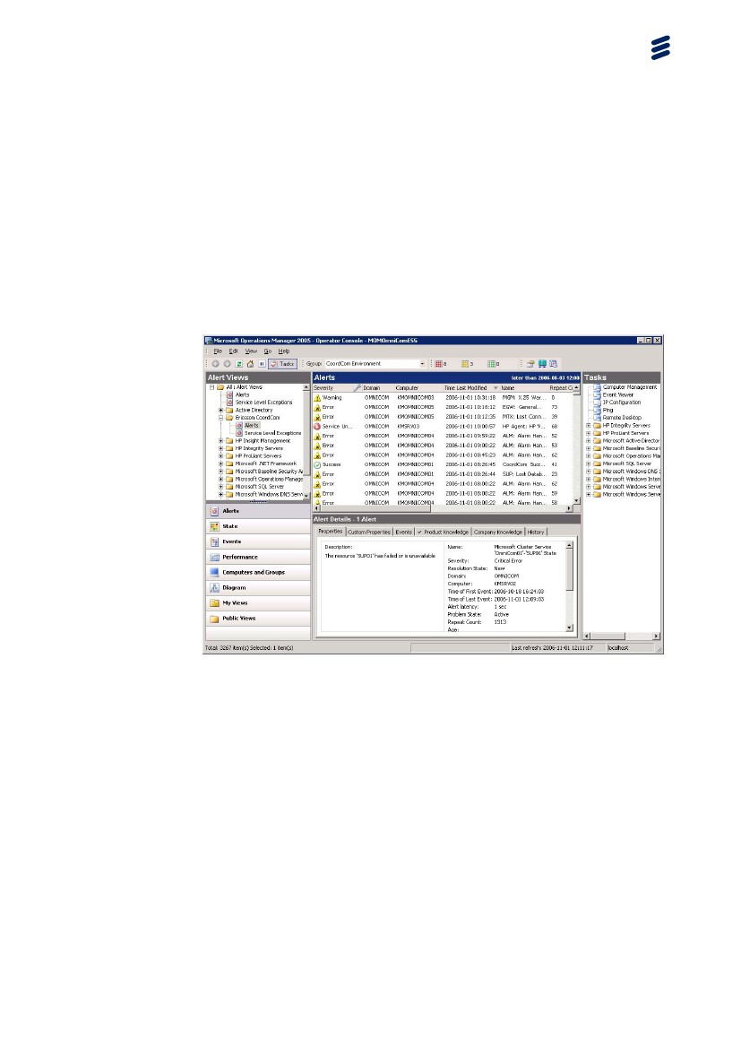

Figure 1 System Center Operations Manager Operator Console

* 1. Basic overview of SCOM
     1. Alerts

SCOM will raise a number of alerts with different severities.

* Service Unavailable
* Critical Error
* Error
* Warning
* Information
* Success

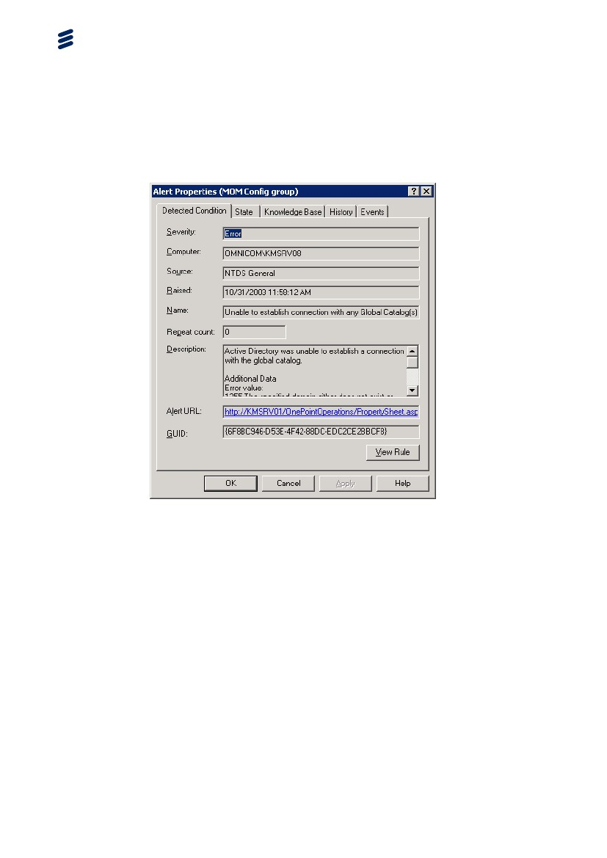

Figure 2 Example of SCOM Alert Property

The raised alerts can be then be set in different states. When the alert is no longer valid, it should be set to status resolved.

* + 1. Rules

The alerts are defined in a number of rules. It is possible to enable and disable the rules. You can also write you own rules, as you like. However all changes in the configuration of SCOM should be reported to Ericsson.

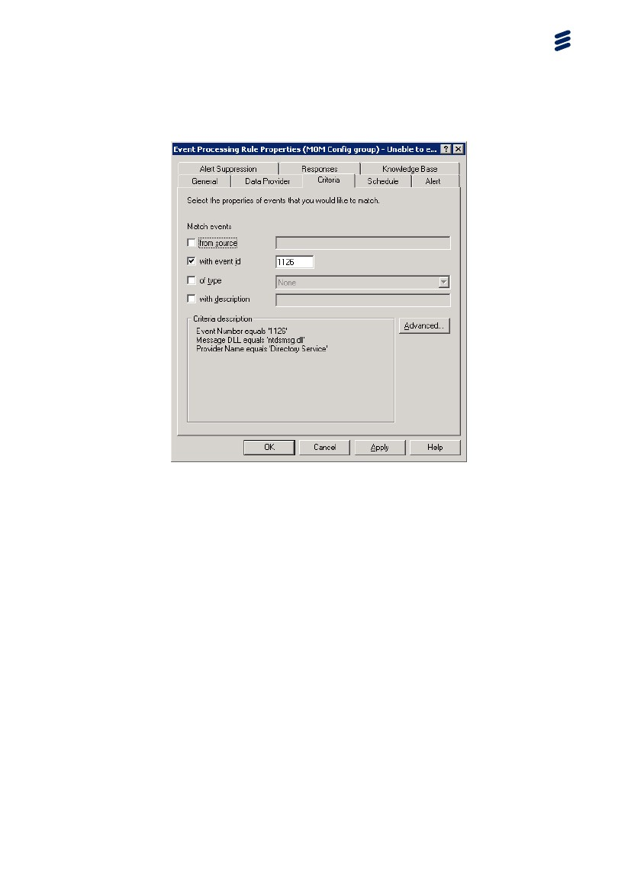

Figure 3 Example of SCOM event processing rule

* + 1. SCOM Notification Groups

SCOM comes with a set of notification groups Helpdesk, SQL experts and so on. You can also define your own.

Use these groups to notify a specific technician for a specified problem. It is possible to set a number of ways to notify these persons.

1. Windows tools

Here follows some basic Microsoft Windows tools to help you troubleshoot.

This section is not intended to give an in-depth knowledge of Windows, but just point to some helpful tools and commands to help you solve Windows related problems. For more information on how to install, administrate, configure and troubleshoot. Please refer to Microsoft Windows Server manuals and user guides.

* 1. Computer Management

Right-clicking the icon “My Computer” best starts the computer manager. Now you will have an overview of your computer. The main features are described below. It is also possible to connect to a different computer.

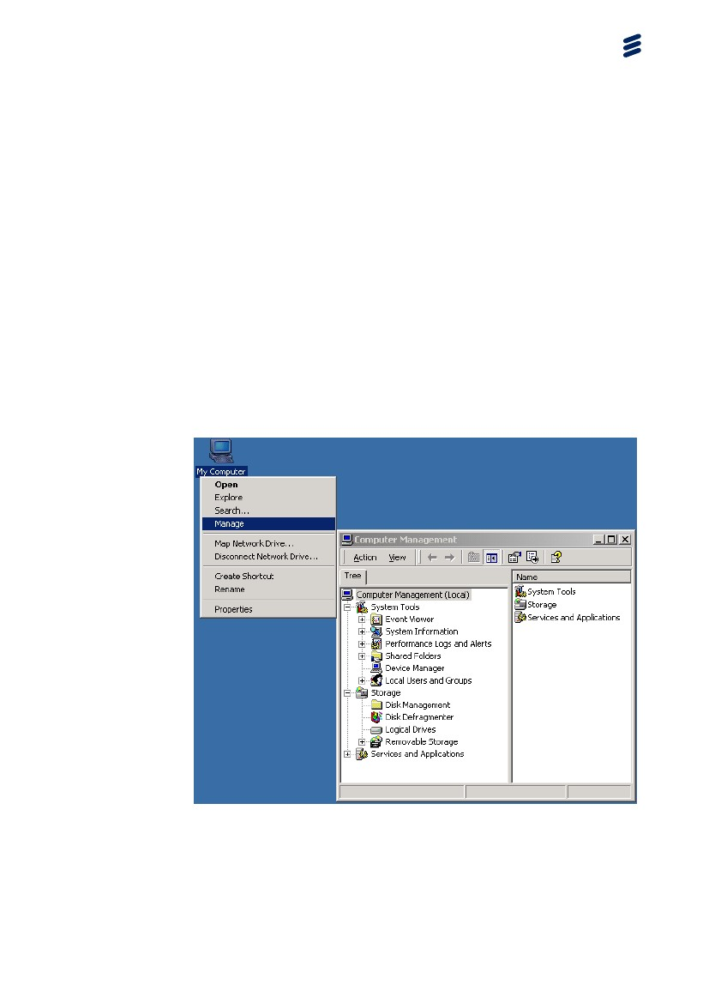

Figure 4 Computer Management

It is possible to connect to another computer without having to login. Select Action > Connect to another computer ...

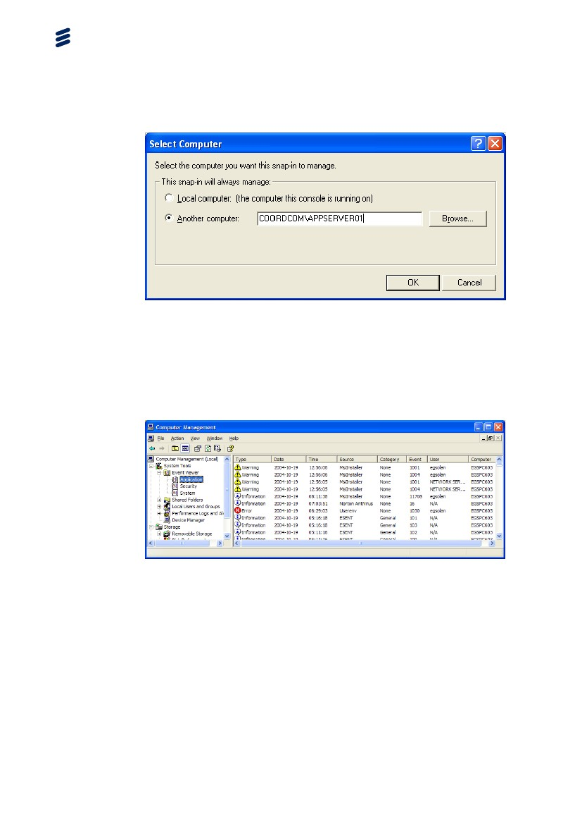

Figure 5 Connect to another computer

* + 1. Event Viewer

This is the log of Windows. The applications will write information of errors,

warnings and general information about the status of the application. This is the

main source of information of errors in the Windows environment.



Figure 6 Event Viewer

* + 1. Device Manager

Here you can see the status of the hardware and driver information of the computer.

If Device Manager is not found in Computer Management it can be found by right-clicking on My Computer, select Properties and then under the Hardware tab in the System Properties window clicking on the Device Manager button.

Figure 7 Device Manager

* + 1. Disk Management

Show the status of the disk(s).

Figure 8 Disk Management

* + 1. Services

Control the services that are running on the computer.

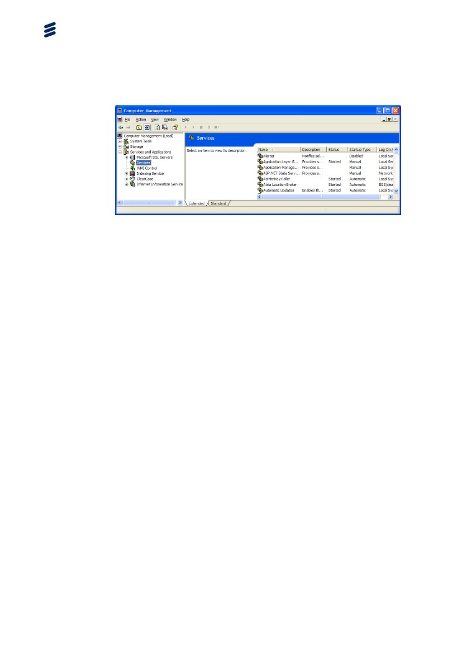

Figure 9 Services

* 1. Network Connections

Network Connections provides connectivity between your computer and the Internet, a network, or another computer. With the Network Connections feature, you can configure settings to reach local or remote network resources or functions.

Network Connections combines Windows Dial-Up Networking with features that were formerly located in the Network Control Panel, such as network protocol and service configuration. Each connection in the Network Connections folder contains a set of features that creates a link between your computer and another computer or network. By using Network Connections, performing a task, such as modifying a network protocol, is as easy as right-clicking a connection and then clicking Properties.

For more information about using Network Connections in Windows use the built in Help and Support Center accessed from the Help menu in the Network Connections window.

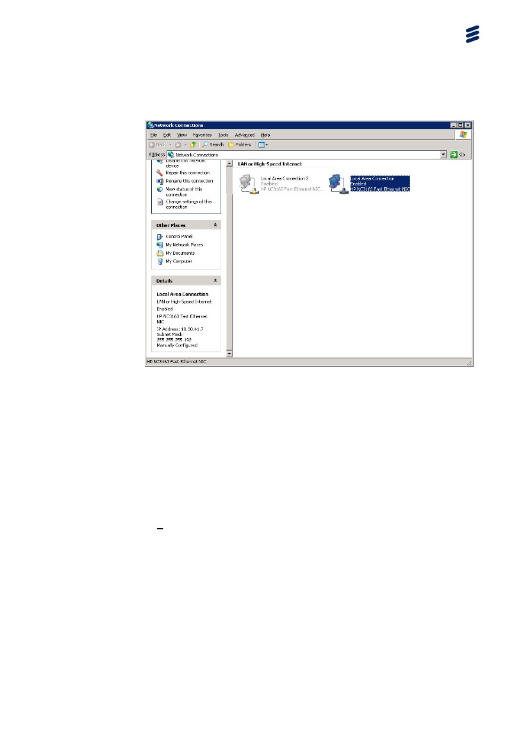

Figure 10 Network Connections

* 1. Task Manager

Task Manager (Taskmgr.exe) is a GUI tool that enables you to view or end a processes or an unresponsive application. You can also use Task Manager to gather other information, such as CPU statistics.

To start Task Manager •

At the command prompt, type taskmgr.

or –

You can start Task Manager by pressing CTRL+ALT+DEL and then clicking Task Manager.

The Task Manager window contains four tabs: Applications, Processes, Performance, and Networking. The Applications and Processes tabs provide a list of applications or processes currently active on your system.

These lists are valuable, because active tasks do not always display a user interface, making it difficult to detect activity. Task Manager displays active processes and enables you to end most items by clicking End Process.

You cannot end some processes immediately, and you might need to use other programs such as the Services snap-in, Task Kill, Process Viewer, or equivalent tools, to end them. You can also customize Task Manager to increase or decrease the level of detail shown on the Processes tab.

To display additional information on the Processes tab

1. Start Task Manager, and then click the Processes tab.

2. On the View menu, click Select Columns

3. Select or clear the columns that you want to add to, or remove from, the Processes tab.

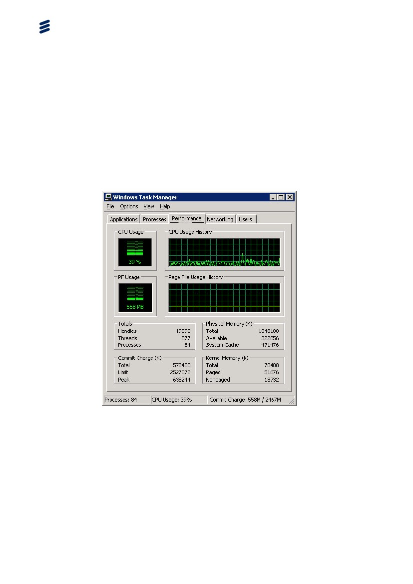

Figure 11 Task Manager

* 1. Command Prompt

Many commands are still “DOS” and need to be executed in a command prompt window.

Figure 12 Command Prompt

* + 1. ping [ip address]

This MS-DOS utility is best run when typing it in an MS-DOS window. It will "ping" a server, testing its response times, showing the server's IP address, and checking if the server is up. (Replace [ip address] with the address of the site you are testing.) Type ping /? to get more information.

* + 1. Ipconfig

Ipconfig is a MS-DOS utility which can be used from MS-DOS and a MS-DOS shell to display the network settings currently assigned and given by a network.

This command can be utilized to verify a network connection as well as to verify your network settings. Type ipconfig /? to get more information.

* + 1. tracert [ip address]

This MS-DOS utility is best run when typing it in an MS-DOS window. It traces the route to a web server. (Replace [ip address] with the address of the site you are tracing.) Type tracert /? to get more information.

* + 1. mem

This utility should always be accessed through an MS-DOS window. It will display information on your computer's memory usage. Type mem /? to get more information.

* + 1. route

Manipulates network routing tables. Type route print to get current routing settings and type route /? to get more information.

* + 1. W32TM

A tool used to diagnose problems occurring with Windows Time. Type w32tm /? to get more information.

* 1. Regedit

This application is used to display and alter the computer registry. Normally shouldn’t be tampered with.

Figure 13 Registry Editor

* 1. Remote Shutdown

Allow you to shut down or restart a local or remote computer.

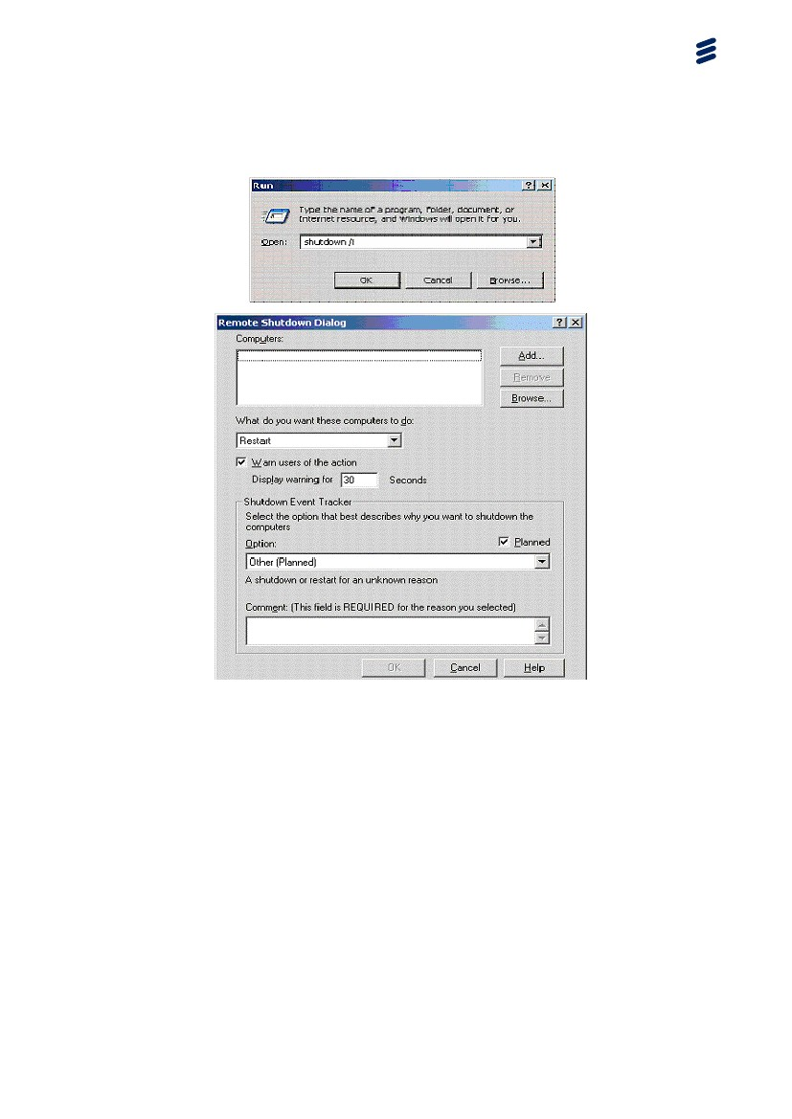

Figure 14 Remote Shutdown

* 1. Remote Desktop

Use remote desktop to log in to other computers remotely

Note: Remote Desktop does not take control of the console A session that will disconnect the person at the console can be run mstsc /v:10.30.41.7 /admin

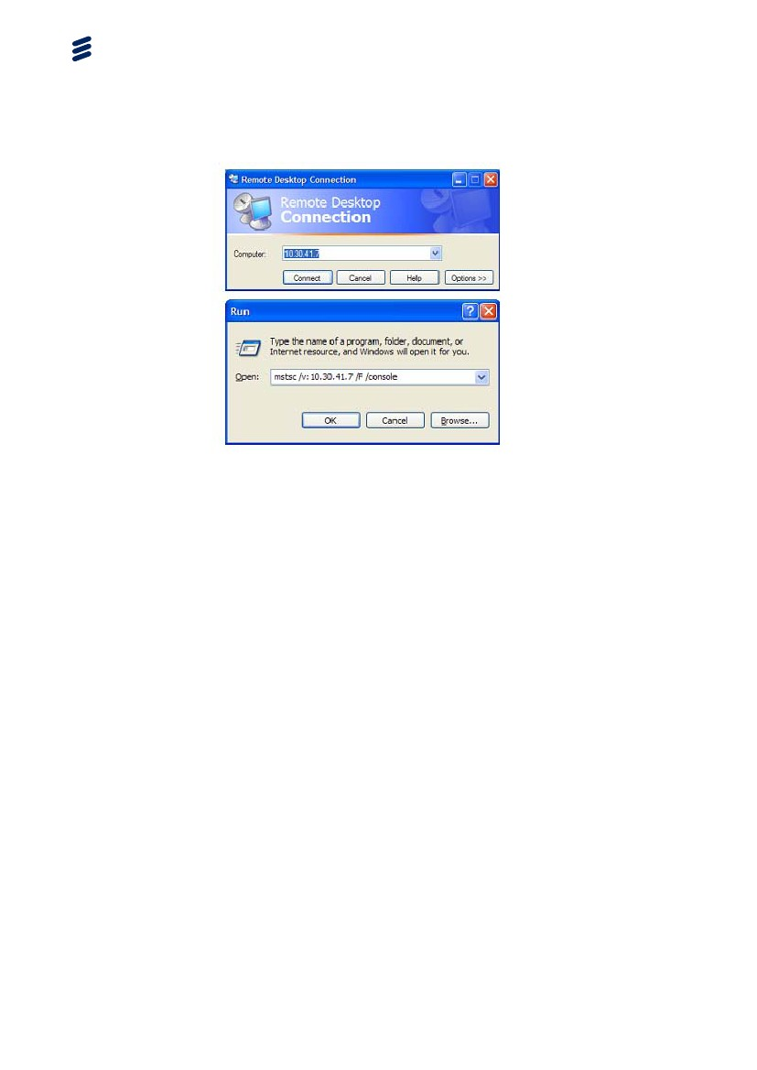

Figure 15 Example of Remote Desktop

* 1. perfmon

The perfmon tool comes with Microsoft Windows operating systems. It is installed by default in Programs > Administrative Tools > Performance Monitor. As it comes with Windows, performance will show a number of different system level statistics such as CPU usage, disk activity, number of interrupts per second. All of these are shown on an integrated display. If you do not know what performance is, we suggest that you start it up (you do not need to be administrator) and add the CPU and interrupts per second and then do some things (move the mouse around, perhaps) and observe the Windows system through the performance display.

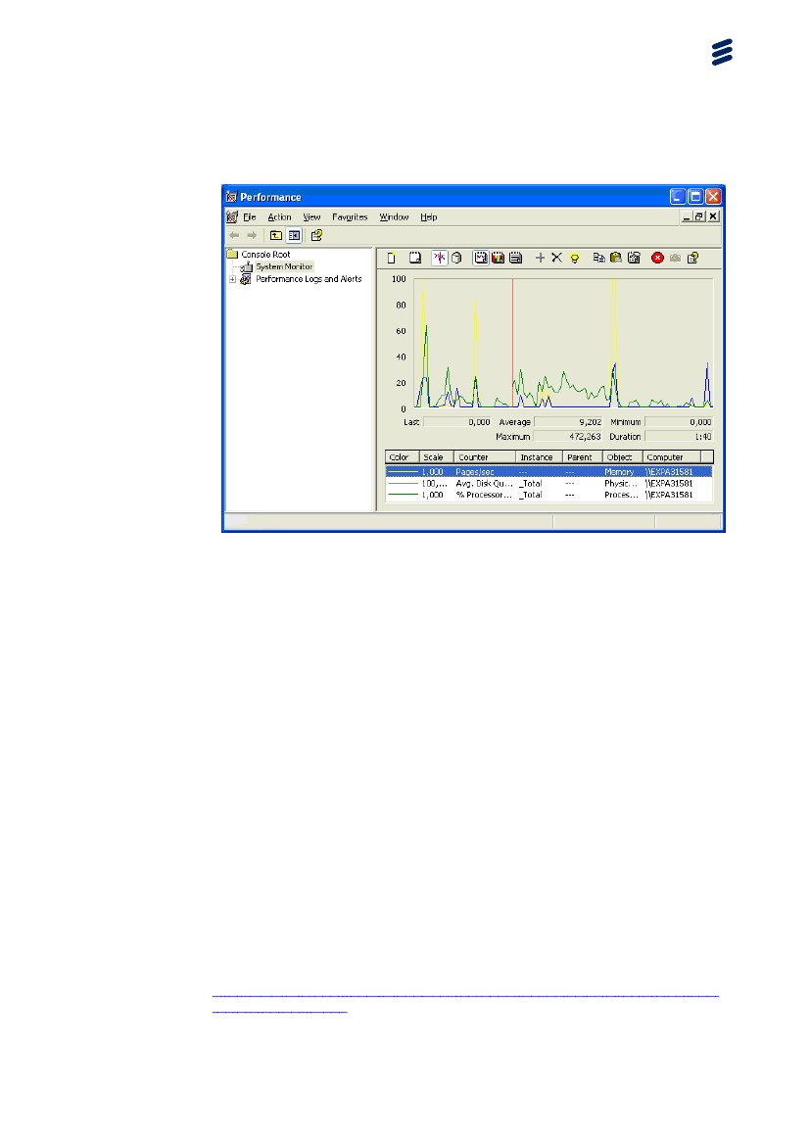

Figure 16 perfmon

* 1. Active Directory

The Active Directory directory service can be installed on servers running Microsoft Windows Server. For recommended software versions, see CoordCom System Software Environment, Reference [1]. Active Directory stores information about objects on the network and makes this information easy for administrators and users to find and use. Active Directory uses a structured data store as the basis for a logical, hierarchical organization of directory information.

This data store, also known as the directory, contains information about Active Directory objects. These objects typically include shared resources such as servers, volumes, printers, and the network user and computer accounts.

Security is integrated with Active Directory through logon authentication and access control to objects in the directory. With a single network logon, administrators can manage directory data and organization throughout their network, and authorized network users can access resources anywhere on the network. Policy-based administration eases the management of even the most complex network.

For more information, see Windows Server 2003 Active Directory on the web:

<http://www.microsoft.com/windowsserver2003/technologies/directory/activedi>rectory/default.mspx.

Active Directory also includes:

* A set of rules, the schema that defines the classes of objects and attributes contained in the directory, the constraints and limits on instances of these objects, and the format of their names.
* A global catalog that contains information about every object in the directory. This allows users and administrators to find directory information regardless of which domain in the directory actually contains the data.
* A query and index mechanism, so that objects and their properties can be published and found by network users or applications.
* A replication service that distributes directory data across a network. All domain controllers in a domain participate in replication and contain a complete copy of all directory information for their domain. Any change to directory data is replicated to all domain controllers in the domain.

The Active Directory is essential to the CoordCom system and a good knowledge and understanding is important.

* + 1. Active Directory Tools
       1. Active Directory Users and Computers

Active Directory Users and Computers is a Microsoft Management Console snap-in. It is started by selecting "Start", "Programs", "Administrative Tools", and "Active Directory Users and Computers". Only members of the Domain Admins or Enterprise Admins group can use this tool. This tool is used to create, configure, locate, move, and delete objects including:

* User (automatically published)
* Group (automatically published)
* Computer (Those in the domain are automatically published)
* Contact (automatically published)
* Domain
* Organizational Unit (automatically published)
* Shared folder
* Printer (Most are automatically published)

It is also used to publish resources, control security and access to objects, and set up administrative control of objects to users. Published resources allow users to find and use them without knowing what server they reside on. Most browse lists do not cross subnet boundaries, but published resources are seen across subnets. These published resources may be browsed from "My Network Places". The "Computer Management" administrative tool or "Active Directory Users and Computers" is used to publish resources in Active Directory.

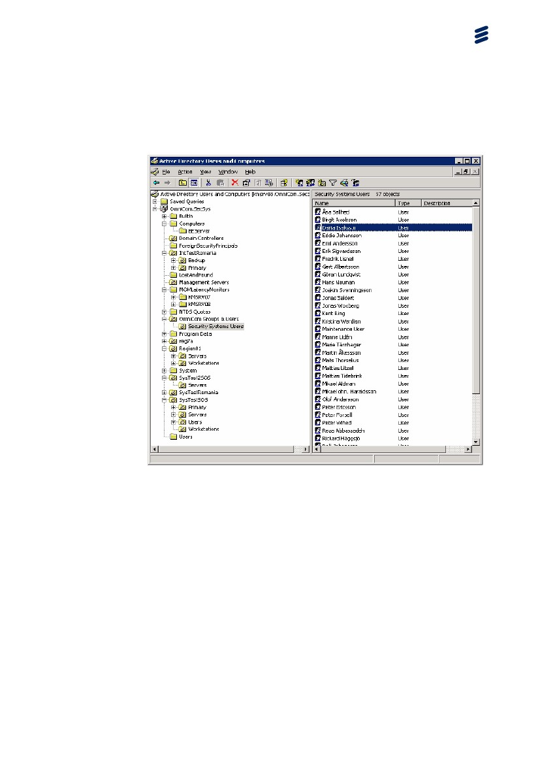

Figure 17 Active Directory Users and Computers

The computers are specified to be members of OU. It is important for the correct Group Policies to be applied and also for the correct CoordCom region.

Figure 18 Active Directory Workstations

* + - 1. Active Directory Sites and Services

Active Directory uses multimaster replication, enabling any Windows domain controller in the forest to service requests, including modifications to the directory by users.

Authorized administrators provide information about the physical structure of the network by publishing sites to Active Directory using Active Directory Sites and Services. Active Directory uses this information to determine how to replicate directory information and handle service requests.

A site represents a region of uniformly good network access, which can be interpreted as being generally equivalent to local area network (LAN) connectivity. LAN connectivity assumes high, inexpensive bandwidth that allows similar and reliable network performance, regardless of which two computers in the site are communicating. This quality of connectivity does not indicate that all servers in the site must be on the same network segment nor that hop counts between all servers must be identical. Rather, it can be interpreted as the measure by which it is known that if a large amount of data needed to be copied from one server to another, it would not matter which servers were involved. If there is concern about such situations, consider creating another site.

Computers are assigned to sites based on their location in a subnet or in a set of well-connected subnets. Subnets provide a simple way to represent network groupings, much the same way that postal codes conveniently group mailing addresses. Subnets are formatted in terms that make it easy to post physical information about network connectivity to the directory. Having all computers in one or more well-connected subnets also reinforces the standard that all computers in a site must be well-connected, since computers in the same subnet typically have better connections than an arbitrary selection of computers on a network.

Figure 19 Active Directory Sites and Services

* + - 1. Active Directory Domains and Trust

The Active Directory Domains and Trusts snap-in provides a graphical view of all domain trees in the forest. Using this tool, an administrator can manage each of the domains in the forest, manage trust relationships between domains, configure the mode of operation for each domain (native or mixed mode), and configure the alternative User Principal Name (UPN) suffixes for the forest.

Figure 20 Active Directory Domains and Trust

* + - 1. Group Polices Management
         1. Group Policy Overview

You can use Group Policy to manage the configurations on computers throughout networks with domains based on Microsoft Windows Server. You can also use Group Policy to meet service-level agreements. For example, you can make software available to users based on their security group memberships and other criteria and to enforce the organization’s policies regarding computer usage.

Group Policy depends on several technologies in Windows Server. These include Active Directory, Domain Name System (DNS), and File Replication Service (FRS). Group Policy is delivered to clients based on the placement of both the computer and the user account in the Active Directory hierarchy.

In addition, Group Policy uses the security groups defined through Active Directory to determine whether policies are applied, as well as to control who can manage Group Policy in the organization. The interactions between Group Policy and its supporting technologies make Group Policy flexible. It is important to understand these interactions when troubleshooting Group Policy.

Before you work with Group Policy, you need a firm understanding of the interactions between Group Policy and its supporting technologies and the ways Group Policy objects themselves are managed, deployed, and applied.

This white paper highlights some key points to keep in mind as you troubleshoot Group Policy problems. For detailed information about Group Policy and the various supporting technologies, see Designing a Managed Environment (http://go.microsoft.com/fwlink/?LinkId=4755) in the Microsoft Windows Server Deployment Kit.

The Group Policy Management Console (GPMC) is the recommended tool for managing Group Policy. GPMC is also an excellent troubleshooting tool.

If you have a licensed copy of Windows Server, GPMC is available to you as a free download from the Microsoft.com Group Policy Home Page. It can be installed on any computer running either Microsoft Windows Server or Windows XP Professional. The computer that runs Windows XP Professional must have Service Pack 1 or later and .NET Framework installed. You can use GPMC to manage Group Policy in domains based on Windows Server.

For more information, see Introduction to Group Policy for Windows Server 2003. (<http://go.microsoft.com/fwlink/?LinkId=14958>).

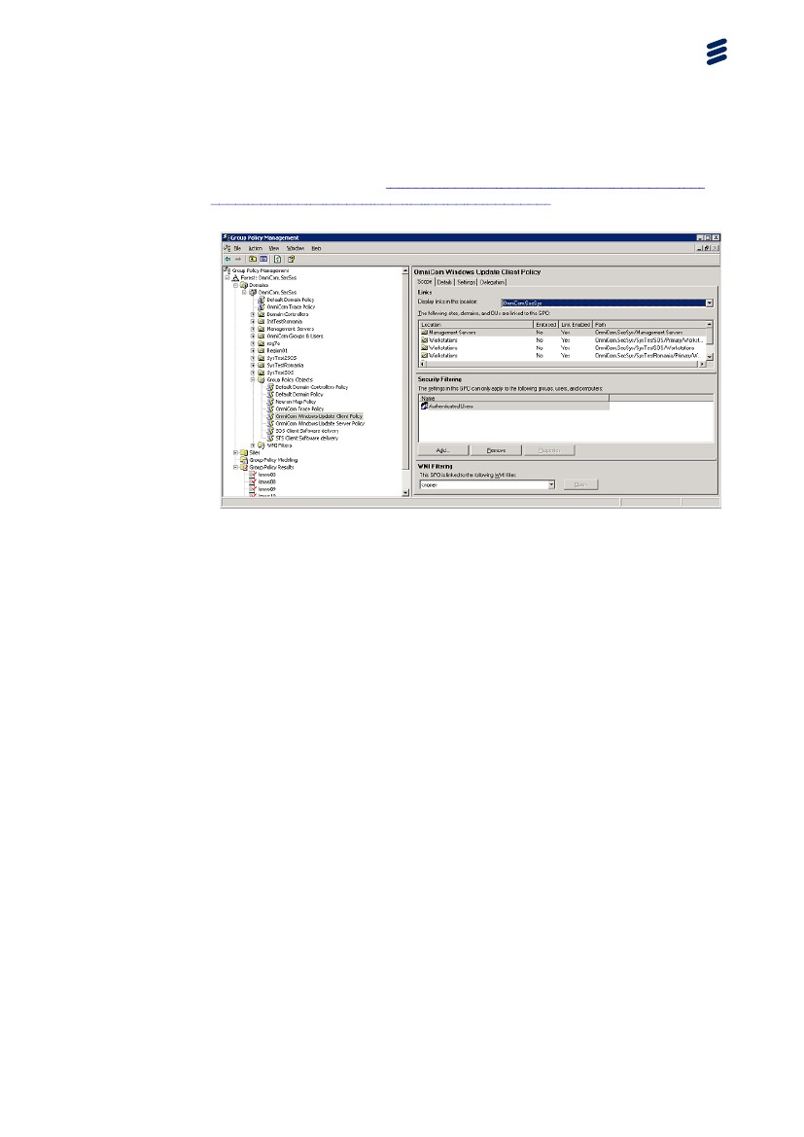

Figure 21 Group Polices Management

* + - 1. adsiedit.msc

This GUI tool is a Microsoft Management Console (MMC) snap-in that acts as a low-level editor for Active Directory. Network administrators can use Active Directory Service Interfaces (ADSI) for common administrative tasks such as adding, deleting, and moving objects with a directory service. Attributes for each object viewed can be changed or deleted.

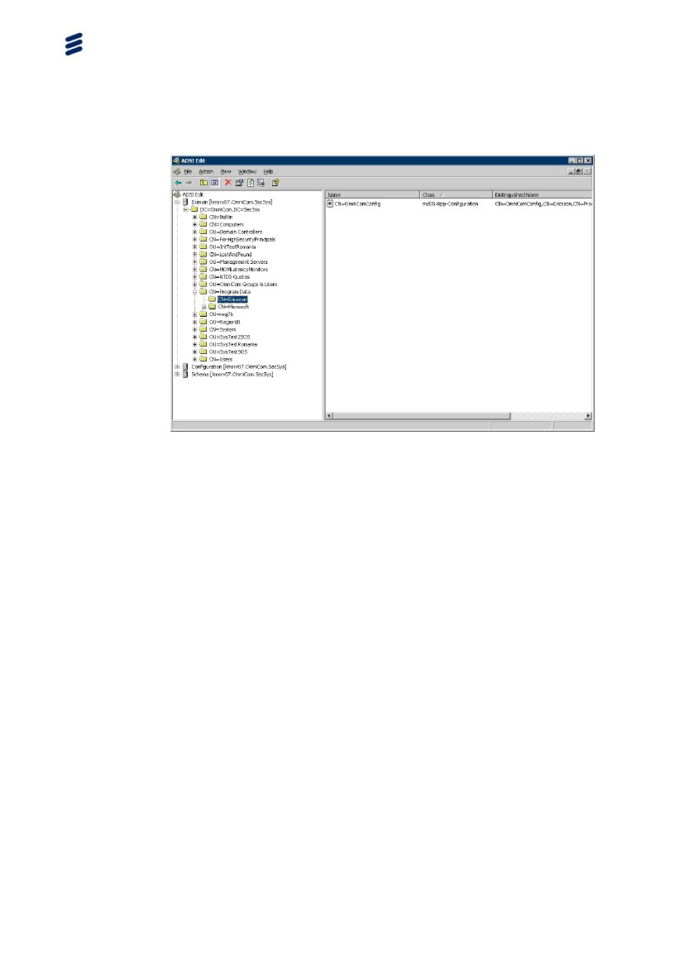

Figure 22 Adsiedit

* + - 1. Example of Domain Structure

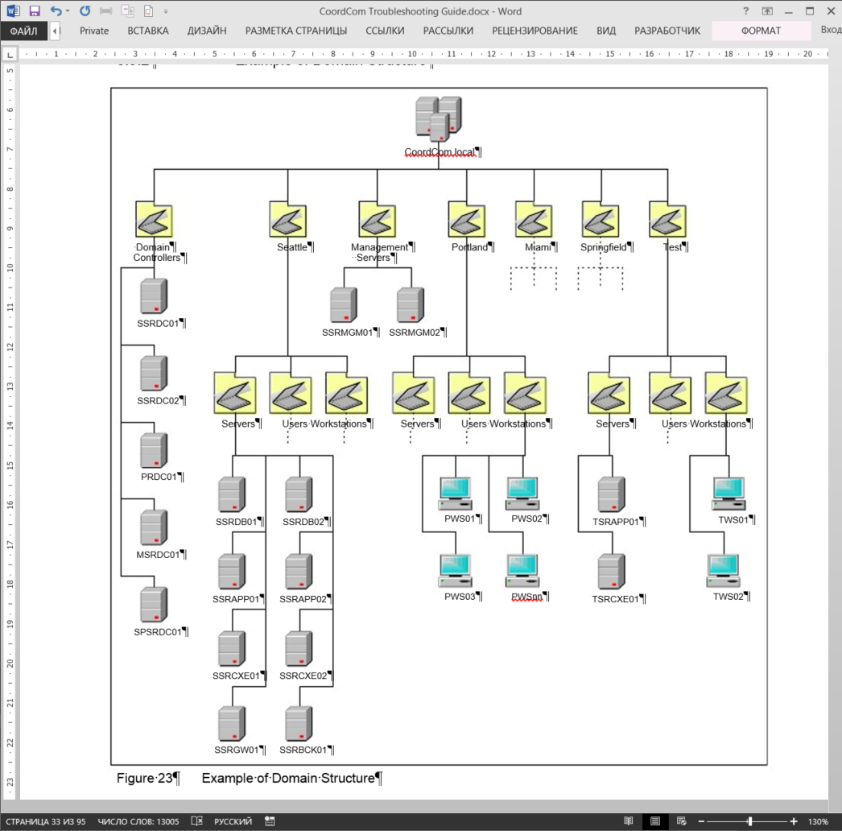

Figure 23 Example of Domain Structure

* 1. DNS

DNS is an abbreviation for Domain Name System, a system for naming computers and network services that is organized into a hierarchy of domains. DNS naming is used in TCP/IP networks, such as the Internet, to locate computers and services through user-friendly names. When a user enters a DNS name in an application, DNS services can resolve the name to other information associated with the name, such as an IP address. The DNS is essential for Active Directory.

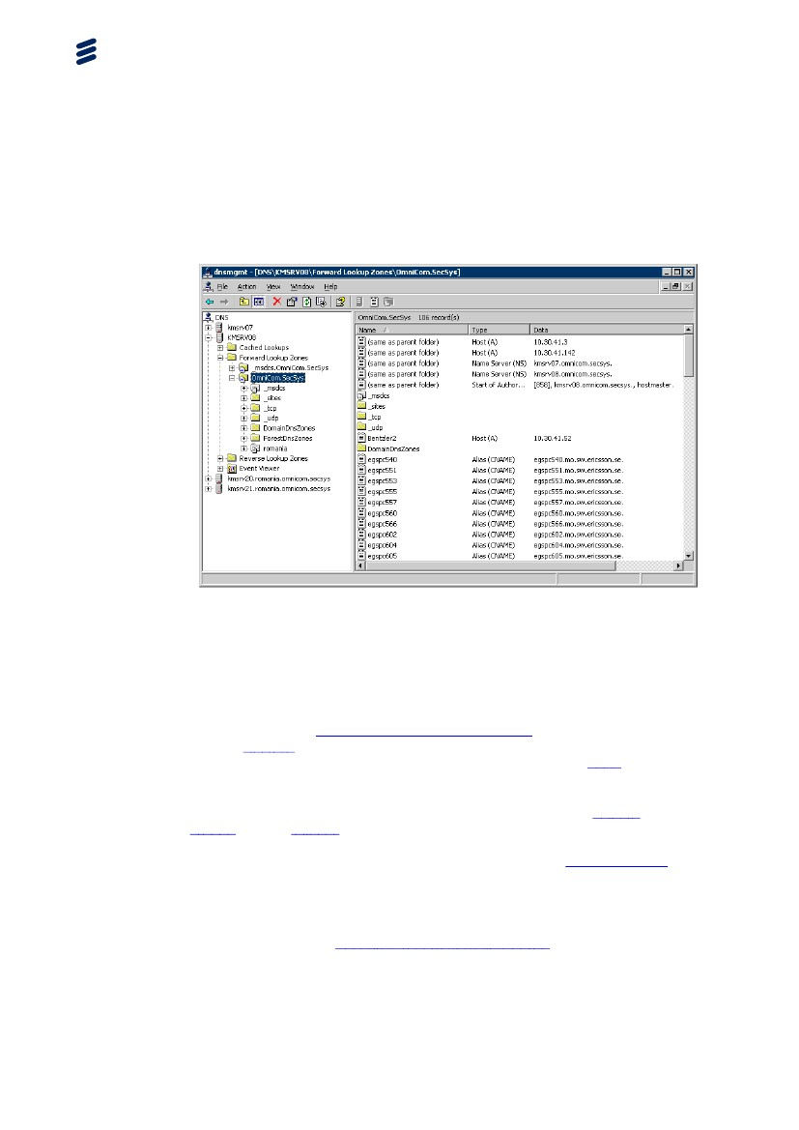

Figure 24 DNS

* 1. Cluster Administrator

Some CoordCom system use Windows Cluster.

Administrators use cluster management applications to configure, control, and monitor clusters.Cluster Administrator is an example of a cluster management application. Any system, regardless of whether it is a cluster node, can install Cluster Administrator.

Cluster Administrator allows administrators to manage cluster objects, establish groups, initiate failover, handle maintenance, and monitor cluster activity through a convenient graphical interface. Third-party developers can extend the functionality of Cluster Administrator by implementing extension DLLs.

Note: When you use Cluster Administrator to create a new File Share resource, permissions for the Everyone group for that file share are set to read-only by default. You can change the default permissions by modifying the Security Property for File Shares.

For more information on Cluster Administrator, see the documentation included with the operating system or the built in help system in the operating system.

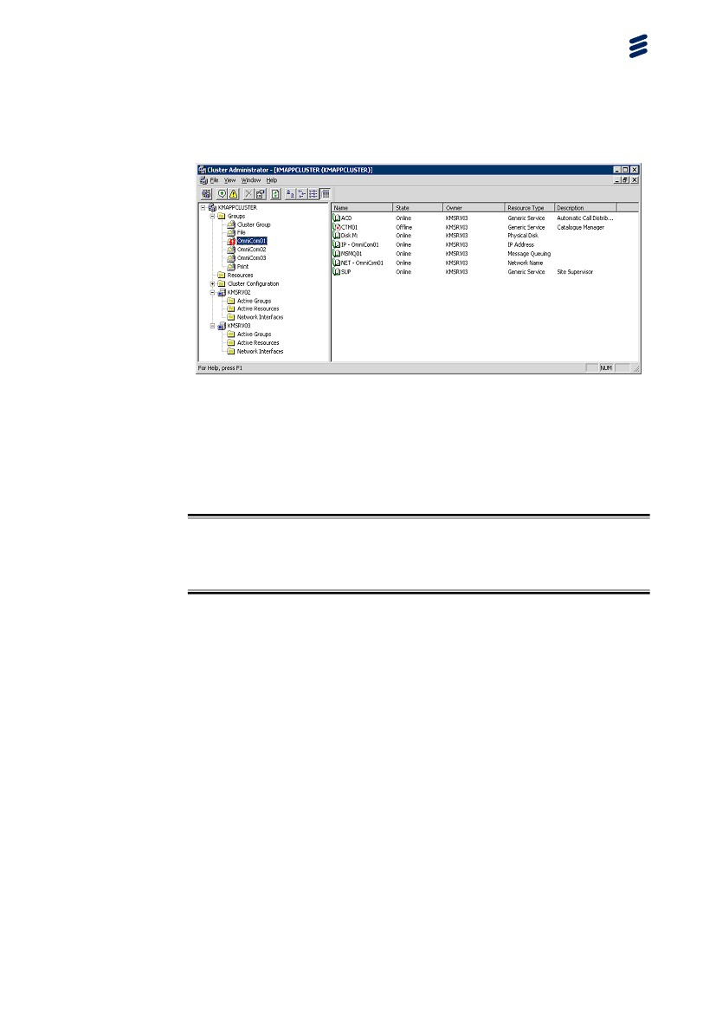

Figure 25 Cluster Administrator

* 1. Microsoft SQL Server Management Studio

SQL Server Management Studio is used to manage the SQL server or manipulate the database directly.

Warning!

Use this tool with caution and only together with Ericsson support personnel.

SQL Server Management Studio is a graphical tool you can use for just about anything you need to do to manage your server and its databases (see the following figure). SQL Server Management Studio is the easiest way to access settings, databases, security, Data Transformation Services, and replication. You can even use it to browse the data in your tables and views, although I don't recommend it for that purpose because it can prevent the users from accessing the data in a way you may not expect (a behavior called locking).

The primary concept behind the SQL Server Management Studio is that there are objects in the left pane of the tool in a tree format; that is, there are parents and children that logically belong together. For instance, the databases object has databases that are underneath it. If these objects and children are nouns (things), then verbs (actions) applying to those things are accessed by right-clicking them. The actions change based on the object; for example, the databases object has Create new database, while a particular database object has Backup database. A great way to learn more about the SQL Server Management Studio is to expand and right-click each object, one at a time. (You may not want to actually perform these actions; some of them are CoordCom Troubleshooting Guide dangerous.) If you see something that you don't immediately understand, mark that down as an item to research further.

The SQL Server Management Studio tool is installed on the server by default, but it can also be installed on another system. The important thing to remember if managing a server remotely is that what you do remotely is happening on the server. If you are managing a remote server from your workstation, actions as a backup to C: are sent to the C: of the remote server and not to the C: of the local workstation.

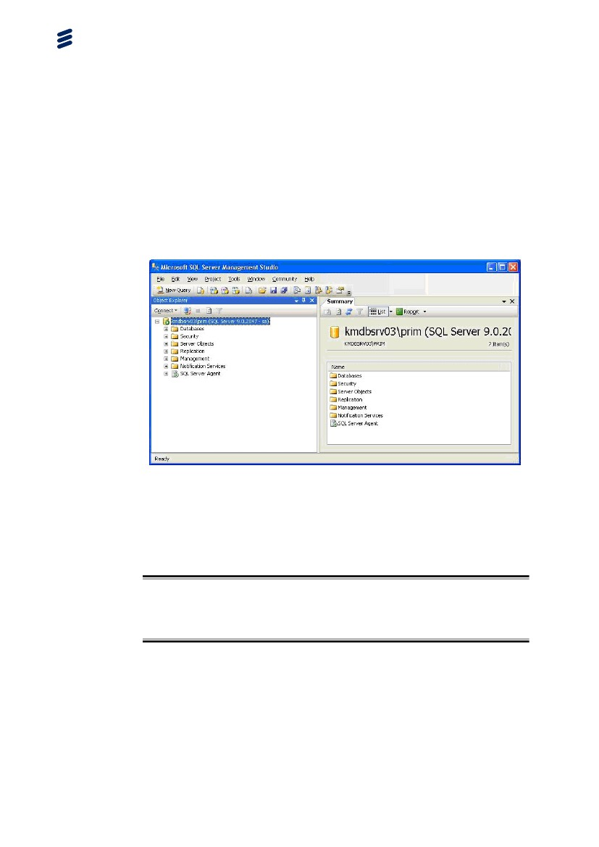

Figure 26 SQL Server Management Studio

* 1. New Query in Microsoft SQL

This tool is used to execute SQL commands into the database.

Warning!

Use this tool with caution and only together with Ericsson support personnel.

To access the SQL New Query part of SQL Server Management Studio click on the New Query button in the upper left part of the SQL Server Management Studio window.

The New Query in SQL Server Management Studio is the graphical command-driven method to manage the SQL server and more (see the following figure).

The New Query in SQL Server Management Studio is the tool of choice for most developers. In this tool, you type commands, or press a key or click an icon to execute the commands. You can check the syntax before you execute the commands, observe their proposed plan of execution, time them, and analyze their use of indexes.

SQL Server Management Studio has a left pane (which can be turned off), called the Object Explorer. The Object Explorer allows quick access to all the objects on the server and like the rest of SQL Server Management Studio, has a right-click-for-actions function. These actions include scripting options that will create the Structured Query Language (SQL) for selecting, updating, adding, and deleting data in tables and views.

Viewing data is best done with this tool because you can limit the data returned by the server. Another advantage is that during the query you can specify the type of locking you want, giving you more control over the way you affect users.

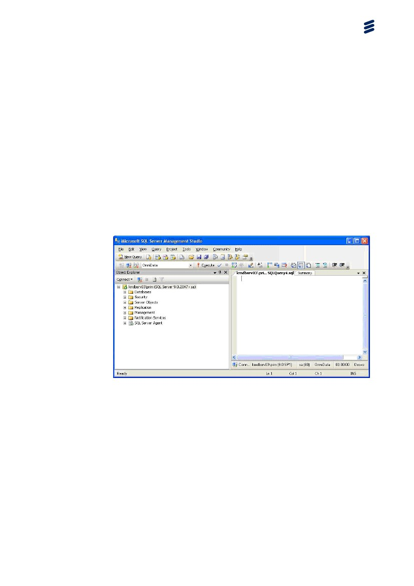

Figure 27 New Query in SQL Server Management Studio

* 1. SQL Server Profiler

Microsoft SQL Server Profiler is a graphical user interface to SQL Trace for monitoring an instance of the SQL Server Database Engine or Analysis Services. You can capture and save data about each event to a file or table to analyze later.

To run SQL Server Profiler, on the Start menu, point to Programs, Microsoft SQL Server, Performance Tools, and then click SQL Server Profiler.

1. CoordCom Tools
   1. Overview

Example of a CoordCom system

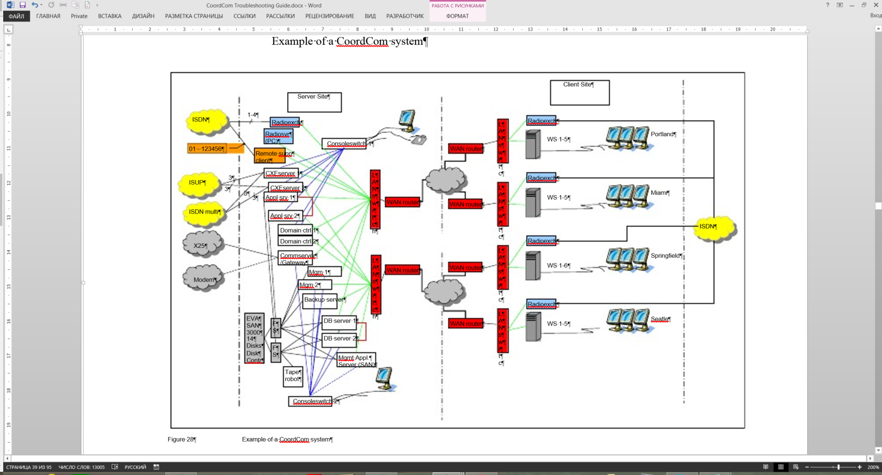

Figure 28 Example of a CoordCom system

* + 1. CoordCom System Services

The CoordCom system services can be set up to run in a clustered environment

or a standard Windows environment.

Table 1 CoordCom system services

|  |  |
| --- | --- |
| ACD – Automatic Call Distributor | The Automatic Call Distributor is responsible for distributing Calls to the Operator Positions (clients) according to their work choice selection at login locally or remote. The Calls could be phone calls, automatic alarms, reminders and so on. Only one Operator is able to answer a specific Call. |
| AGW – AddressGateway | Based on an incoming A-number the Address gateway queries an external subscriber database interface for subscriber information. The AGW has a generic subscriber information exchange interface. |
| ALM – Alarm Manager | The Alarm Manager is responsible for the handling of automatic alarms. The alarms are processed, cases are created if applicable and Calls are generated and distributed using ACD. It communicates with external alarm receiver as CCAR. |
| ALT – Alert Manager | The Alert Manager handles mobilization of fire stations, police stations and so on. The Operator activates the mobilization (usually from an action plan) and ALT is responsible for the communication with the external equipment and the feedback to the Operator. |
| APS – Application Supervisor | The Application Supervisor process monitors that all processes are up and running. This process in configured from the CoordCom Software Supervisor program. |
| AVL – Automatic Vehicle Location System | The Automatic Vehicle Location System process handles communication with the position system of the resources (vehicles) in the system. This makes it possible to know exactly where all the resources are located. Optional process. |
| BAT – Batch Job Manager | The Batch Job Manager runs scheduled batch files and database scripts. |
| CTM – Catalogue Manager | Catalogue Manager, this is the process in CoordCom that connects to the catalogue service (CAT). CTM is only used in the Swedish solution. |
| DBS – Database Supervisor | The Database Supervisor process monitors that the contact and communication with the database work properly. This process in configured from the CoordCom Software Supervisor program. |
| DRM – DigitalRadio Managment | The Digital Radio Manager manages various Digital Radio functions, such as radio groups. |
| ECL – eCall Manager | The eCall Manager is responsible for the handling of eCall’s. The eCalls are processed, cases are created and Calls are generated and distributed using ACD. It communicates with external In-Vehicle Systems according to the eCall standard.  Note: The eCall feature is implemented only for test, trial and demo purposes in this version of CoordCom. |
| ECM – ExportCase Manager | The Export Case Manager exports Case data to an external system via the ECM interface. |
| EGW – E-mail Gateway | The E-mail Gateway handles communication with SMTP servers. Both in- and outgoing mails are handled by EGW. |
| EIH – ExternalInterf aceHost | The External Interface Host acts as a generic interface towards all adaptor services. |
| ELM – Emergency Location Manager | The Emergency Location Manager handles communication with mobile operators and retrieve information about the position of mobile phones. |
| FCT – FixedCellular | The FCT handles communication with SMS-C:s via an external FWT equipment. The communication is performed via the air interface. Both in- and outgoing messages are handled by FCT. |
| FEM – File Encoding Manager | The File Encoding Manager encodes sound files into an mp3-format. The mp3 files are then stored in a file share, which is accessible for other processes in the system. |
| HIS – History | The History process handles the removal of old data in the system. After a configured time data can be moved into a historical database, thus increasing performance of the system, and after another configured time the data can be deleted. |
| MAP – Map Manager | The Map Manager handles communication with the GIS application. If an Operator wants to show on the map where a specific case is located, or if he or she performs actions in the GIS application that has an effect on the case or a resource, MAP processes the information. |
| MGM –Message Manager | The Message Manager handles external data communication, for example SMS, e-mail, fax and FTP. It uses bearers such as TCP, X.25 and Mobitex. |
| MHR – Modem Handler | The Modem Handler is used when communicating with text phones. |
| MTX – Mobitex Gateway | The Mobitex Gateway handles communication using a mobitex bearer. |
| NET – Network Manager | The Network Manager is used for availability purposes. Whenever a process in the system cannot be reached, NET is used to see if the problem is network related or not. |
| OMT – Operator Middle Tier | The Operator Middle Tier process is used to increase performance for the Operator application. Database heavy transactions are handled in OMT to decrease the traffic between database server and the Operator Positions. |
| ORS – OptionalPositionReferenceSystem | The Optional Position Reference system converts coordinates from an optional reference system to WGS84. |
| REF – RefreshManager | The Refresh Manager serves all clients with refresh signals. When a Case or Overview is changed, REF sends refresh signals to all clients subscribing on actual refresh signals. |
| REP – Report Manager | The Report Manager handles creating and exporting of statistical reports. The system can create manually or automatic reports in many different formats. |
| RSS – ReadinessRuleSurveillanceManager | The Readiness Rule Surveillance Manager coordinates major resource handling work. |
| SMSGW – SMSGateway | The SMS Gateway handles communication between the system and the external communication net. |
| SMS – SMS Proxy | The SMS Proxy handles communication with SMS-C:s. Both in- and outgoing messages are handled by SMS. |
| TCM – Telematic Manager | The Telematic Manager handles voice connections in the system. This includes telephony, radio and voice messages. Incoming phone or radio calls are processed and distributed using ACD. Call control for outgoing calls are processed and TCM communicates with the corresponding CXE services. |
| TIM – Timer Manager | The Time Manager, generates Case surveillance calls for cases, resources or delayed action plan instructions. |
| TNA – TacticalNumberAllocationService | The Tactical Number Allocation Service translates numbers used in Digital Radio. |
| TOM – Tone Macro | The Tone Macro process handles playback and processing of DTMF tone signaling macros. |
| VOM – Voice Message | The Voice Message process handles playback of voice messages and processing of interactive voice response functionality. |
| X25 – X.25 Proxy | The X.25 Proxy handles communication using an X.25 bearer. |
| X25GW – X.25 Gateway | The X.25 Gateway handles communication between the system and the external communication net. |

For a more detailed function description refer to CoordCom Feature Description, Reference [3].

* + 1. CoordCom CXE System Services

The CXE system services are all started as Windows services.

Table 2 CoordCom Cxe system services

|  |  |
| --- | --- |
| CxeAlarm | CxeAlarm handles alarms in CXE. |
| CXEBoardOam | CXEBoardOam is responsible that the telephony boards are started correctly. |
| CxeConf | The CxeConf process handles the voice conferences on the telephony board. Note that the term conference is used also when only one person participates in a Call. |
| CxeDispatch | Distributes incoming calls to clients to CXE. In a CoordCom context this is TCM. It will also load balance the CXE servers. |
| CxeDsp | The CxeDsp process handles sound detection, recording and playback of sound files on the telephony board. |
| CxeIsdn | The CxeIsdn process handles the call control and voice of phone calls using ISDN. |
| CxeIsup | The CxeIsup process handles ISUP calls. |
| CxeRadio | The CxeRadio process handles the communication with external radio switches. |
| CxeRvx2000 | The CxeRvx2000 handles radio calls with Microbit radio system. |
| CxeSwitch | The CxeSwitch process handles the connections internally on the telephony board. |
| CxeVoip | The CxeVoip process handles the Voice over IP communication between the server and the Operator Positions. |

* + 1. CoordCom Work Station
* CxeSound – Connects the sound to and from CXE.
* CoordCom Operator – The main Operator program
* Education – Sets your Operator program to a education mode.
* CoordCom Script Editor – Handles your educational scripts.
* CoordCom Business Administrator – Program to administrate the CoordCom database.
  1. CoordCom Software Supervisor

CoordCom Software Supervisor (CSS) is a program for monitoring and managing sites (including services), servers, and databases, see Figure 29. CSS is also used to configure the CoordCom DBS and APS monitoring services. See CoordCom Operation and Maintenance, Reference [2], for more information.

You can use CoordCom Software Supervisor for the following:

* Manage and acknowledge process errors
* Configure database availability
* Perform manual failover and failback on a database
* Update database configurations
* Poll and manage services
* Display software revision information
* Measure performance
* Create availability reports

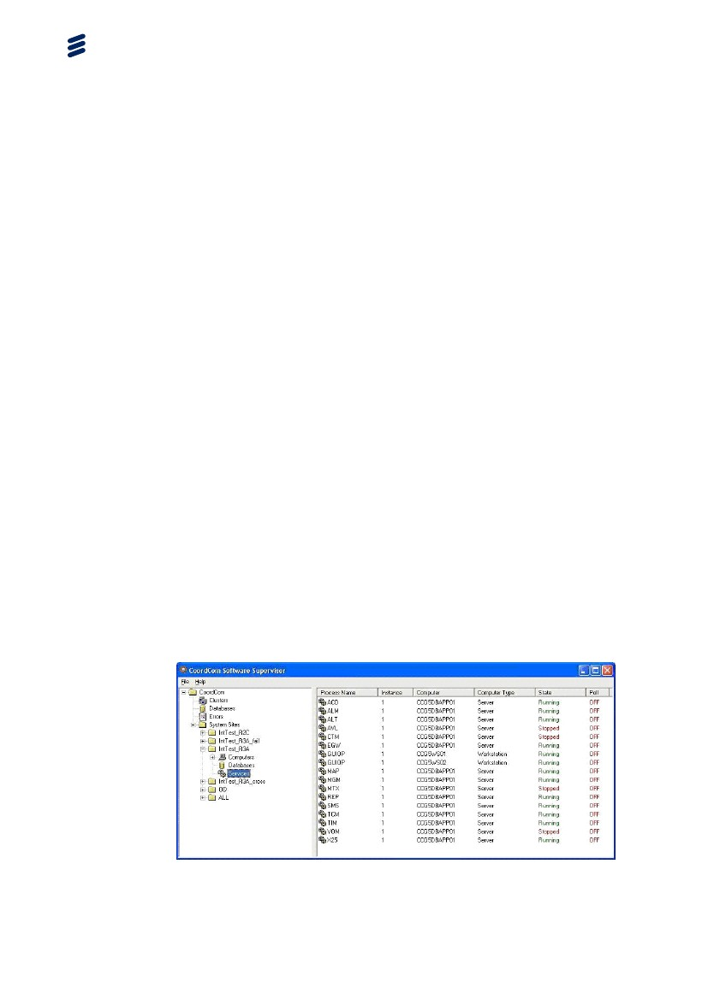

Figure 29 CoordCom Software Supervisor Program

* 1. CoordCom Business Administrator Program

The configuration of CoordCom is mainly done using the Business Administrator program. Many errors are caused by configurations errors in the CoordCom database. Use this tool to change the configuration.

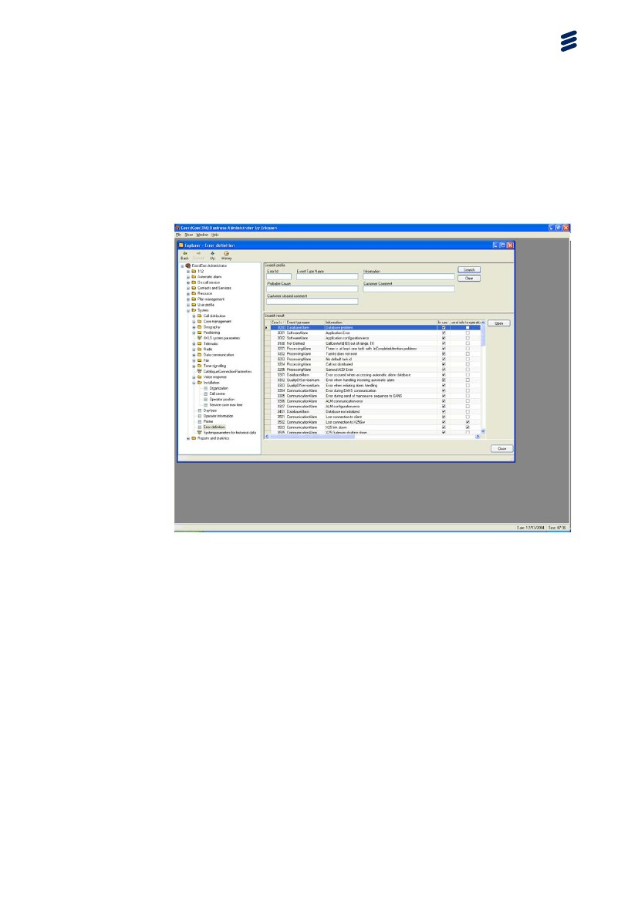

Figure 30 CoordCom Business Administrator Program

* 1. Operator Program

The CoordCom Workstation is a normal Windows workstation with extra video cards to enable multiple screens. The operator program is distributed with Active Directory Group Polices.

The applications are installed under c:\program files\Ericsson.

The sound is distributed through an extra Soundblaster card.

System alarms to the operators are shown as number in the lower left hand corner of the communication window. Click this window and the system alarms will be shown in detail in a separate window. The system administrator configures these alarms with the Business Administrator. The alarms and text to be show to the operators is configured here.

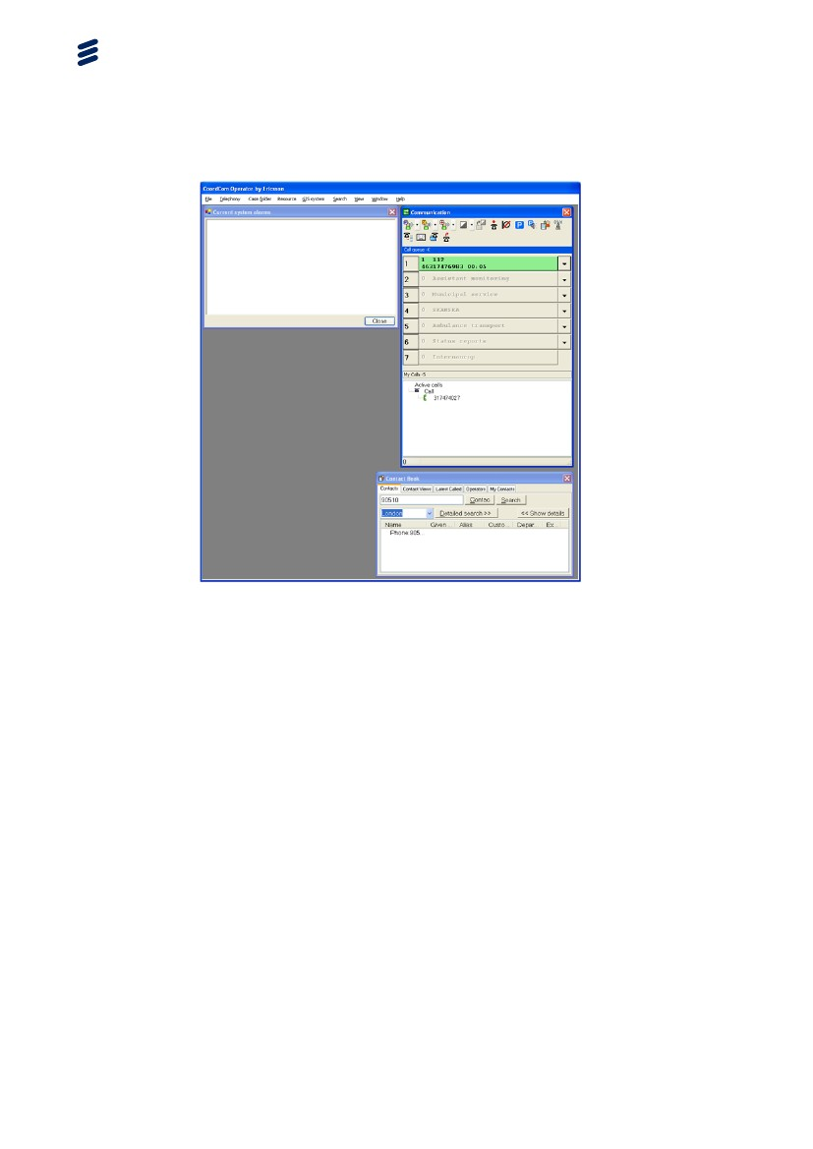

Figure 31 CoordCom Operator Program

* + 1. Creating Dump Diagnostic File

If the Operator application ends unexpectedly, there will be a crash dump file at C:\Program Files\Ericsson\Operator\Cache. Please supply this xml file when reporting an error.

To create a Dump Diagnostic File with the 5 last events of CoordCom Operator, select Help > About this product and click on the button Dump Diagnostic File. The xml file will be created at C:\Program Files\Ericsson\Operator\Cache.

* 1. Trace Viewer

Trace Viewer is a program designed by Ericsson. The main purposes of this program is to help the developers and aid in troubleshooting. It can be helpful in communication with Ericsson personnel to start this application and it is also possible to save output to a text file.

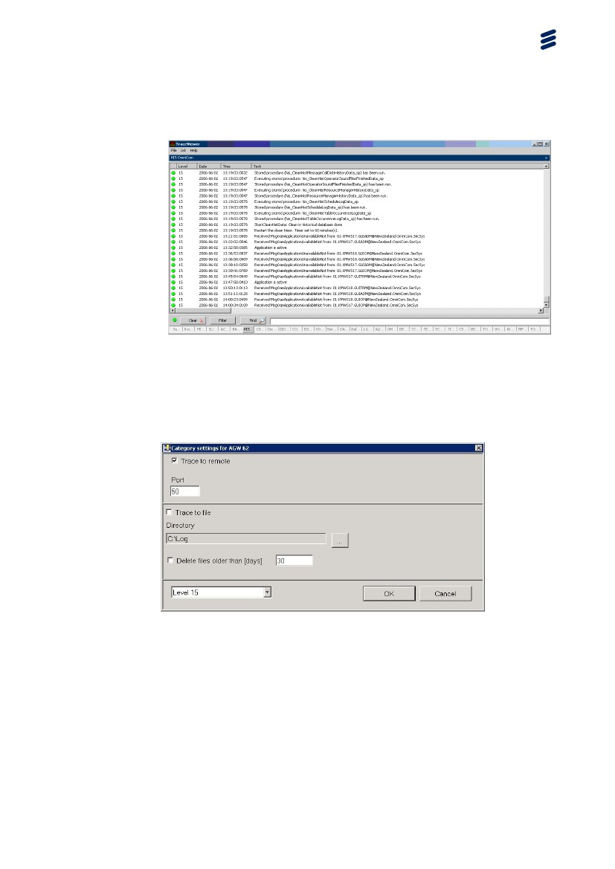

Figure 32 Trace Viewer

* + 1. Trace Setup

Use the Trace Setup application to setup Trace Remote. You can set the level of trace and also if you wish to trace to file.



Figure 33 Trace Setup Properties

* 1. Education Simulator

The Education simulator, see Figure 34, can be used for educational purpose or in an advanced trouble shooting to simulate incoming Automatic alarm, Radio Calls and Mobitex. No shortcut is made by default by installation program.

It will be located c:\Program Files\Ericsson\Education\Simulator(SIM).

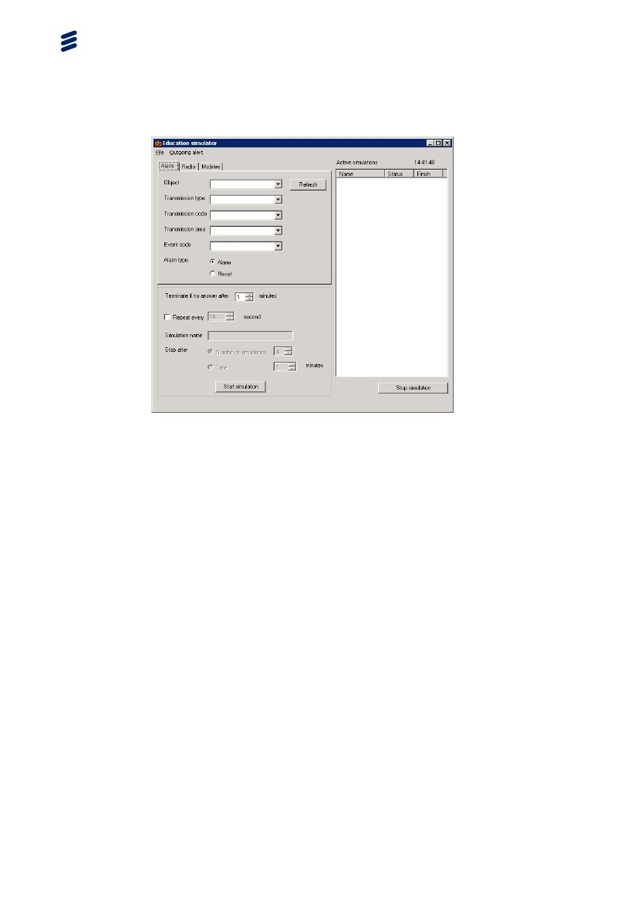

Figure 34 The Education simulator

* 1. CXE Commands and Services
     1. TxAlarm

Use this command to get an overview of ISUP trunks.

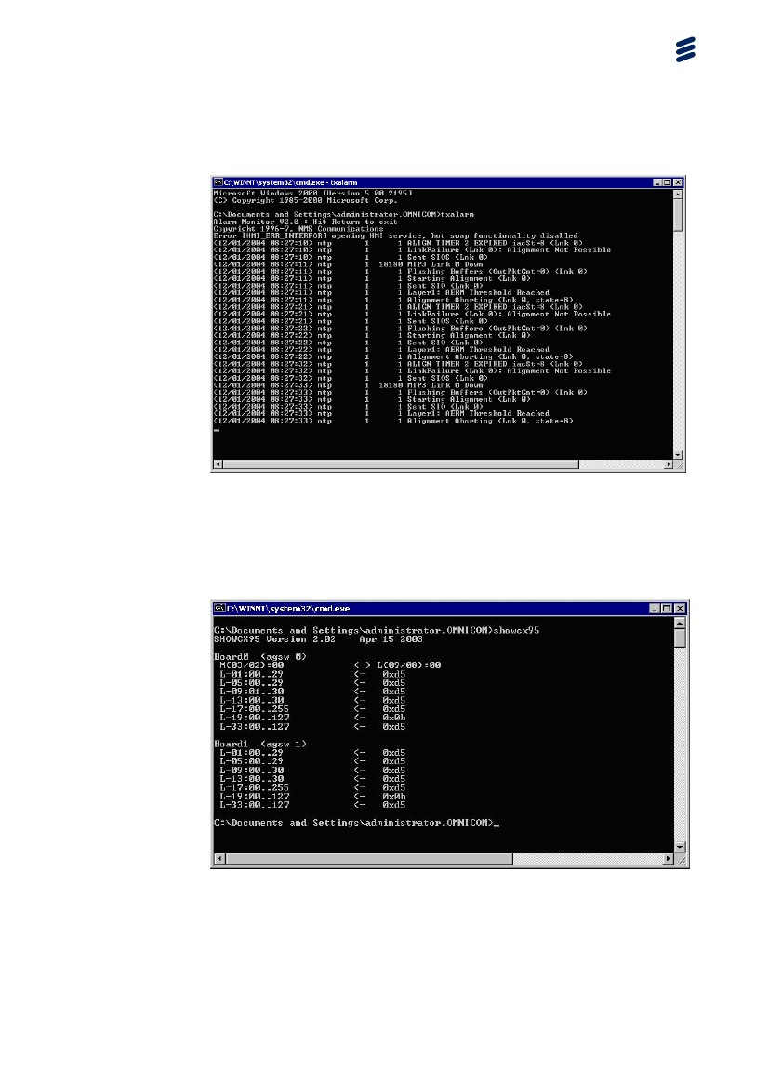

Figure 35 txalarm picture

* + 1. showcx95

Shows the connections between resources.



Figure 36 showcx95 picture

* + 1. showclks

Show clock state for NMS boards.

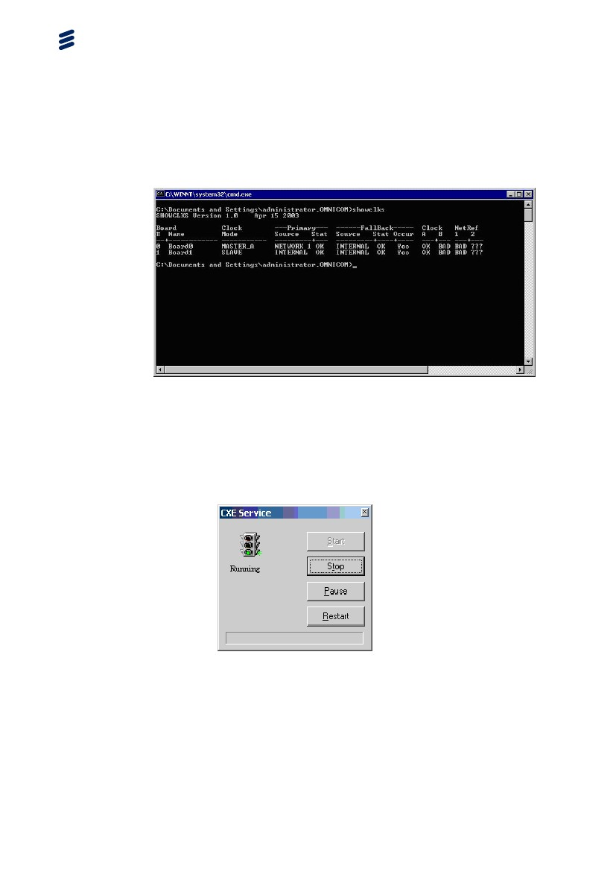

Figure 37 showclks picture

* + 1. CXE Services

The CXE services are normal Windows services and can be stopped and start in normal Windows fashion. However Ericsson have written a small application to stop and start the services in the correct order.



Figure 38 CXE services restart

1. Process Description

This section describes the different processes running in a CoordCom system, regardless of hardware layout. Table 1 and Table 2 show most, but not all, processes available. This section includes some specific situations and shows which processes are involved and how they communicate.

Note:

Some processes are customer specific and may not be included in the general lists.

* 1. Processes Generated by Incoming Telephony Call

This section displays, on a high level, a scenario of an incoming telephony emergency call and the CoordCom system processes that are activated step by step to manage the emergency call.

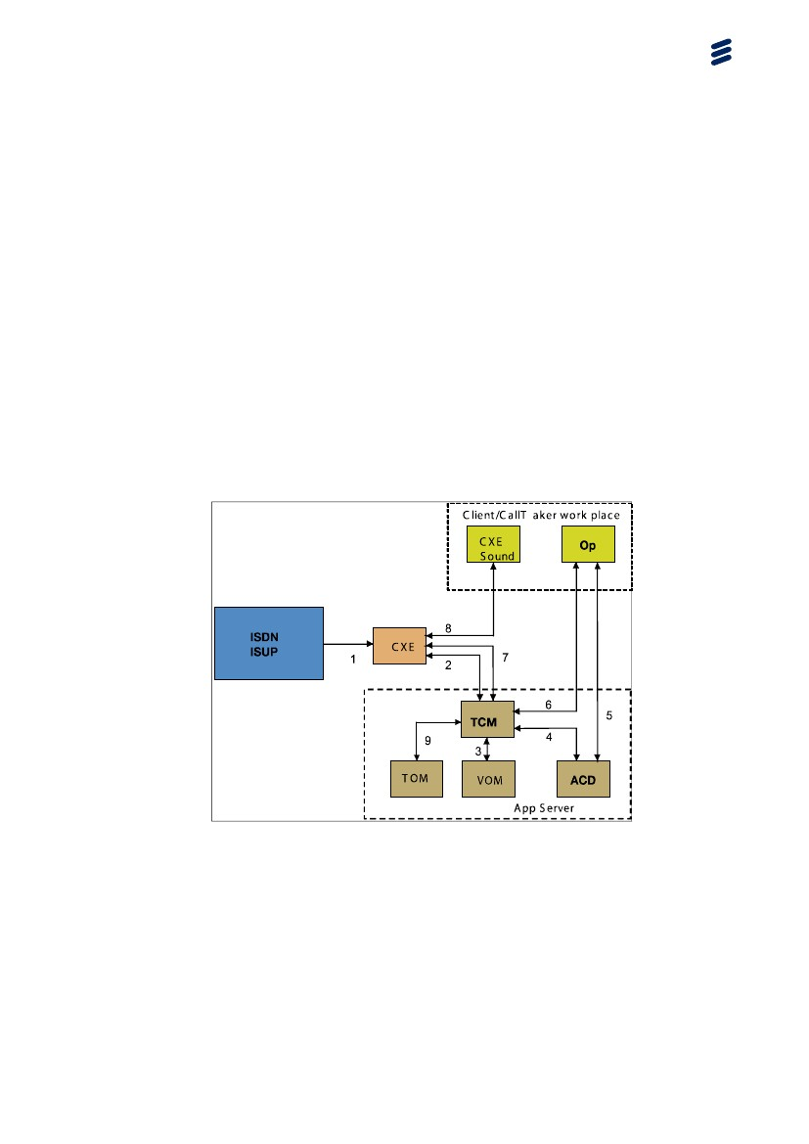

Figure 39 Incoming Telephony Call

1. An ISUP telephony call incoming from the network to the CXE:s ISUP service.

2. The CXE sends the call to the TCM process as an incoming call.

3. The TCM sends the call to the VOM process that check if there is a need to play of a predefined message or not (for example: Big Fire in the City Hall, Fire Squad alerted and on the way).

4. The TCM sends the call to the ACD process checking (area location info or customer specific service number, 112 service or private service) what receiving operators to distribute the call to.

5. The ACD sends the call to the client operators (Call taker / Dispatcher).

6. The client operator OP acknowledges and sends instruction to the TCM to answer the call for this client operator and set up the communication for the emergency Call.

7. The TCM sends the communication initiation setup massage to the CXE.

8. The CXE activates the distributed CXE sound for enabling voice communication.

Following trace log files are recommended to supply to CoordCom support

1. CXE server

* Cxe – CxeCONF
* Cxe – CxeDSP
* Cxe - CxeISDN or CxeISUP
* Cxe – CxeSwitch
* Cxe - CxeVoIP

1. Application server

* OmniCom - TCM, TEL, RIO, MFM
* OmniCom - VOM
* OmniCom - TOM, TOS
* OmniCom - ACD

1. Workstation

* Omnicom - Operator: TEL, MFM
* CXE – Sound
  1. Processes Generated by Incoming SIP Call

This section displays, on a high level, a scenario of an incoming telephony emergency call and the CoordCom system processes that are activated step by step to manage the emergency call.

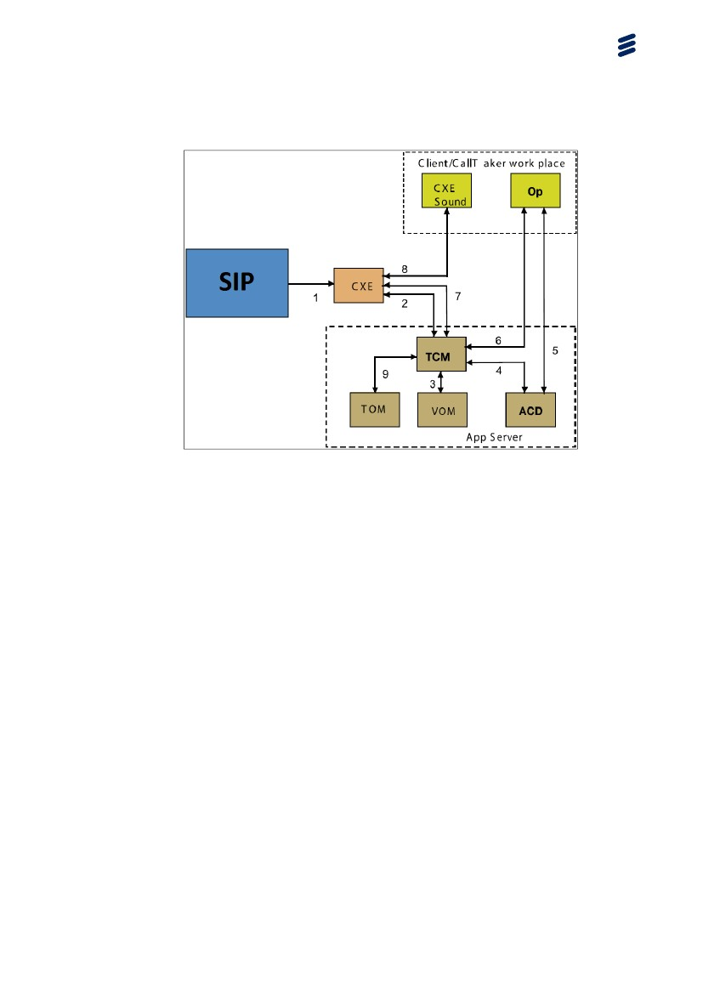

Figure 40 Incoming SIP Call

1. An incoming SIP VoIP call to the CXE XSIP service .

2. The CXE sends the call to the TCM process as an incoming call.

3. The TCM sends the call to the VOM process that check if there is a need to play of a predefined message or not (for example: Big Fire in the City Hall, Fire Squad alerted and on the way).

4. The TCM sends the call to the ACD process checking (area location info or customer specific service number, 112 service or private service) what receiving operators to distribute the call to.

5. The ACD sends the call to the client operators (Call taker / Dispatcher).

6. The client operator OP acknowledges and sends instruction to the TCM to answer the call for this client operator and set up the communication for the emergency Call.

7. The TCM sends the communication initiation setup massage to the CXE.

8. The CXE activates the distributed CXE sound for enabling voice communication.

Following trace log files are recommended to supply to CoordCom support

1. CXE server

* Cxe – CxeCONF
* Cxe – CxeDSP
* Cxe - XSIP
* Cxe – CxeSwitch
* Cxe - CxeVoIP

1. Application server

* OmniCom - TCM, TEL, RIO, MFM
* OmniCom - VOM
* OmniCom - TOM, TOS
* OmniCom - ACD

1. Workstation

* Omnicom - Operator: TEL, MFM
* CXE – Sound
  1. Processes Supporting External Communication

The list to the left on the slide represents the existing CoordCom system services supporting external communication. Most of those services run either in the COM-server or application server depending on the configuration.

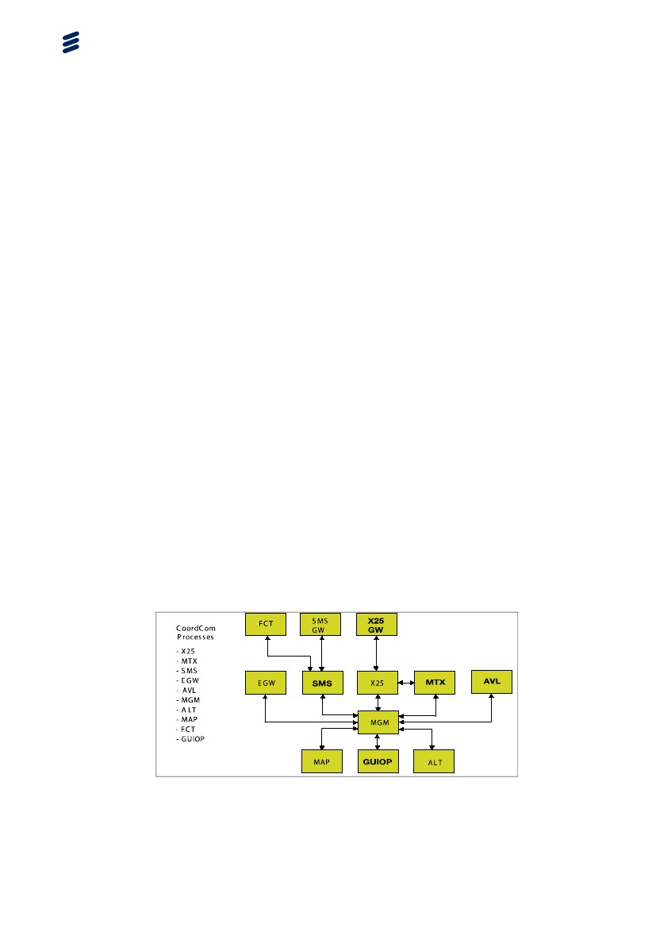

Figure 41 External Communication

Note: You can connect to SMS GW or FCT for SMS

* + 1. Following trace log files are recommended to supply to CoordCom support

1. Application server

* OmniCom - MGM
* OmniCom - X25
* OmniCom - MTX
* OmniCom - SMS
* OmniCom - EGW
* OmniCom - AVLS
* OmniCom - ALT
* OmniCom - MAP
* OmniCom – ACD
* OmniCom - FCT

1. Workstation

* Omnicom - Operator
  1. Processes Supporting Automatic Alarm

This section describes the automatic alarm function in CoordCom. Automatic alarm is used for Burglar alarm, Fire alarm, Technical alarm or Supervision alarm as flood alarm.

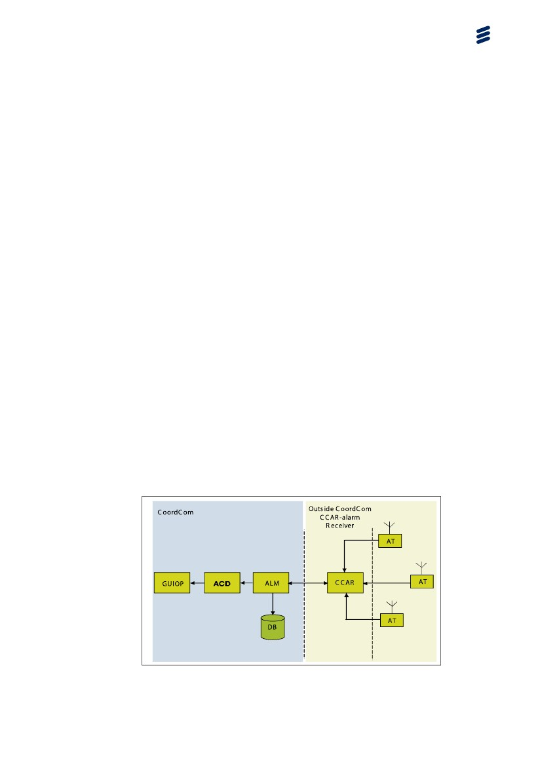

Figure 42 Automatic Alarm

Alarm is handled within CoordCom by ALM (Automatic aLarm Management), which is a process supporting all logic needed to receive automatic alarms and parsing them to ACD and OP. ALM will create case information into database as alarm is received.

CCAR – this is a automatic alarm receiving system. There are a lot of different types of automatic alarm systems on the market, with or without voice. Burglar alarm is a typical alarm without voice, while lift emergency alarm very often has voice alarm. There is also a lot of different ways to transport the alarm information. Famous protocols are SIA protocol, Contact ID, Ademco, L400, Robofone. There are modem protocols, DTMF or pulse protocol. The alarm transmitters (AT) send alarms on the PSTN network or wireless by SMS. Alarms are received by the CCAR system. The CCAR detects the alarm codes and convert them to a standard common protocol that is automatically dispatched to CoordCom by TCP/IP or X25. The ALM process in CoordCom handles alarms.

ALM can be an option on some markets.

* + 1. Following trace log files are recommended to supply to CoordCom support

1. Application server

* OmniCom - ALM
* OmniCom - ACD

1. Workstation

* Omnicom - Operator
  1. Processes Supporting Address Information

This picture displays the external ANI function used in Sweden to connect to an external number provider. This is equivalence to CoordCom:s built in ANI. ANI means taking the A-number from the phone line (who is calling) and send that phone number to a database and get back the name of the owner, address and other information that are then automatically filled into the case form. As communication we use TCP/IP and XML protocol.

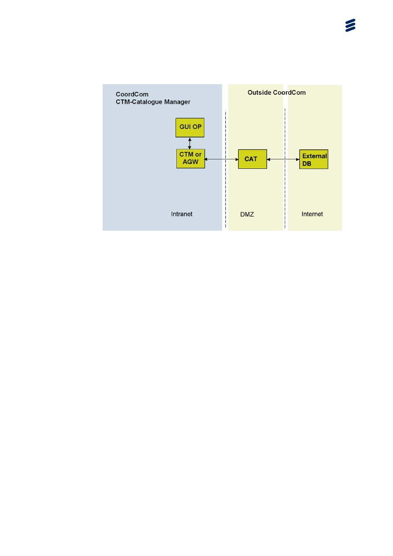

Figure 43 Address Information

* + 1. Following trace log files are recommended to supply to CoordCom support

1. Application server

* OmniCom - CTM or AGW depending on installed solution.

1. Workstation

* Omnicom - Operator
  1. Processes Supporting Incoming Security Alarm

This picture shows the signal flow and the processes involved when a security alarm is received.

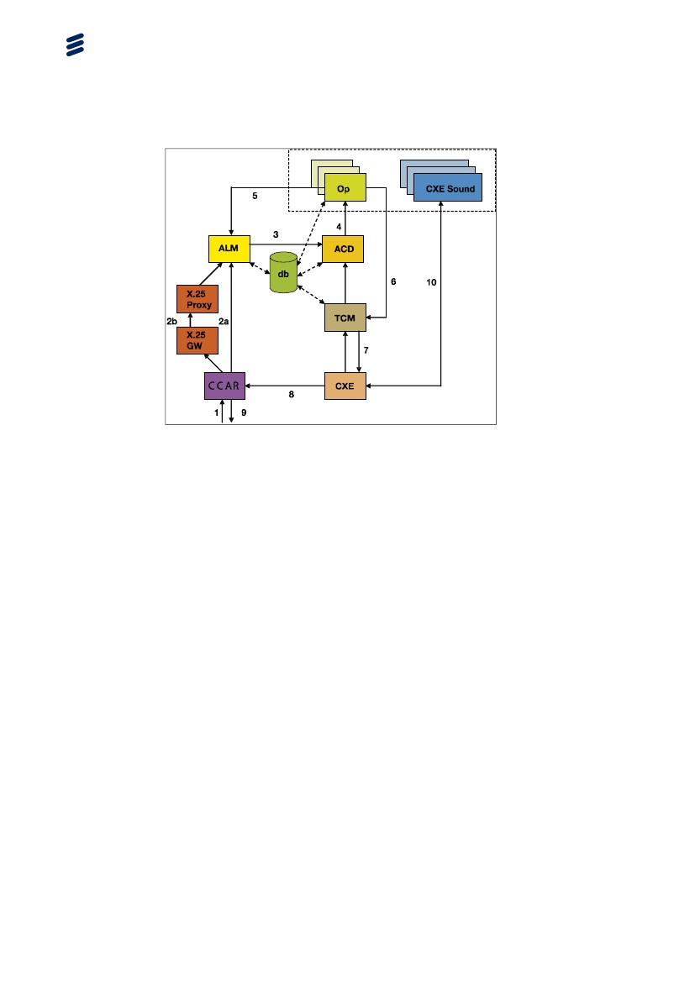

Figure 44 Incoming Security Alarm

1. Incoming security alarm to CCAR

2. CCAR contacts ALM via either X.25 or directly, depending on hardware configuration

3. ALM notifies ACD

4. ACD notifies Op which puts the incoming alarm in an appropriate Inbox

5. Op acknowledges the alarm to ALM

6. When the Operator accepts the alarm, TCM is notified

7. TCM notifies CXE

8. CXE connects to CCAR

9. CCAR connects the call via CXE to the alarm caller.

10. The call is now handled between the caller and CXE Sound, via CXE

* + 1. Following trace log files are recommended to supply to CoordCom support

1. CXE server

* Cxe – CxeDSP
* Cxe - CxeISDN or CxeISUP
* Cxe – CxeSwitch
* Cxe - CxeVoIP

1. Application server

* OmniCom - ALM
* OmniCom - TCM
* OmniCom - ACD
* OmniCom - X25

1. Workstation

* Omnicom - Operator
  1. Processes Supporting External Analog Radio Call

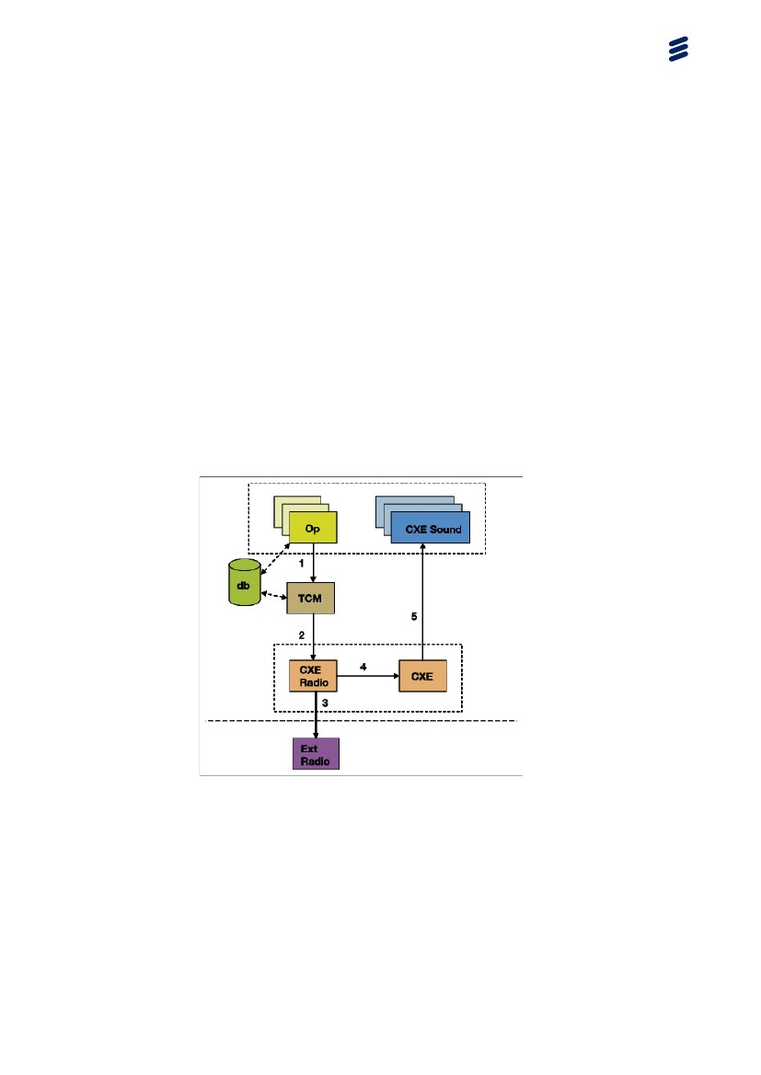

Figure 45 External Analog Radio Call

1. Op notifies TCM that an outgoing radio call is being placed.

2. TCM notifies CXE Radio, which handles the radio call, depending on which radio system is being used.

3. CXE Radio sets up the radio call to the external radio system

4. CXE Radio redirects the call to CXE

5. CXE sends output to CXE Sound

Note:

External Radio can be RVX2000, TOPEX or other.

* + 1. Following trace log files are recommended to supply to CoordCom support

1. CXE server

* Cxe – CxeCONF
* Cxe – CxeDSP
* Cxe – CxeSwitch
* Cxe - CxeVoIP
* Cxe – CxeRVX2000 or CxeTopex & CxeSIP

1. Application server

* OmniCom - ALM
* OmniCom - TCM
* OmniCom - ACD
* OmniCom - X25

1. Workstation

* Omnicom - Operator
  1. Processes Supporting External Digital Radio
     1. Digital Radio Call

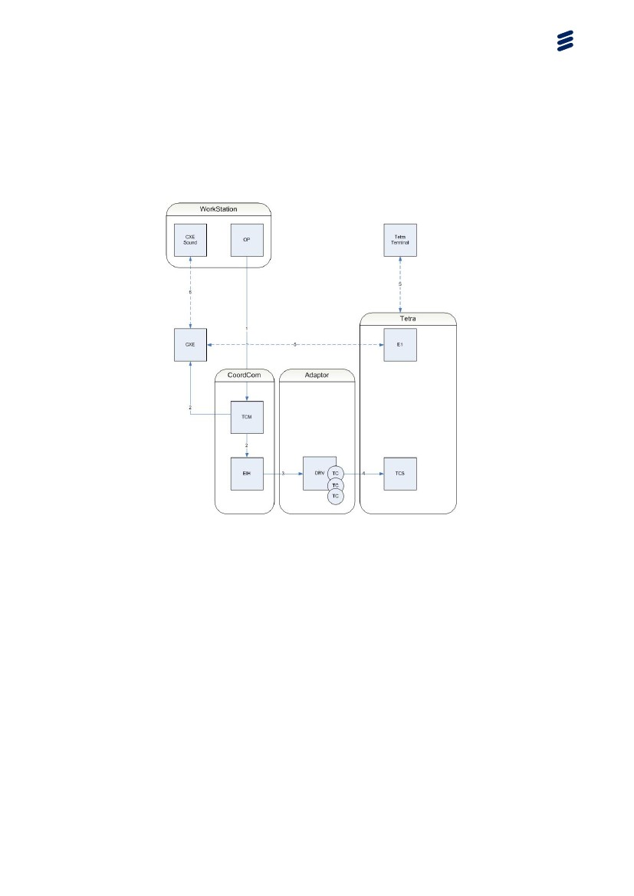

Figure 46 Digital Radio Call process

1. Operator initiates call

2. TCM identifies it as a Digital Radio Call and send request to EIH and allocates conference in CXE.

3. EIH sends request to DRV adaptor, whom allocates a TC client.

4. DRV adaptor sends request to TCS on Tetra system.

5. Tetra system contacts Tetra terminal and allocate voice stream on E1.

6. CXE sets up conference with CXE sound.

* + 1. Digital Radio Short Message and Status Change

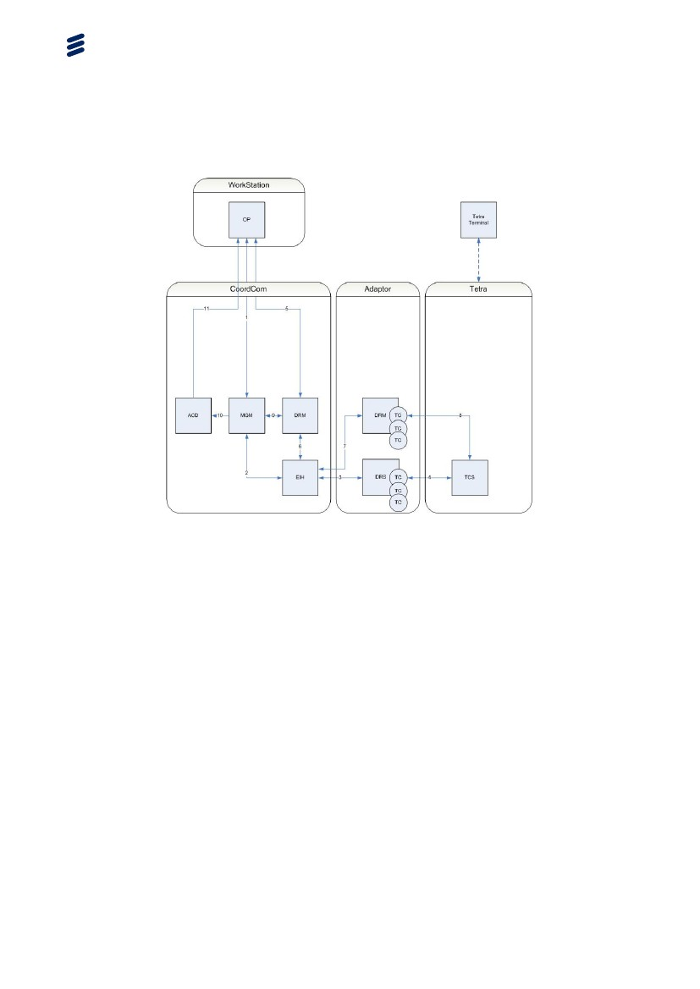

Figure 47 Digital Radio Short Message and status change process

Outgoing short message

1. Operator sends Short Message request to MGM.

2. MGM send request to EIH.

3. EIH contacts DRS whom allocate a TC client.

4. TC Client send request to TCS on Tetra system and sends Short message to Tetra client.

Incoming short message

Tetra terminal sends short message

4. TCS sends message to DRS TC client.

3. DRS sends message to EIH.

2. EIH send message to MGM.

10. MGM sends alert to ACD.

11. ACD distribute notification to CoordCom Operators.

Status change of Tetra terminal

Operator change group of a Tetra terminal

5. OP sends request to DRM.

6. DRM contacts EIH.

7. EIH sends request to DRM adaptor.

8. DRM assigns a TC client and sends information to TCS.

Tetra system updates status and sends information to Tetra terminal

* 1. Processes Supporting Startup of Client

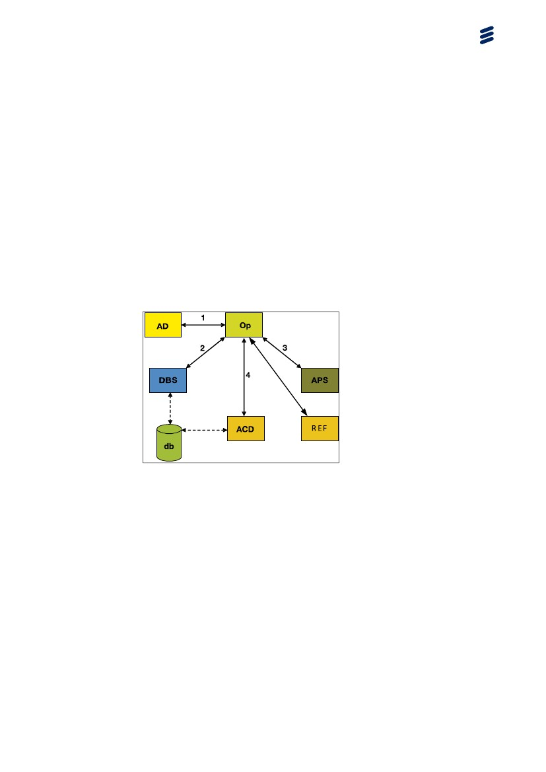

Figure 48 Client Startup

1. Op requests configuration data from the AD during computer startup.

2. Op requests information from DBS about which databases to use.

3. Op notifies all other processes in the system that operator has started through REF. APS starts to poll operator, if polling of operator has been enabled.

4. Op requests authorization and choice of work role from ACD.

Note:

Information regarding which databases to use is stored in the registry. Op can access the database configuration information from the registry if the DBS service is down. The ACD service must however be

available in order for operator to start.

Note: Use the CSS tool to configure polling.

* + 1. Following trace log files are recommended to supply to CoordCom support

1. Application server

* OmniCom - APS
* OmniCom - ACD

1. Workstation

* Omnicom - Operator
  1. Processes Supporting Position Query to a Unit

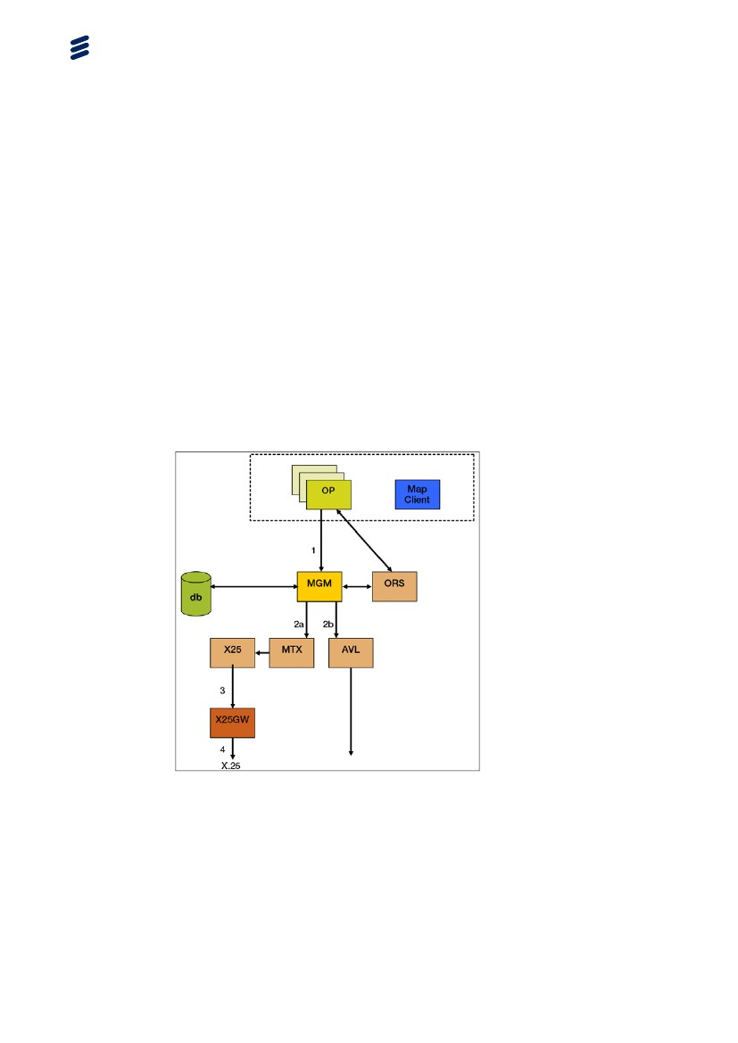

Figure 49 Position Query to a Unit

1. Op sends a query to MGM

2. MGM sends it further to MTX or AVL

3. MTX sends it to X25GW

4. X25GW sends the request to external X.25 net

* + 1. Following trace log files are recommended to supply to CoordCom support

1. Application server

* OmniCom - MGM
* OmniCom - MTX & X25 or AVL

1. Workstation

* Omnicom - Operator
  1. Processes Supporting Positioning from Case

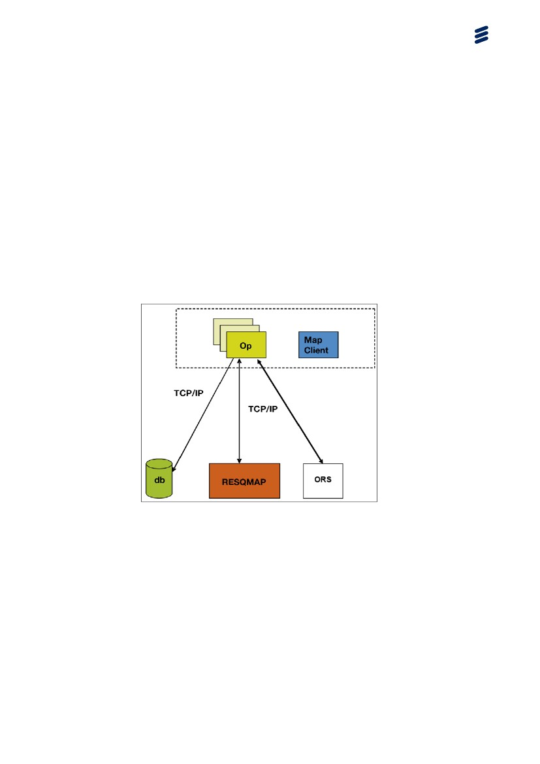

Figure 50 Positioning From a Case

1. When a Case needs positioning, Op collects data from the database

2. OP then sends information to MAP Client, which places the correct graphics on the Map.

When a Case needs positioning, Op collects data from the database and then sends information to RESQMAP, which places the correct graphics on the Map.

* + 1. Following trace log files are recommended to supply to CoordCom support

Omnicom – Operator: CSE

* + 1. Processes Supporting Positioning a Resource from Map Client

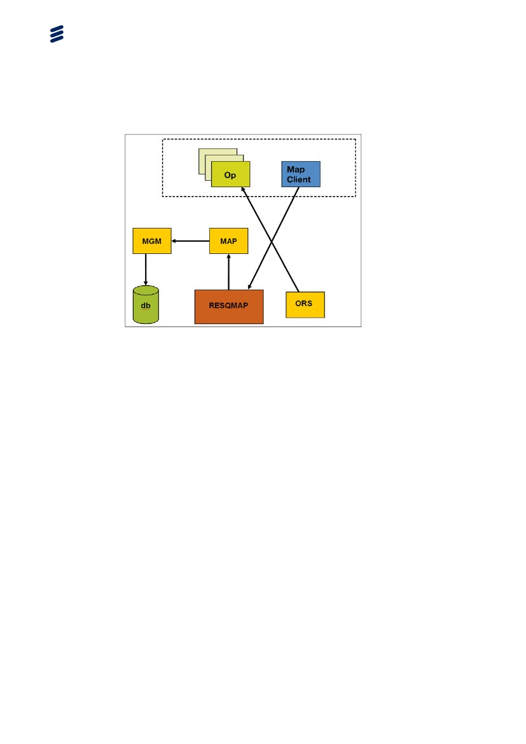

Figure 51 Positioning a resource from map

1. When a Resource needs positioning from map client The MAP Client send information to RESQMAP.

2. RESQMAP sends information to MAP.

3. MAP contact MGM.

4. MGM writes information to database.

* + - 1. Following trace log files are recommended to supply to CoordCom support

1. Application server

* OmniCom - MAP
* OmniCom – MGM: POS
  + 1. Processes Supporting Positioning a Resource

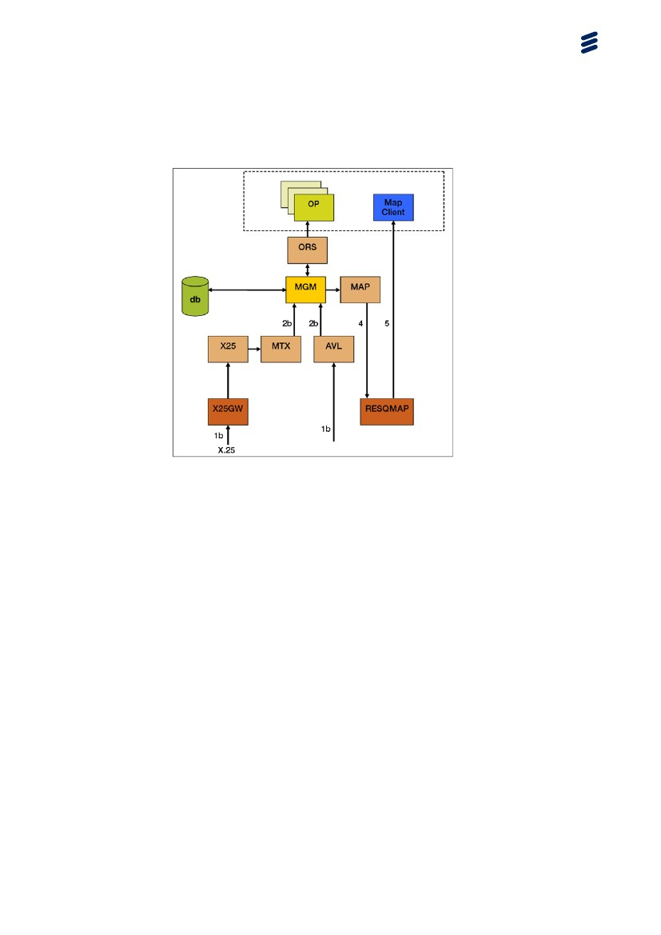

Figure 52 Positioning a resource on Map Client

1. When a Resource needs positioning it sends a position with OVLS or AVLS.

2. MTX or AVL receives information and sends it to MGM.

3. MGM writes information in database and contacts MAP.

4. MAP sends information to RESQMAP server.

5. RESQMAP server updates Map Client.

* + 1. Following trace log files are recommended to supply to CoordCom support

1. Application server

* OmniCom - MAP
* OmniCom – MGM: POS
* OmniCom – MTX & X25 or AVL

Always remember to include:

* CoordCom Version
* Workstation name
* Date and time of error
  + 1. Processes Supporting Incoming Mobitex Alarm

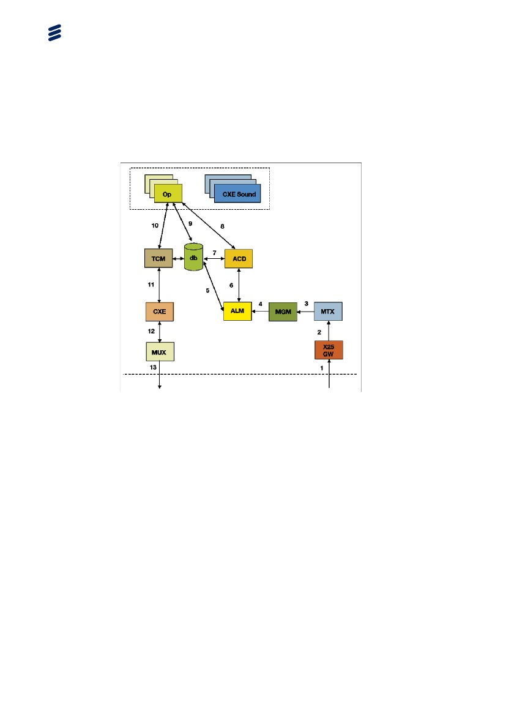

Figure 53 Incoming Mobitex Alarm

1. Alarm comes from external MTX(X.25) network to the X.25 gateway.

2. Via MSMQ, the alarm is sent to MTX.

3. Via MSMQ, the alarm is sent to MGM.

4. MGM sends the alarm via MSMQ to ALM

5. ALM contacts the database to get relevant data regarding this particular alarm.

6. ALM sends the alarm to ACD, via MSMQ.

7. ACD communicates with the database to find correct Operator and so on.

8. ACD sends the alarm to the correct Operator, via MSMQ.

9. Operator contacts the database to update with relevant data, via TCP/IP.

10. If an outgoing telephone call is needed for this particular alarm, Operator connects to TCM via MSMQ.

11. TCM connects to CXE via VOIP.

12. CXE connects to the MUX via PCM(E1).

13. MUX sends the call to the MTX(X.25) network.

* + 1. Following trace log files are recommended to supply to CoordCom support
* CXE serverCxe – CxeCONF
* Cxe – CxeDSP
* Cxe – CxeSwitch
* Cxe - CxeVoIP

1. Application server

* OmniCom - X25
* OmniCom - MTX
* OmniCom - MGM
* OmniCom - ALM
* OmniCom - ACD
* OmniCom - TCM

1. Workstation

* Omnicom - Operator
  1. Processes Supporting Outgoing E-mail

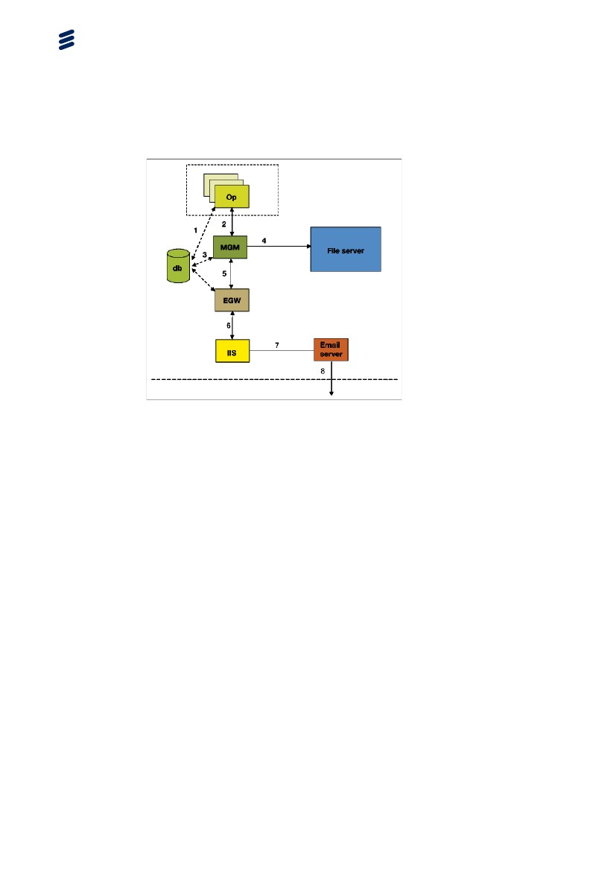

Figure 54 Outgoing E-mail

1. Operator updates the database with information regarding the e-mail, via TCP/IP.

2. Operator sends the e-mail to MGM via MSMQ.

3. MGM updates the database.

4. MGM saves a copy of the e-mail on the File Server.

5. MGM sends the e-mail via MSMQ to EGW.

6. EGW send the e-mail to IIS.

7. IIS sends the e-mail to the E-mail Server, via TCP/IP.

8. The E-mail Server sends the e-mail to the Internet for normal distribution.

* + 1. Following trace log files are recommended to supply to CoordCom support

1. Application server

* OmniCom - MGM
* OmniCom - EGW

1. Workstation

* Omnicom - Operator
  1. Processes Supporting Outgoing SMS Minicall

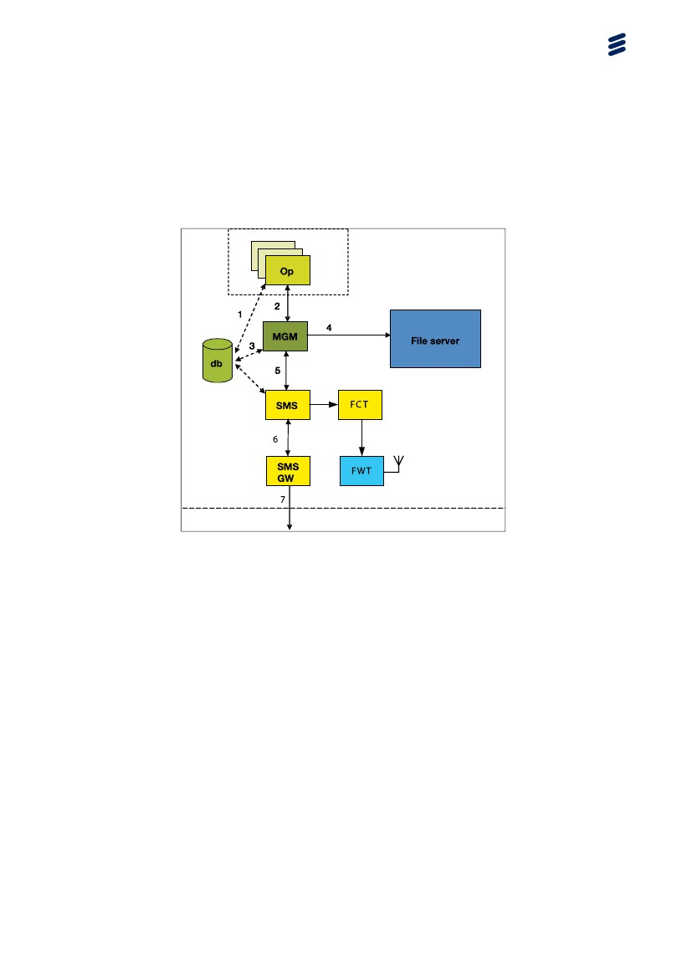

Figure 55 Outgoing SMS or Minicall

1. Operator updates the database with information regarding the SMS, via TCP/IP.

2. Operator sends the SMS to MGM via MSMQ.

3. MGM updates the database.

4. MGM saves a copy of the SMS on the File Server.

5. MGM sends the SMS via MSMQ to the process SMS.

6. The process SMS send the SMS to SMSGW or to FCT.

7. SMSGW sends the SMS to the Internet, via HTTPS, where the Paging network is located.

8. FCT connects to attached FWT (Fixed wireless Terminal)

Note:

You can connect to SMS GW or FCT for SMS

* + 1. Following trace log files are recommended to supply to CoordCom support

1. Application server

* OmniCom - MGM
* OmniCom – SMS
* OmniCom - FCT

1. Workstation

* Omnicom - Operator
  1. Processes Supporting Case Management

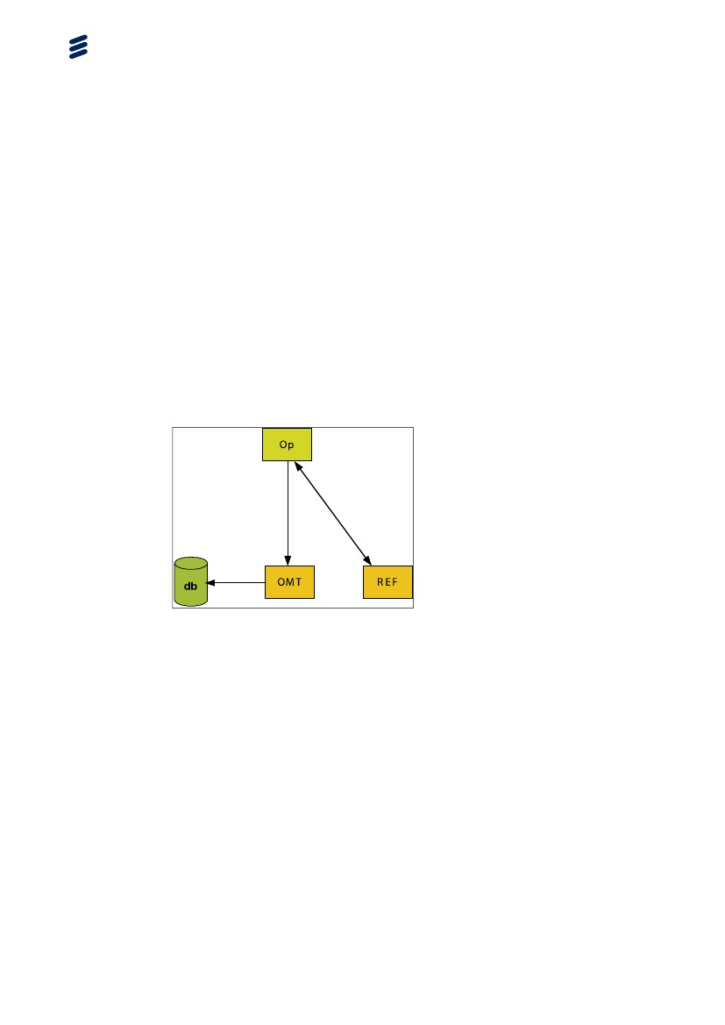

Figure 56 Process Supporting Case management

1. Operator creates case.

2. OMT process information from Operator.

3. OMT writes information to database.

4. If refresh is needed REF will send refresh signal to other operators.

* + 1. Following trace log files are recommended to supply to CoordCom support

1. Application server

* OmniCom - OMT
* OmniCom – REF
* OmniCom - RES, CSE, PLN, GEO
* Omnicom - All available trace logs

1. Questions and Answers

This section will be constantly under development as the CoordCom system is updated.

* 1. Installation

Question:

When I install Windows XP Professional on an HP Elite 8000 or another recent PC hardware the installation is incomplete regarding to SATA disk drivers.

Answer:

When installing on an HP Elite 8000 or another recent PC hardware without floppy drive the SATA disk drivers must be integrated into the Windows XP Professional SP3 installation media before installing. The process of integrating the drivers is often referred to as slipstreaming.

* 1. CoordCom Work Station
     1. Operator

Question:

When I start Operator program the application respond, “You are not authorized to run application”

Answer:

Check that user is created in Active Directory

Check that user is entered with his/her Windows name into CoordCom database.

Check that user is allowed to run Operator program

Check that the workstation is created in the database

Question:

When I start the application it starts with wrong language

Answer:

Check the shortcut of the application. It should have the parameter “sv-SE” for Swedish.

Question:

How do I get the latest version of the program?

Answer:

Group policy is used to send out the latest version, reboot computer.

If you still don’t get latest version try again to reboot or give the command gpudate /force to force the group policy to be applied to your computer the next time it is rebooted.

Question:

What screen resolution should I have?

Answer:

The screen resolution should be set to 1280 x 1024 for all screens.

Question:

A certain Operator has problem with his layouts.:

Answer:

There are two different types off errors that can occur:

* Problem with Case folders. Remove operator entries from lay_OperCaseTypeViewLayout_tab check in bas_operator_tab for OperatorId.
* Problem with changing windows. Remove operator entrees from lay_OperatorFormLayout_tab check in bas_operator_tab for OperatorId.

The operator must reconfigure his personal settings again.

Question:

My case list doses not automatically refresh.

Answer:

Each operator subscribe on a personal list

* Change tabs view and refresh should start to work.
* If above dose not work restart operator program and new subscriptions will be made and the refresh should start to work.

Question:

Inbox soundfile is changed in Business Administrator, but will not take effect.

Answer:

As the Operator program caches sondfiles under C:\Program Files\Ericsson\Operator\Cache and if soundfile name is the same the old one it will not be replaced. Solution clear cache directory of Operator.

The incoming Call could be set with priority and will override inbox soundfile.

Question:

I set inbox to play sondfile continusly but is only played once

Answer:

The incoming Call could be set with priority and will override inbox

soundfile. Thus you will need to set Call Priority to play sound continuosly.

* + 1. Telematic

Question:

When a call is answered the telmatic picture is not updated.

Answer:

If you have separate network for VoIP and data, check that Data and VoIP network is separated

Check that you have Local IP address set in the registry.

Question:

It is not possible to answer a specific Call in the Call queue.

Answer:

Check with the SQL Server Studio that the field “reserved” in the table acd_Call_tab is set to “0” for the specific Call.

* + 1. Networking

Question:

When I ping my own computer it answers with VoIP address.

Answer:

Check properties for VoIP card that the IP–address is not to be registered in the DNS.

Check that VoIP card is routed correctly in a command window with the command route print.

Example of how to add a route:

route add –p 10.113.0.0 mask 255.255.0.0 10.113.nnn.1

Check the order of initialization of the network cards. In Network Connections select Advanced and Advanced settings. Make sure that the data network card is listed first in the connections list.

* + 1. Sound

Question:

I have no sound in the microphone / earpiece.

Answer:

* Check that the headset is connected and plugged in properly.
* Use the Windows sound recorder and try to record and play back.
* Is the VoIP network card routed correctly? See networking.
* Is CXESound service running? Restart?
* Open Status Windows for Data and VoIP network cards and check activity on send receive for VoIP card. It should be steaming on both send and receive.
* Is the microphone enabled and the volume turned up in the Windows Recording Control (reached through the Volume Control) Check in CXEvoip.ini that parameter VoIP extension is entered correctly Check by playing a sound file with Windows media player. You should get sound both in earpiece and loudspeaker.
* Is the sound card working?

Question:

I have an echo.

Answer:

One way to determine where the echo is coming from is to record the sound from the mic and from the voip. This is done by changing RECORD_SOUND_OUTPUT to 1 in CXESound.ini and restart CXESound service to make the change.

Example of CXESound.ini

[PARAMS]

RECORD_SOUND_OUTPUT = 1

Remember to restore after you have collected some samples.

Question:

I have sound files for Inbox and Priority played in both Headset and Speakers.

Answer:

Sound files for Inbox or Priority are played in Right channel (Headset) and Left channel (Speakers) in CoordCom. This instruction will show an example how to edit a sound file and how to mute the right channel to play the sound in speakers only. The example will use a third party application called Audacity but you may choose any sound editor of your preferred choice.

Opening a sound file in Audacity

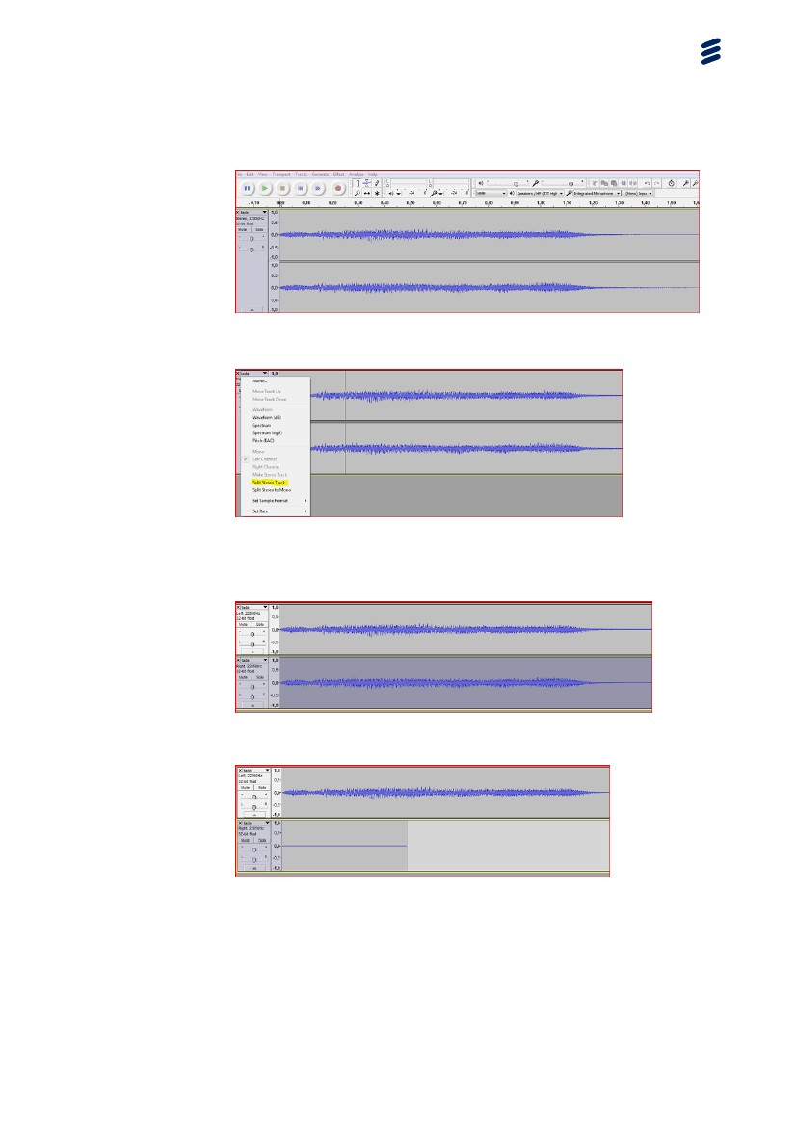

1. On the File menu, click Open file. Select the Stereo sound file you want to change.

2. Select the black triangle in the corner and click Split Stereo Track.

3. Select the left channel, select all of the waveform by pressing Home button and press and hold the Shift key + END. Then go to the Generate menu and choose Silence.

4. Afterwards it should look similar to this.

5. Select the black triangle in the corner and click Make Stereo Track. Now the Sound file can be saved.

* + 1. CoordCom Business Administrator

Question:

When I start the application it starts with wrong language.

Answer:

Check the shortcut of the application it should have the parameter “sv-SE” for Swedish.

Question:

I want be able to run two different CoordCom Business applications on the same computer, is this possible?

Answer:

Yes, add the parameter multi in the shortcut.

* + 1. CoordCom Workstations

Question: I can only start 5 CoordCom Workstations.

Answer:

This could be a result of that the application server has not been set to the correct license model. Set it to "Per Device or User" or increase the server licenses from the default 5 to a high number.

Question:

Some CoordCom workstations suddenly starts operating slowly and operates with the local OMT process.:

Answer:

This could be a result of that the application server running OMT nearest the primary database has not been set to the correct license model. Set it to "Per Device or User" or increase the server licenses.

* + 1. Active Directory Group Policies

Question:

My Active Directory Group Polices can not be applied.

Answer:

This could be a result of that correct DNS server(s) in the network IP settings in the CoordCom Workstation Operating System has not been specified.

* 1. Server
     1. Network

Question:

When I copy files between the servers it is taking very long time.

Answer:

Check that the speed of network card and the network switch match.

* + 1. CXE

Question:

Where do I connect the trunks?

Answer:

ISDN is connected to slot 0 and 1, ISUP to slot 2 and 3.

Question:

But there are only 2 slots on my Dialogic board?

Answer:

Use a splitter to divide each slot into 2 slots. Without the splitter you have slot 0 and 1 directly on the board, and with the splitter you get 0 and 2 from the first splitter and 1 and 3 from the second splitter.

Question:

How does the failover work?

Answer:

In the configuration there is a parameter called backup which is the receiver of messages when sending to TCM fails. The backup is normally a TCM running on another server. The backup is used as the receiver of messages until the CXE manages to establish a connection to the primary again.

Ex: Global.ini

[TelematicManager]

Name = 01.kmsrv01.tcm

Backup = TelematicManager2

[TelematicManager2]

Name = 01.kmsrv02.tcm

Backup = TelematicManager

Question:

Can I have two CoordCom systems, but only one CXE?

Answer:

Yes, ServiceStatus is to be sent to both systems. This is done with the Copy parameter. Notifications about incoming calls are sent to one of the systems based on the B-number.

Ex: Global.ini

[Process]

ServiceStatus = ServiceNot

[ServiceNot]

Name = SystemA

Copy = SystemB, SystemC

Question:

How do I direct incoming calls to a specific TCM based on the B-number?

Answer:

Set the ACD parameter in ISDN and ISUP to point to Dispatch. Configure the distribution list in Dispatch.

Ex: CxeIsdn01.ini

[Params]

Acd = 01.kmcxe01.Dispatch

[Params]

Acd = 01.kmcxe01.DispatchEx:

Ex: CxeDispatch01.ini

CxeIsup01.ini

[DistributionList]

+46317470000 = TelematicManager

031* = TelematicManager2

Default = TelematicManager3

Question:

What is the timeout value of a MSMQ message?

Answer:

10 seconds

Question:

How do I do a graceful shutdown of a CXE?

Answer:

Use the CXE Server Manager to pause the CXE. Wait until all active calls are terminated and then stop the CXE. Use CXEMonitor to se the number of active calls.

Question:

How many conferences can you create in a CXE?

Answer:

Each board can have 256 conference members. A normal conference has 3 to 8 members.

Question:

How can I see if there are any resources allocated?

Answer:

Send a DumpData message using CXEMonitor to the service handling the resource you are interested in and you will get a text file with the current status.

Question:

How can I see if the trunk is connected?

Answer:

Check the Event Viewer for the Link up or Link down events.

Question:

I only have 15 timeslots on my ISDN trunk. Do I need to configure this?

Answer:

Yes.

Ex: CxeIsdn01.ini

[Trunk0]

OutOfService = 15,16,17,18,19,20,21,22 (and 23..29)

Question:

Can I use one trunk only for incoming calls?

Answer:

Yes.

Ex: CxeIsdn01.ini

[Trunk0]

[Trunk1]

In = 0,1,2,3,4,5,6,7,8,9,10,11,12,13,14 (and 15..29)

Question:

I get an error from VoIP, what could be wrong?

Answer:

Check the boards ethernet cable and the configuration.

Ex: cg6kboard0.cfg

IPC.AddRoute[0].DestinationAddress = 10.30.40.233

IPC.AddRoute[0].Mask = 255.255.255.0

IPC.AddRoute[0].Interface = 1

IPC.AddRoute[1].DestinationAddress = 0.0.0.0

IPC.AddRoute[1].Mask = 0.0.0.0

IPC.AddRoute[1].GatewayAddress = 10.30.40.1

Question: How do I configure the clock synchronization?

Answer:

A well working trunk on the master board should be the clock synchronization source.

Ex: cg6kboard0.cfg

Clocking.HBus.ClockMode = MASTER_A

Clocking.HBus.ClockSource = NETWORK

Clocking.HBus.ClockSourceNetwork = 1

Clocking.HBus.AutoFallBack = YES

Clocking.HBus.FallBackClockSource = OSC

Question:

How to interconnect or loopback an ISDN trunk?

Answer:

Use a twisted/cross cable and configure one trunk to act as AXE station.

Ex: CxeIsdn01.ini

[Trunk0]

EquipmentType = NT

[Trunk1]

EquipmentType = TE

Question:

CXE configured with just one incoming PRI makes communication failure in CoordCom. Why?

Answer:

Each CXE server must be connected and configured so that it can both receive incoming and create outgoing calls. An outgoing call is always started in the same CXE server as the incoming call, since both calls must be in the same CXE server to make it possible to combine them in a conference.

* + 1. ISUP

Question:

How do I check that ISUP trunks are up?

Answer:

Run CXE command txalarm and verify that the link is up. Also check that you have received event ID 1703 have been received after the latest 1704 event.

* + 1. ISDN

Question:

How do I check that ISDN trunks are up?

Answer:

In the event viewer check that you have received event ID 1608 have been received after the latest 1609 event. This is more reliable than to use CXE command trunkmon.

* + 1. Voice Message Server VOM

Question:

My recorded sound files are not being played

Answer:

* Check that the sound file is stored in correct format. Use ADM System > Voice Response > Recording > double click on the sound file name. This window tells in what format a sound file must be.
* Are the files located in the correct directory? Use System > Installation > System Site > Open > Shared Files Path. The sound files must be located at this file share. This file share must be available for both the CxeDsp service and the VOM service.
  1. External Communications

Temporary files for many external communications functions are stored in \\fileservername\externalinformation. There will be many subdirectories, do not remove these but you can delete files older that 10 days. Also remove corresponding entries from the table ext_SentExtInfoMessage_tab older then 10 days.

* + 1. Radio

Question:

I cannot choose a certain base station. I got an error message that it is busy but no operator has chosen it.

Answer:

Look in the database with sql New Query and check table rio_BaseStationChannel_tab. Check that field UsedByUserName is empty. If not erase it.

* + 1. SMS

Question:

I send a SMS but it is not sent and I get no fail message back.

Answer:

* Check that MGM and SMS Gateway are working.
* Send a SMS and look in Event log for any clues.
* MGM must be able to write to file share ExternalInfo as user OMNICOM\MGM. Check with cluster admin.
  + 1. E-mail

Question:

I cannot send e-mail.

Answer:

* Are there any files on the directory c:\inetpub\mailroot\drop ? If there is and they are over 20Mbyte remove the files and restart EGW on the application server.
* Are the CoordCom processes EGW and MGM running? Check with Cluster manager on a application server.
* Is the SMTP server running? Check with IIS Manager on the Gateway server.
  + 1. FAX - GFI FAXmaker Solution

For questions regarding GFI FAXmaker please refer to manufactures documentation or http://www.gfi.com.

Question:

I cannot send fax.

Answer:

Is the E-mail function working? As GFI FAXmaker is using the e-mail functionality.

Is the POP3 server running and working? Try to send e-mail to fax@Omnicom.local. Use Outlook Express to verify. GFI Faxmaker uses this mail box to send faxes. If you cant send mail you most likely will need to reinstall the POP3 server on the Gateway server. Use the standard Windows add/remove program function.

Note: You will need the Windows server disc or access to the i386 directory to be able to reinstall.

If there are a lot of pending faxes you might get fail to send fax from CoordCom. Normally if there are many pending faxes it is to one and same fax machine with a problem. Remove pending erroneous faxes.

* + 1. Text Telephone

Question:

The text telephone does not work.

Answer:

If you are logged in with VNC the text telephone will not work. Use Remote desktop instead.

* 1. Database

Question:

My system reports that a disk containing the tempdb database is almost full. How do I increase the size of the disk?

Answer:

Try to shrink the database. This is done in SQL Server Management Studio.

Question:

My system reports that tempdb is full when there is plenty of free space on the disk.

Answer:

If the system is new the default size of tempDB is 8 Mb and 1 Mb for the log file (with auto growth of 10%). The SQL server will be busy with increasing sizes when the system starts running and will not have time to answer database questions. Increase the sizes of tempDB and log file to 1024 Mb. Also increase the initial size of OmniData if this has not been done.

* 1. General Networking

Question:

I have accidentally entered same IP address for my Domain Controller and a network switch.

Answer:

1. Shutdown the Domain Controller

2. Connect to the switch with Internet Explorer.

Note: Java must be installed.

3. Login with a password, User not necessary.

4. Go to config and change IP address of the switch.

Question:

I cannot login with Remote Desktop due to that the server has “Exceeded License Limits”

Answer:

Login to the console with command mstsc /consoleIp-address /F /console or when SP3 mstsc /adminIp-address /F /console

Now start task manager and select tab “Users”. If user is “Disconnected” end his or hers session.

1. Appendix
   1. Troubleshooting Windows Flowchart

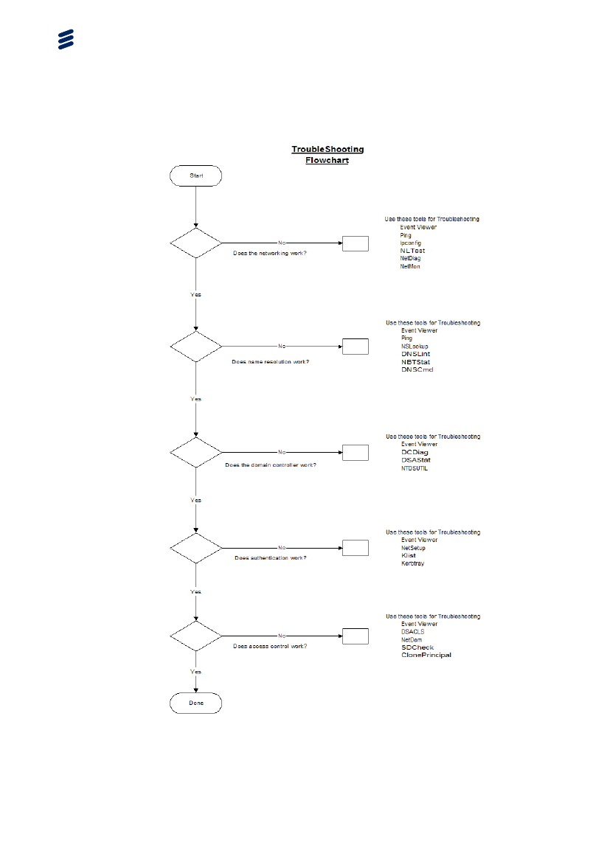

Figure 57 Troubleshooting Windows Flowchart

* 1. Basic CoordCom-Sound Troubleshooting Flowchart

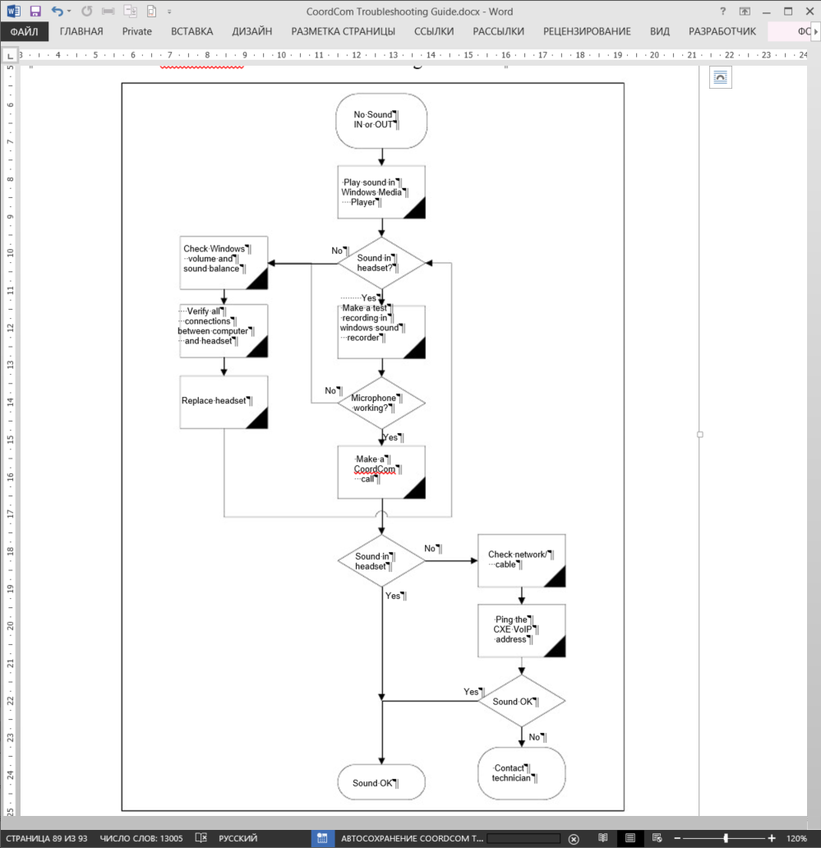

Figure 59 Advanced CoordCom-Sound troubleshooting flowchart

* 1. Event ID Information

An Event ID does not always mean exactly the same thing. It is important to also read the information tag related to the event.

For more information about Event ID's created by CoordCom, see CoordCom Event ID Information, Reference [4]

1. Reference List

Ericsson Documents

[1] CoordCom System Software Environment, 4/221 02-FGC 101 1467/1 Uen

[2]CoordCom Operation and Maintenance, 1543-AXT 201 09/1 Uen

[3]CoordCom Feature Description, 221 04-FGC 101 1467/1 Uen

[4]CoordCom Event ID Information, 1/1545-AXT 201 09/4 Uen