Assignment 3: 09/11/2020

Q-1)How to Compare the two JSON have the same properties without order

var obj1={name:"snehal",age:18}

var obj2={name:"snehal",age:18}

var obj3={age:18,name:"snehal"}

function isequal(obj1,obj2)

{

const obj1keys=Object.keys(obj1)

const obj2keys=Object.keys(obj2)

if(obj1keys.length!==obj2keys.length)

{

return false

}

for(let objkey of obj1keys)

{

if(obj1[objkey]!==obj2[objkey])

{

return false

}

}

return true

}

console.log(isequal(obj1,obj2))

console.log(isequal(obj1,obj3))

Q-2)Why Objects are copied and compared by reference?

Size of Object is not fixed hence the object is stored in heap. For eg if any object contains 10 million properties then copy by value is very hectic job as well as lot of memory is wasted hence copy by reference is used in case of objects

Q-3)WeatherForecast API SnapShots

Banglore City Info

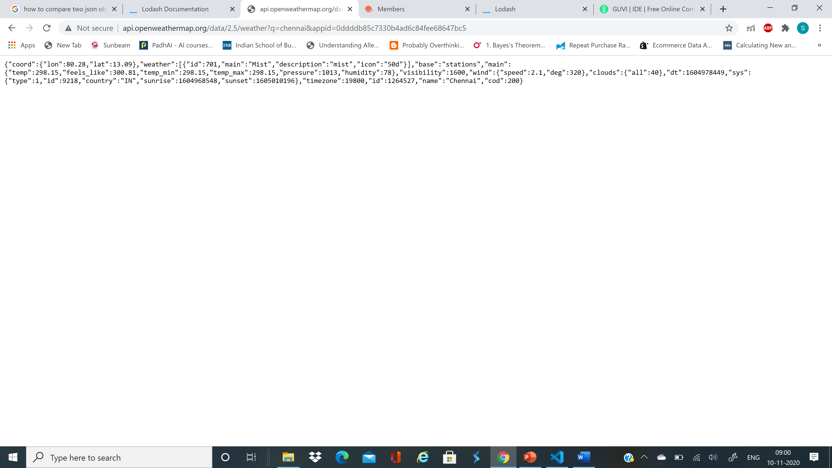

Nashik City info

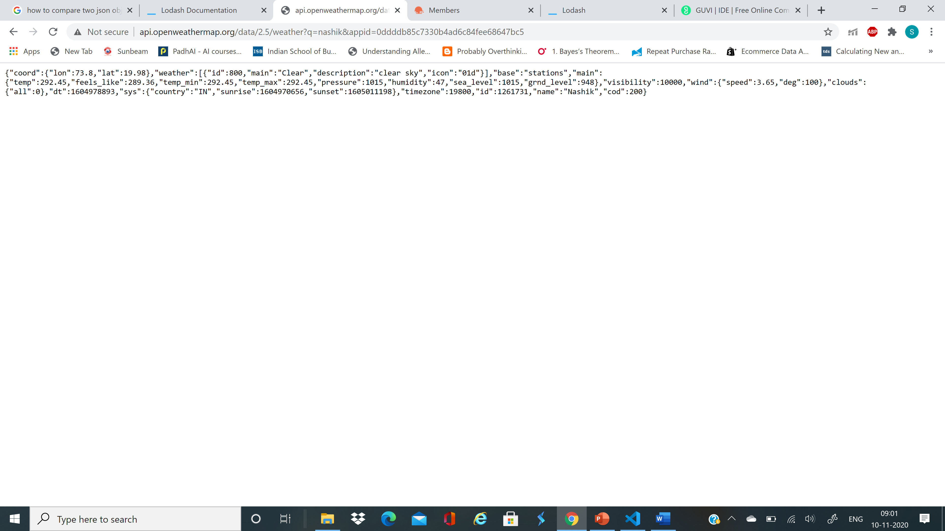

Info for Lat=33 and Lon=65

