Quick setup — if you’ve done this kind of thing before
Set up in Desktop
or

HTTPS

SSH


Get started by creating a new file or uploading an existing file. We recommend every repository include a README, LICENSE, and .gitignore.

…or create a new repository on the command line
echo "# proyectotesoreria" >> README.md
git init
git add README.md
git commit -m "first commit"
git branch -M main
git remote add origin https://github.com/sistemas-gobvalle/proyectotesoreria.git
git push -u origin main

…or push an existing repository from the command line
git remote add origin https://github.com/sistemas-gobvalle/proyectotesoreria.git
git branch -M main
git push -u origin main

…or import code from another repository
You can initialize this repository with code from a Subversion, Mercurial, or TFS project.
Import code

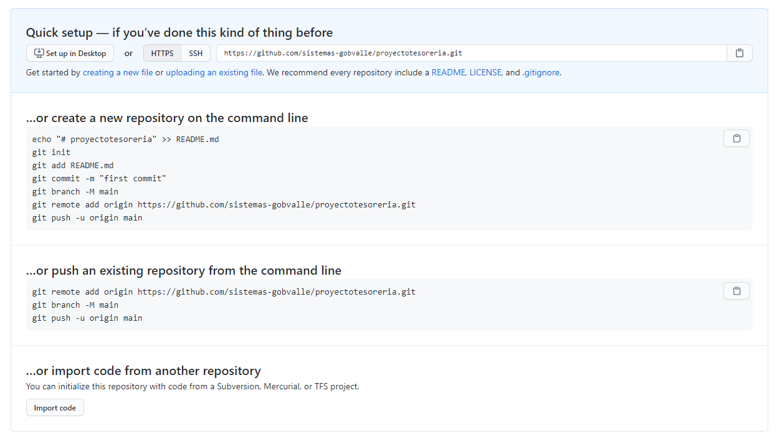
https://github.com/sistemas-gobvalle/proyectotesoreria.git

