Portfolio Website

### Shyam Selvam 2025-04-27

**Contents**

1. Overview 1
2. Features 3
3. Technology Stack 3
4. Deployment 3
   1. Visit the Live Website 3
   2. Build and Run from Source 3
5. Project Structure 4
6. Requirements 4
7. License 4
8. Change Log 4
   1. Features Added 4

# Overview

A modern, interactive portfolio website built with standard web technologies and Node.js for routing.

This project is a personal portfolio showcasing my skills in front-end and back-end web development.

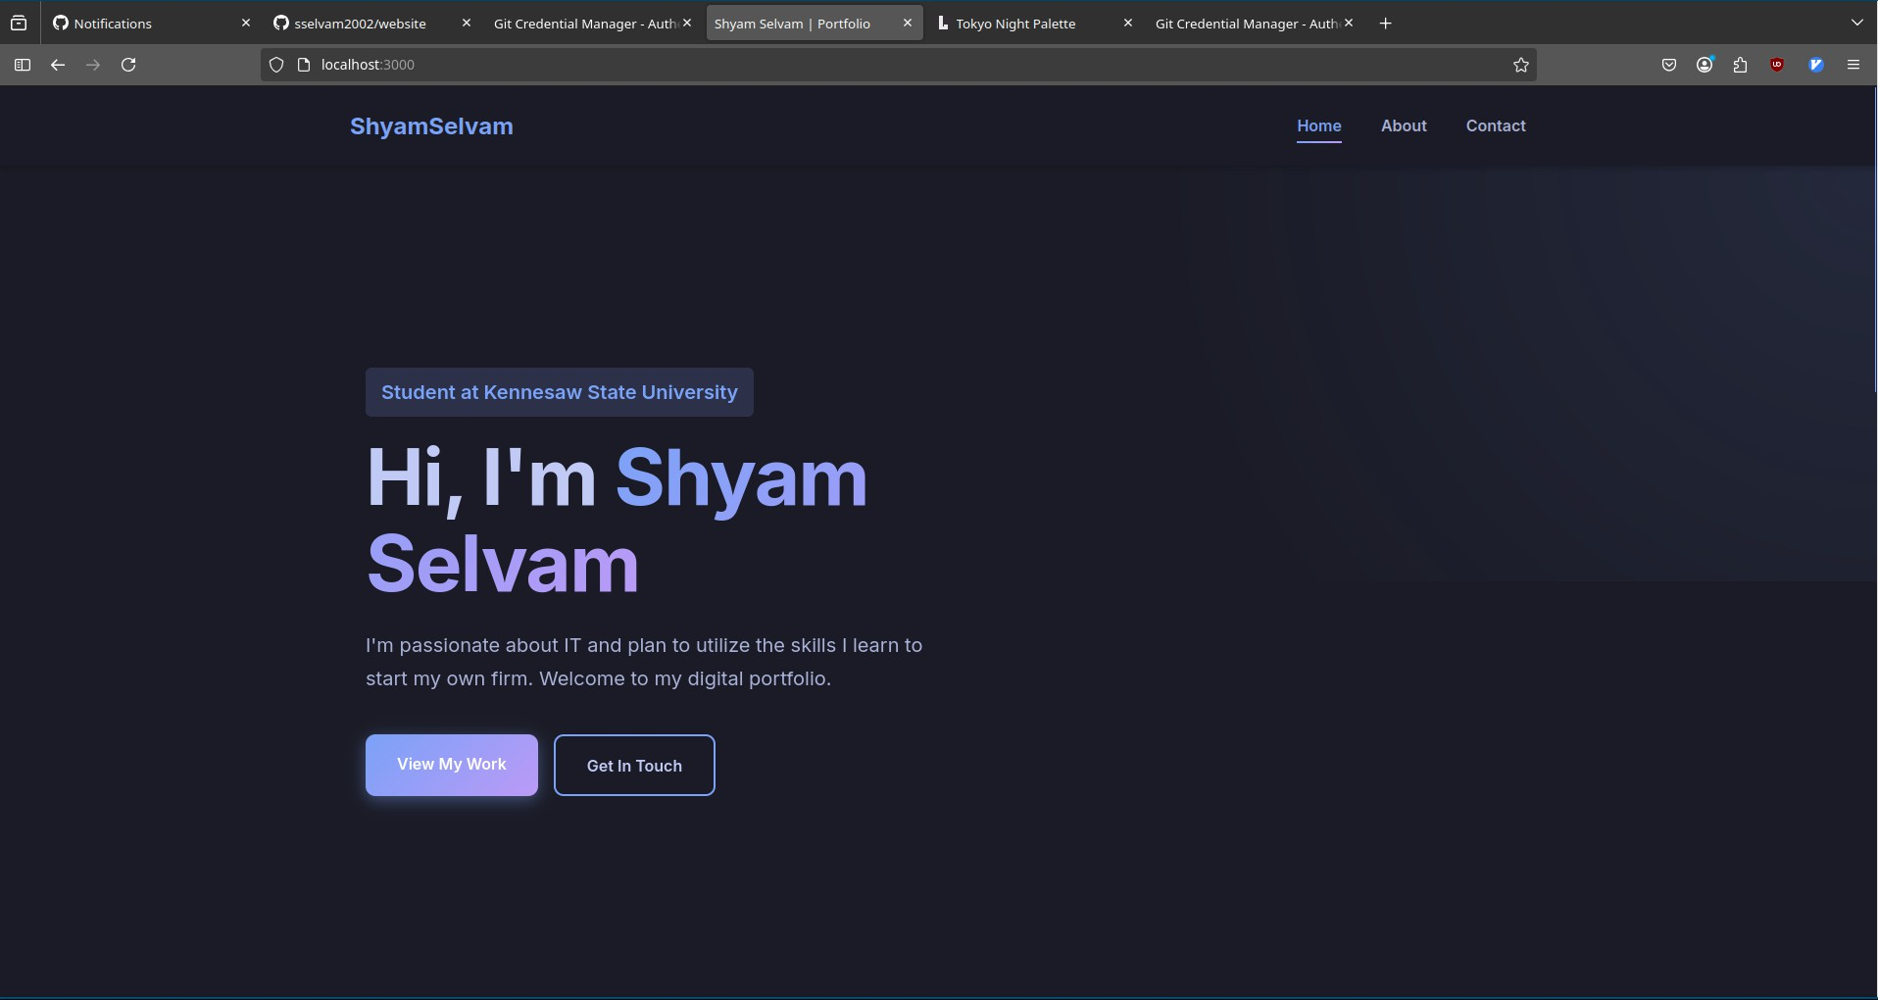

Figure 1: Landing Page

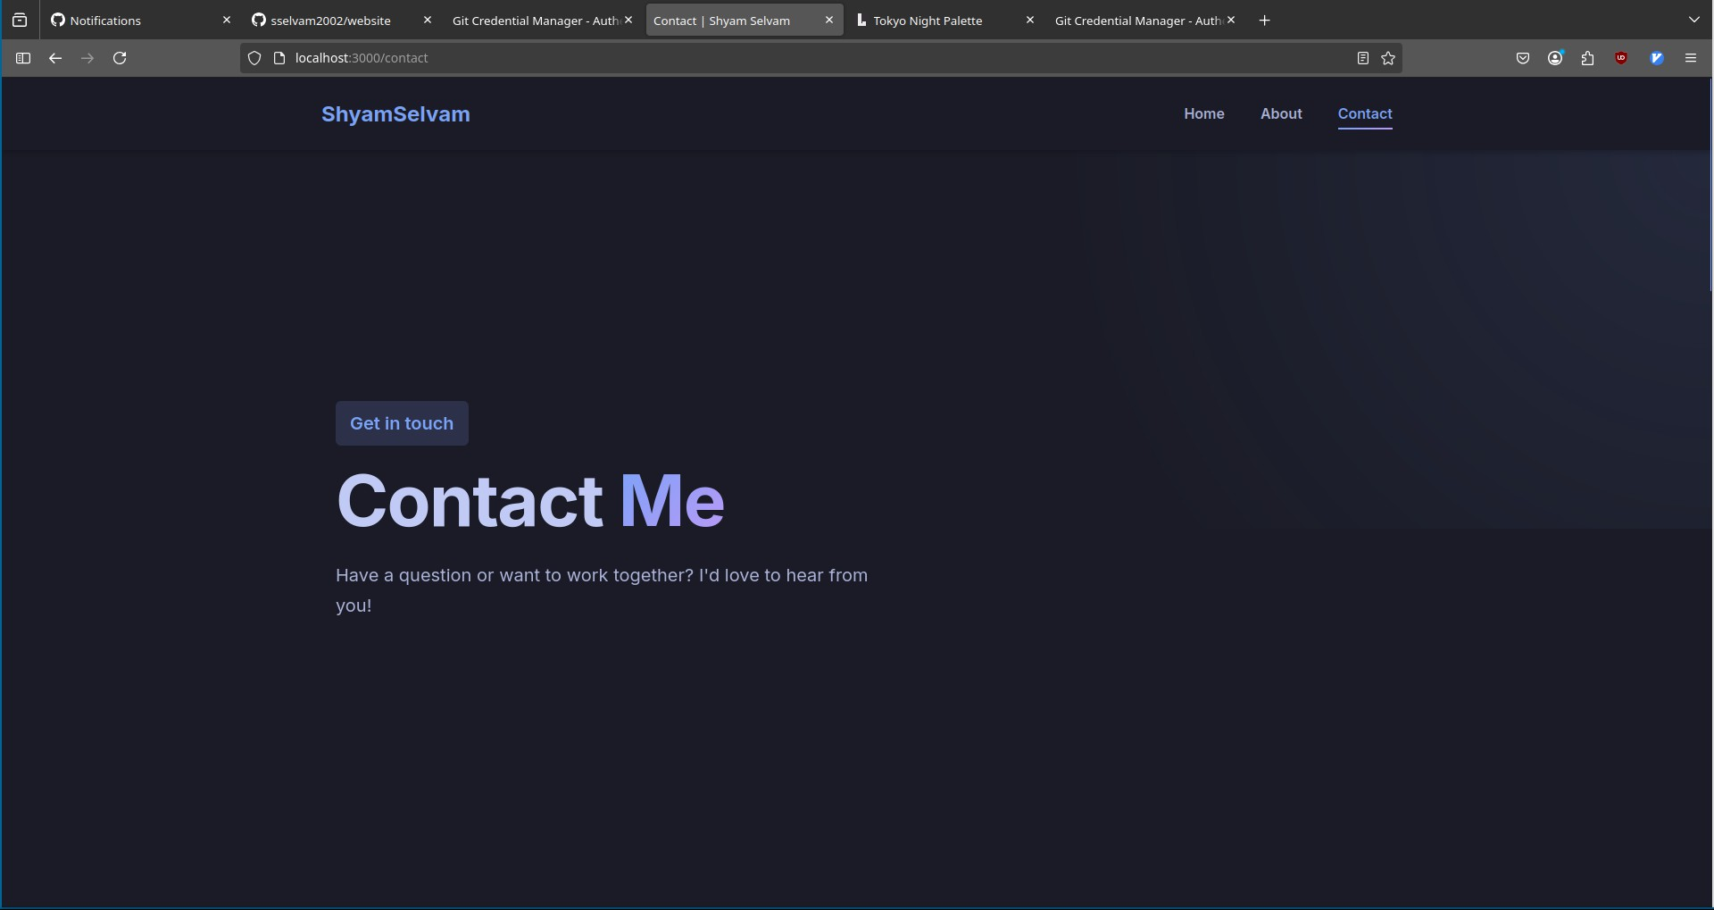

Figure 2: Contact Page

# Features

* **Rich UI**: Uses Font Awesome icons with Nerd Font support and Tokyo Night color scheme.
* **Interactive**: JavaScript-driven interactivity for a smooth user experi- ence.
* **Server-side Routing**: Handled by Node.js and Express.

# Technology Stack

* HTML5
* CSS3
* JavaScript (ES6)
* Node.js
* Express.js

# Deployment

## Visit the Live Website

Visit the live portfolio here: [portfolio-eight-flax-98.vercel.app](https://portfolio-eight-flax-98.vercel.app/)

## Build and Run from Source

To run the project locally:

* + 1. Clone the repository:

git clone https://github.com/sselvam2002/website

* + 1. Navigate into the project directory:

cd website

* + 1. Install project dependencies:

npm install

* + 1. Start the local server:

node app.js

* + 1. Open your browser and visit:

[http://localhost:3000](http://localhost:3000/)

# Project Structure

* public/ : Static assets (CSS, images, JavaScript)
* views/ : HTML templates
* app.js : Main server file

# Requirements

* [Node.js](https://nodejs.org/en/download)
* [Express.js](https://www.npmjs.com/package/express)
* [Font Awesome](https://cdnjs.cloudflare.com/ajax/libs/font-awesome/6.5.1/css/all.min.css)
* [Tokyo Night Color Palette](https://lospec.com/palette-list/tokyo-night)

# License

This project is licensed under the MIT License. See the LICENSE file for details.

# Change Log

## Features Added

⊠ Separated static files into a public/ directory for cleaner code man- agement:

app.use(express.static(path.join( dirname, "public"))); app.use(express.urlencoded({ extended: true }));

⊠ Fixed image rendering so that routes work correctly:

<div class="about-image animate-fadeInUp">

<img src="/shyamphoto.jpg" alt="Shyam Selvam" />

</div>

⊠ Used self-closing tags for better HTML5 compliance:

<div class="about-image animate-fadeInUp">

<img src="/shyamphoto.jpg" alt="Shyam Selvam" />

</div>

⊠ Added Font Awesome icons:

<link

rel="stylesheet"

href="https://cdnjs.cloudflare.com/ajax/libs/font-awesome/6.5.1/css/all.min.c

/>

⊠ Applied Tokyo Night color scheme (inspired by [this palette)](https://lospec.com/palette-list/tokyo-night).

⊠ Improved routing approach: no file path passing in HTML links:

<li><a href="/" class="active">Home</a></li>

<li><a href="/about">About</a></li>

<li><a href="/contact">Contact</a></li>

⊠ Implemented a basic form submit route:

app.post("/submit-form", (req, res) => { const username = req.body.username; res.send(‘Username is $sselvam‘);

});

⊠ Corrected GET and POST server routing:

app.get("/", (req, res) => {

res.sendFile(path.join( dirname, "public", "index.html"));

});