HW10 <Chapter 5>

R12.  For the network in Figure 5.19, the router has two ARP modules, each with its own ARP table. Is it possible that the same MAC address appears in both tables?

ARP tables have their own IP address mappings to MAC address. If different ARP modules are used, different MAC address is used for the router.

P2.  Show (give an example other than the one in Figure 5.5) that two-dimensional parity checks can correct and detect a single bit error. Show (give an example of) a double-bit error that can be detected but not corrected.

two-dimensional parity checks can correct and detect a single bit error.

0000

1101

0101

1010

double-bit error that can be detected but not corrected

0000

1001

0101

1010

P12.  Graph the efficiency of slotted ALOHA and pure ALOHA as a function of *p* for the following values of *N*:   
a. *N=*15. b. *N=*25. c. *N=*35.   
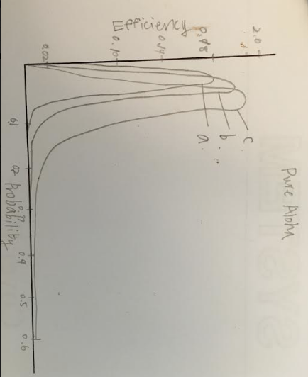

P18.  Suppose nodes A and B are on the same 10Mbps broadcast channel,and the propagation delay between the two nodes is 325 bit times. Suppose CSMA/CD and Ethernet packets are used for this broadcast channel. Suppose node A begins transmitting a frame and, before it finishes, node B begins transmitting a frame. Can A finish transmitting before it detects that B has transmitted? Why or why not? If the answer is yes, then A incorrectly believes that its frame was success- fully transmitted without a collision. *Hint*: Suppose at time *t* = 0 bits, A begins transmitting a frame. In the worst case, A transmits a minimum-sized frame of 512 + 64 bit times. So A would finish transmitting the frame at *t* = 512 + 64 bit times. Thus, the answer is no, if B’s signal reaches A before bit time *t* = 512 + 64 bits. In the worst case, when does B’s signal reach A?

t=0 when A starts to transmit and t=512+64=576 when A completes transmitting. if t=324 when B starts to transmit, B completes transmitting when t=649. Since 649>576, A completes transmitting before B. A will think its frame transmission was without collision.