**Assignment 9**

Chapter 4

R12, 13, 15, 16, 21, 22, 32, 33

R12.  Do routers have IP addresses? If so, how many?

Yes. 1 address with 1 interface

R13.  What is the 32-bit binary equivalent of the IP address 223.1.3.27?   
11011111 00000001 00000011 00011100

R15.  Suppose there are three routers between a source host and a destination host. Ignoring fragmentation, an IP datagram sent from the source host to the desti- nation host will travel over how many interfaces? How many forwarding tables will be indexed to move the datagram from the source to the destination?

8 interfaces and 3 forwarding tables will be indexed to move the datagram from the source to the destination.

R16.  Suppose an application generates chunks of 40 bytes of data every 20 msec, and each chunk gets encapsulated in a TCP segment and then an IP datagram. What percentage of each datagram will be overhead, and what percentage will be application data?

50%

R21.  Compare and contrast link-state and distance-vector routing algorithms.

The least cost path is computed in link state with complete knowledge and is repeatedly distributed in distance vector routing. Distance vector routers know only the neighboring routers while link state routers need to know the all reachable routers in network.

R22.  Discuss how a hierarchical organization of the Internet has made it possible to scale to millions of users.

Router is in autonomous systems. In AS, all routers have the same protocol. A hierarchical organization made it possible to scale to millions with router in AS needing to know only about routers in AS. the inter-AS protocol is based on the AS graph and saves time by not going through each individual routers.

R32.  What is an important difference between implementing the broadcast abstraction via multiple unicasts, and a single network- (router-) supported broadcast?

Via multiple unicasts, they make multiple copies from source node and are used to find all destination nodes.

Via single network broadcast, it makes duplicate copies to destination and are used to find all destination addresses.

R33.  For each of the three general approaches we studied for broadcast communi- cation (uncontrolled flooding, controlled flooding, and spanning-tree broad- cast), are the following statements true or false? You may assume that no packets are lost due to buffer overflow and all packets are delivered on a link in the order in which they were sent.   
a. A node may receive multiple copies of the same packet.

True, True, False  
b. A node may forward multiple copies of a packet over the same outgoing link.

True, True, False

* Wireshark Task: Provide proof that you have downloaded and installed the free open source WireShark packet analyzer application (or its equivalent) and can see packets moving across an Ethernet port. The goal of this assignment is to help students move up from Operating System provided terminal tools (that confirm basic network connectivity) to more advanced level network analysis tools.

**Download wireshark**

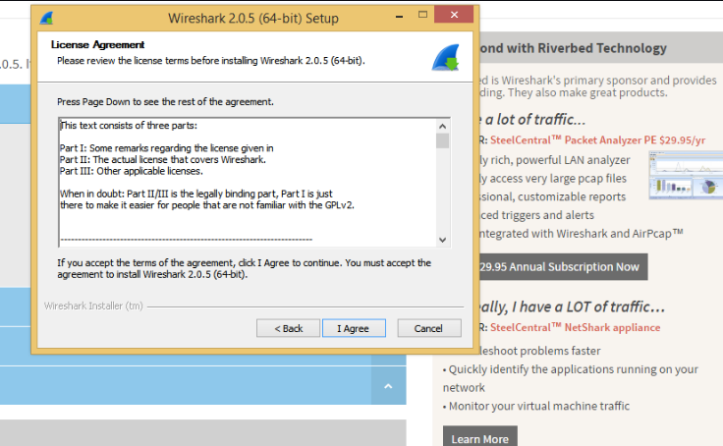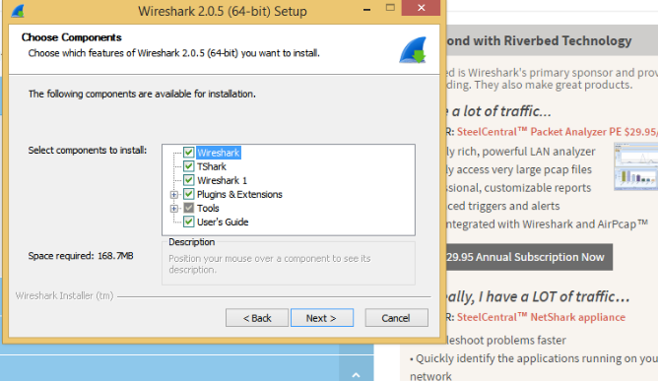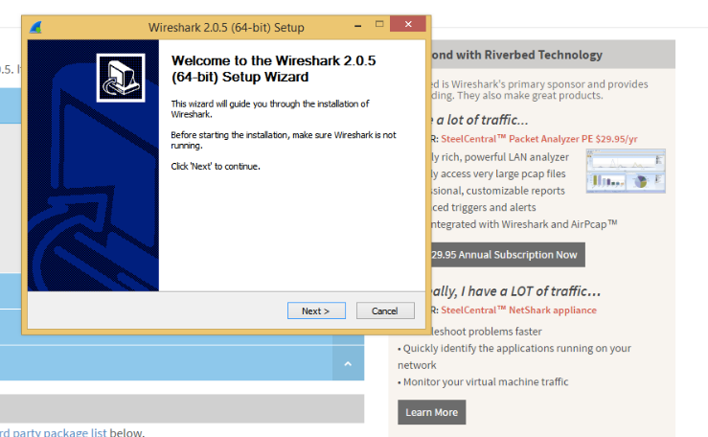

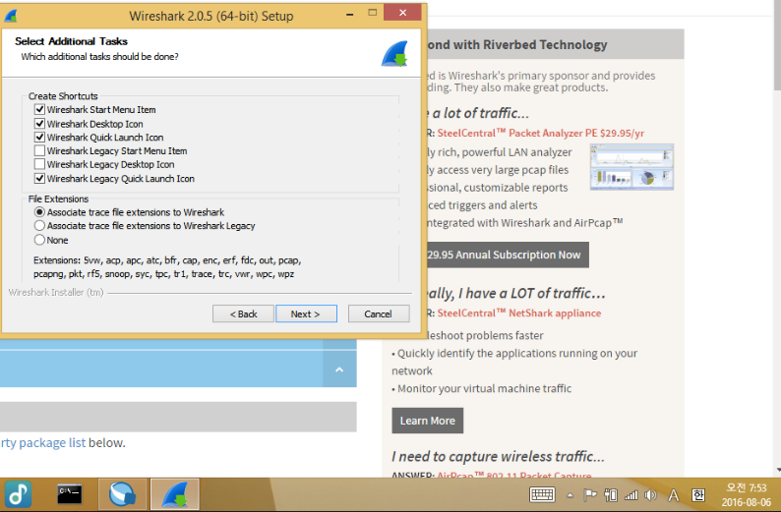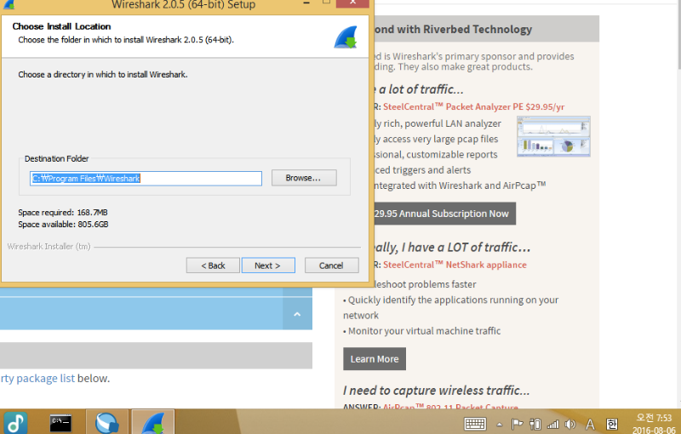

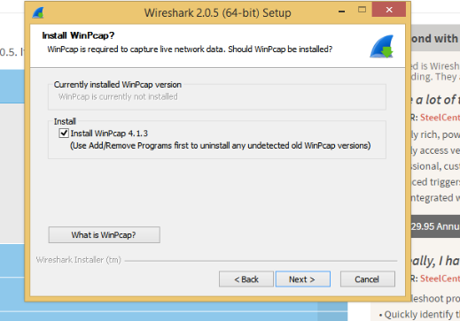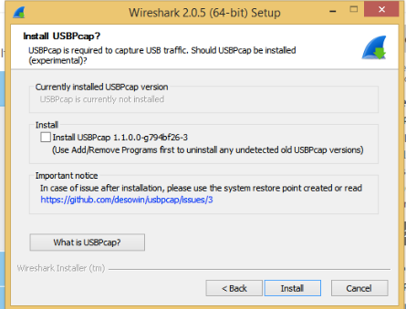

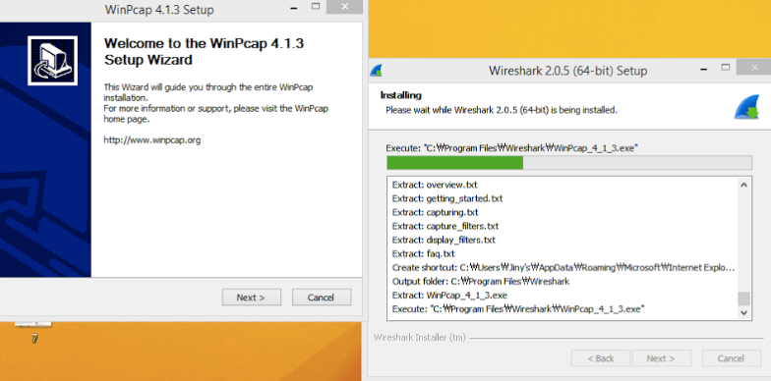

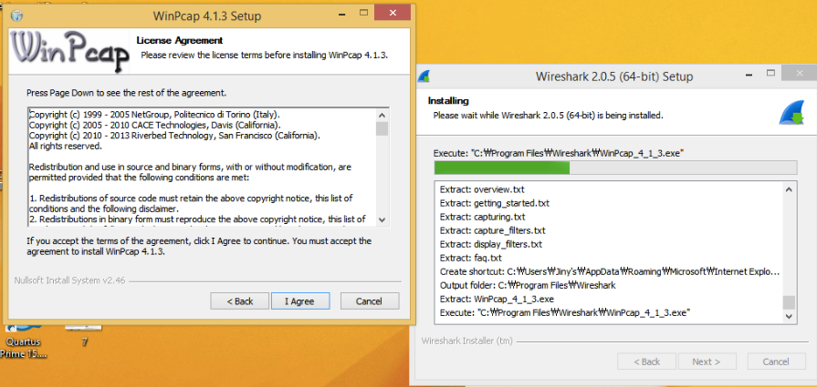

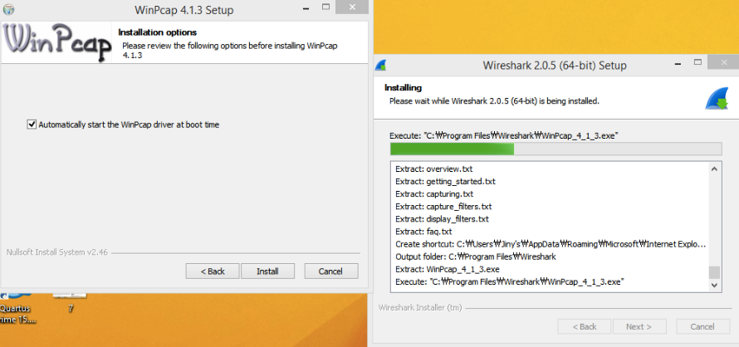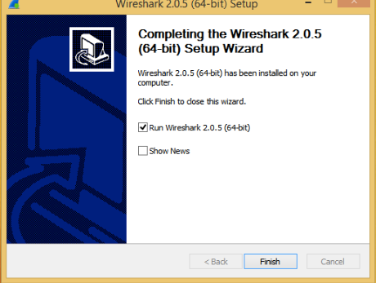

**packets moving across an Ethernet port**

