Chirag solanki

Student id : 15035

Answers:

R4:

1. Dial-up modem over telephone line - residential use

2. DSL over telephone line - small office

3. Cable to HFC – residential

4. 100 Mbps switched Ethernet - company

5. Wireless LAN - mobile

6. Cellular mobile access – mobile

R13

a) Only 2 users can be supported.

b) Because when each user requires 1Mbps when transmitting, so if two or fewer users transmit simultaneously, a maximum of 2Mbps will be required. Since the available bandwidth is 2Mbps, there will be no queuing delay before the link. So if there is 3 users transmit simultaneously, the bandwidth required will be 3Mbps which is more than the available bandwidth. .

c) Probability that a given user is transmitting = 0.2

d) Probability that all three users are transmitting simultaneously = 0.008

R22

So hear is five generic task

1. Error control
2. Flow control
3. Segmentation and Reassembly
4. Multiplexing
5. And connection setup.

And yes this task can be used as duplicated at different layer . as example the error control is often

Provide more than layer.

R28

- Trudy can pretend to be Bob at a later time via record-and-playback, resending passwords and potentially gaining access to authorized services

- Trudy can pretend to be Bob to Alice and partially or completely modify the message being sent from Bob to Alice.

- Trudy can even drop the packets that are being sent by Bob to Alice, even if the packets from Bob to Alice are encrypted.

P1

Solution :

1) Messages from ATM Machine to Server

|  |  |
| --- | --- |
| Message Name | Purpose |
| HELLO <user id > | Informs the server that there is a card in the ATM machine ATM card transmits user ID to server |
| PASSWORD <password> | User enters PIN, which is sent to server |
| BALANCE | User requests Balance |
| WITHDRAWL<amount> | User asks to withdraw money |

2) Messages from Server to ATM Machine

|  |  |
| --- | --- |
| Message Name | Purpose |
| PASSWD | Asks user for PIN |
| OK | Last requested operation was successful |
| ERR | Last requested operation was in error |
| AMOUNT<AMT> | Sent in response to BALANCE request |

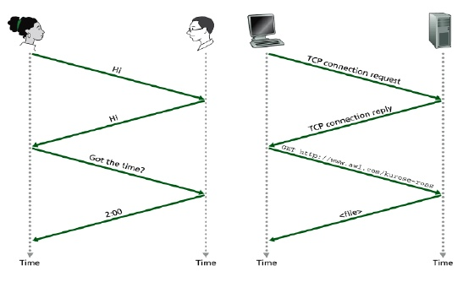

Correct operation:

Client server

ServerHELO (use rid) -------------------🡪 (check if valid user id)

🡨--------------------PASSWD

PASSWD (passwd) -------------------- 🡪(check password)

🡨---------------------OK ( password is OK )

BALNCE -------------------🡪

🡨--------------------- AMOUNT <amt>

WITHDRAWL <amt > -----------------🡪 check if enough $ to cover withdrawals

🡨------------------- OK

ATM dispenses $ ------------------🡪

In situation when there’s not enough money:

HELO (use rid) -------------------🡪 (check if valid user id)

🡨--------------------PASSWD

PASSWD (passwd) -------------------- 🡪(check password)

🡨---------------------OK ( password is OK )

BALNCE -------------------🡪

🡨--------------------- AMOUNT <amt>

WITHDRAWL <amt > -----------------🡪 check if enough $ to cover withdrawals

🡨------------------- ERR (not enough funds)

Error mgs displayed

No $ given out

Essay

* I am explaining hear that how Google hangout works. So first for I am telling you what is hangout, hangout is application that made by Google for free calling, massaging and also you can have face-to-face video calls with up to 9 other people. You can share photos in conversations.

Also Google hangout main and most amazing feature is you can call anyone on mobile or landline using this without any kind of extra changes so when u call anyone on directly on mobile so u can make communication without any kind of charges is totally free because when u call throat hangout so Google voice going to use their own minute for voice call and let u talk totally free so where u did call just u have to be connected with internet by cellular data or Wi-Fi so you can connected with hangout .

Furthermore, now we are going to discuss how it works totally free for you. So first we have to create account by our Gmail and then we can made the call. Every Hangouts call starts with all participants connecting to a Google server. The audio and video are then relayed to the people in the call. When there are only two participants in the call, Hangouts may attempt to establish a peer-to-peer connection between them. In order to create a peer-to-peer connection, it is necessary for Google to make the IP address of each participant available to the other. The IP address is like a phone number; in order for the two devices to speak to each other, they need to know how to contact each other. so for our each call Google going to use their own voice minutes and create IP address using our information’s and let us to call totally free any time .

In conclusion, we know that how hangout is work and how we can dial free audio and video call by using Google hangout.