Chirag solanki

15035

Answer 1

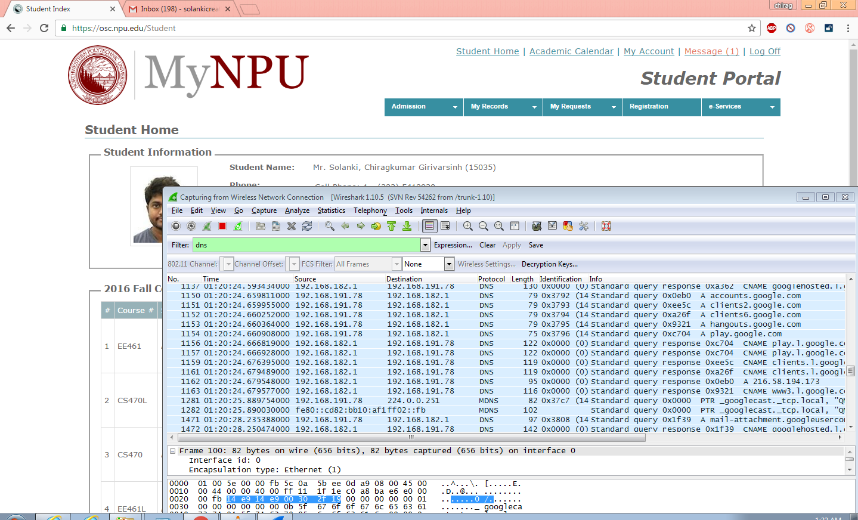

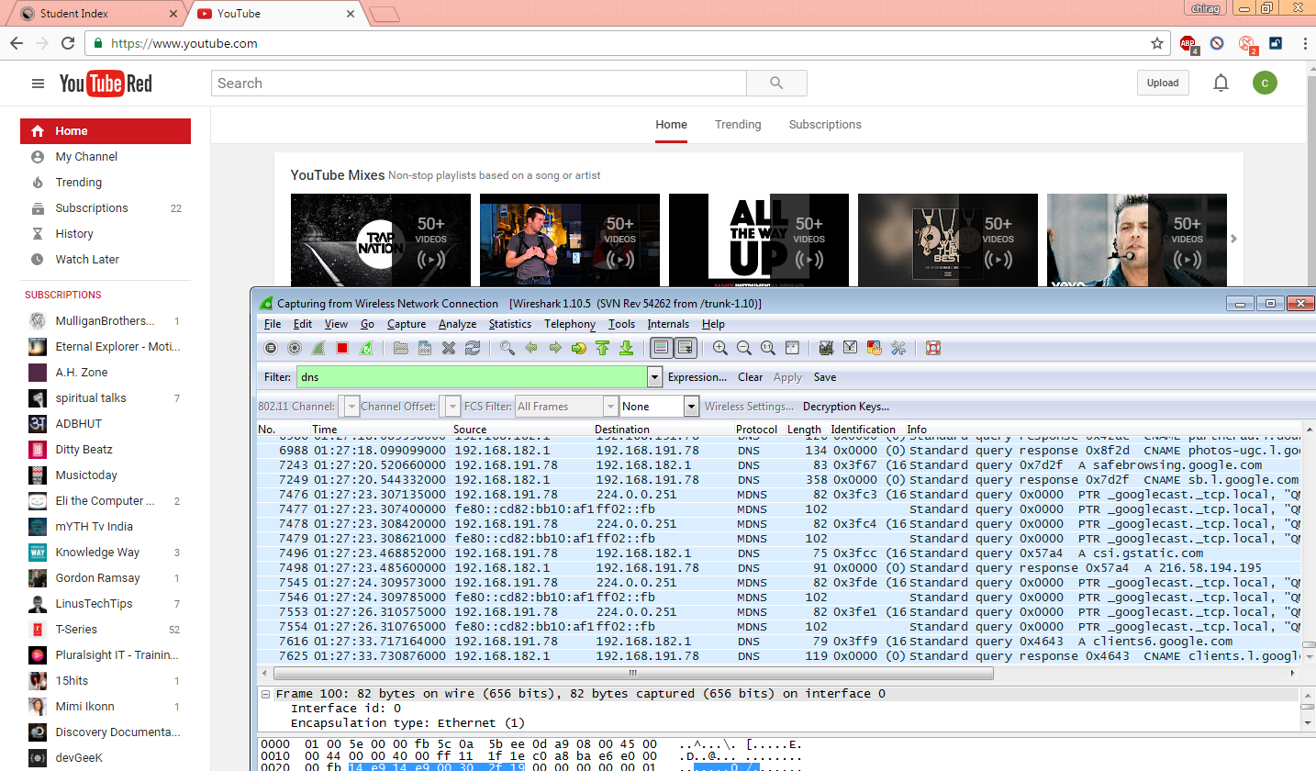

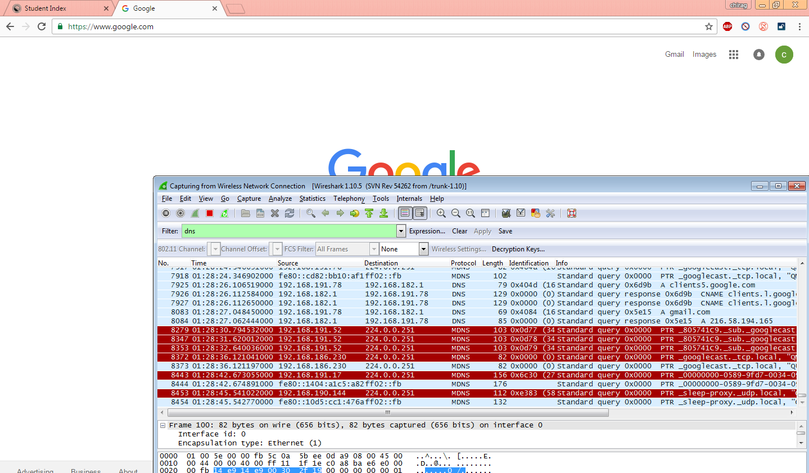

Answer 2

1. I can see hear MDNS and DNS protocols.
2. With use of pinging I can filter the information that I want see also I can search the things that I need And I can get destination information etc. .