Chirag solanki

15035

Answer 2

**2. Write a verilog module that initializes memory from a file?**

**● Read memory initialization data from a file**

**● Initializes the memory**

**● Write output from memory to a file**

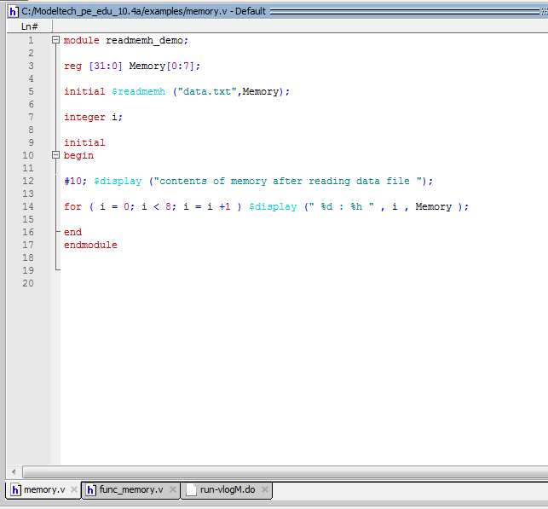

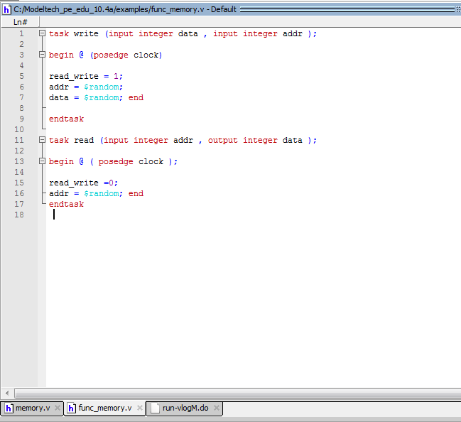

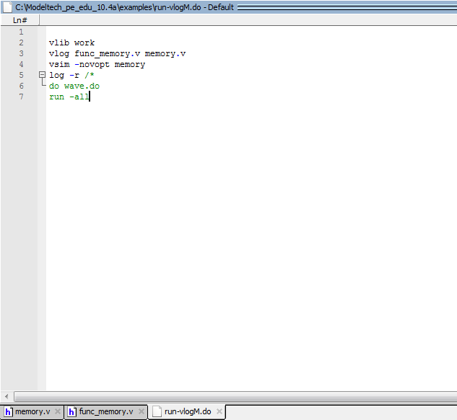

Answer 1

**1. Write a Verilog module that performs file I/O operation?**

**● opens a file**

**● Write data to the file**

**● Close the file**

