It is as if you were…

Pippin Barr & Devolution

2025-03-17

Table of contents

# Preface

This is…

Ideas / Questions:

* is it important to assume that somebody checks this without any context?
* intro into Devolution
* intro into *Pippin Barr x Devolution*
* clarifying what type of documents this are (?)
* (visual) overview on *It is as if…*
* link to the repository (QR-Code?)
* copyright / year / imprint?

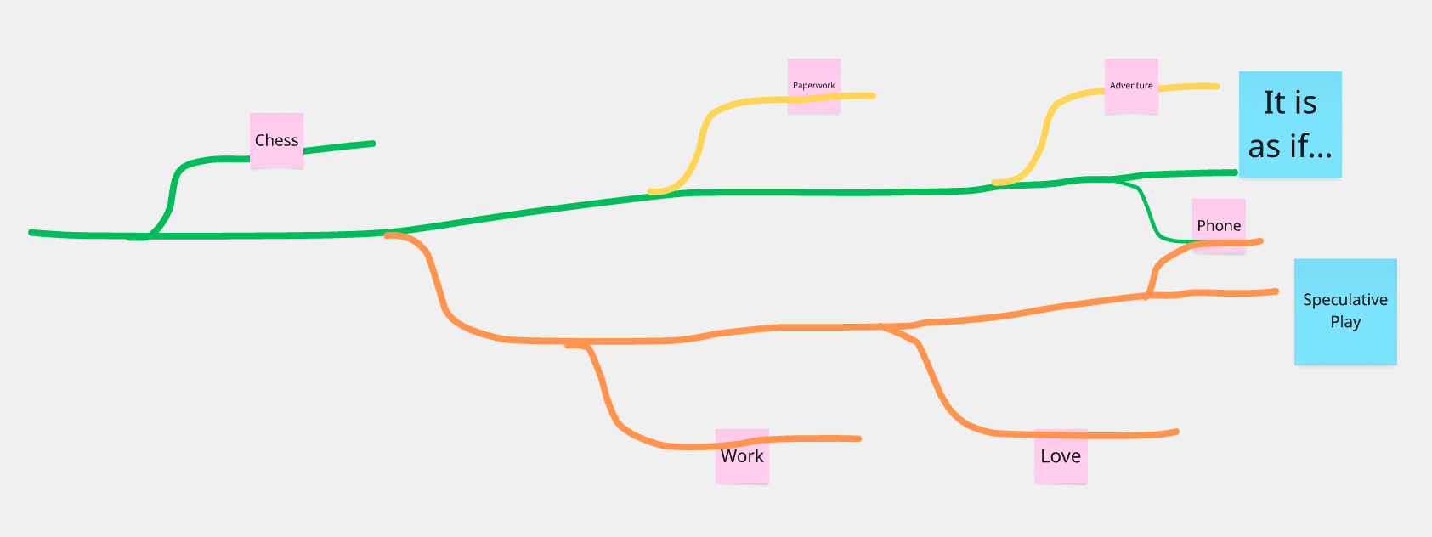

100% a series yes! There are some bits in there where I feel like they end up being a bit about distinct things. I think of *Love* and *Work* as both existing in specific fictional universes where they’re “needed” as a kind of therapeutic intervention into a problem. *Chess* didn’t really come from that place, was more of a “wouldn’t it be funny if…”. And then *Phone* is unclear to me right now… I think probably giving it some Speculative Play scaffolding does make a bit of sense, but it feels reactive to exactly *now* rather than the future? So I’m not even sure it works out as speculative at all…[1]

# 1. Info



##### [Play Online](http://www.pippinbarr.com/it-is-as-if-you-were-playing-chess/) (desktop and mobile)

### Description

*You’ve always wanted to be a chess master! But you aren’t one! Are you! Now you can at least look like one! Pretend you’re playing chess! Make moves! Act like you feel things! Smirk! Frown! Weep! Chess!*

*It is as if you were playing chess* was written in JavaScript/HTML5 using the [Phaser](http://www.phaser.io/) game framework. It’s a game that allows you to pretend to be playing chess. You know, impress your friends and strangers on the metro…

### Documentation

* Read the [Process Documentation](../process)
* Look at the [Code Repository](https://github.com/pippinbarr/it-is-as-if-you-were-playing-chess) for source code etc.

### License

*It is as if you were playing chess* is licensed under a [Creative Commons Attribution-NonCommercial 3.0 Unported License](http://creativecommons.org/licenses/by-nc/3.0/).

# 2. *It is as if you were playing chess* Press Kit

### Information

* Released: August, 2016
* Website: http://www.pippinbarr.com/games/
* Platforms: Browser
* Link: https://www.pippinbarr.com/it-is-as-if-you-were-playing-chess/
* Price: Free.

### Description

You’ve always wanted to be a chess master! But you aren’t one! Are you! Now you can at least look like one! Pretend you’re playing chess! Make moves! Act like you feel things! Smirk! Frown! Weep! Chess!

### History

“It is as if you were playing chess” is part of a larger project I’m calling “It is as if you were playing a videogame”. In both, the idea is to create games that aren’t game in themselves, per se, but allow/force/encourage the player to act as if they’re playing a game of some kind. The central image for me in this is that of a player sitting at their computer or using their mobile device while be observed by another person. To the observer it should look as though the player is genuinely playing some kind of game. In this case the idea is for them to look as though they are playing a game of chess, making the appropriate motions (to drag chess pieces around), facial expressions, eye movements, and so on. “It is as if you were playing chess” is thus an interface designed to support you in pretending that you’re playing a game of chess.

Whether I will ever succeed in creating the more general “It is as if you were playing a videogame” is less certain. “It is as if you were playing chess” is valuable as it provides a simple way of testing out the idea of an interface as a kind of game or game-referring experience. Chess, the game, provides a well-known set of movements and emotional experiences that most players should be able to “play along with” and thus “get” what the interface is doing. Importantly, in the case of this game, there is actually an underlying game of chess you are playing through as you follow the instructions, although only the white side of the moves are actually stored in the game. I pursued this angle, rather than completely random moves, to avoid the dissonance that would be created by either impossible moves or incredibly unlikely moves, for those who play enough chess to think through what is happening, much more abstractly, on the screen.

### Features

* Being told what to do.
* Being told how to act.
* Being told where to look.
* Chess?

### Images

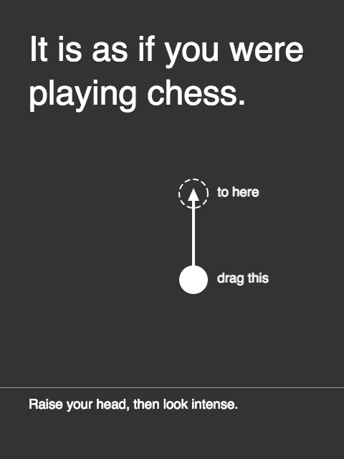



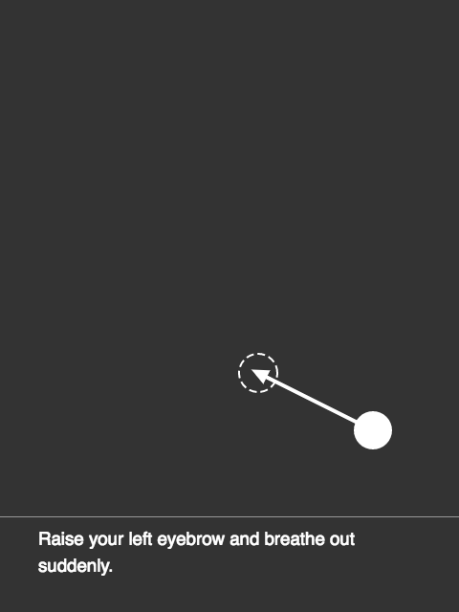

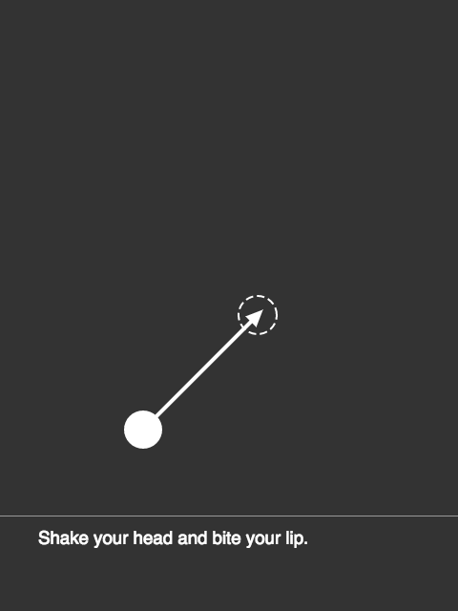

### Credits

* Pippin Barr: Everything

# 3. Commits

TBD

# 4. Journal

### Tuesday, 16 August 2016

Release

### Sunday, 14 August 2016

Todos: * Work on the emotion timing, right now it feels too fast and kind of out of synch (But also think about how it will affect the game over stuff.) * Add a “look here” symbol that plays between moves, moves around, probably an arrow or X

Issues: * Dragging super fast at beginning leaves arrow faded in SEEMS TO HAVE VANISHED? Possible to have both events be null on showGameOver No, still possible for both events to be null (co-incided with arrow faded in once) * Seems to be if you manage to end the game before any emotion? * Super fast drag to game over leave dashed line unfaded * Use minimal phaser build

### Thursday, 11 August 2016

Made quite a lot of progress on this yesterday evening in the end. Have the basic UI and interaction working. Mostly need to insert the underlying chess game(s) and then come up with a way to generate emotional cues at the bottom, most likely through Tracery for some variety with a grammar. Then it’d be done because it just ain’t that complex babe.

# 5. Blog Posts

Here are public-facing blog posts I wrote while creating the game.

### New Project: It is as if you were playing a videogame (2016-06-16)

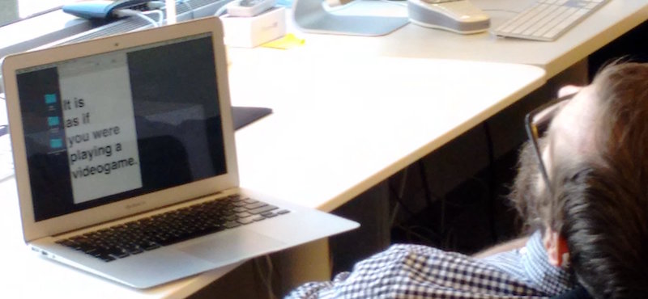 (Image credit: Dietrich Squinkifer)

I tried to relax for a couple of days after polishing off *Let’s Play: Ancient Greek Punishment: Limited Edition* (coming next Tuesday!) but I felt weird and out of sorts. It’s probably a little bit depressing, but at present I find it stressful to just detune and not work on a game/thing. I’ve started reading Gertrude Stein’s “The Making of Americans” (so far so, so hard to read) and I thought I’d just spend a day doing that. But no. Just listless wandering around the house, checking Twitter too much, answering emails, etc.

So I decided to just plow on ahead and have been giving some thought to the next project on my list, which is called *It is as if you were playing a videogame*. (The photo above, by Squinky, would make a great “genesis image”, but sadly I’d already thought of the game name by then and had written it in a text document to see what it could look like on a mobile device. Still, I like the idea that my “design process” might just be “looking like I’m asleep”.)

The genesis of this particular game idea came on the metro looking at all the people with their phones and tablets, deeply engrossed, moving their fingers around on the screens mystically. Being perverse, I liked the idea that somehow they were all actually doing nothing at all, but rather following banal instructions to “interact” with their device in such a way as to look like they were playing a game (or whatever else they might appear to be doing).

So that’s the plan with *It is as if you were playing a videogame* – it is to be a game that enables you to pretend (to others, perhaps even to yourself?) that you are playing a videogame. In some ways I also think of this as some sort of bizarre futuristic anxiety-support tool, allowing you to exist in a social space and appear to be busy at a socially sanctioned activity while in fact not really doing anything. (Why wouldn’t you just actually play a game? I don’t quite know, perhaps it would just be too stressful? Perhaps you don’t want to have real [game] emotions in public?)

This is all ties in with a longer-standing interest in making an abstract game that doesn’t rely on any narrative or world building properties for its graphics/text/aesthetics, but only has basic shapes and movements (e.g. “drag the circle to position (x,y)”). In fact the whole thing is more an exercise in interface design than game design because I want to explicitly avoid (as much as is possible in this weird situation) having it feel “like a game” in a more traditional sense. The affect of play/success/failure/tension etc. should all be as *fake* as possible, I think.

Anyway, that’s where my thinking is for the moment. No doubt it will evolve/devolve as I move along with it. Be seeing you.

### New (old) Project: It is as if you were playing chess (2016-08-10)



Turning my mind back to the world of making the videogames. A while back I [~~announced a new project~~](http://www.pippinbarr.com/2016/06/16/new-project-it-is-as-if-you-were-playing-a-videogame/) called *It is as if you are playing a videogame*. I spent a bit of time thinking about it before I made *Independence, Missouri* and one of the big struggles was how to think of it as a single, unified game. Bits and pieces of different ideas kept shuffling around as I tried to fix it in place – notably the question of how you generically represent “videogame” in abstract mechanics.

So, as a way to tunnel in, I thought I’d make one of the more specific versions I’ve been thinking about: chess. Thus, *It is as if you were playing chess* has been born and is underway. It’s much easier, because the overriding idea of “pretend you’re playing a game” is much more straightforwardly expressed with a known game with know inputs and outcomes like this. It lets me get at a few of the key ideas without getting lost in side-tracks.

Those key ideas as I see them right now revolve around the idea of “performing” a game without actually playing it. So you look like you’re playing chess, but actually you’re just performing quite abstract movements and expressions with your device. The game explicitly tells you what movements to make with your hands (using the mouse or on a touch screen) and also instructs you on how you should appear emotionally. In this way, all of “chess” is there as far as an observer might be concerned, but of course you’re not actually playing chess at all.

Making it be chess specifically also helps on the “visualisation” side of the game, which has been a tricky element for the design of the more abstract “videogame”, version. If you’re performing this abstract inputs, you’ll connect them to the idea of a “real” underlying game. If the game is telling you to make gestures with your mouse, clicking and dragging shapes around, you’ll probably associate that to the idea you’re moving pieces in an invisible “real game of chess”. As such, a decent chess player would be able to tell that the game wasn’t really reflective if I made the movements completely arbitrary. With the chess version, I *can* insert an underlying game of chess that you play through – you don’t decide the moves of course, you just make them when instructed, but they *are from a legal game of chess*, so you don’t have that kind of dissonance that could be created.

That’s where I’m at with it. Hoping this will be pretty straightforward to develop and release quite soon. I have a bunch of basic interface stuff implemented and mostly need to insert the real chess game and think about the “emotion instructor” part of it all.

Hope you’re well, say hi to the kids for me.

### Invisible Realism (2016-08-17)

(Excuse me while I push through the pain and write a quick post about something or other.)

While I was writing the press kit for *It is as if you were playing chess* (out Friday!) I reminded myself of the fact that the game features a real underlying game of chess. The rationale for that is that if you’re making these abstract “chess moves” with the interface, even someone not very attuned to chess might be able to notice if the moves were essentially generated at random. Like, “hang on, there isn’t even a piece on that square right now” or “there is literally no piece that can move like that”. Rather than write sufficient code to generate plausible moves, I just imported the move of pre-existing (and famous, as it happens) chess games. Because otherwise, even if you make sure the game shows *legal* moves it might still show *stupid* moves, and nobody wants to play *It is as if you were playing chess and were not very good at it at all*. (Although, having written that title, I’m like…)

Anyway, the game contains the moves (for white) of three classic chess matches, such that when you make the abstract moves there’s a sense in which you’re “really playing chess” I suppose, but also not, since nowhere in the game are the moves for black, for example. So you’re not really. But there *is* a kind of ground realism for the moves you make under there. And I like that idea that even in a deeply meaningless-looking interface there can still be seriousness below the surface. In fact it also refers back to [*Best Chess*](http://www.pippinbarr.com/2015/07/30/best-chess/) for me – in that game it looked to a large extent like nothing at all was happening, but in fact under the hood the game was literally working on *solving chess*, not just pretending to. That kind of authenticity is, I think, oddly powerful. Perhaps all the more so in this world of online games and especially JavaScript where, if people want to, they can pretty easily *check* what’s going on in the innards of a game they’re playing. (Unless I went out of my way to obfuscate it, which I don’t. See also: [*Leaderboarder*](http://www.pippinbarr.com/2014/04/25/leaderboarder/) for hilarity involving players and code.)

Do I have a point? I’m not 100% sure I do, but I do like internal authenticity and “responsibility” in games, games that don’t just pretend something is happen, but “do the work” beneath the surface, even if it’s invisible?

Anyway, don’t mind me.

### It is as if you were playing chess: Is it a game? (2016-09-01)

While working on the course I teach on game making this semester, I got to thinking about the old, (bitter?) chestnut of game definitions, and I found myself wondering whether a pseudo-game such as *It is as if you were playing chess* meets the definition of a game or not. So, with the help of the excellent Jesper Juul, who wrote a [nicely modular and clear definition of ‘game’](https://www.jesperjuul.net/text/gameplayerworld/), let’s see…

*1. Fixed rules.*

Seems legit. We definitely have rules, even visible in the above screenshot from the game – the rules are that you drag circles into destinations.

*2. Variable and quantifiable outcomes.*

Uh-oh? So this gets at the reason I thought this might be an interesting exercise, because *It is as if you were playing chess* is a ‘game’ that *contains* a game in some sense. Although the player isn’t specifically aware of it, the chess game she is going through the motions of (or ‘performing’) has a quantifiable outcome (a draw, or black or white wins). Furthermore, it’s variable because the chess game you’re playing through is randomised (not that you influence this outcome as a player).

Even furthermore, if we look at the meta-game of performance, we could claim there are variable outcomes, because the game always ends on an implied emotional tone, randomly generated by the game’s grammar. (Although the emotional tone implied at the end does not necessarily match the actual result of the game being performed, which is unknown to the game in the first place.)

_3. Valorisation of the outcome.

_ Following on from the above, it’s clear that the outcomes are valorised as well to the extent that in the underlying chess game it’s desirable to win (presumably), and to the extent that the final emotional tone implies a valence above the ending of the game, even if it’s maybe up to the interpretation of the player whether that implication seems to be “good” or “bad”.

_4. Player effort.

_ This one is a problem I think. The obvious actions you take in *It is as if you were playing chess* are trivial, just dragging a circle to a destination. On the other hand, the performative element of the game, striking the appropriate poses with your body and expressions with your face, isn’t trivial at all and could be said to involve player effort. In a cute way, we might say that the player’s performance even “influences the outcome of the game”, because it will shape the player’s affect and emotional connection to the game’s imagined end over time. On the other hand, Juul’s definition doesn’t seem to strictly *require* having an influence over the outcome (e.g. games of chance).

_5. Attachment of the player to the outcome.

_ This seems entirely possible to claim for the game. Even when pretending to play chess, we might imagine that one wants to pretend to win? Or perhaps we could even become attached to other performative outcomes, like appearing to lose, or appearing to go through a great struggle during play. Such outcomes are admittedly mostly defined by the player, but it’s in collaboration with the emotional and spatial cues provided by the game.

_6. Negotiable consequences.

_ It seems fairly clear that *It is as if you were playing chess* could be “*optionally* assigned real-life consequences” – its actions/moves are indeed “predominantly harmless”, as all you do is move shapes around on a screen and do some acting (unless you perhaps find the acting itself traumatic I suppose). So you could negotiate any kind of consequences for the game you might want – you might agree to act as if your imagined result of the game affects your whole day afterwards, for example, or you might bet money on the game’s outcome, deciding whether you won or lost at the end!

So having gone through with that exercise, it seems like *It is as if you were playing chess* is a game. So there?

**Update:** [Jesper Juul says it’s not a game](https://twitter.com/jesperjuul/status/771626951446401025), my world is in ruins around me. But I’ve always kind of liked post-apocalyptic settings, so it’s okay?

# 6. Press About

Read the [Press Kit](../press) for press information

* [Warp Door](http://warpdoor.com/2016/08/17/it-is-as-if-you-were-playing-chess-pippin-barr/) (before it was even released!)
* [Rock, Paper, Shotgun](https://www.rockpapershotgun.com/2016/08/20/best-free-games-of-the-week-29/)
* [Oujevipo](http://oujevipo.fr/general/5508-it-is-as-if-you-were-playing-chess/)
* [Kill Screen](https://killscreen.com/articles/game-pretending-play-chess-performance/)
* [Anait Games](http://www.anaitgames.com/articulos/it-is-as-if-you-were-playing-chess)
* [Comonuseless](https://commonuseless.com/2016/09/18/it-is-as-if-you-were-playing-chess-pippin-barr/) (an interview)
* [Brendan Keogh’s blog](https://brkeogh.com/2016/10/19/theyre-good-games-brent/)
* [Thoughts of A Third World Filmmaker](https://thoughtsofathirdworldfilmmaker.wordpress.com/2016/10/18/megabyte-size-look-at-it-is-as-if-you-were-playing-chess-and-bennet-foddys-speed-chess/).

# 7. Info

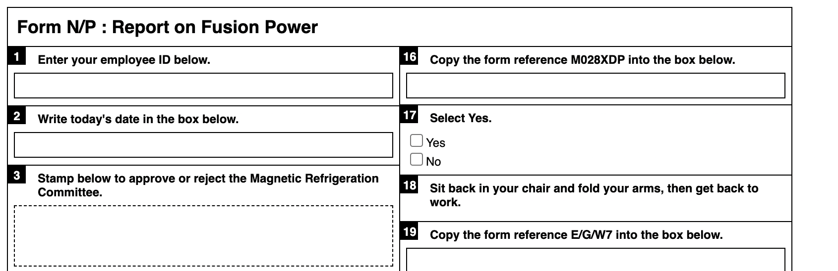

##### [Click here for paperwork generator and instructions](https://www.pippinbarr.com/it-is-as-if-you-were-doing-paperwork)

### Description

*Nothing feels quite as good as filling out forms! Am I right?! Choose any pen you want and get to it! Check boxes! Sign your name! Calculate numbers! Sigh loudly and scratch your neck! It’s all the action of the non-digital office environment in the discomfort of your own home!*

*It is as if you were doing paperwork* is a game of doing paperwork. At its heart it is a paperwork generator that creates forms that contain precise instructions for filling them out. You can’t go wrong. It’s an analog spiritual successor to my game [*It is as if you were doing work*](https://www.pippinbarr.com/itisasifyouweredoingwork/info) and was developed for the [“What Are the Rules?”](https://v-a-c.org/en/ges2/festival-of-play-and-games-what-are-the-rules) festival at the [VAC](https://v-a-c.org/) in Moscow.

The paper generator was written in JavaScript using jQuery.

### Press

There is no press kit. Should there be? If you want one, I guess I’ll make one.

### Process

* Take a look at the [process documentation](../process) for a very incomplete picture of development
* Go through the [code repository](https://www.github.com/pippinbarr/it-is-as-if-you-were-doing-paperwork) if you want the source code

### License

*It is as if you were doing paperwork* is an open source “game” licensed under a [Creative Commons Attribution-NonCommercial 3.0 Unported License](http://creativecommons.org/licenses/by-nc/3.0/). You can obtain the source code from its [code repository](https://github.com/pippinbarr/chesses) on GitHub.

# 8. Commits

TBD

# 9. Process

* You can read [arguably my least well-done process “journal”](./process-journal.md) if you want.

### Form Generator for It Is As If You Were Doing Paperwork

#### Crappy process notes:

* Writing words
  + Technologies I guess
* Add some of the Chess instructions - work environment things to do while going through the form so you can play along

#### From Jim

Copies to: (please list below)  
Please write number of copies required  
  
Origin code number here (three letters and fifteen digits)  
  
Enter your PIN number below  
  
Register here  
  
Time allocated 1hr 2hrs 3hrs 4hrs  
Time spent 1hr 2hrs 3hrs 4hrs  
  
Comments:  
  
Yes or no  
If yes please state name  
  
Please initial all pages  
  
Please tick box  
  
To order more forms select yes yes/no

# 10. Info

##### [Play Online](https://www.pippinbarr.com/it-is-as-if-you-were-playing-a-text-adventure)

### Description

*…*

*It is as if you were playing a text adventure* is an attempt to tell a story through the user-interface of a classic parser-based text adventure.

### Documentation

* Read the [Process documentation](../process/) for process journal, to do list, and related work
* Read the [Commit History](https://github.com/pippinbarr/it-is-as-if-you-were-playing-a-text-adventure/commits/main) for step-by-step information about how the project was built
* Look at the [Code Repository](https://github.com/pippinbarr/it-is-as-if-you-were-playing-a-text-adventure) for source code etc.

### License

*It is as if you were playing a text adventure* is an open source game licensed under a [Creative Commons Attribution-NonCommercial 3.0 Unported License](http://creativecommons.org/licenses/by-nc/3.0/). You can obtain the source code from its [code repository](https://github.com/pippinbarr/it-is-as-if-you-were-playing-a-text-adventure) on GitHub.

# 11. Commits

TBD

# 12. Journal

### The Basics – Sunday 8 September 2024

I’ve made a genuine start at this point, two sessions to try to get a basic skeleton of how the basic input-output flow would be able to work.

I’ve also had a brief conversation with Michael B about kind of piggy-backing on/reacting to a short story of his that I really loved, so that’s still in my mind as something to do.

Having made it this far though the next step is really to understand how I should be generating/choosing the sequence of commands for the user to input. In an earlier version of this I’d imagined something more or less like *It is as if you were playing chess* where I’d just have a fixed sequence the user would type it.

And that still makes sense - a lot of sense in some ways because it mirrors the essentially linear nature of stories. That is, there would be a fixed, implicit story being told that the user is perceiving only through the commands they type in as well as any suggested reactions they should have to it.

But I also feel a weird kind of pressure in that scenario where I actually need to understand what is happening moment to moment - there’s a need for a real story to exist in that scenario I think. And… well, I suppose that’s what I wanted, a chance to secretly write a story that nobody would actually read?

As I approach it, though, I’ve also found my brain going the more generative track. What would it take to perhaps generate commands instead, so that different people would have different experiences and we’d be talking more about how you build up an understanding of a world by probing it with commands? Which is *also* interesting.

In that case I’ve started thinking in terms of a data structure that would represent the *world* in much the same way an Inform story does (rooms, objects, special/relevant commands). And then having a system that would track: where the user is, what they’re holding, maybe other status effects if I want to go nutso?

And that is appealing… I gotta say, because there could be some pretty fun serendipty around it? And it’s this weird idea of designing some of a game but not all of it? (It would frankly even leave room for freakier stuff like actually letting story bleed in some places, though that sounds a bit much.)

Anyway, that’s where we are with this right now. I think I will at least try out the weird structural idea if only because it just seems technically challenging and funny as an idea. A secret structure of a game that only exists to generate relevant commands is pretty great.

Oh also, I suppose some kind of statistical likelihood thing may make sense? Because you obviously do “look” a lot more than other things and so on?

And some way of creating some more specific “reaction” suggestions for the user? So that they seem a bit more relevant? Shocks versus boredom etc.? Annoyance?

And can you win? It would be really funny if you could technically win?

### Further thoughts – Sunday 8 September 2024

I spent some more time with this this evening and it’s now crossed some kind of threshold where it both seems real (I have two locations, a few commands available) but where it also starts to seem like the contortions involved in a more “simulation” approach may not be all that fun and nor all that important?

There is tension - probably interesting, probably worth reflecting on - between creating something more procedural (leaning more into the “truth” of parser-based IF I guess?) and something more (or totally) linear (leaning more into the nature of story telling).

When I actually “play” what I have so far I think the thing that gives me the best little thrill is, well, just any command input, but especially changing locations (and seeing the location acknowledged in the menu bar) and picking something up… because those are moments where you really feel like you act on the world (unlike looking etc.).

I feel like getting a “realistic” representation of the command sequence in the simulation version might just be too hard and it might seem too weird without it? Like how do you reproduce the idea that if you enter a room you almost always “look”, but not all the time. Or how when you pick something up you might look at it. Or how you often try using all your items on a specific situation.

And it’s not even totally about realism there, but also about the narrative potential of those things too? Or of just being able to communicate a state of play… the story of playing sitting on top of the story itself…

So I’m perhaps just talking myself into a version where:

* It’s linear… you will just be typing in a set of instructions (which, I mean, who is ever going to replay this!)
* But it includes triggers around location, points, and anything else that could make sense to sort of reflect action through the UI

I briefly thought I’d need an inventory, but I suppose not actually. I’d need to keep track of it personally though.

Hmmm. Yeah well I think I just plow on with the linear version as my next thing, maybe just string together 10-20 commands including a location change to get a sense of what that would feel like? Maybe look at some walkthroughs of *good* IF to see how many commands etc. it might make sense to have? Start stockpiling forms that might be in there (“ask X about Y” for example).

### Reminding myself of where I am – Monday 16 September 2024

Yes, it has been eight days. Sosumi. It would be nice to round the corner into an understanding of what the screen itself needs so that I can “just” write the thing. If it’s linear is the point to also pre-write all the “reaction” stuff, or should that be drawn from a pool? Or… really, why do that? Might as well use the reactions as a way to further communicate about what might be happening.

The biggest question to me ultimately become: how much do *I* need to know about what is “really happening” both in the sense of the overarching story being told and the structuring of the parser-based IF that’s telling it?

I do like that this is yet another different take on the use of “It is as if” though. Speculative fiction, looking smart on the metro, … narrative vehicle…

Well but how do I write this then? I suppose first approximation is that each beat needs data, the same data… which would amount to what?

* Input (what they should type)
* Reaction (how they should “act”, including instructions on how much to read? Or text padding that lets them read “the right amount”? A shape…)
* Location (to display)
* Points (to add)

Plausibly something else? But also I suppose I should take a look at some walk throughs and some actual IF as some point soon. Maybe that’s tonight’s little job? Or is it just to put together a teeny draft of the above so I can see what that looks like? Or both, let’s see.

# 13. To-do

* **Bascally fine** ~~Fix it so that the history of commands shows up like a normal IF~~
* ~~Do enough styling so it looks like an IF instead of a piece of shit~~
* Probably not this, even with Lorem ipsum I’m kind of sold on the idea that there’s a way to write something here ~~Consider some kind of styling that looks more like text and the~~ *~~contains~~* ~~the preaction and reactions? Some way to fill the space out a bit more?~~
* Yes I do want to ~~Or do I want to write more extensively? Is there a writing opportunity here to say more at a meta level…~~
* For now I think that it’s better NOT to have timing introduced ~~Work on the time of pre and re actions as well as the command, give it a more natural flow, consider the relationship of delays to storytelling~~
* Write one scene (paragraph-level preactions)

1. GrowingStuff…