It is as if you were doing paperwork (2022)

The evolution of…

Pippin Barr x Devolution

Abstract

@ A MAZE. / Berlin 2025

# readme.md

This is the process documentation for the game *It is as if you were doing paperwork* (2024) by Pippin Barr.

* There is no press kit. Should there be? Read **Info** (Chapter 1) instead
* Take a look at the **Journal** (Chapter 2) for a very incomplete picture of development
* Read the **Commit History** (Chapter 3) for detailed, moment-to-moment insights into the development process
* Look at the **File Structure** (Chapter 4) for the evolution of the source code

## A note on the text

The text has been edited for print, but remains as close to the original as possible. Its main purpose is to provide the original material for exploration, the data is preserved *as is* and not updated.

## It is as if you were…

See: *Love*

# info.md

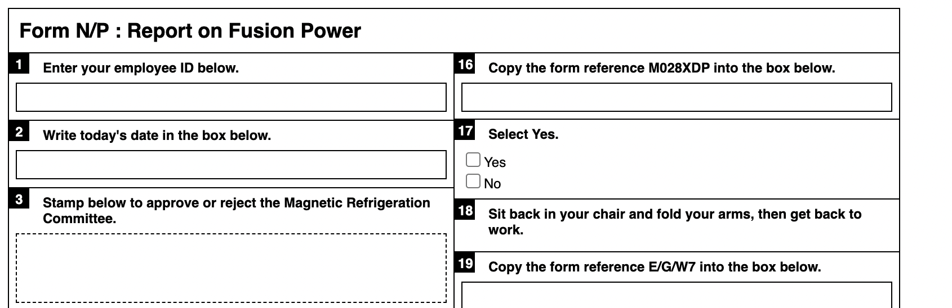

##### Click here for paperwork generator and instructions[1]

### Description

*Nothing feels quite as good as filling out forms! Am I right?! Choose any pen you want and get to it! Check boxes! Sign your name! Calculate numbers! Sigh loudly and scratch your neck! It’s all the action of the non-digital office environment in the discomfort of your own home!*

*It is as if you were doing paperwork* is a game of doing paperwork. At its heart it is a paperwork generator that creates forms that contain precise instructions for filling them out. You can’t go wrong. It’s an analog spiritual successor to my game [*It is as if you were doing work*](https://www.pippinbarr.com/itisasifyouweredoingwork/info) and was developed for the [“What Are the Rules?”](https://v-a-c.org/en/ges2/festival-of-play-and-games-what-are-the-rules) festival at the [VAC](https://v-a-c.org/) in Moscow.

The paper generator was written in JavaScript using jQuery.

### Press

There is no press kit. Should there be? If you want one, I guess I’ll make one.

# journal.md

Form Generator for It Is As If You Were Doing Paperwork

## Crappy process notes:

* Writing words
  + Technologies I guess
* Add some of the Chess instructions - work environment things to do while going through the form so you can play along

## From Jim

Copies to: (please list below)  
Please write number of copies required  
  
Origin code number here (three letters and fifteen digits)  
  
Enter your PIN number below  
  
Register here  
  
Time allocated 1hr 2hrs 3hrs 4hrs  
Time spent 1hr 2hrs 3hrs 4hrs  
  
Comments:  
  
Yes or no  
If yes please state name  
  
Please initial all pages  
  
Please tick box  
  
To order more forms select yes yes/no

# Commit History

## Overview

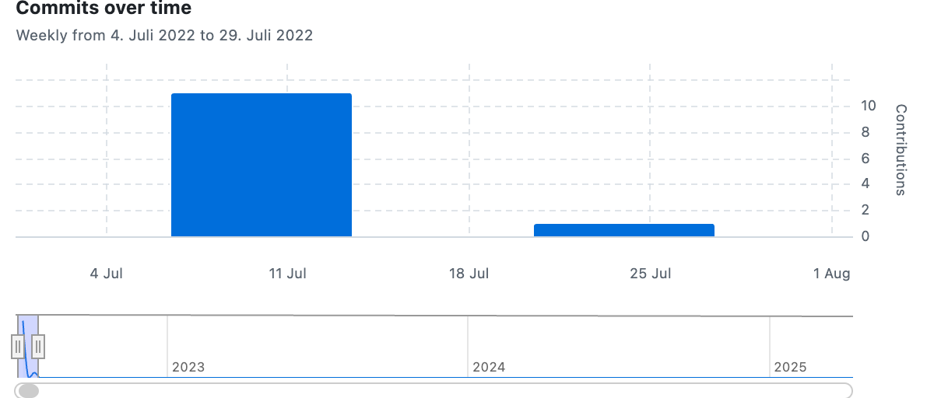

## Messages

**Thu, 14 Jul 2022 15:46:26**  
Initial commit

**Thu, 14 Jul 2022 15:55:43**  
Getting this thing properly online

**Thu, 14 Jul 2022 15:56:49**  
Continuing to get it website ready

**Thu, 14 Jul 2022 16:06:04**  
Getting it together

**Fri, 15 Jul 2022 14:27:46**  
Made a nicer presentation of the game, finished up the info

**Fri, 15 Jul 2022 14:36:40**  
Trying to be more clear…

**Fri, 15 Jul 2022 14:36:59**  
Typo

**Fri, 15 Jul 2022 14:37:42**  
Clear clear clear

**Fri, 15 Jul 2022 14:38:37**  
CSS fuck ups

**Fri, 15 Jul 2022 14:43:09**  
Improving CSS

**Fri, 15 Jul 2022 15:01:08**  
Description for paperwork

**Wed, 27 Jul 2022 11:09:32**  
Added a question mark?

# File Structure

## 2022-07-14

📋 It is as if you were doing paperwork/  
├── 📁 assets/  
├── 📁 css/  
 └── style.css  
├── 📁 info/  
├── 📁 js/  
 ├── FormGenerator.js  
 ├── html-version.js  
 ├── script.js  
 └── script-original.js  
├── 📁 process/   
├── .gitignore  
├── index.html  
└── README.md

## 2022-07-15

📋 It is as if you were doing paperwork/  
├── 📁 assets/  
├── 📁 css/  
 └── generator-style.css  
├── 📁 info/  
├── 📁 js/  
 ├── FormGenerator.js  
 ├── generator.js  
 ├── script.js  
 └── script-original.js  
├── 📁 process/   
├── .gitignore  
├── _config.yml  
├── generator.html  
├── index.html  
└── README.md

# Imprint

The evolution of…  
It is as if you were doing paperwork (2022)

See: Love.

1. [pippinbarr.com/it-is-as-if-you-were-doing-paperwork](https://www.pippinbarr.com/it-is-as-if-you-were-doing-paperwork)