It is as if you were doing paperwork

Pippin Barr & Devolution

2025-03-17

Table of contents

# Preface

* see *Phone*
* mentioning that to-dos were keept in the readme file for a long time? maybe not thaaat interesting…

# 1. Info

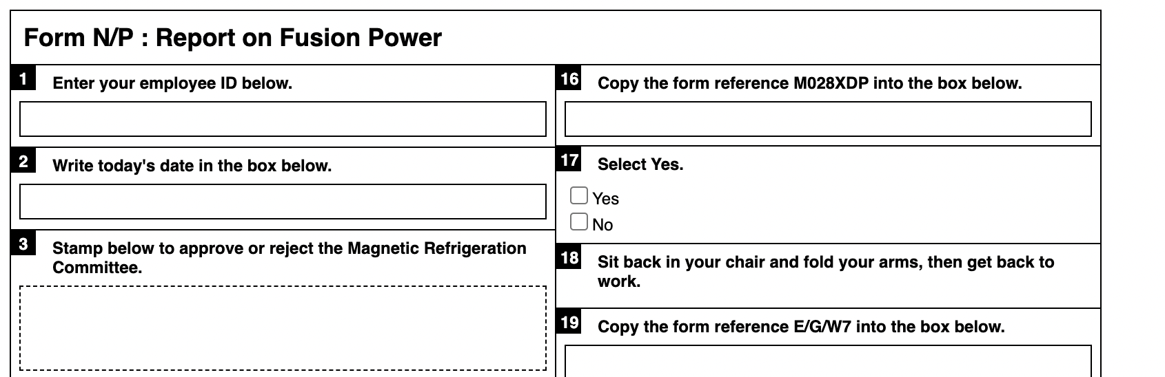

##### [Click here for paperwork generator and instructions](https://www.pippinbarr.com/it-is-as-if-you-were-doing-paperwork)

### Description

*Nothing feels quite as good as filling out forms! Am I right?! Choose any pen you want and get to it! Check boxes! Sign your name! Calculate numbers! Sigh loudly and scratch your neck! It’s all the action of the non-digital office environment in the discomfort of your own home!*

*It is as if you were doing paperwork* is a game of doing paperwork. At its heart it is a paperwork generator that creates forms that contain precise instructions for filling them out. You can’t go wrong. It’s an analog spiritual successor to my game [*It is as if you were doing work*](https://www.pippinbarr.com/itisasifyouweredoingwork/info) and was developed for the [“What Are the Rules?”](https://v-a-c.org/en/ges2/festival-of-play-and-games-what-are-the-rules) festival at the [VAC](https://v-a-c.org/) in Moscow.

The paper generator was written in JavaScript using jQuery.

### Press

There is no press kit. Should there be? If you want one, I guess I’ll make one.

### Process

* Take a look at the [process documentation](../process) for a very incomplete picture of development
* Go through the [code repository](https://www.github.com/pippinbarr/it-is-as-if-you-were-doing-paperwork) if you want the source code

### License

*It is as if you were doing paperwork* is an open source “game” licensed under a [Creative Commons Attribution-NonCommercial 3.0 Unported License](http://creativecommons.org/licenses/by-nc/3.0/). You can obtain the source code from its [code repository](https://github.com/pippinbarr/chesses) on GitHub.

# 2. Commits

TBD

# 3. Process

* You can read [arguably my least well-done process “journal”](./process-journal.md) if you want.

### Form Generator for It Is As If You Were Doing Paperwork

#### Crappy process notes:

* Writing words
  + Technologies I guess
* Add some of the Chess instructions - work environment things to do while going through the form so you can play along

#### From Jim

Copies to: (please list below)  
Please write number of copies required  
  
Origin code number here (three letters and fifteen digits)  
  
Enter your PIN number below  
  
Register here  
  
Time allocated 1hr 2hrs 3hrs 4hrs  
Time spent 1hr 2hrs 3hrs 4hrs  
  
Comments:  
  
Yes or no  
If yes please state name  
  
Please initial all pages  
  
Please tick box  
  
To order more forms select yes yes/no